

**Version 1.1**

**Date: 2019/02/27**

AbstractDue to the great number of stocking items and broad based demand planning, much of the purchasing decisions is driven by a semi-automated process based on sales demand, supplier fulfilment rate, available funding etc

Supplier Ordering Process

Optimised purchasing from Suppliers

**Table of Contents**

Document approval and distribution list 2

1. Introduction 3

2. Audience 3

3. Objectives 3

4. Business Flow 3

5. Detailed description of functionality 3

6. Dependencies 4

7. Application design philosophy 4

8. Database design philosophy 4

9. Catalogue lookup to sales-order 4

10. Database entities and relationships 6

11. Programs 8

11.1 MS Windows Executables 8

11.2 SQL Stored Procedures 8

12. Acceptance 10

# Document approval and distribution list

|  |  |  |  |
| --- | --- | --- | --- |
| **Description** | **Name / Title** | **Signature** | **Date** |
| **Document Type / purpose** | | | |
| Prepared by |  |  |  |
| Reviewed by |  |  |  |
| Approved by |  |  |  |

# Introduction

Due to the great number of stocking items and broad based demand planning, much of the purchasing decisions is driven by a semi-automated process based on sales demand, supplier fulfilment rate, available funding etc

More recently, post liquidation, an advanced stock demand modelling system was acquired and now forms [art of the bulk of purchasing done by Engineparts from internal (Imperial based) suppliers.

# Audience

* Management
* Purchasing

# Objectives

Sales demand is expressed as an AMS factor (3-month Average Monthly Sales). This is a calculated value using sales for the past period where every month’s sales is folded into the current AMS factor.

The main reason for using this method rather than re-calculating demand from the immediate past 3 months of turnover is that there can be an intrinsic demand without any stock availability. This will skew the AMS is based on the immediate past 3 month.

Additionally, the AMS recalculation is NOT recalculated when stock availability reaches zero. This is to preserve the purchasing model in the event of supply failure.

Considering that ePART is designed to be multi-company multi-warehouse capable, demand is apportioned to each point of ***consumption,*** carrying and own AMS factor deriving a collective demand model.

Each point of consumption with its own demand model provides input to the purchasing levels and frequency based on several factors exposed in the ***workbench*** program.

Some of these factors are GP%, AMS, supplier capacity / reliability to supply etc.

The notion should be for the purchaser to minimise stock holding without negatively affecting sales availability. Using the ePART workbench empowers buying staff to make effective and informed decisions to balance investment vs. availability; there is a cost in purchasing too much stock and loss of GP if unable to supply.

# Database entities and relationships

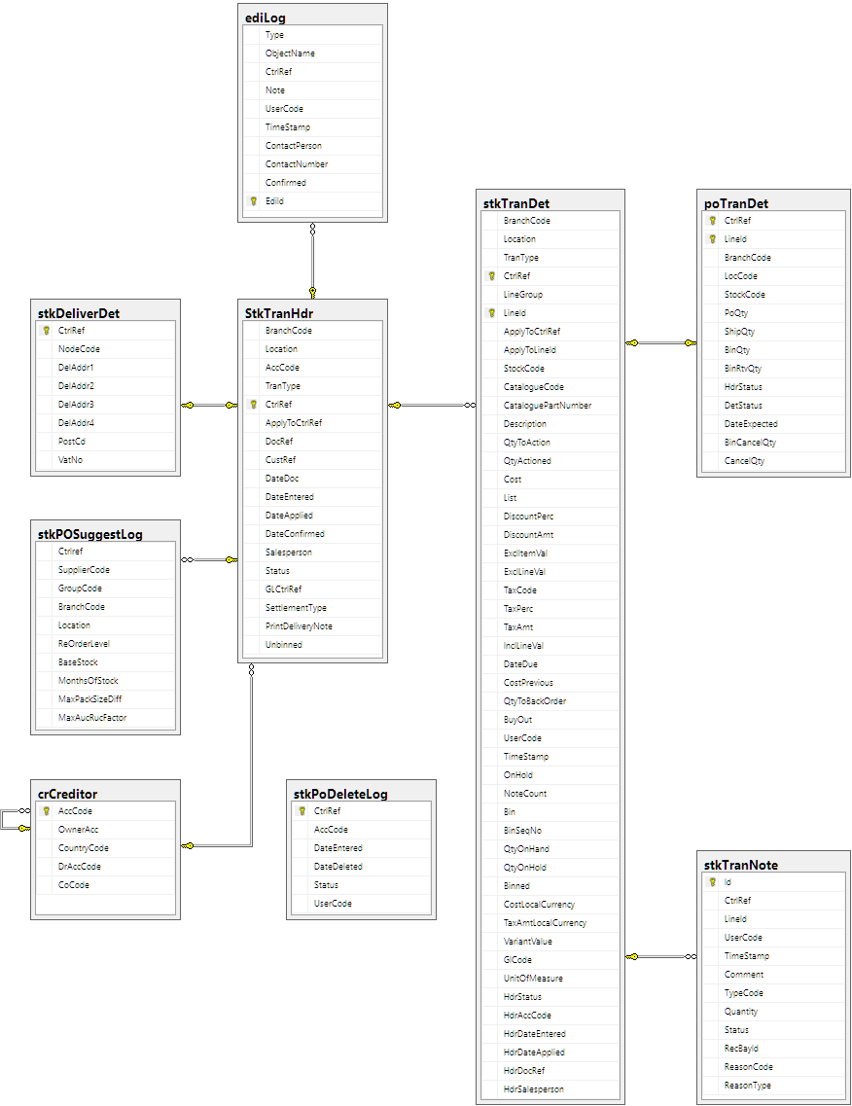

# Programs

# MS Windows Executables

|  |  |
| --- | --- |
| **Name** | **Description** |
| stkPurchaseOrder.exe | Used to auto-suggest, modify, manage and send purchase orders. |

# SQL Stored Procedures

|  |  |
| --- | --- |
| **Name** | **Description** |
| stkPurchaseOrderDefaultAddress | Gets the branch’s address as the default delivery address. |
| stkPurchaseOrderSearch | Searches for a purchase order |
| stkPurchaseOrderSuggest | Creates a new order filled with suggested purchases. |
| stkPurchaseOrderDelete | Sets the order’s status to “deleted”. |
| stkPurchaseOrderLine | Verifies changes and do cascading updates. |
| stkPurchaseOrderLineDisplay | Refreshes cache fields before displaying the line. |
| stkPurchaseOrderDetAlternates | Lists alternates for an item. |
| stkPurchaseOrderDetSuppliers | Lists possible suppliers for an item. |
| stkPurchaseOrderDetBranchLoc | Gets branch-specific info for a part. |
| stkPurchaseOrderDetPurchaseOrders | List ALL the purchase orders that an item has been on. |
| stkUpdateSupplierPrices | Refreshes the order’s prices to match the SPL. |
| stkEDIComfirmOrder | Beware the spelling on this one. Marks an EDI order as being confirmed, and updates the contact details. |
| stkEDITelephoneOrder | Does this schedule a telephone call to place an order? |
| stkStatusLog | Logs the order’s status change. |
| stkTranDetNextLineId | Gets the next line id for the current order. |
| ediExportOrder | Enqueues either an HTML or a CSV EDI order. |
| ediCSVPluginOrder | Generates a CSV EDI order and schedules its e-mail. |
| ediLogFaxPrint | Enqueues either a fax or a printed(?) EDI order. |
| ediCheckEmail | Gathers the list of EDI options for an account. |
| purPurchaseOrderCheckAccCode | Checks whether the account can accept orders. |
| catSupplierCatalogueList | Retrieves catalogue part numbers for an item. |
| catSupplierPriceListCount | Returns the number of prices that the supplier has for the item. |
| crClaimCount | Gets the number of open claims on a supplier. |

# Acceptance

I hereby confirm that I have been fully informed of the documents content and received training to understand how the detailed instructions are to be applied:

Name ……………………………………………………………………………

Job Title ……………………………………………………………………………

Signed ……………………………………………………………………………

Date ……………………………………………………………………………