Meal Suggester Web App
Languages and frameworks used: C#, Blazor, MudBlazor, and Linqpad queries
- Home (Landing Page)
  - Purpose = Orientation
    - Short intro to app
    - Nav options: Inspire Me & Find a Meal
- Inspire Me Page (Want = Unknown)
  - Purpose = Passive Directory
    - Shows 3-7 random meals
    - Group by cuisine or mixed
    - Has “Shuffle”/refresh
    - No filters
- Find a Meal Page
  - Purpose = Active Filtering
    - Select cuisine (clickable card)
    - Filter by ingredients: Search Bar & Selectable buttons
    - Click “Show Meals”
    - Display results as meal cards
* Use inserts to seed DB --------- Empty DB = broken UI
- Extras
  - “Clear Filters” button
  - Empty States (no results, etc.)
  - Optional “Surprise Me” button
Admin Functionality
- Manage Meals
  - Create/Edit meals
  - Assign
    - Cuisine
    - Ingredients
    - Dietary Flag (optional)
- Many-To-Many relationship
  - Meals Ingredients
Business Rules:
- A meal can belong to a single cuisine.
- Meals can have many ingredients and many dietary tags
- Meal plan can have multiple meals
- A meal plan can have a minimum of 3 and a maximum of 7 meals
- Meal Id, Ingredient Id, Cuisine Id, Dietary Tag Id, and Weekly Plan Id uniquely identify Meals, Ingredients, Cuisines, Dietary Tags, and Weekly Plans respectively.
- Cuisines, ingredients, and dietary tags can be individually filtered/searched for by the user.
Entities: Meal, Ingredient, Cuisine, DietaryTag, WeeklyPlan
Primary Keys: Meal Id, Ingredient Id, Cuisine Id, DietaryTag Id, WeeklyPlan Id
1NF – Atomic Data
Meal
(
Meal Id, Meal Name, Cuisine Id, Cuisine Name,
(Ingredient Id, Ingredient Name, DietaryTag Id, DietaryTag Name, WeeklyPlan Id)
)
2NF – Dependency Breakdown (Partial Dependencies included)
Meal Cuisine --- One To Many Relationship
Meal Ingredient --- Many to Many Relationship
Meal
(CuisineId (FK) IngredientId (FK) MealId MealName PrepTime CreatedOn)
Cuisine
(CuisineId CuisineName)

Meal MealType --- Many to Many Relationship
MealType
(MealTypeId (PK) MealTypeName)

Meal WeeklyPlan --- Many to One Relationship
WeeklyPlan
(MealId (FK) WeeklyPlanId DayOfWeek)

Ingredients
(IngredientId IngredientName)

Meal DietaryTag --- Many to Many Relationship
DietaryTag
(MealId (FK) DietaryTagId DietaryTagName)

3NF – Relationship Breakdown Completion and Cleaned Up
Meal Cuisine --- One To Many Relationship
Meal
(CuisineId (FK) MealId MealName PrepTime CreatedOn)

Cuisine
(CuisineId CuisineName)

Meal WeeklyPlan --- Many to One Relationship
WeeklyPlan
(MealId (FK) WeeklyPlanId DayOfWeek)

Meal Ingredients --- Many to Many Relationship
MealIngredients
(MealId (FK) IngredientId (FK))

Ingredients
(IngredientId IngredientName)

MealType
(MealTypeId MealTypeName)
Meal MealType --- Many to Many Relationship
MealTypeAssignment
(MealId (FK) MealTypeId (FK))
DietaryTag
(DietaryTagId DietaryTagName)
Meal MealDietaryTag --- Many to Many Relationship
DietaryTag MealDietaryTag --- Many to Many Relationship
MealDietaryTag
(MealId (FK) DietaryTagId (FK))

Joining Tables used to resolve Many-To-Many Relationships:
- MealIngredients
- MealTypeAssignment
- MealDietaryTag

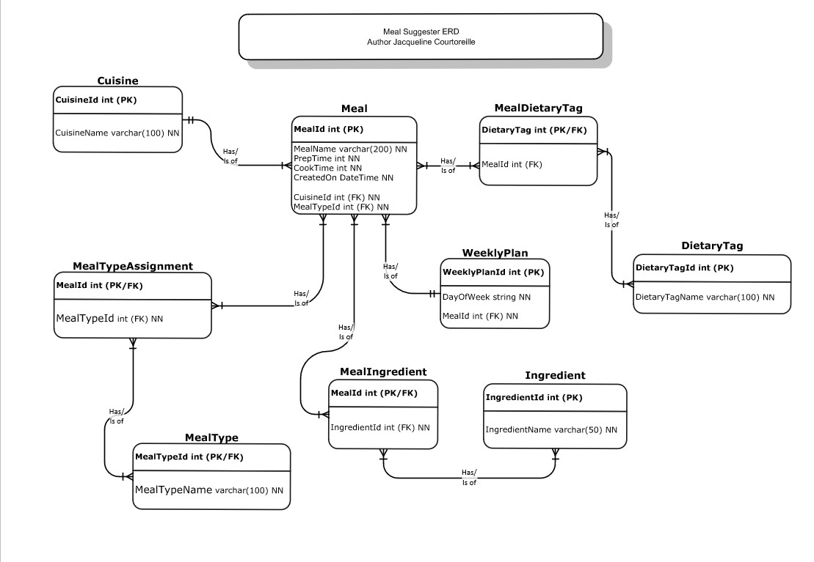
Completed Entity Relationship Diagram (ERD)

