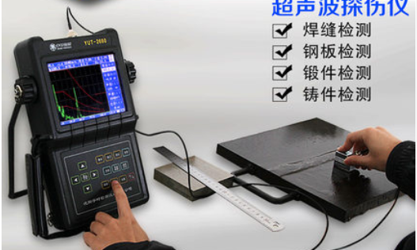

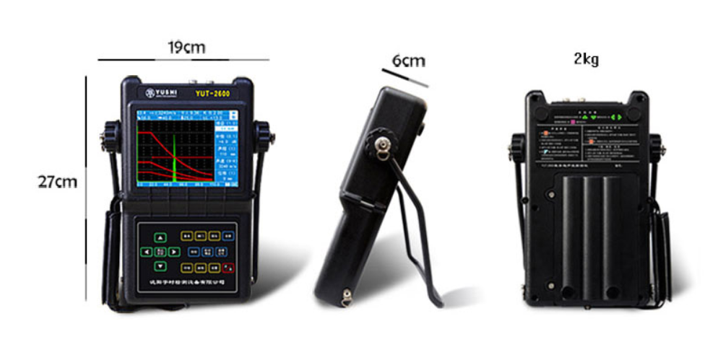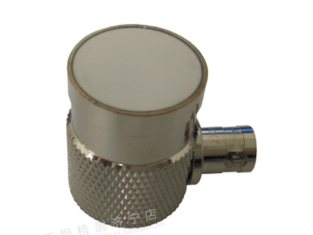

Weight：2kg（with battery）

The device is big, but the detector of it is small, maybe we can just but a detector on the drone and send the signal back wirelessly. I did not find wireless detector yet.