Bio-Log Database Project

Ary Hernandez, Jacquelyn Johnson, Andrew Samuel

### Abstract

The proposed database will allow for a logical and concise storage of data collected from the Gen III MicroPlate Biolog lab being conducted at Lone Star College-Montgomery. This database application will allow students and professors the ability to query through large amounts of data collected, draw inferences from the data to extend hypothesis, and further the research in the field of microbiology pertaining to this specific lab. The platform is a MySQL database with the application GUI written in VB using Windows Forms App(.NET Framework). The result is a database which enables students and professors to enter, manage, and query data through a user-friendly interface.

### Mission Statement

The purpose of the Biolog database project is to maintain the data collected during the course of performing the steps associated with the Gen III Microplate Lab being conducted at Lone Star College-Montgomery under the direction of Dr. Julie Harless. This database will allow for data to be organized in such a way that hypothesis can be formulated and tested . The students and professors will be able to query the data in such a way to allow for new labs to be developed and further their research into the electrical output of microorganisms.

### Mission Objectives

To maintain (enter, update, and delete) data on Student_id

To maintain (enter, update, and delete) data on Location

To maintain (enter, update, and delete) data on Semester

To maintain (enter, update, and delete) data on Type of Land

To maintain (enter, update, and delete) data on Electrical Output

To maintain (enter, update, and delete) data on Campus

To maintain (enter, update, and delete) data on Class ID

To maintain (enter, updatem and delete) data on Reaction

To maintain (enter and update) data on Professor

To perform searches on Location

To perform searches on Electrical Output

To perform searches on Campus

To perform searches on Reaction

To perform searches on Semester

To perform searches on Type of Land

To perform searches on Student_id

To perform searches on Class ID

To track status of Electrical Output

To track status of Reaction

To report on Student_id

To report on Class ID

To report on Reactions

To report on Location

To report on Type of Land

To report on Semester

To report on Campus

To report on Electrical Output

### Major User Views

### E/R Diagram

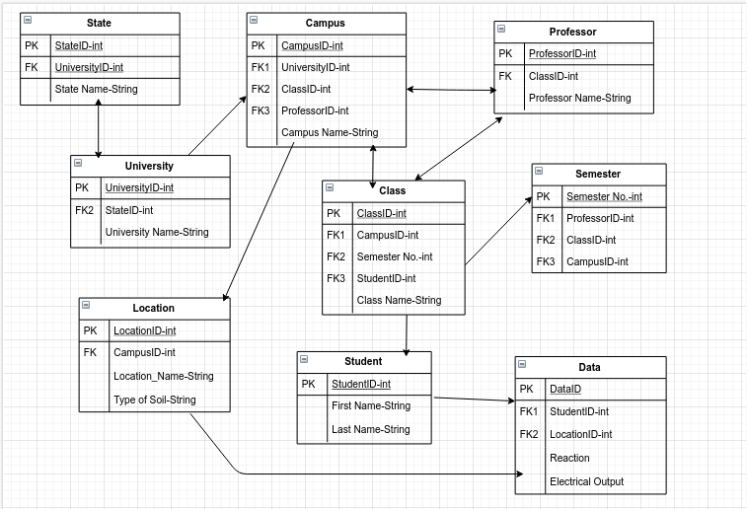

### Use Cases