Bio-Log Database Project

By Ary Hernandez, Jacquelyn Johnson, and Andrew Samuel

### Abstract

The proposed database will allow for a logical and concise storage of data collected from the Gen III MicroPlate Biolog lab being conducted at Lone Star College-Montgomery. This database application will allow students and professors the ability to query through large amounts of data collected, draw inferences from the data to extend hypothesis, and further the research in the field of microbiology pertaining to this specific lab. The platform is a MySQL database with the application GUI written in VB using Windows Forms App(.NET Framework). The result is a database which enables students and professors to enter, manage, and query data through a user-friendly interface.

### Mission Statement

The purpose of the Biolog database project is to maintain the data collected during the course of performing the steps associated with the Gen III Microplate Lab being conducted at Lone Star College-Montgomery under the direction of Dr. Julie Harless. This database will allow for data to be organized in such a way that hypothesis can be formulated and tested . The students and professors will be able to query the data in such a way to allow for new labs to be developed and further their research into the electrical output of microorganisms.

### Mission Objectives

To maintain (enter, update, and delete) data on State

To maintain (enter, update, and delete) data on University

To maintain (enter, update, and delete) data on Campus

To maintain (enter, update, and delete) data on Professor

To maintain (enter, update, and delete) data on Class

To maintain (enter, update, and delete) data on Semester

To maintain (enter, update, and delete) data on Location

To maintain (enter, update, and delete) data on Student

To maintain (enter and update) data on Data

To perform searches on State

To perform searches on University

To perform searches on Campus

To perform searches on Class

To perform searches on Semester

To perform searches on Location

To perform searches on Student

To perform searches on Data

To track status of Data

To report on State

To report on University

To report on Campus

To report on Professor

To report on Class

To report on Semester

To report on Location

To report on Student

To report on Data

### Major User Views

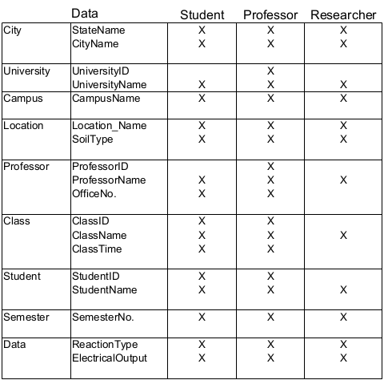

### E/R Diagram

### 

### Use Cases

**Student**

Insert

1. Student can add new data log
2. Student will name data log
3. Student will enter recorded electrical output of microorganism
4. Student will enter recorded reaction of microorganism
5. Student will save inputted information
6. A data ID will be generated

Delete

1. Student will click on data log they wish to delete
2. Student will be prompted to confirm deletion
3. Student will then delete data log if they confirm

Update

1. Student will choose which data log they wish to update
2. Student can then change electrical output and/or reaction of microorganism
3. Student will then confirm update

Search by Location

1. Student will be prompted to enter a location
2. If the location exist, user will be given data logs pertaining to that location

Search by Electrical Output

1. Student will be prompted to enter a range of values for a electrical output
2. If it exists, the user will be given data logs with the entered electrical output values

Search by Reaction

1. Student will be prompted to enter keyword for reaction of microorganism
2. Student will then be given list of data logs with containing that reaction keyword

Search by Semester

1. Student will be prompted to enter year of semester
2. Student will be given semesters pertaining to entered year

Search by Type of Land

1. Student will be prompted to enter type of land
2. Student will be given list of types of land entered by user

Search by Student ID

1. Student will enter student ID
2. If valid, data logs entered by that student ID will be displayed

Search by Campus

1. Student will enter name of campus
2. List of data logs located in that campus will be returned

Search by Soil type

1. Student will enter name of soil
2. Data logs that contain entered soil will be returned

**Professor**

Insert

1. Professor can add new Class ID
2. Professor will name new class
3. Professor will confirm creation

Delete

1. Professor will click on class
2. Professor will be prompted to confirm deletion
3. Professor will then delete class if they confirm

Update

1. Professor will choose which class to update
2. Professor can then change the name of the class
3. Professor will then confirm update

### Database Prototype

### Project Timetable

**Task 1: Finalize needed tables and attributes**

**Members responsible for task: Ary Hernandez, Andrew Samuel, Jacquelyn Johnson**

As a democratic team, all members will review the tables and attributes found within the database to make certain that there aren't any entities or attributes being overlooked.

**Task 2: Write code using MySQL for the database**

**Members responsible for task: Andrew Samuel (lead), Ary Hernandez, Jacquelyn Johnson**

The team will meet each week, at least once weekly, to write the code for the database from March 17, 2020 through April 7, 2020. For this task, Andrew Samuel will take lead and assign tasks to the other members of the team until the database is fully coded.

**Task 3: Implement database within an application**

**Members responsible for task: Jacquelyn Johnson (lead), Ary Hernandez, Andrew Samuel**

The team will work together for the design and implementation of the database within an application. As this project is beign designed for delivery to another university that uses Microsoft exclusively, this application will be written in VB for ease of installation and use on the machines that are currently being used by the university. For this task, Jacquelyn Johnson will take the lead, assign tasks to the other members of the team, and call meetings as needed until the database is fully implemented. This task should be completed by April 21, 2020, leaving a week to make any necessary changes to visual presentation and application logic answsering the question: does the layout make sense to an end user.

