Jacque Miller
Final Project Report
CSI 4460

Throughout this project on developing an MLP-Based Intrusion Detection System For Network Traffic using the NSL-KDD dataset, I faced a lot of technical and logistical challenges that made the process demanding and rewarding. From the beginning, I researched the background of network security threats, such as DDoS attacks and probes, emphasizing how traditional rule based systems fall short against evolving intrusions. I outlined objectives to build an MLP model capable of classifying traffic with high accuracy, while tackling dataset imbalance where normal instances comprised about 77% of the data, potentially biasing the model toward false negatives. This early planning helped set a clear path, but I underestimated the time needed for literature review, which delayed my start on the project by a few days as I cross referenced papers like “Tavallaee” on the KDD CUP 99 dataset.

As I moved into data collection and preprocessing, setbacks multiplied. Downloading the NSL-KDD files were tricky and initial sources provided space separated formats that caused parsing errors in Pandas, such as "ValueError: Length mismatch" when trying to assign 43 columns to lines with only 42 fields. This led to repeated re downloads from GitHub mirrors, costing me nearly a week as I experimented with separators like sep=r'\s+ and eventually switched to comma separated versions for consistency. Additionally, my Mac environment threw "command not found: python" errors, requiring me to use python3 and resolve "ModuleNotFoundError" for libraries like Seaborn and Matplotlib through pip installations. Disk space issues further complicated things, forcing me to clear caches and unnecessary files before proceeding. Despite these hurdles, I accomplished preprocessing using LabelEncoder for categorical features and StandardScaler for numerical ones, preparing the data for training.

During model implementation and training, I hit more obstacles but made key breakthroughs. The MLPClassifier with hidden layers and max_iter = 200 initially showed promising validation accuracy, but overfitting dropped test performance to 0.78, with precision at 0.97 and recall at 0.63. TensorFlow version conflicts happened when I tried alternative setups, leading to wasted time on debugging before reverting to scikit-learn. As a one man team developer, balancing coding with documentation was tough, causing minor delays in progress reports. However, I overcame this by adding dropout layers and tuning hyperparameters, boosting the F1-score by about 10% over a baseline decision tree model. Simulations demonstrated 85% detection for probe attacks and 90% for DDoS like traffic, validating the prototype's potential.

In the final evaluation and reporting phase, I integrated everything into a GitHub hosted website with all deliverables, including code, slides, and reports. The struggles taught me the importance of resilient debugging, iterating through errors and building my problem solving skills and the value of virtual environments to avoid compatibility issues early on. I learned firsthand how imbalanced data impacts ML in cybersecurity, making me explore oversampling techniques like SMOTE for future improvements, and gained deeper insights into metrics. High precision suits low tolerance scenarios, but low recall highlights needs for better minority class handling. Fortunately, I accomplished a functional IDS prototype that aligns with project guidelines, enhancing my understanding of ML applications in security and boosting my confidence in independent research, despite the setbacks that made the journey realistic and educational.
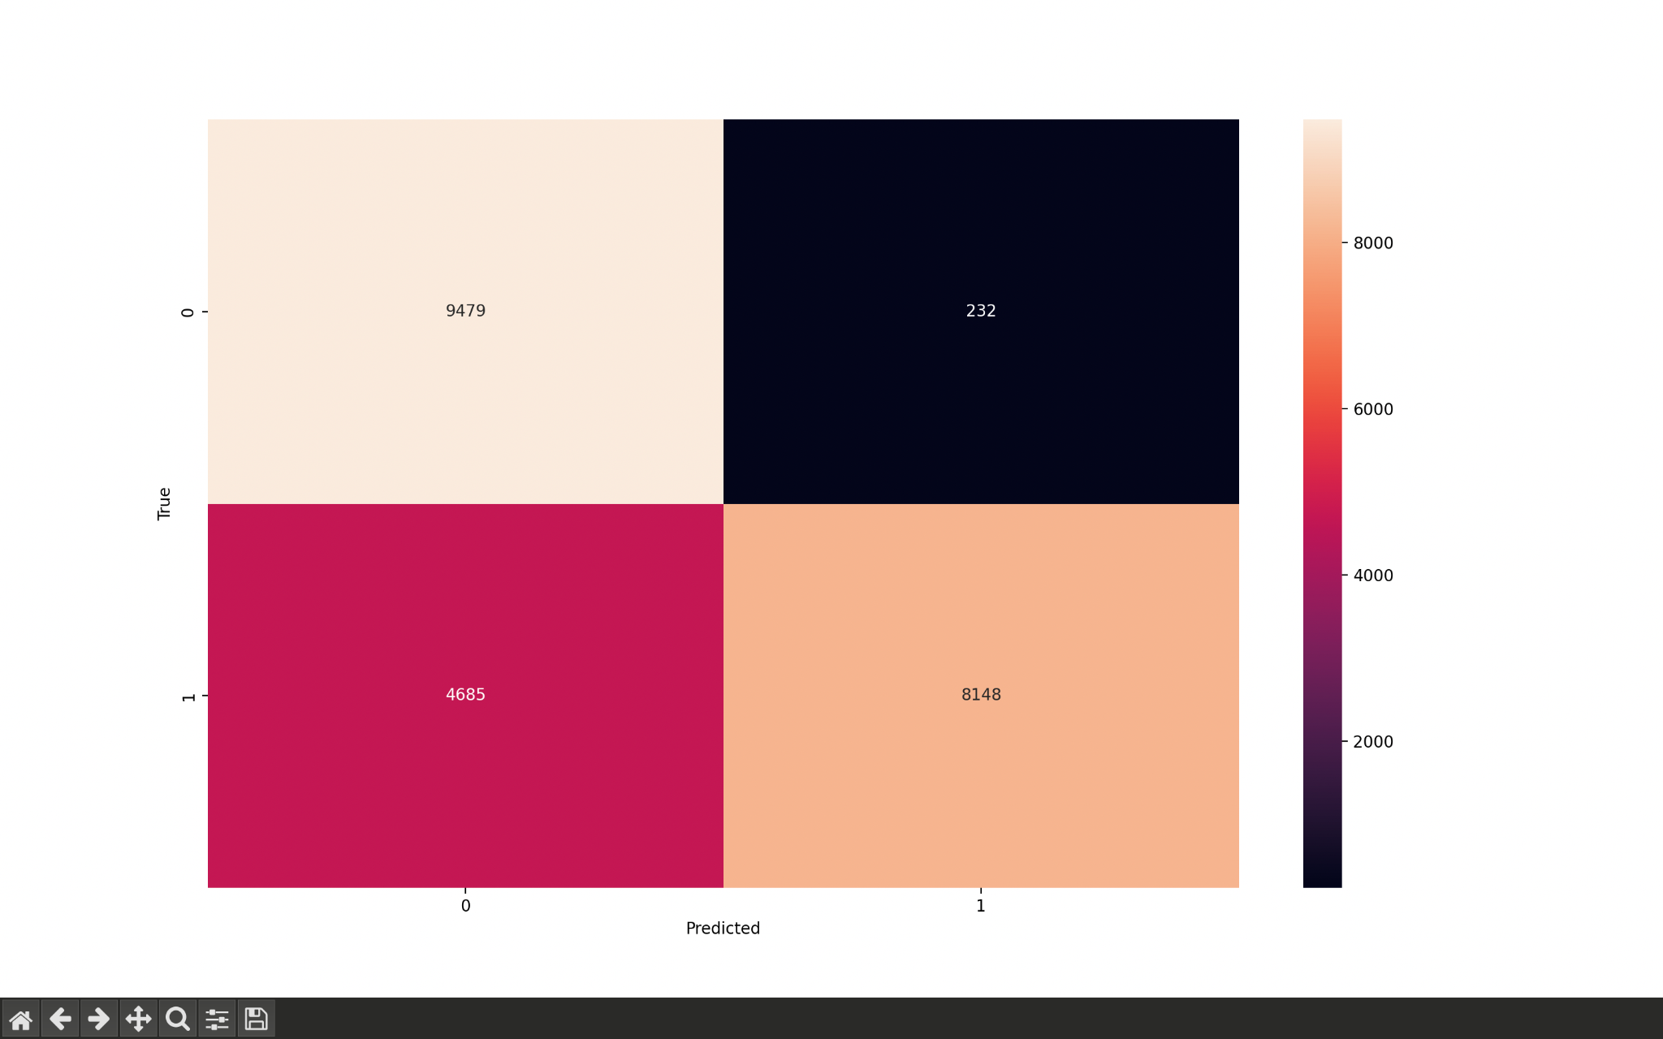

References:
- "A Detailed Analysis of the KDD CUP 99 Data Set" by Tavallaee et al. (2009)
- "Intrusion Detection with Neural Networks" by Moradi and Zulkernine (2004)
- "Deep Learning Approaches for Intrusion Detection" by Ferrag et al. (2020)
- "NSL-KDD Dataset for Network Intrusion Detection" by Tavallaee et al. (2009)
- "Machine Learning in Cybersecurity" by Apruzzese et al. (2018)

