H1-PI Project

MVP v1

Jacques Van Der Merwe

2021

Contents

Introduction: 2

Project Description: 2

Scope: 2

Need for the system: 2

Users: 2

Responsibilities: 2

Functional Objectives: 2

Mobile Application: 2

Hardware: 3

Non-Functional Requirements: 3

Mobile Application: 3

Hardware: 3

Higher-Priority Objectives: 3

First version of MVP-1: 3

Lower-Priority Objectives: 3

Use Cases: 3

Electric Fence Toggle: 3

Bibliography 4

Document Version History 4

# Introduction:

This document will provide a simple description of the H1-PI Project as a whole, as well as detail the user/ functional requirements of the MVP-1. The scope, goals, responsibilities and use cases of the MVP-1 will also be defined. It is worth noting however, that this document will go through further modification, as the most prioritised goal (as mentioned in objectives) currently is to produce a minimum viable product.

# Project Description:

The following description is of the entire H1-PI, rather than only the MVP-1.

H1-PI is a project of home-automation. It has the purpose of providing end-users with a mobile app that is able to provide various home-automation features such as, toggling a home electric fence on or off. Once the H1-PI project is complete, this app will be usable at any remote location (assuming internet access is available). Said app will feature security features such as a log in screen in order to ensure that only authorised users will be able to access the automation features it provides.

H1-PI is split into three main sub-projects, namely: electric fence control, integrated intercom system, electric gate control. These subprojects will be handled has separate projects, where this document covers the first, namely MVP-1.

# Scope:

## Need for the system:

MVP-1 of the H1-PI project will focus on the remote control of the electric fence. Currently enabling and disabling the electric fence requires a person from the inside of the property. This causes a problem in the event that no-one is at home and the main-gate motor stops functioning. In such an event the mini-gate cannot be accessed safely while the electric fence system is active.

## Users:

The main users of MVP-1 will include the van der Merwe family as well as any other authorised users.

## Responsibilities:

The following summarises the responsibilities of MVP-1:

* Provide a mobile app with the following features:
  + Secure Log-In Screen.
  + Display the status of the electric fence.
  + Enable the user to toggle the state of the electric fence on/off.
* Ensure security of said mobile app.
* Remote access to the apps features from any location via the internet.
* Hardware that enables the aforementioned mobile app to function.
* Said hardware must always be active/usable, even after a power outage.

# Functional Objectives:

## Mobile Application:

* Provide UI.
* Enable user to toggle electric fence.
* Constant availability.

## Hardware:

* Functional communication with application.
* Able to toggle electric fence.
* Constant availability.

# Non-Functional Requirements:

## Mobile Application:

* Provide security.
* Functional at any location.
* State of the electric fence must always be displayed.
* A login screen using a username and password must be used.
* Notifications must be sent to all users once an app feature is used.
* User emails must be used as a login backup (if users forget their passwords).

## Hardware:

* Reliability/ Resistant to elements.
* Security.
* Hardware must be easy to access for future use.
* Hardware must have a good connection to the home Wi-Fi.

# Higher-Priority Objectives:

## First version of MVP-1:

The up-most priority is to produce an application that can do the following:

* Enable/Disable electric fence.
* Functional at any location.

The hardware to enable the application must also be created and functioning. This hardware does not (at this stage) need to function at all times.

# Lower-Priority Objectives:

Once the higher-priority objectives have been reached, any and all remaining objectives and functionalities make up the low-priority objectives.

# Use Cases:

## Electric Fence Toggle:

PROBLEM: Gate doesn't work.

User Story:

* All users must be able to control electric fence remotely, in order allow for mini-gate to be opened manually.
* This should be done via a mobile app.
* Users must be aware of the state of the electric fence.

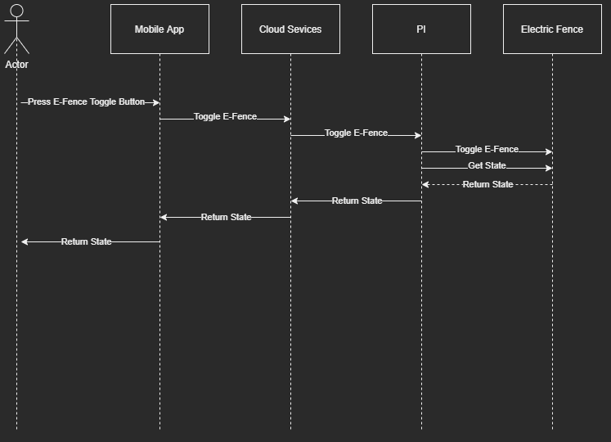

MVP-1 (version 1)

# Bibliography

**H1-PI:** (Pronounced as “hippy”) Home One PI project.

**MVP-1:** Minimum Viable Product (version 1)

# Document Version History

* **H1PI_Requirements_MVP1(v1)**