**Table of Contents**

Plagiarism/Cheating1

Declaration of Originality1

Table of Contents2

1. Program Description3
2. Class Diagram3
3. Application Flow5
4. Lesson that have been Learned5
5. Code Explanation6
6. Project Link8
7. References8

**“Restaurant App”**

**Name : Ferdinand Jacques**

**NIM : 2501982600**

1. **Program Description**

This is a simple restaurant application that is created by using java as the main programming language and a few imported modules, which are javax.swing, java.awt, java.util, and java.text. The main purpose of this application is to help the owner of restaurants save their money from hiring a worker to take their customers’ order. By using this application, customers can place their orders at the restaurant.

1. **Class Diagram**

* The class App is used to run the frame that has been created in Frame.java.
* The class Frame is used to store/add all the panels and buttons that has been created and act as the main window of the application.
* The class Food is used to create the panel of foods and carts that will be shown in the main frame. It also creates the logic of adding or removing items from the cart.
* The class Window is used to create the popup window as the thank you window when the user has checked out their items.
* The class Button is used to create the button such as adding or removing items from the cart. Also, Button class create the label that act as the number of items that has been added to the cart.

1. 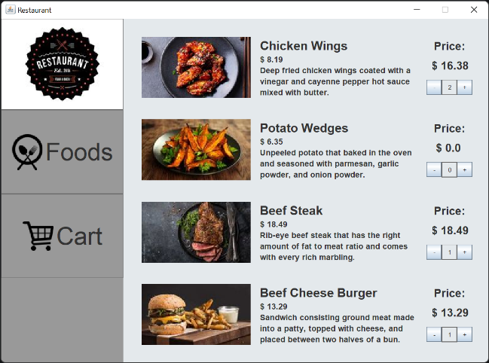**Application Flow**

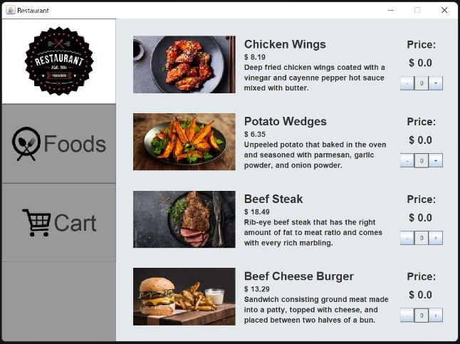

Adding items

The main page

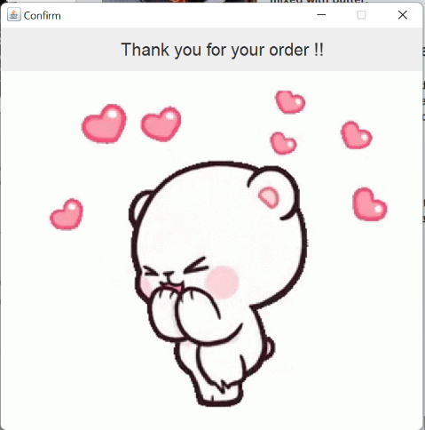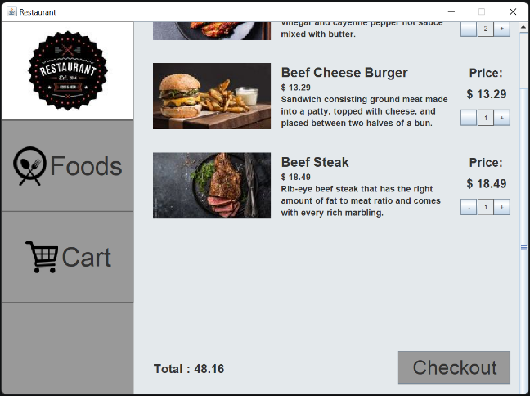

Check the cart and Checkout

Transaction successful

1. **Lesson that have been Learned**

In this project, I’ve learned a lot of things such as creating a GUI window in Java language. I learned how to create a logic that can add a label from one panel to another by clicking a button. Also, I learned how to add a gif and image to a panel and set the position of the panel to the location that I wanted.

1. **Code Explanation**

In this program, I divided the code into 5 files, which are :

1. **Text

   Description automatically generated**App.java

“App.java” is the file that I used as the main file to run the GUI application. In the main function of this file, it creates a variable that named JCafe that is imported from the package design. The name of the file that the JCafe called is Frame.java. JCafe variable is used to run the function “createFrame” that is created inside the Frame.java.

1. **Text

   Description automatically generated**Frame.java

“Frame.java” is the file that is used to create the frame to store all the panels and buttons that will be shown. “Frame.java” also acts to build the left side panel that is used by the user to choose between the food menu or the cart (to see the items that have been added) and call the right panel that show the food menu and the cart panel from the “Food.java”.

1. **Text

   Description automatically generated**Food.java

“Food.java” is the file that used to create the right panel such as food panel and cart panel. Each of the panel has its own function that will return the panel itself. The food panel’s function will add all the function that act to show the name of the items, price, image, and also description. Also, there is a function that is used to call the add and remove button that is use to add or remove items from the cart and the label to show how many items that is added. The cart scroll panel’s function to show the items that have been added to the cart. In this function, there is a logic that check if the user has added the item from the food panel or not. This logic use the module javax.swing.Timer to set a timer that keep checking and updates the panel.

1. **Text

   Description automatically generated**Window.java

“Window.java” will create a window that is used to be the popup window that is shown when the user has checkout their order. In this window, there is a label and a gif that says thank you.

1. **Graphical user interface, text

   Description automatically generated**Button.java

“Button.java” is the file that is used to create the add and remove button. The class “Button” has two function which is addCart function that is used to create the add button and removeCart function that is used to create the remove button. However, there’s still no logic in this function. At this function, it has specified the size, text, margin and location of the button.

1. **Project Link**

https://github.com/Jacques7103/OOP/tree/main/Project

1. **References**
2. <https://www.clipartmax.com/middle/m2i8G6Z5Z5b1b1d3_plate-with-fork-and-knife-cross-vector-food-plate-icon-vector/>
3. https://flyclipart.com/add-to-cart-icons-download-free-png-and-vector-icons-shopping-cart-icon-png-301425
4. https://www.mashed.com/img/gallery/chicken-wings-are-more-nutritious-than-you-thought/how-to-get-the-most-nutrition-out-of-a-chicken-wing-1605217268.jpg
5. https://www.britannica.com/topic/buffalo-wings
6. https://www.dreamstime.com/photos-images/potato-wedges.html
7. https://www.allrecipes.com/recipe/199575/oven-fresh-seasoned-potato-wedges/
8. <https://stock.adobe.com/id/images/sliced-beef-steak-on-black-plate/235139347>
9. https://guide.michelin.com/en/article/dining-in/restaurant-secrets-how-to-cook-the-perfect-steak
10. https://luxatic.com/the-top-10-most-expensive-burgers-in-the-world/
11. https://www.recipetips.com/glossary-term/t--36063/cheeseburger.asp#:~:text=A%20traditional%20grilled%20sandwich%20that,create%20this%20favorite%20international%20food.
12. https://graphiccloud.net/restaurant-logo-design/