Sustainable Software via Generation

Spencer Smith1, Jacques Carette1

*1Computng and Software Department, McMaster University, Canada.*

Email address: smiths@mcmaster.ca

Keywords—software documentation, generative programming, sustainable software

Sustainable software projects satisfy, for a reasonable amount of developer effort, the requirements for the present, while also being maintainable, reusable and reproducible to address future needs. Achieving sustainability requires docu- mentation (requirements specification, design documents, test plans, test reports, etc). Developers recognize the value of documentation, but often do not feel that they have the time/resources needed to write and maintain it in the face of inevitable software changes [1]. A solution to this problem is to provide a process that emphasizes documentation from the start, along with tools that facilitate change.

[Drasil](https://github.com/JacquesCarette/Drasil) provides such a process and tools. Drasil is a framework for generating all of the software artifacts (code, documentation, scripts, etc.). Drasil takes advantage of the inherent knowledge duplication by capturing the knowledge once and providing means to transform that information into all of the views needed within a given project.

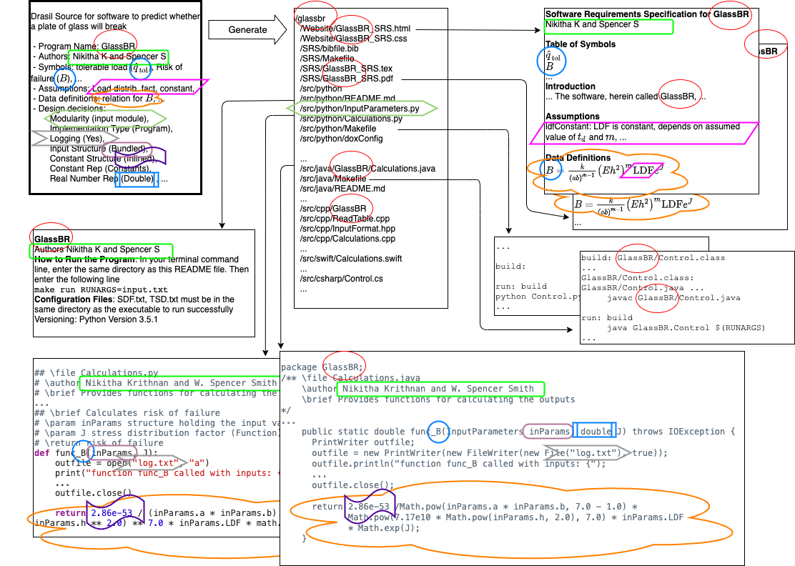Figure 1 shows an example of the transformation of captured knowledge (as shown in the darker bordered box at the top left). The software predicts whether a given plane of glass is likely to break when subjected to an explosion. An important property of the software is its name. In this case the name is GlassBR. In the generated artifacts the name GlassBR appears more than 80 times – in the folder structure, in the requirements specification, in the README file, in the Makefile, and in the source code. In a conventional software project changing the name across all artifacts is surprisingly difficult–difficult enough that the change may not be made. With Drasil a change like this is made by one change to the source knowledge and regeneration. By capturing domain knowledge, Drasil facilitates more than just renaming. For instance, if the assumption of a constant Load Distribution Factor (LDF) changes, the regenerated software will have LDF as an input variable. Drasil also captures design decisions, like whether to log all calculations, whether to in-line constants rather than show them symbolically, etc. Drasil becomes even more powerful with the revelation that the same knowledge can be reused in different projects.

Developers can now generate sustainable software, with documentation and code that are consistent by construction.

##### References

1. W. S. Smith, T. Jegatheesan, and D. F. Kelly, “Advantages, disadvan- tages and misunderstandings about document driven design for scientific software,” in Proceedings of the SE-HPCCE, November 2016, 8 pp