Experiment 2

Aim: To study sampling and reconstruction of signals

Objective: To develop a program to sample a continuous time signal and convert it to Discrete Time Signal

Software: Scilab Version 5.5.2

Theory:
In the domain of Discrete Signal Processing, sampling an analogue signal converts it into a digital signal (which is safe for standard digital transmission), but it may lead to a lossy reconstruction of the signal on the other side. Since it is possible to undersample a signal (in which case, the reconstructed signal does not represent the original signal at all) and oversampling – to an extent – is impractical. Therefore, it is important to simulate signal sampling rates to figure out the ideal rate at which to sample an analogue signal.

Problem Statements:
- Sample the input signal and display first 50 samples.
- Calculate data rate and bit rate
- Reconstruct the original input signal from this sampled version and display the original and reconstructed signals
- Vary the sampling frequency and observe the change in the quality of reconstructed signal.

Algorithm:
1. Start
2. Enter the input for value of fm.
3. Enter the input for values of fs1,fs2,fs3.
4. Plot continuous time signal for fm using the formula sin(2*pi*fm*t). Plot (t,a) to a continuous graph.
Note: Take t=0:0.001:1
5. Plot the discrete signal and reconstruct the CT signal for different values of fs1,fs2,fs3.
6. Compare the continous signals of fm,fs1,fs2,fs3
7. Stop

Code:
-->fm = 50;

-->f1 = 60;

-->f2 = 100;

-->f3 = 150;

-->xm = 0:0.001:1;

-->x1 = 0:(1/f1):1;

-->x2 = 0:(1/f2):1;

-->x3 = 0:(1/f3):1;

-->ym = sin(2*%pi*fm*xm);

-->y1 = sin(2*%pi*fm*x1);

-->y2 = sin(2*%pi*fm*x2);

-->y3 = sin(2*%pi*fm*x3);

-->plot(xm,ym);title("Original - roll no. 16");

-->subplot(2,1,1);plot2d3(x1,y1);title("Undersampling-discrete");subplot(2,1,2);plot(x1,y1);title("Undersampling - reconstructed");

-->subplot(2,1,1);plot2d3(x1,y1);title("Undersampling - discrete");subplot(2,1,2);plot(x1,y1);title("Undersampling - reconstructed");

-->subplot(2,1,1);plot2d3(x2,y2);title("Critical sampling - discrete");subplot(2,1,2);plot(x2,y2);title("Critical sampling - reconstructed");

-->subplot(2,1,1);plot2d3(x3,y3);title("Over sampling - discrete");subplot(2,1,2);plot(x3,y3);title("Over sampling - reconstructed");

Output:
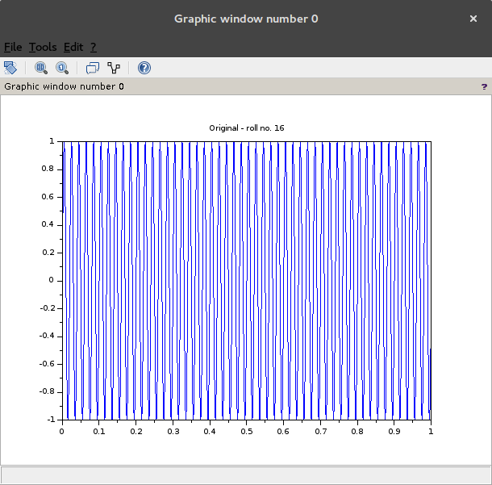
Illustration 1: Original Signal

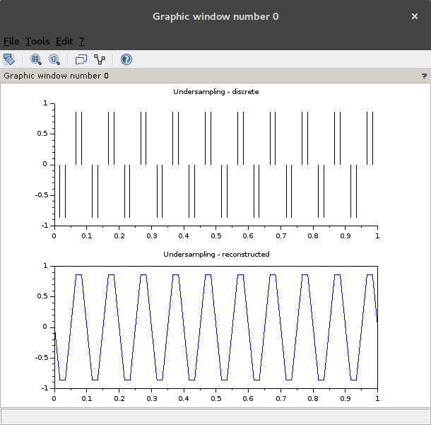
Illustration 2: Under Sampling

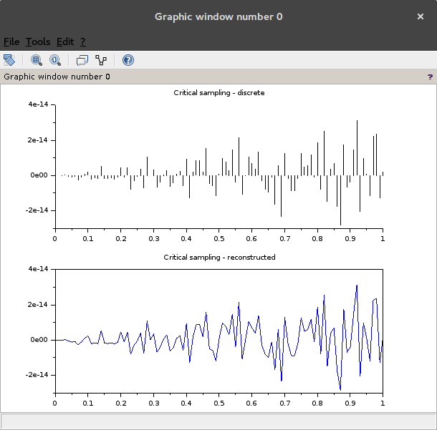
Illustration 3: "Perfect" Sampling

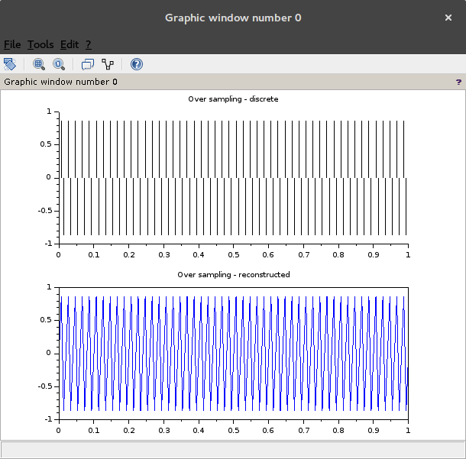
Illustration 4: Over Sampling
Conclusion:
After simulating various methods of sampling, it is shown that, whilst in theory perfect sampling (double the max frequency) should result in ideal sampling set, practically, the ideal sampling frequency is roughly more than 3-5 times the Nyquist rate (double the max frequency).

