**Sequence Diagrams:**

**CSwap:**

**Deliverable 3:**

**Create Account Description 1:**

|  |  |  |  |  |
| --- | --- | --- | --- | --- |
| # | Subject | Action of Subject | Other Data Objects | Object Acted Upon |
| 1.0.0 | Unauthorized User | Input | Email and password | CSwap GUI |
| 1.0.1 | Unauthorized User | Button Clicked | Create Account button | CSwap GUI |
| 1.0.2 | CSwap GUI | Request | Account Creation | Creation Controller |
| 1.0.3 | Creation Controller | Sends | User info | DB Manager |
| 1.1.0 | If Account Created | | | |
| 1.1.1 | DB Manager | Return | User Created | Creation Controller |
| 1.1.2 | Creation Controller | Sends | Creation Success | CSwap GUI |
| 1.1.3 | CSwap GUI | Display | Account Success Message | Unauthorized User |
| 1.2.0 | Else if account not created | | | |
| 1.2.1 | DB Manager | Return | User not created | Creation Controller |
| 1.2.2 | Creation Controller | Sends | Error: Creation Controller | CSwap GUI |
| 1.2.3 | CSwap GUI | Displays | Error | Unauthorized User |

**Analysis Sequence Diagram 1:**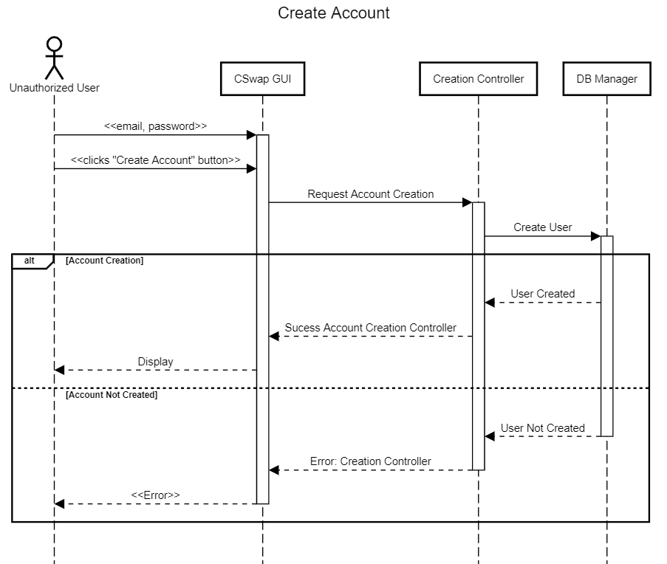

**Design Sequence Diagram 1:**

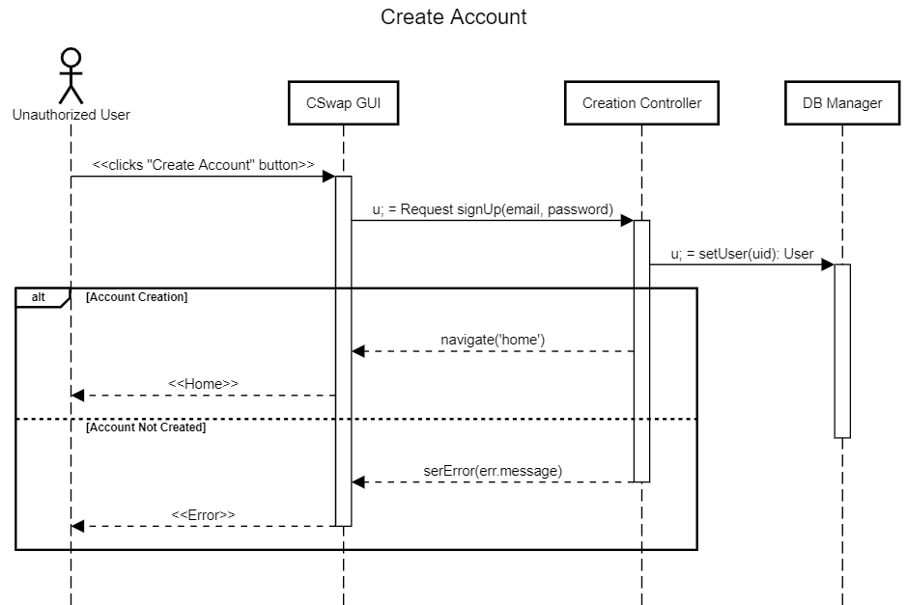

**Create Listing Description 2:**

|  |  |  |  |  |
| --- | --- | --- | --- | --- |
| # | Subject | Action of Subject | Other Data Objects | Object Acted Upon |
| 1.0.0 | Authorized user | Button Clicked | Create Listing | CSwap GUI |
| 1.0.1 | CSwap GUI | Request | Listing Creation | Create Listing |
| 1.0.2 | Create Listing | Returns | Listing options | CSwap GUI |
| 1.0.3 | CSwap GUI | Display | Listing options | Authorized User |
| 2.0.0 | If textbook selected | | | |
| 2.1.1 | Authorized user | Button Clicked | Textbook | CSwap GUI |
| 2.2.0 | Else if furniture selected | | | |
| 2.2.1 | Authorized user | Button Clicked | Furniture | CSwap GUI |
| 2.3.0 | Else if Apartments selected | | | |
| 2.3.1 | Authorized user | Button Clicked | Apartments | CSwap GUI |
| 2.4.0 | Else if Appliances selected | | | |
| 2.4.1 | Authorized user | Button Clicked | Appliances | CSwap GUI |
| 2.5.0 | Else if Electronics selected | | | |
| 2.5.1 | Authorized user | Button Clicked | Electronics | CSwap GUI |
| 2.6.0 | CSwap GUI | Request | Listing type selected | Create listing |
| 2.6.1 | Create Listing | Returns | Specified Form | CSwap GUI |
| 2.6.2 | CSwap GUI | Displays | Form | Authorized User |
| 3.0.0 | Authorized User | Inputs | Listing information | CSwap GUI |
| 3.0.1 | Authorized User | Button Clicked | Add Listing | CSwap GUI |
| 3.0.2 | CSwap GUI | Request | Listing Creation | Create Listing |
| 3.0.3 | Create Listing | Send | Listing information | DB Manager |
| 3.1.0 | If success | | | |
| 3.1.1 | DB Manager | Return | Success | Authorized User |
| 3.2.0 | Else failed |  |  |  |
| 3.2.1 | DB Manager | Return | Failed | Authorized User |

**Analysis Sequence Diagram 2:**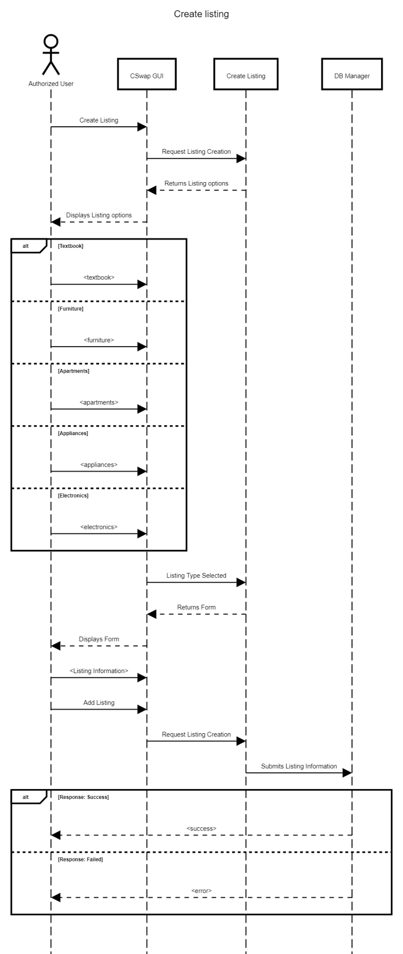

**Delete Account Description 3:**

|  |  |  |  |  |
| --- | --- | --- | --- | --- |
| # | Subject | Action of Subject | Other Data Objects | Object Acted Upon |
| 1.0.0 | Authorized User | Button Clicked | Delete Account | CSwap GUI |
| 1.0.1 | CSwap GUI | Request | Delete User | Account Controller |
| 1.0.2 | Account Controller | Command | Ask for deletion | DB Manager |
| 1.0.3 | DB Manager | Request | Ask for Password | Account Controller |
| 1.0.4 | Account Controller | Request | Ask for Password | CSwap GUI |
| 1.0.5 | CSwap GUI | Display | Display Password Prompt | Authorized User |
| 1.1.0 | Authorized User | Input | Enters Password | CSwap GUI |
| 1.1.1 | CSwap GUI | Send | Password Sent | Account Controller |
| 1.1.2 | Account Controller | Send | Password Sent | DB Manager |
| 2.0.0 | If Password Correct | | | |
| 2.0.1 | DB Manager | Delete | Delete Account | Account Controller |
| 2.0.2 | Account Controller | Send | Message | CSwap GUI |
| 2.0.3 | CSwap GUI | Display | Display Message | Authorized User |
| 2.1.0 | If Password Incorrect | | | |
| 2.1.1 | DB Manager | Create Error Message |  | Account Controller |
| 2.1.2 | Account Controller | Send | Message | CSwap GUI |
| 2.1.3 | CSwap GUI | Display | Display Message | Authorized User |

**Analysis Sequence Diagram 3:**

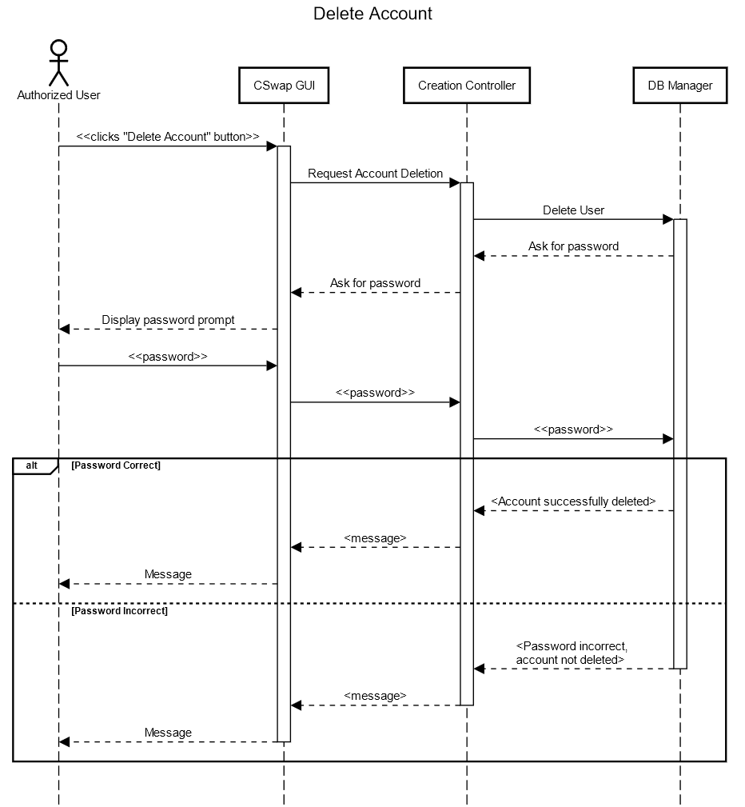

**Design Sequence Diagram 2:**

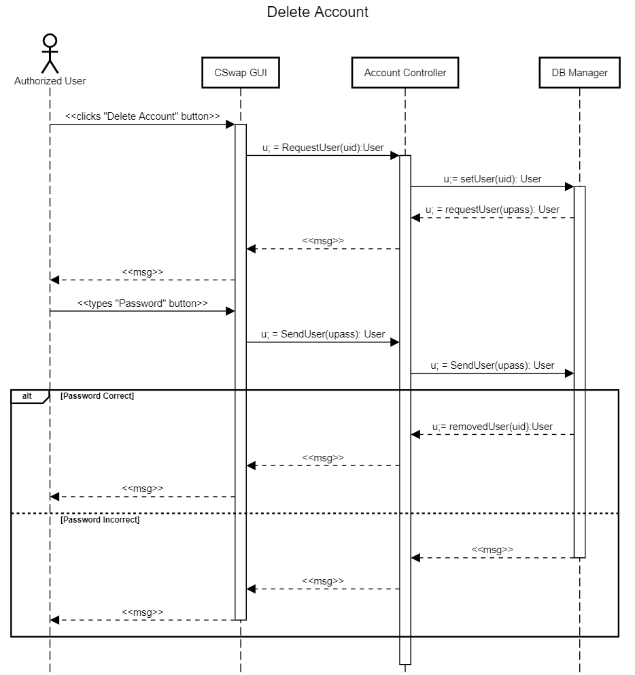

**Log in Description 4:**

|  |  |  |  |  |
| --- | --- | --- | --- | --- |
| # | Subject | Action of Subject | Other Data Objects | Object Acted Upon |
| 1.0.0 | Unauthorized User | Input | Email and Password | CSwap GUI |
| 1.0.1 | Unauthorized User | Button Clicked | Login | CSwap GUI |
| 1.0.2 | CSwap GUI | Request | Login | Login Controller |
| 1.0.3 | Login Controller | Sends | Get user | DB Manager |
| 1.0.4 | If User Found | | | |
| 1.1.0 | DB Manager | Returns | User found | Login Controller |
| 1.1.1 | Login Controller | Send | Success: Login Controller | CSwap GUI |
| 1.1.2 | CSwap GUI | Display | Success | Unauthorized User |
| 1.2.0 | Else if user not found | | | |
| 1.2.1 | DB Manager | Returns | User not found | Login Controller |
| 1.2.2 | Login Controller | Send | Error: Login Controller | CSwap GUI |
| 1.2.3 | CSwap GUI | Display | Error | Unauthorized User |

**Analysis Sequence Diagram 4:**

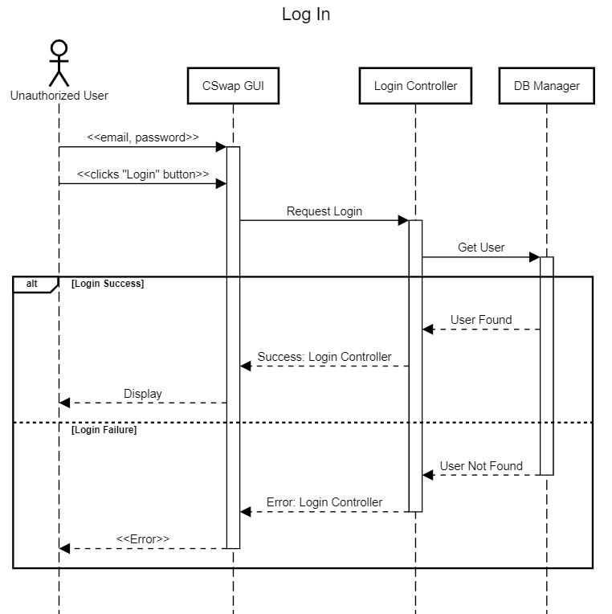

**Design Sequence Diagram 3:**

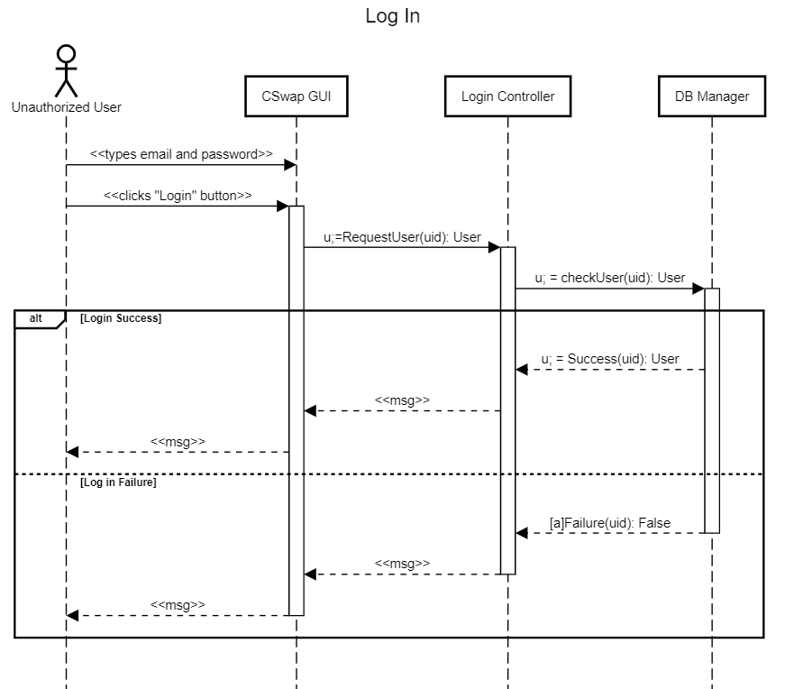

**Log out Description 5:**

|  |  |  |  |  |
| --- | --- | --- | --- | --- |
| # | Subject | Action of Subject | Other Data Objects | Object Acted Upon |
| 1.0.0 | Authorized user | Clicks Button |  | CSwap GUI |
| 1.0.1 | CSwap GUI | Send | Get User | Login Controller |
| 1.0.2 | Login Controller | Send | Process User | DB Manager |
| 1.0.3 | DB Manager | Send | Deauthorize | Login Controller |
| 1.1.0 | Login Controller | Send | Message | CSwap GUI |
| 1.1.1 | CSwap GUI | Display | User Logged Out | Authorized User |

**Analysis Sequence Diagram 5:**

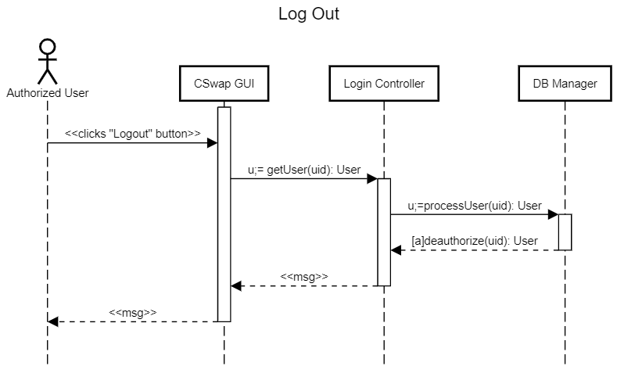

**Design Sequence Diagram 4:**



**Receive message Description 6:**

|  |  |  |  |  |
| --- | --- | --- | --- | --- |
| # | Subject | Action of Subject | Other Data Objects | Object Acted Upon |
| 1.0.0 | Authorized User | App Initialized |  | CSwap GUI |
| 1.0.1 | CSwap GUI | Request | Check messages | Message Controller |
| 1.0.2 | Message Controller | Request | Messages | DB Manager |
| 1.1.0 | If messages found | | | |
| 1.1.1 | DB Manager | Returns | Message found | Message Controller |
| 1.2.0 | Else no message found | | | |
| 1.2.1 | DB Manager | Send | No messages found | Message Controller |
| 1.3.0 | Message Controller | Returns | Message | CSwap GUI |
| 1.3.1 | CSwap GUI | Displays | Message | Authorized User |

**Analysis Sequence Diagram 6:**

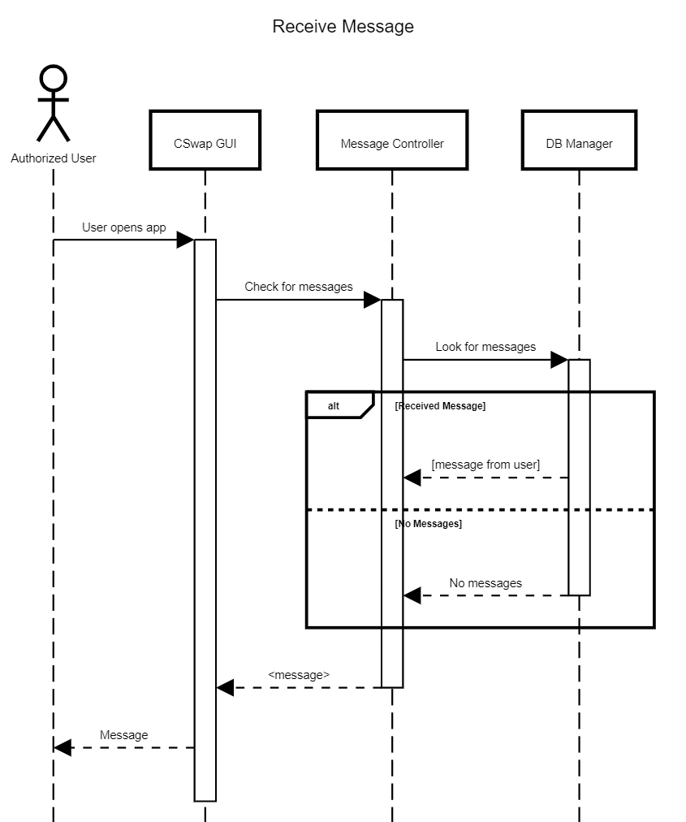

**Send message Description 7:**

|  |  |  |  |  |
| --- | --- | --- | --- | --- |
| # | Subject | Action of Subject | Other Data Objects | Object Acted Upon |
| 1.0.0 | Authorized User | Input | Message | CSwap GUI |
| 1.0.1 | CSwap GUI | Send | Message | Message Controller |
| 1.0.2 | Message Controller | Store | Message | DB Manager |
| 2.0.0 | If Message Sent | | | |
| 2.0.1 | DB Manager | Send Success | Message | Message Controller |
| 3.0.0 | Else if Failed to Send Message | | | |
| 3.0.1 | DB Manager | Create Error Message | Message | Message Controller |
| 3.0.2 | Message Controller | Send | Message | CSwap GUI |
| 3.0.3 | CSwap GUI | Display | Message | Authorized User |

**Analysis Sequence Diagram 7:**

