Our three design class diagrams were Create Account, Create Listing, and View Listing. We took what we had from our analysis sequence diagrams and utilized them to create our DCDs. We decided to create three different design class diagrams based on the three main features CSwap users have. This also made each diagram simpler to understand.

**Create Account**

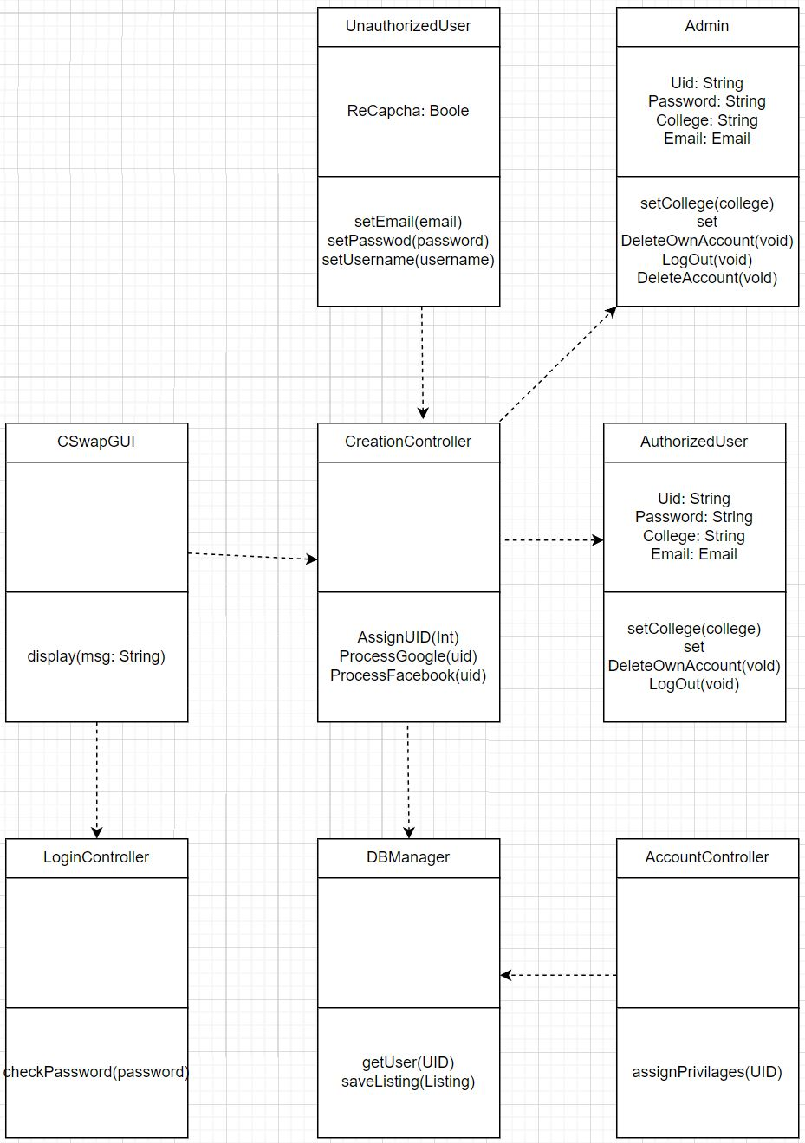

**Create Listing**

**View Listing**

