Domain Models:
The CSwap application consists of three main domain model diagrams. These diagrams are Account, Create Listing, and Find Listing. The Account model describes how the login and signup classes are related to a more general authentication class. When a user logs in or signs up, that information would be captured by the authentication class and inherited by signup and login classes. The create listing model describes how an authorized user can create a listing of various types. Each category of listing inherits from a more abstract Create Listing class. This more general class is interacted with by the authenticated user. Lastly is the find listing model which describes how an authorized user can find a listing through filters and keyword searches. An authorized user can either interact with the search class or the filter class to narrow their search to an item they’re looking for. Each individual item is itself a class which inherits from the more abstract Items class. The authorized user is also able to interact with the LogOut class once.

Account:

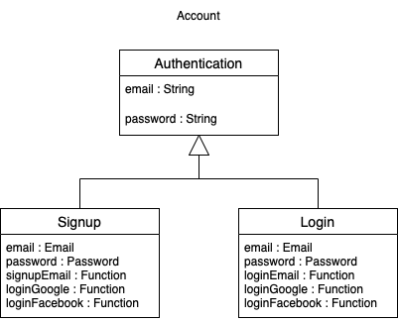

Create Listing:
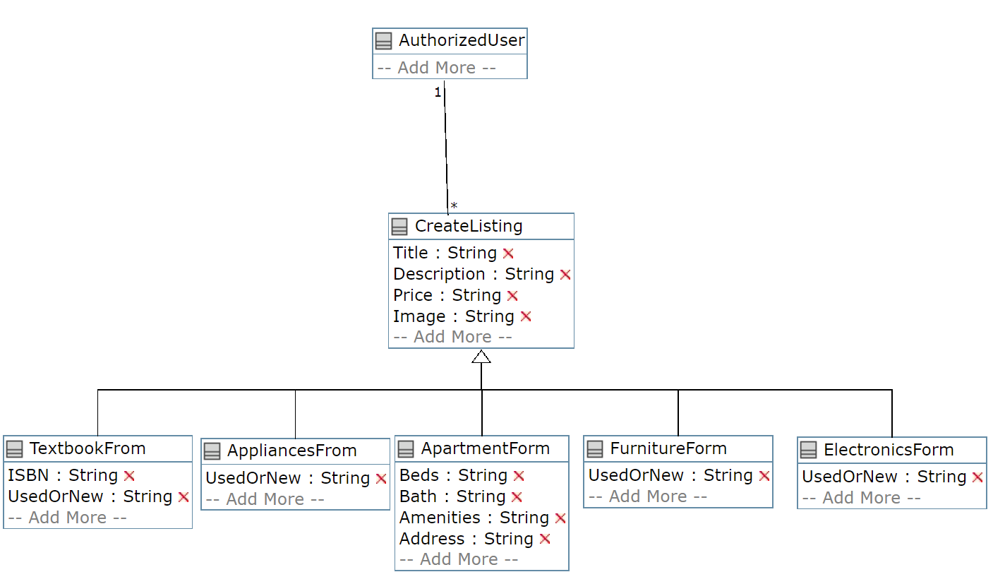

Find Listing:
