Software Requirements Specification

for

CSwap

Version 1.0 approved

Prepared by Caccese, Fahey, Thibodeau, Massari, Bourgoin

College Swap

2/14/2022

Table of Contents

Table of Contents -------------------------------------------------------------------------- 1

Revision History ---------------------------------------------------------------------------- 2

1. Introduction ----------------------------------------------------------------------------- 2

1.1 Purpose ----------------------------------------------------------------------------------- 2

1.2 Document Conventions ---------------------------------------------------------------- 2

1.3 Intended Audience and Reading Suggestions --------------------------------------- 2

1.4 Product Scope ---------------------------------------------------------------------------- 2

1.5 References ------------------------------------------------------------------------------- 3

2. Overall Description 3

2.1 Product Perspective --------------------------------------------------------------------- 3

2.2 Product Functions ----------------------------------------------------------------------- 3

2.3 Assumptions and Dependencies ------------------------------------------------------- 4

3. External Interface Requirements --------------------------------------------------- 4

3.1 User Interfaces --------------------------------------------------------------------------- 4

4. System Features ------------------------------------------------------------------------ 7

4.1 Functional Requirements --------------------------------------------------------------- 7

5. Other Nonfunctional Requirements ------------------------------------------------ 7

5.1 Performance Requirements ------------------------------------------------------------ 7

5.2 Safety Requirements -------------------------------------------------------------------- 8

5.3 Security Requirements ------------------------------------------------------------------ 8

5.4 Software Quality Attributes ------------------------------------------------------------ 8

6. Other Requirements ------------------------------------------------------------------- 8

Appendix A: Glossary --------------------------------------------------------------------- 8

Appendix B: Analysis Models ----------------------------------------------------------- 8

Appendix C: To Be Determined List --------------------------------------------------- 8

Revision History
Name | Date | Reason For Changes | Version
Caccese, Fahey, Thibodeau, Massari, Bourgoin | 2/14/2022 | Initial Document Setup | 1.0
Caccese, Fahey, Thibodeau, Massari, Bourgoin | 2/23/2022 | Updated the Functional and Non-Functional requirements | 1.01

Introduction

Purpose

The application CSwap is an online local area marketplace designed to allow college students to have a centralized place to buy and sell college related items. The main objective of this application is to provide college students a way to buy and sell items relevant to their student life. The following document will describe the software requirements needed to create such an application.

Document Conventions

This Document was created based on the IEEE template for System Requirement

Specification Documents.

The following conventions in the document were used as follows:

Convention | Description
CSwap | The Company Name: College Swap
Firebase | Backend as a Service

Intended Audience and Reading Suggestions

This document will be made for developers, project managers, users, testers, marketing staff, and document writers. The rest of this SRS contains Product Scope, An overall description of the product, External Interface Requirements, System Features, Nonfunctional Requirements, and Other Requirements.

Product Scope

The Software will be a Backend as a service (Baas, a NoSQL database program). We are specifically using Firebase to create the application. Its purpose is to act as an online local marketplace for students attending college. The software promotes the corporate goal of loyal customers. The average student is taking 5 years to graduate from college. The software is designed to appeal to students going from one semester/school year to another. This makes it easy to create loyal customers.

References

CSwap Git Hub Link: https://github.com/JacquesLJT/COS420_Project

Overall Description

Product Perspective

CSwap is being developed for everybody who is attending college. Any student that has books, electronics, or a lease that they don’t want can use it more specifically. CSwap is also being made for any student that is looking for these items. There is also a section for users that want to buy and sell leases. It is a new product being created with open-source code.

Product Functions

Account Creation
- Input Username: Allows the user to put in a username to log in.
- Input Password: Allows the user to put in a password to log in.
- Login with Google: Allows the user to log in with an existing Google account.
- Login with Facebook: Allows the user to log in with an existing Facebook account.

Sorting Posts
- Input Zip Code: Input the zip code of where you are selling the item.
- Select Category: Filters listings by type so only one type is visible.

Post Manipulation
- Post Listing: Allows the user to post a listing.
- Remove Listing: Allows user to remove a listing.

Class Manipulation
- Authorize user: Allows unauthorized users to become authorized users
- View Listing: Allows the user to view a listing’s details.

Assumptions and Dependencies

CSwap is developed in HTML, CSS, and Java Script. We are assuming users are not blocking Java Script, if they are our application will not work on their device.

External Interface Requirements

User Interfaces
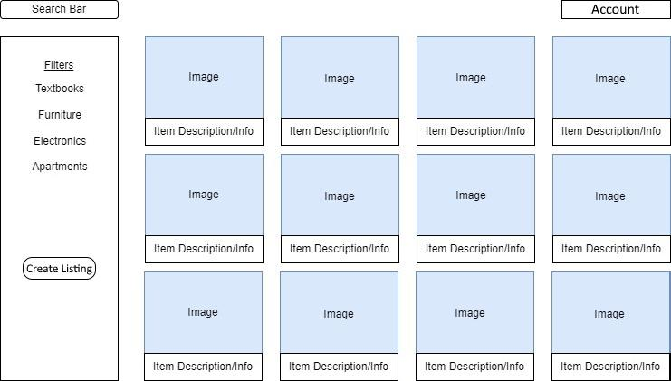

This is an example of what our front page would look like. It has a button (Account) that will open a dropdown menu that will have options to view your account page, edit your account information and log out. The search bar will allow you to search by the names of items or the ISBN for books. The Filters will allow you to filter by our four categories Textbooks, Furniture, Electronics, and Apartments. The Create Listing button will allow people looking to put create a listing to do just that. All our UI will be designed to work on Desktop and Mobile on the major web browsers.

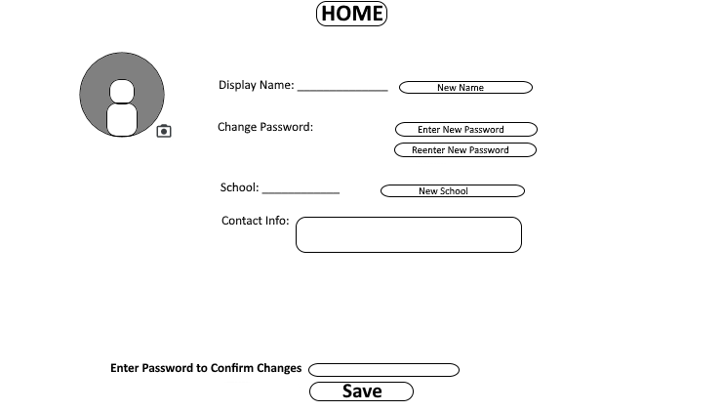

This is a basic look for what people's account pages will look like when they edit them. It will allow you to change your profile picture, display name, password, school, and contact information. To confirm changes, you need to enter your current password otherwise it won't save for security purposes.

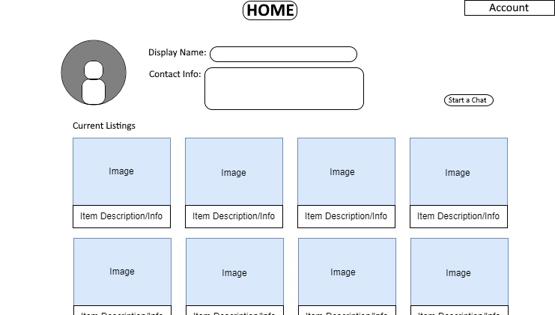

This is a basic look for what people's profiles will look like when people view them.

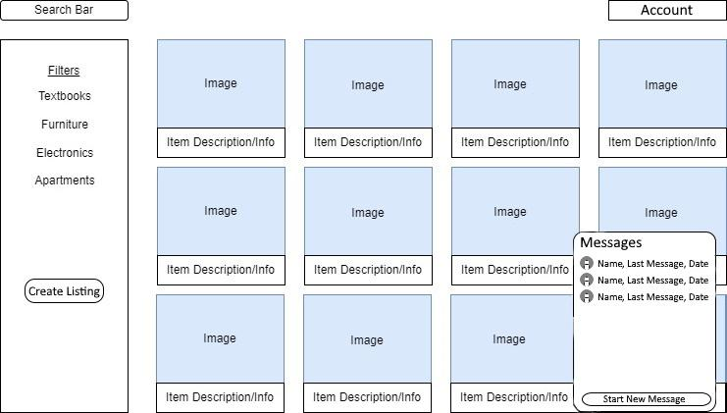

Additionally, on the bottom right corner of most pages, we will have a chat button which when clicked will open all chats that the logged-in user currently has. This will allow them to access their chats from most pages and keep up with their chats.

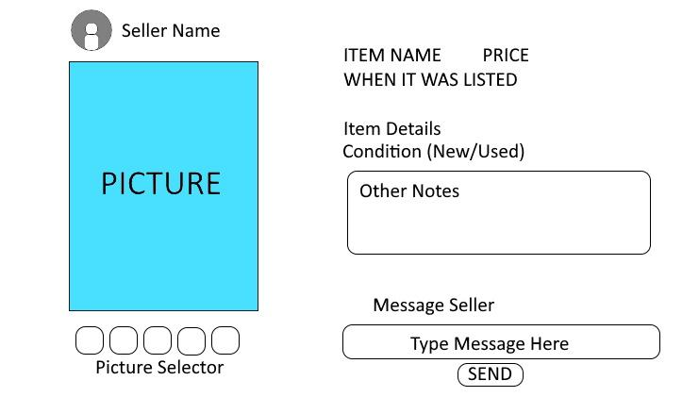

When someone clicks on an item to further look at it this is a rough look at what it would look like. You can see the seller's name at the top and clicking on that will link to their profile. Right below that, you will see (a) picture(s) of the item. To the right is a list of details including the name of the item, the price, when it was listed on CSwap, the condition of the item, and a section for other notes that the seller has put on the item. Below is a quick way to start a message with the seller.

System Features

Functional requirements

1: The system shall allow the user to log in using an email and password.

2: The system shall allow the user to log in through Google.

3: The system shall allow the user to log in through Facebook.

4: The system shall allow the user to log out of their account.

5: The system shall ask the user for their location via ZIP Code.

6: The system shall allow the user to change their ZIP Code.

7: The system shall allow the user to change their password.

8: The system shall display the provided picture of the item for sale.

9: The system shall display items from the corresponding categories.

10: The system shall allow the user to click on the item’s image to see more information about the item.

11: The system shall allow the user to search by title to find the item.

12: The system shall allow the user to select a category to view items from.

13: The system shall allow the user to find items by adding search filters.

14: The system shall allow the user to change the area they will see items listed for sale.

15: The system shall allow the user to add an item for sale.

16: The system shall require a title for the item a seller wants to sell.

17: The system shall require a picture of the item the seller is trying to sell.

18: The system shall require a description of the item a seller wants to sell.

Other Nonfunctional Requirements

Performance Requirements

The CSwap application will offer a fast and quick to use marketplace for college students to buy and sell goods in their local area. The application will also offer a quick to use marketplace which allows landlords in the area to list units for rent. The following Nonfunctional requirements are to describe the performance of the application

The system shall be available for 24hrs a day, 7 days a week to all users, 99% of the time.

The system shall not take more than one second to respond 99% of the time.

The system shall allow 10,000 messages to be sent between users at one time.

The system shall notify the user when they receive a message within 5 seconds.

The system should limit the photo file size to 500MB.

Security Requirements

The CSwap application will be using Firebase to store and handle user data instead of using first party servers which drastically improves the security of the application. The following Nonfunctional requirements are regarding the applications security requirements.

The system shall comply with CCPA policies for protecting user data.

The system shall keep all user data on a secure database.

The system shall securely process payments.

Privacy Requirements

The CSwap application will be collecting user data in terms of the user’s approximate location using their ZIP Code, name of the university, and radius of location to supply the user with items in their approximate location. The following non-functional requirements are meant to maintain privacy regarding the user’s location.

The system shall not share user location data with third parties.

The system shall handle user data in compliancy with all local privacy regulations.

The system shall follow the FTC guidelines for location privacy.

The system shall remove users’ personal financial information from database 90 days last login.

Software Quality Attributes

The system shall be portable across devices such as laptops to mobile.

The system shall reliability process request to the application is made, 99% of the time.

The system shall be capable of handling a typical workload of 10,000 users at the same time 95% of the time.

Other Requirements

Appendix A: Glossary

CSwap: The Company Name

