Summary? That is what “Generalization of” was. I changed it to a summary. Good point.

Use Case id: 1 | Use Case: Create an Account
Related Use Cases: Login with Username and Password, Login with Facebook, Login with Google | Summary: Unauthorized users can create an account
Actor: Unauthorized User | System: Account Selection and Account Validation
Precondition: The User has an email address, or Google account, or Facebook account that is not already registered on CSwap. The log in page is displayed.
User Input | System
1. The unauthorized user clicks the “sign up” button | 2. The user is directed to a sign up page
3. The unauthorized user  - Enters the email address and password into the email and password boxes clicks signup or  - Select “Log In” under “Already have an account?” | 4. The system accordingly displays  - “Sign up Successful” and send the user back to the sign in page or  - “Firebase: Error (auth/email-already-in-use).” or  - “Passwords should be at least 6 characters (auth/weak-password).
Post-conditions: The unauthorized user becomes an authorized user and can immediately search listings
Related Functional Requirement: 1

Use Case id: 2 | Use Case: Login with Username and Password
Related Use Cases: Login through Google, Login through Facebook | Summary: Unauthorized users that have created an account and log in with a username and password
Actor: Unauthorized User | System: Account Selection and Account Validation
Precondition: This use case assumes that the unauthorized user has already created an account. The login page is displayed.
User Input | System
1. The unauthorized user clicks the Recaptcha button | 2. The Recaptcha is  - verified or  - failed and must be attempted again.
3. The unauthorized user  - enters the email address and password into the email and password boxes and clicks login button  - Or clicks ”Sign up” under “Don’t have an account” | 4. The system checks that the login information matches the system database. The user is directed to  - the successful login page or  - the failed to login popup
Post-conditions: The unauthorized user becomes an authorized user and can immediately search listings
Related Functional Requirement: 1

Use Case id: 3 | Use Case: Login with Google
Related Use Cases: Login with Username and Password, Login with Facebook | Summary:Unauthorized users that have created an account and log in with Google
Actor: Unauthorized User | System: Account Selection and Account Validation
Precondition: This use case assumes that the unauthorized user has already created an account with Google. The login page is displayed.
User Input | System
1. The unauthorized user clicks the Recaptcha button | 2. The Recaptcha is  - verified or  - failed and must be attempted again.
3. The unauthorized user clicks the “Login with Google” button | 4. The system accordingly displays the  “Sign in - Google Accounts- Google Chrome” page.
5. The unauthorized user  - clicks on the account of their choosing or  - clicks “use another account” | 6. The system displays “Hello Welcome user_email”
Post-conditions: The unauthorized user becomes an authorized user and can immediately search listings
Related Functional Requirement: 2

Use Case id: 04 | Use Case: Login with Facebook
Related Use Cases: Login with Username and Password, Login with Google | Summary: Unauthorized users that have created an account and log in with Facebook
Actor: Unauthorized User | System: Account Selection and Account Validation
Precondition: This use case assumes that the unauthorized user has already created an account with Facebook. The login page is displayed
User Input | System
1. The unauthorized user clicks the Recaptcha button | 2. The Recaptcha is  - verified or  - failed and must be attempted again.
3. The unauthorized user clicks the “Login with Facebook” button | 4. The system accordingly displays the  “Sign in - Facebook Accounts- Google Chrome” page.
5. The unauthorized user  - clicks on the account of their choosing or  - The user clicks “use another account” | 6. The system displays “Hello Welcome user_email”
Post-conditions: The unauthorized user becomes an authorized user and can immediately search listings
Related Functional Requirement: 3

Use Case id: 05 | Use Case: Logout
Related Use Cases: Logout | Summary: Authorized users and Admins can log out of their account
Actor: Authorized User | System: Account Selection and Account Validation
Precondition: This use case assumes that the user is logged in
User Input | System
1. The authorized user clicks on logout. | 2. The system accordingly displays a log out screen confirming the successful log out.
Post-conditions: Authorized user is logged out and is now an unauthorized user.
Related Functional Requirement: 4

Use Case id: 06 | Use Case: Remove Account
Related Use Cases: | Summary: An admin may remove an authorized user’s account from Firebase’s Authentication Users
Actor: Admin | System: Account Selection and Account Validation
Precondition: This use case assumes that the user is logged in as an admin. The authorized user’s profile is displayed.
User Input | System
1. The admin clicks “remove account” | 2. The system accordingly displays a screen that reads “are you sure you want to remove this account?”
3. The admin clicks
- “Yes” or
- “No”
Post-conditions: The authorized account is removed from the Firebase’s Authentication Users
Related Functional Requirement:

Use Case id: 7 | Use Case: Remove own account
Related Use Cases: Extend Remove Account | Summary: An authorized user may removed their own account from the Firebase’s Authentication Users
Actor:Authorized User | System: Account Selection and Account Validation
Precondition: The user has logged in and is in the profile section. The Authorized user’s account is displayed.
User Input | System
1. The authorized user clicks “remove account” | 2. The system accordingly displays a screen that reads “are you sure you want to remove this account?”
3. The admin clicks  - “Yes” or’  - “No” | 4.
Post-conditions: The authorized account is removed from the Firebase’s Authentication Users
Related Functional Requirement:

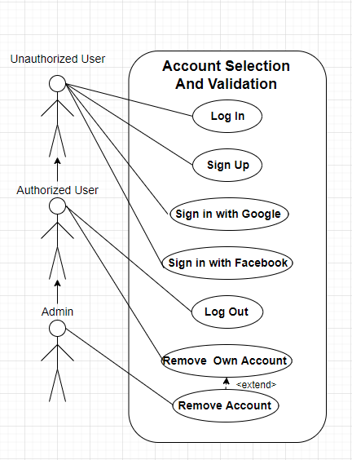

Use Case id: 8 | Use Case: Navigate to Book Section
Related Use Cases: Navigate to Electronics Section | Summary: An authorized user can navigate to the book section from the front page.
Actor: Authorized User | System: Filter System
Precondition: Authorized user has logged in. The front page is displayed
User Input | System
1. User selects Textbooks under Filters | 2. The Front Page listings that are not tagged Textbooks are hidden.
Post-conditions: The user only has textbooks shown.
Related Functional Requirement: 12

Use Case id: 09 | Use Case: Navigate to Electronics Section
Related Use Cases: Navigate to Books Section | Summary: An authorized user can navigate to the book section from the front page.
Actor: Authorized User | System: Filter System
Precondition: Authorized user has logged in. The front page is displayed
User Input | System
1. User selects Electronics under Filters | 2. The Front Page listings that are not tagged Electronics are hidden.
Post-conditions: The user only has electronics shown.
Related Functional Requirement: 12

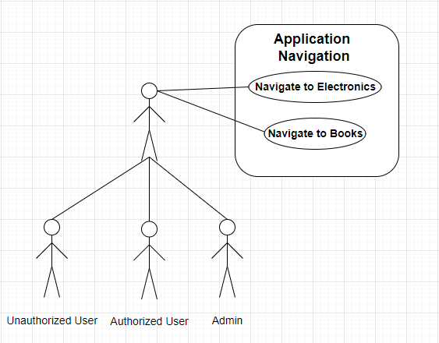

Use Case id: 10 | Use Case: Create Listing
Related Use Cases: Add picture to listing | Summary: An authorized User can create a listing that is able to be tagged
Actor: Authorized User | System: Listing
Precondition: Authorized user has logged in. The front page is displayed
User Input | System
1. User clicks on “Create Listing” | 2. The system displays a “Listing Template”
3. The user fill out u price and a description of the item | 4 The system automatically fills the “Seller name” and “Listing Date”
5. The user tags based on the item’s listing category. | 6. The system adds a tag to the item
Post-conditions: The Authorized user has a listing under their profile that is searchable by any CSwap user.
Related Functional Requirement: 14, 15

Use Case id: 11 | Use Case: Add picture to listing
Related Use Cases: Add listing | Summary: An authorized user can add a picture to an existing listing
Actor: Authorized User | System: Listing
Precondition: Authorized user has logged in and created a listing. The listing is displayed
User Input | System
1. User clicks “Add picture” | 2. “Upload a .png” is displayed
3. The user selects the file that they want | 4 The system displays  - “File type not recognize” or  - Where the “Upload a .png” was displayed the image is instead
Post-conditions: The authorized user will be able to view the listing with a picture of the item.
Related Functional Requirement: 8, 17

Use Case id: 12 | Use Case: Delete Listing
Related Use Cases: Add listing | Summary: An authorized user can delete one of their own listings
Actor: Authorized User | System: Listing
Precondition: Authorized user has logged in and created a listing. The listing is displayed
User Input | System
1. User clicks “Remove Listing” | 2. “Are you sure you want to remove the listing?” is displayed
3. The user selects “yes” | 4 The listing is removed from CSwap.
Post-conditions: The listing is no longer available to CSwap users
Related Functional Requirement: 14

Use Case id: 13 | Use Case: Add Tag
Related Use Cases: Include in 9 “Create Listing” | Summary: An authorized user can add a tag to an existing listing hey own
Actor: Authorized User or Admin | System:Search and Filter
Precondition: User has logged in and created a listing
User Input | System
1. User clicks in the tag section and types # followed by  - high or low based on the quality of the item and course number if it is a textbook or  - type of furniture if it is furniture or  - company manufacturer if it is an electronic or  - number of years if it is a lease | 2. The system attaches the tag to the user
Post-conditions:The item is now search able by authorized users by the tag.
Related Functional Requirement: 13

Use Case id: 14 | Use Case: Search by Title
Related Use Cases: | Summary: An authorized user can search for a listing by typing into a search bar
Actor: Authorized User | System: Search and filter
Precondition: User has logged in and clicked on the search bar
User Input | System
1. User types key term | 2. The system filters out items that do not have the key term typed in.
Post-conditions: The system displays only listings that have the key term
Related Functional Requirement: 11

Use Case id: 15 | Use Case: Search by category
Related Use Cases: | Summary: The authorized user is able to filter out listings that are not of the selected category
Actor: Authorized User | System: Search and Filter
Precondition: Listings have been created in the search category, the user is logged in.
User Input | System
1. The user clicks on a category displayed on the left side of the screen | 2. The system displayed only listings under those categories.
Post-conditions: The authorized user can now see only listings under those categories.
Related Functional Requirement: 12

Use Case id: 16 | Use Case: Search by tag
Related Use Cases: | Summary: The authorized user is able to filter out listings that do not have the tag typed in
Actor: Authorized User | System: Search and Filter
Precondition: Listings have been created in the search category, the search bar has been selected, the user is logged in.
User Input | System
1. The user types the tag(s) that is desired | 2. The system displayed only listings that have the tag(s)
Post-conditions: The authorized user can now see only listings that have those tags
Related Functional Requirement: 13

