Gearbox to motor mount
Theoretically, no clutch is required? But shifts while driving will be harsh or could damage gearbox. So keep clutch.

3 parts:
- Motor adapter/coupler for flywheel. Need to be made with extremely fine tolerance. Then heated up either in oven (but takes long, like 10 hours) or with ____. Make it super hot, then put on. This can heat bearing up to dangerous levels, so immediately cool down motor side. Downside is you are not getting it off without damaging motor shaft (took Tony 7 hours and shaft was scoured).
- Custom flywheel with no ring gear (cause no starter motor and need space). This is what the clutch attaches to and thus, presses against. Should be balanced. Can be balanced as a unit with clutch for better balance.
- Bellhousing from motor to gearbox. When designing, make sure clutch screws and surface are correct depth from gearbox mount (the same as on original engine). I think they did this by measuring depth from original motor and crankshaft mount.

Chassis ground, HV ground and ground fault metering.
High voltage positive and negative are floating. Chassis ground is connected to low voltage ground. Why the high voltage ground is not connected to chassis ground I still need to figure out. Instead, there is a ground fault meter that constantly monitors ohms/volts. Find out why this is the unit of measurement. What is the response time? How long before a person shocks to death?

Hyper 9 is very leaky apparently, so should set ground fault metering threshold pretty low (<200ohms/volt). Usually set to 700-900ohm/volt, but hyper 9 mesures about 1kohm/v at idle and 200oh,/v when accelerating.

MCU facts
- Perm 12V to remember some EEPROM?
- Switched on by low voltage KSI signal, then the MCU turns high voltage on in case of no faults.
- Screen shows current from battery sensor only if not charging, but uses charger signal when charging?

Connecting 12V to existing vehicle electronics
ICE car gets 12V from lead-acid battery. The positive is connected to the alternator and the starter contactor (switching side), sometimes without even as much as a fuse. It is also connected to many fuses that goes to the different systems of a vehicle (but the previous two are most important, highest current and always on). Some vehicle systems, like the alarm in more modern cars are always connected, while other systems are only powered with the ignition. The positive is connected to the ignition switch and as soon as the ignition key is turned to the ON position all accessories and systems are powered. When the key is further moved to the temporary START position, the starter contactor’s coil is connected and thus, the starter motor is energised.

On a Beetle then, how will existing electronic systems be powered? First, what needs to be powered? And which connection don’t you need anymore?

Of course, no starter motor (and thus no starter contactor) is needed, nor any alternator (we still use a 12V low voltage battery, but will charge it with a much more efficient DC/DC converter, not a low-efficiency alternator).

What you do need is everything you take for granted - lights, radio, dashboard cluster, fan (and in a fancier car much more).

We can then abstract the existing vehicle electronics as a single load on the 12V LV side of our electric vehicle.

The easiest way to connect all of these systems is to utilise their existing fuses and wiring and simply powering it all with a single 12V connection. Because these systems are often grounded to the chassis and because you are using the existing wiring, this places an important constraint on our design that the chassis is to be connected to the negative of the 12V DC battery. You can’t connect to any point of the original 12V bus (for instance the lights), because the wire is too thin. So you have three options:
- Original lead-acid battery positive connection
- Starter contactor (switching side)
- Alternator

In a converted Beetle, the connection closest to your HV battery and DC/DC converter will be the starter or alternator option.

Important: because we have abstracted the existing vehicle electronics as a simple load, the other two connections (other than the one being used) must be cut off and isolated. In the Beetle’s case, this means the original lead-acid battery connection must be removed/cut off/at least isolated.

Battery cooling

Literature

Battery characteristics
Each of our Tesla battery modules consists of two water/coolant inlets and two water/coolant outlets. Previous versions only had one inlet and one outlet. This is because previous versions only had one cooling channel through the entire module, while the newer version has two separate cooling channels through the module. The older battery module is shown below:
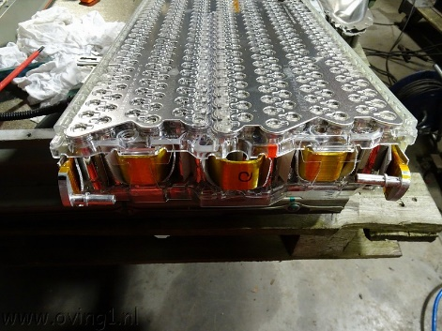

The older version’s cooling channel is shown below:
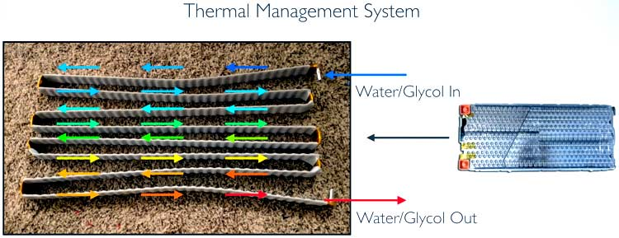

The above tube is an aluminium micro-channel tube. It “is a kind of high-precision extruded aluminium tube, also called multi-port extrusion tube (MPE tube) and an aluminium micro-channel tube.” (https://www.chaluminium.com/aluminium-tube/aluminium-micro-channel-tube)
There is very little information on the specifications of the cooling system on a Tesla battery.
AVL did a test on an older battery pack (with one inlet and one outlet per module) where they repeatedly charged and discharged the battery pack at 250A until steady temperatures were reached with an initial temperature of 20C and a coolant flow rate of 5L/min. The water/coolant temperature of each battery module is indicated in the figure. (https://www.youtube.com/watch?v=izUl28YtQbE)

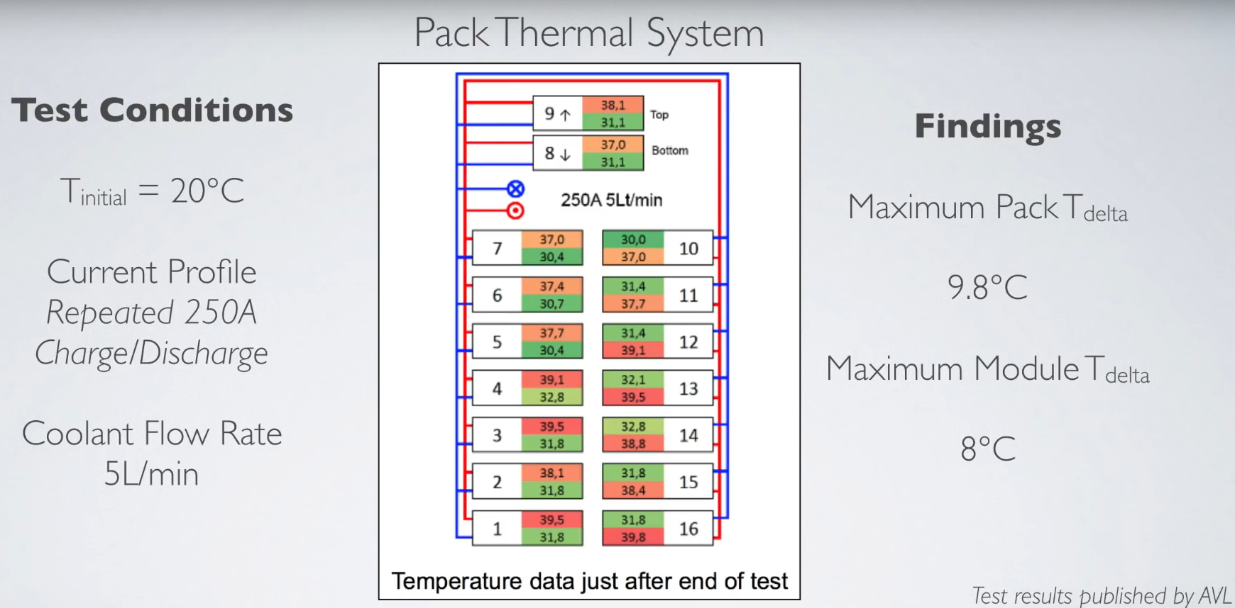

They give the following values for the battery pack internal resistance:

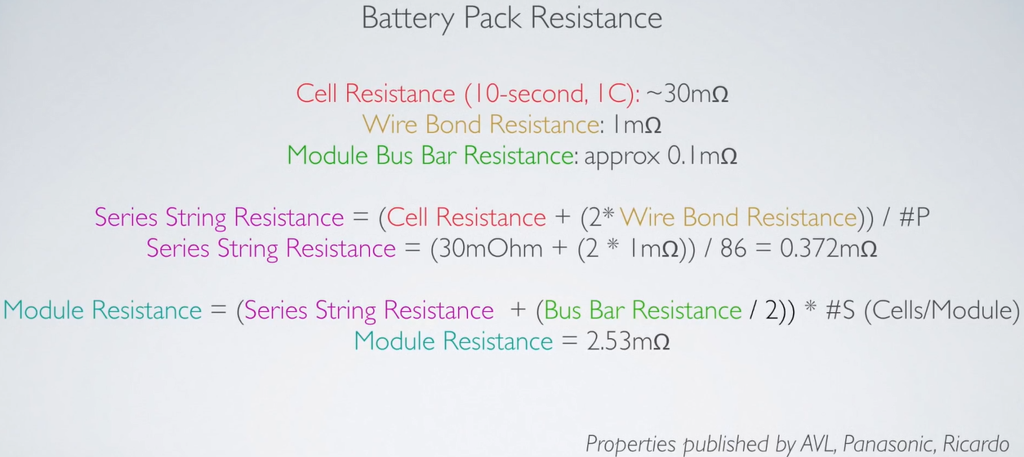

We can do a quick reality check here. We can calculate the heat energy generated by the battery pack theoretically using the module internal resistance and experimentally by using the test above and then we compare.
THEORETICALLY:
250A^2 * 0.00253 = 2530W
EXPERIMENTALLY:
assume all generated heat is transferred to the water (claude.ai and ChatGPT estimate heat dissipation to surroundings to be between 50W and 100W)
average in/out temperature difference of module = 6.86875C
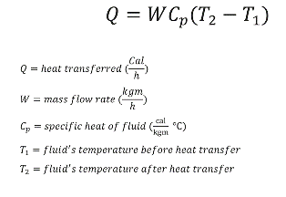
W=5kg/min=0.0833kg/s
Cp=4184J for water
Q=0.0833 * 4184 * 6.86875 = 2394W
CONCLUSION: the theoretical battery module internal resistance of 0.00253ohms is accurate, even under load.

A different test (from https://www.linkedin.com/pulse/tesla-18650-battery-design-analysis-blice-hu/) showed the following result for a single battery module:

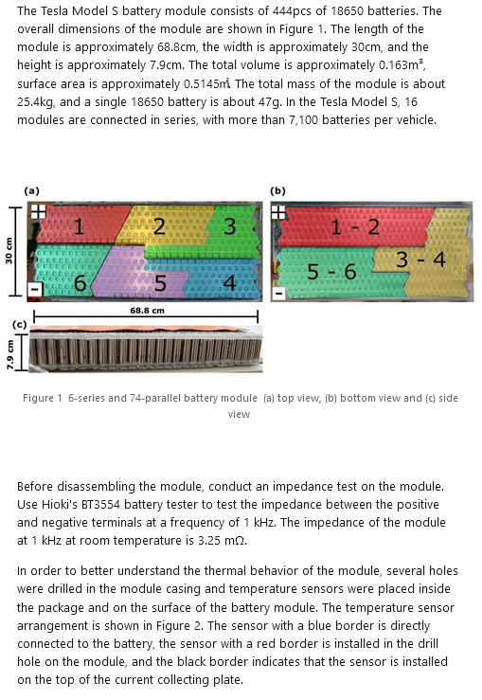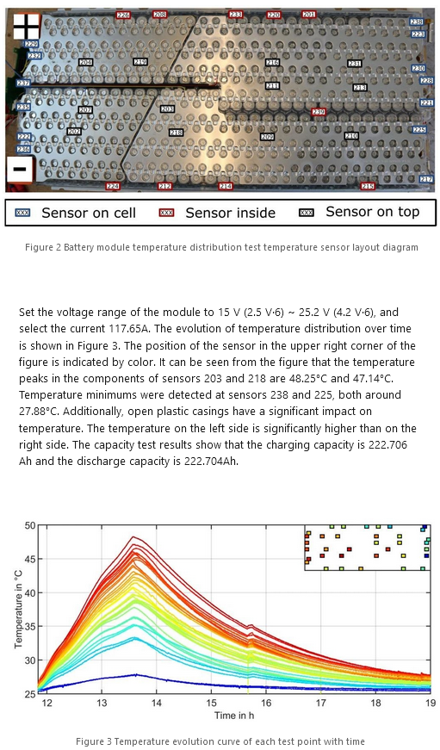

It is clear that the coolant connections to the different modules are connected in parallel.
On our batteries, there are two inlets and two outlets, such as in the picture below.

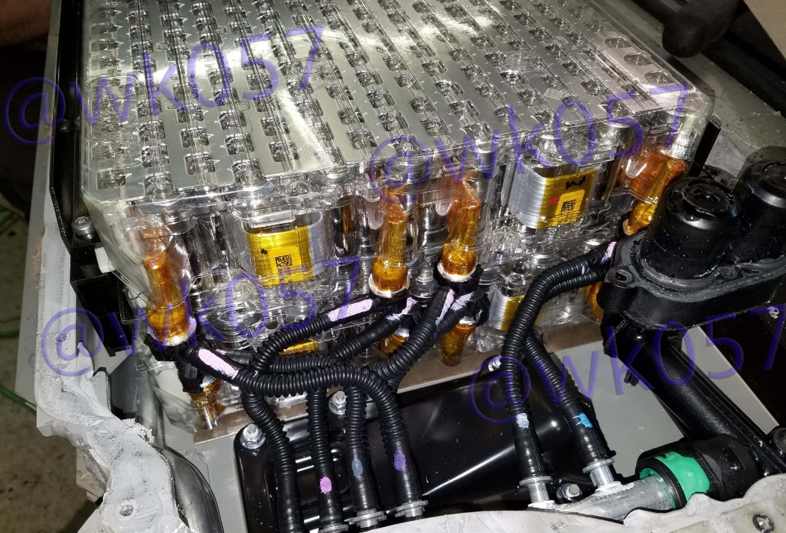

It is difficult to make out from this picture, but it seems like the two channels are connected in parallel and in our view, it wouldn’t make sense for Tesla to have connected the two channels in series, because in that case it would have made more sense to use one cooling channel per module as in previous generations.

To give an idea for coolant flow rate, we have screenshots of the Models 3, Y, Plaid Models S and X. We do not think this is the battery modules we have. The value cannot be used as is as these vehicles have PWM (variable) pumps that can be ramped up or down depending on cooling needs.

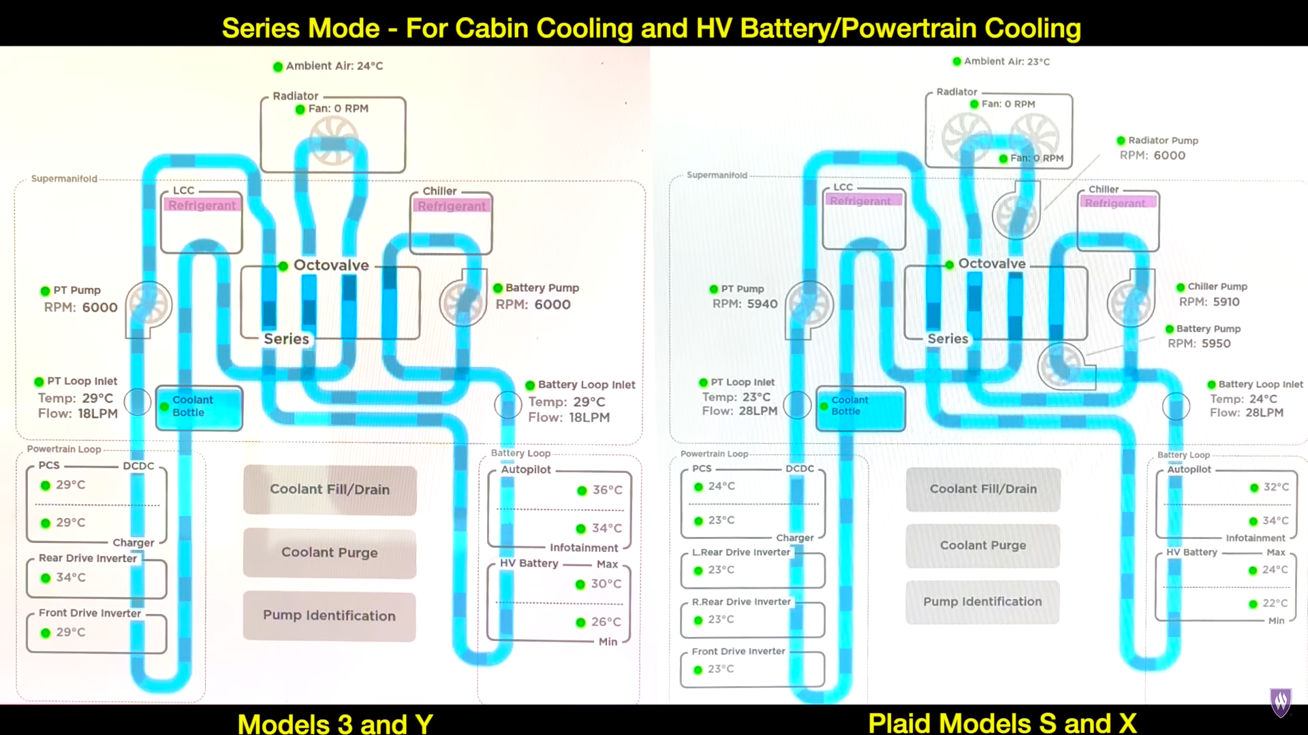
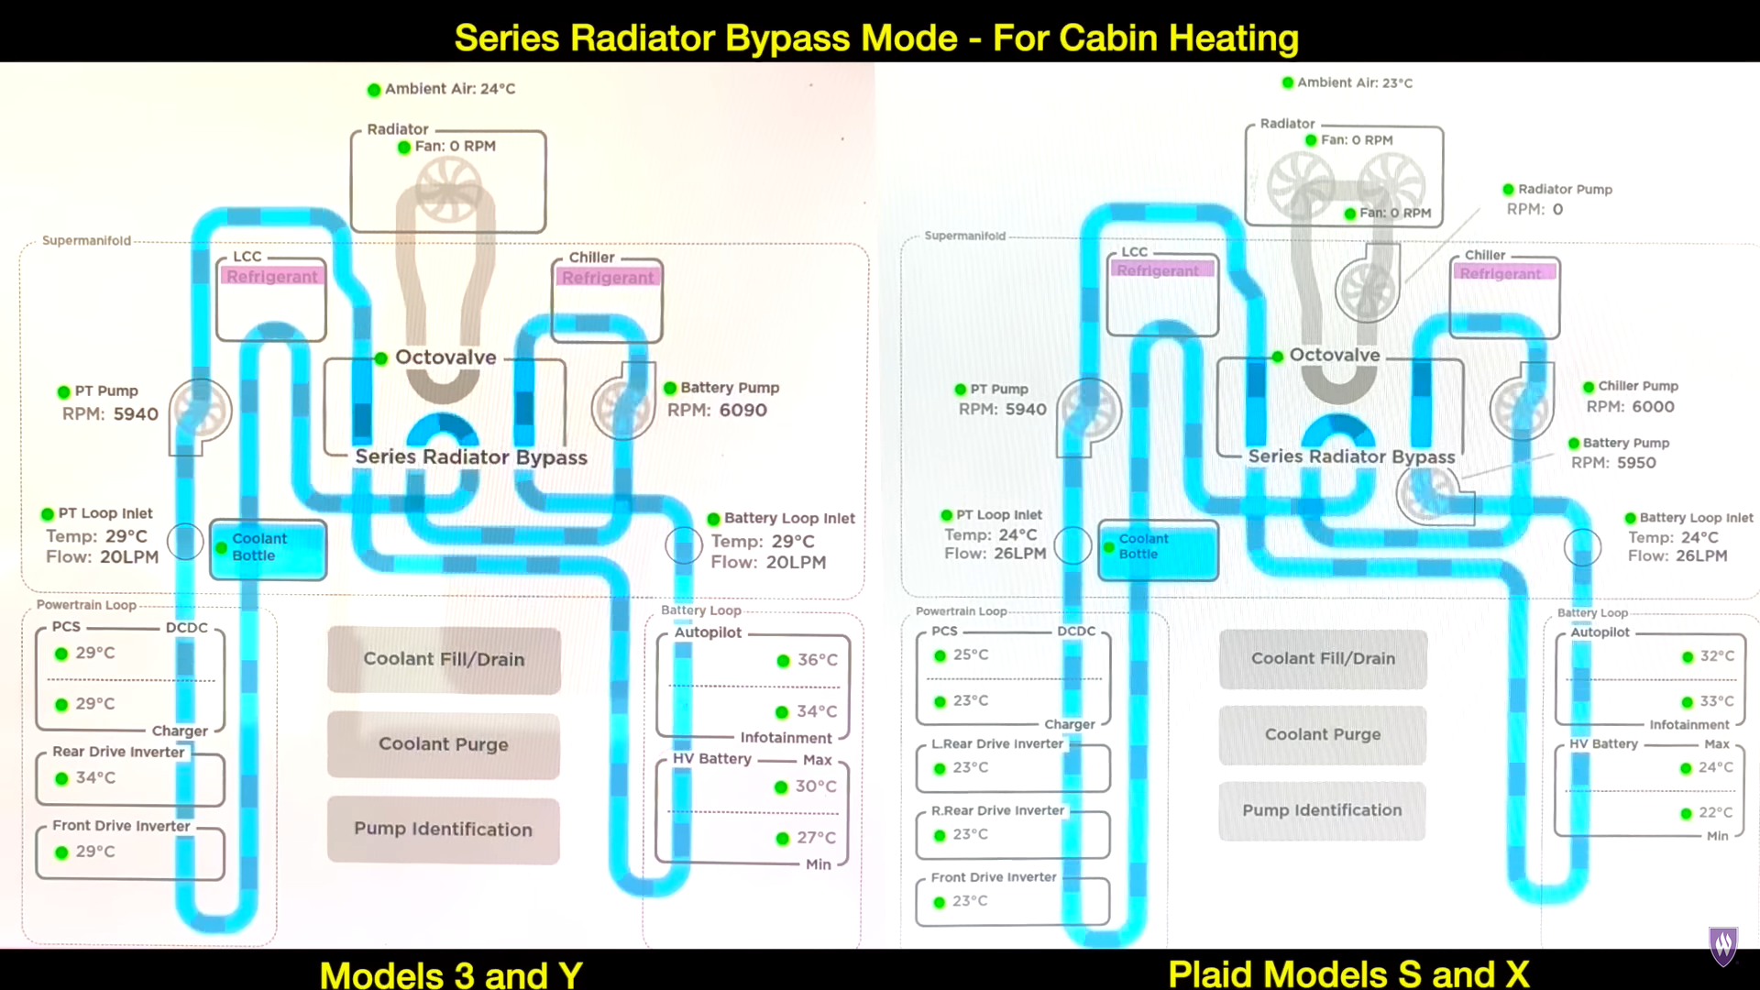
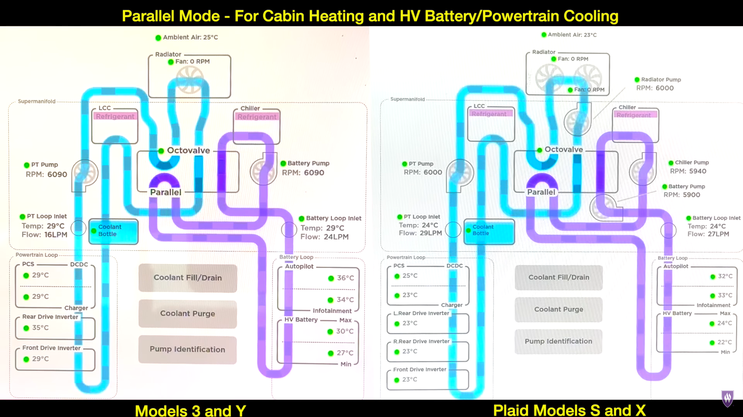
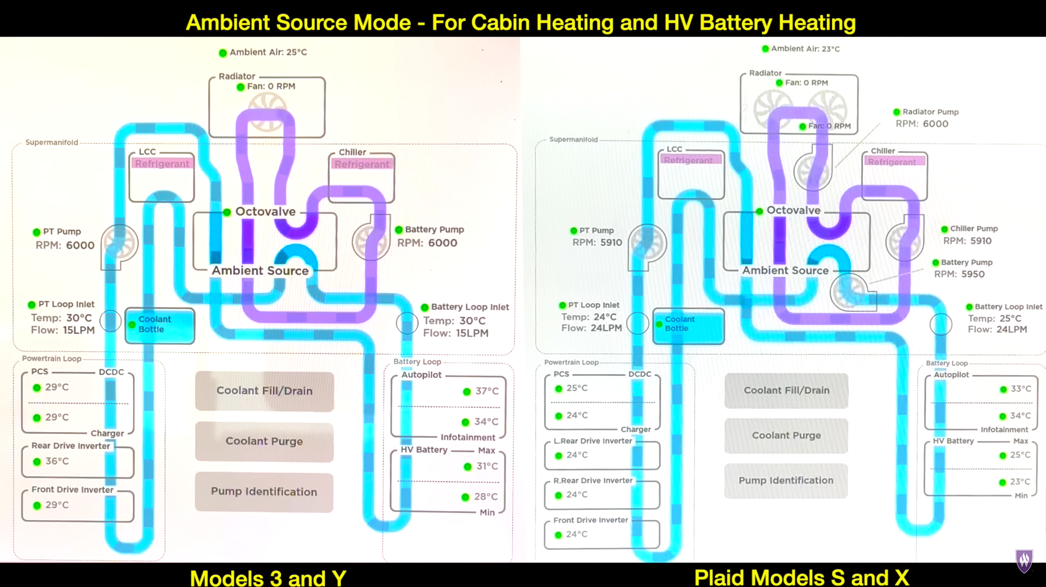
Online resources:
- https://teslamotorsclub.com/tmc/threads/pics-info-inside-the-battery-pack.34934/#post755546
- https://www.youtube.com/@wk057
- https://youtu.be/eYvjVXGBWXQ?si=WDhUJLFQ6iDJLFL0&t=1075
- https://www.youtube.com/watch?v=srraUymsT0U&t=111s
ECC:
- Wouldn’t use anything below 34 L/min for the pump.
- Used 6.3mm x 11.5mm 20 bar yellow hose.
- They link the two furthest hose connections on each battery module (effectively connecting the two cooling channels of each battery module in series). See note above regarding that.

Radiator design basics
First, there is heat transfer from the coolant to the inner surface of the radiator, then heat transfer from the inner tube surface of the radiator to the outer tube surface and to the fins attached to the outer surface and then there is heat transfer from the fins and outer tube surface to the air. Simulating all this is of course, too complicated, especially considering the temperature of the coolant varies within the radiator.
- https://ijrp.org/filePermission/fileDownlaod/4/5896e7ea9e5600db07c80b6385d1ec7f/2

Design questions
- Two cooling systems (one per battery box) or one cooling system?
- Radiator(s) specification?
- Pump(s) specification?

Design constraints
- Essentially, the EV must be able to drive in all weather conditions in South Africa.

Design

Battery module coolant lines hydraulic resistance
Our best bet is to do some rough calculations here. The length of each coolant line through the battery module is 4 times the length of the battery module (68cm), which equates to 2.72m.
The rectangular micro channel hydrodynamic resistance of (https://en.wikibooks.org/wiki/Microfluidics/Hydraulic_resistance_and_capacity#cite_note-1):
(This is assuming laminar flow, but we might be at transient flow with https://www.elveflow.com/microfluidic-calculator/ saying the crossing point to transient flow is at 0.7L/min per channel or 7L/min total)
R_h = 12uL/(wh^3(1-0.63h/w))
With u=0.001 Pa.s, L=2.72 m, w=0.05 m, h=0.0024 m
R_h = 4.87 x 10^7 Pa.s/m^3 (Claude.ai says 3.45 x 10^7)
R_h = 0.487bar.s/L = 0.00811 bar.min/L
So the front battery (4 coolant lines in parallel): R_h = 0.002bar.min/L
Rear battery (6 coolant lines in parallel): R_h = 0.00135bar.min/L

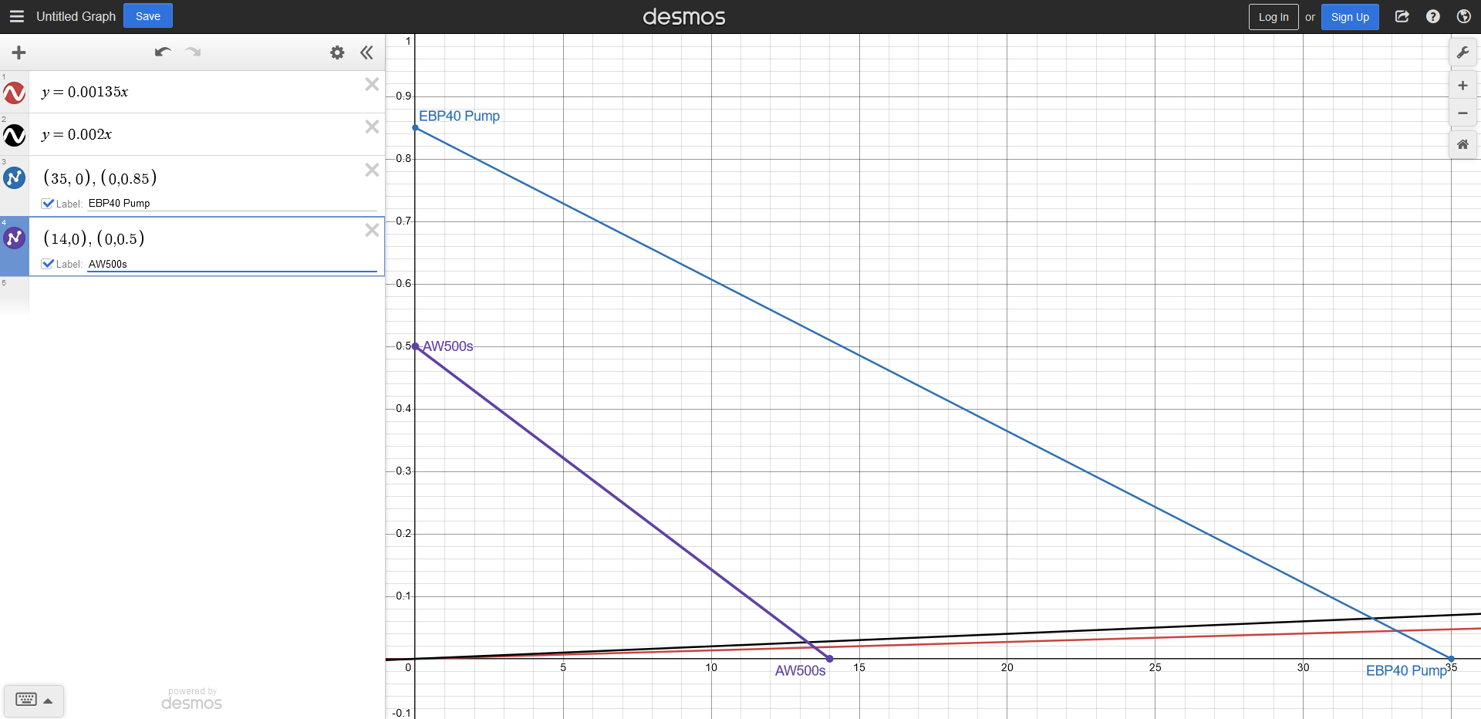

Radiator size
The record high temperature in South Africa is 50C. In the past 13 years it is 46C. The record high in the Western Cape is 46C. (https://www.plantmaps.com/en/za/climate/extremes/c/south-africa-record-high-low-temperatures)
The maximum safe operating temperature of a typical 18650 lithium battery cell (of which our battery modules consist of) is about 60C. For instance, the Panasonic NCR-18650B lithium-ion cell that is used in some Teslas, give an operating ambient temperature of 60C when discharging, 45C when charging and 50C when in storage. https://www.sciencedirect.com/science/article/pii/S2590174522001337 says the threat of thermal runaway starts to arise at above 70C.
Given that the ambient temperature will not be higher than 50C in South Africa, there is no cooling requirements for when the vehicle is idle. However, there is cooling requirements for charging (especially under regenerative braking) and discharging.
We start by determining the heat that needs to be removed by system.
The internal resistance of the Tesla battery module is between 2.5mOhm and 3.25mOhm
The maximum continuous current draw of the Hyper 9 motor setup is 350A and the peak current draw is about 850A.
We do a reality-check to see if 350A is appropriate. At this current, the motor power at a nominal battery voltage is 350 * 111 = 38.9kW. The Helshoogte pass has an average angle of elevation of 3 degrees. With drag coefficient = 0.45, frontal area = 1.8m^2 and mass of car = 1000kg, speed = 23m/s, air density = 1.225kg/m^3. Now P=F*v. We ignore rolling resistance. F= Fd+Fgravity = 0.5*p*Cd*A*v^2+m*g*sin(theta) = 0.5*1.225*0.45*1.8*23^2+1000*9.81*sin(3) = 262.45+1384.4 = 1646.85. P=1646.85*23=37.9kW. These calculations are very rough as the currents will constantly vary due to fluctuations in the gradient and the rolling resistances are omitted. But they do indicate that the continuous power draw of 350A is appropriate even for steep inclines.
If we take a worst-case scenario of 3.25mOhm internal resistance per Tesla battery module and 850A of current draw, the heat that needs to be dissipated per module is R x I^2 = 0.00325 * 850 * 850 = 2350W, equating to ~12kW for the 5 modules.
It would be difficult to dissipate that much heat energy, so we look at several scenarios and then current-limit the motor at certain battery temperatures.
A car radiator is cheaper than even the cheapest PC radiators. So we assume we are using a Toyota Tazz radiator with the following dimensions: 668x325x16 and a 1000CFM fan=0.47m^3/s. Car radiators have an approximate area density beta=1000m^2/m^3. Thus area is ~0.668x0.325x0.016x1000=3.47m^2. Overall heat transfer coefficients of car radiators commonly 600W/m^2*K, based on air-side surface.
We will use
Q=U⋅A_{s}⋅ΔT_{lm}
to calculate battery temperature together with
ΔT_{lm}=(T_{w_in}-T_{a_out}-T_{w_out}+T_{a_in})/ln((T_{w_in}-T_{a_out})/ T_{w_out}-T_{a_in})
(Yunus A. Çengel, Afshin J. Ghajar; Heat and mass transfer: fundamentals and applications; McGraw-Hill Education)
Scenario | Extreme heat, peak power | Extreme heat, normal driving | Hot day, peak power | Hot day, normal driving
Scenario ambient temperature (T_{a_in}) | 45C | 45C | 35C | 35C
Scenario motor current | 850A | 350A | 850A | 350A
Heat generation per battery module = I^2 * R = I^2 * 0.00325 | 2350W | 400W | 2350W | 400W
Total heat generation for battery pack (5 battery modules) | 11750W | 2000W | 11750W | 2000W
Case 1: Assuming 1000CFM fan, calculate air temperature output (T_{a_out}) with m=ρ⋅A⋅v=1.225*0.47 and Q=m⋅cp​⋅ΔT=0.58*1005*ΔT | 65C | 48.5C | 55C | 38.5C
Case 2: Assuming driving at 50km/h=13.9m/s, we calculate air temperature out (T_{a_out}) and entire radiator exposed perpendicular to incoming air. Now m=1.225*0.2171*13.9 and Q=3.68*1005* ΔT | 48.2C | 46.5C | 38.2C | 36.5C
Assume a 50L/min pump to get water inlet and outlet temperature difference (ΔT=T_{w_in}-T_{w_out}) with Q=m⋅cp​⋅ΔT=50/60*4182*ΔT | 3.37C | 0.57C | 3.37C | 0.57C
Now we calculate water input temperature (T_{w_in}) using fan cooling (case 1) with Q=600*3.47*ΔT_{lm} | 65.9C | 48.6C | 55.9C | 38.6C
Now we calculate water input temperature (T_{w_in}) using 50km/h air cooling (case 2) with Q=600*3.47*ΔT_{lm} | 53.9C | 47.1C | 43.9C | 37.1C

Hyper 9 motor

Literature
Continuous performance at 108V: maximum power of ~41kW.
https://www.go-ev.com/PDFs/HyPer_9_108V_Continuous_Performance.pdf
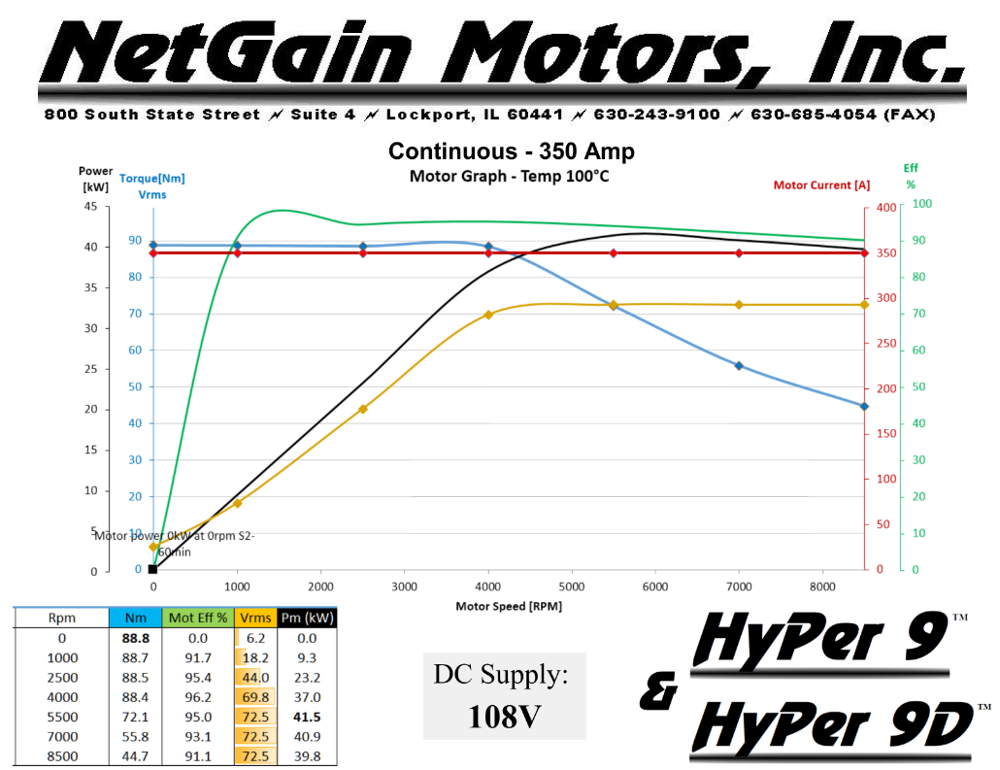

Peak performance at 120V: maximum power of ~105kW
https://www.go-ev.com/PDFs/HyPer_9_120V_Performance.pdf
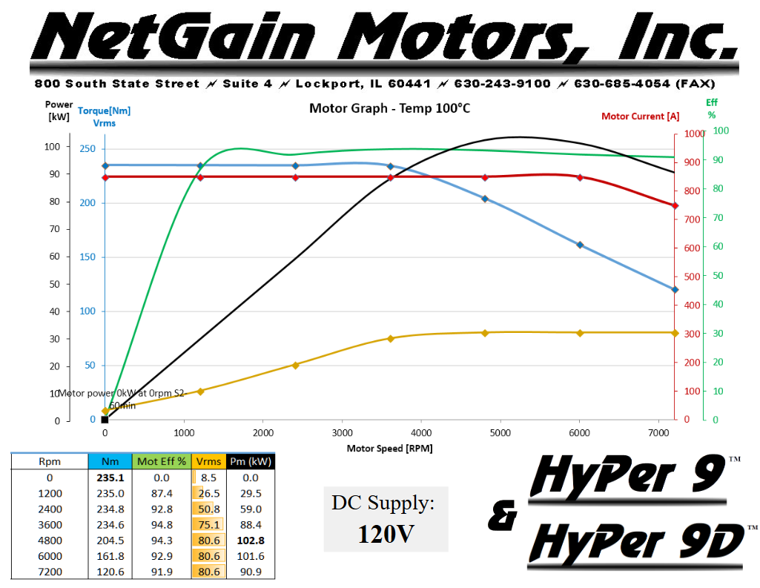
https://www.go-ev.com/PDFs/HyPer_9_IS_User_Manual_REV09.pdf
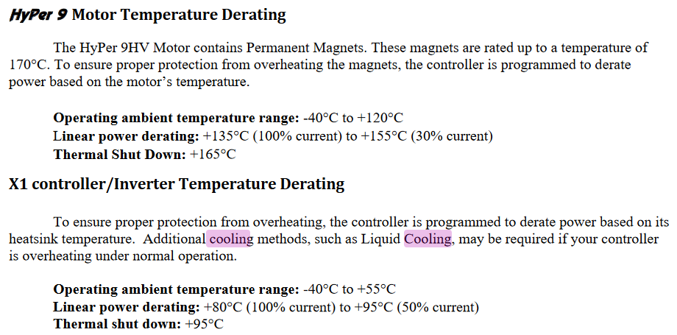

Wiring
Do we need a 12V battery? Yes, because when halogen bulbs are switched on they have inrush current of up to 10x rated current. So just for the high beams, which are 120W together, they can draw 100A of inrush current, exceeding the DC/DC converters rated 50A.

Total power draw:
- 25A peak; 11.5A cont. Lights:
  - Front:
    - 10A 60Wx2 high beams
    - A Wx2 front indicators
  - Rear:
    - 4.5A 27Wx2 brakes
    - 4.5A 27Wx2 rear indicators
    - 4.5A 27Wx2 reverse
    - 1.5A 9Wx2 rear parking lights
- 10A peak; 5A cont. Miscellaneous:
  - 10A 120W radio
- 10A peak; 10A cont. Cooling:
  - 2A pump
  - 7A fan

Terminology

Contactor vs Relay
Contactor is essentially a relay made for currents above 15A.

Battery pack vs module vs cell
One vehicle has one battery pack that consists of many battery modules. And each battery module consists of many battery cells.

