Gray Houston

ghousto

0026483532

Problem Set 1

1. 7 → 25 → 20 → 15 → 9 → 12 → 10

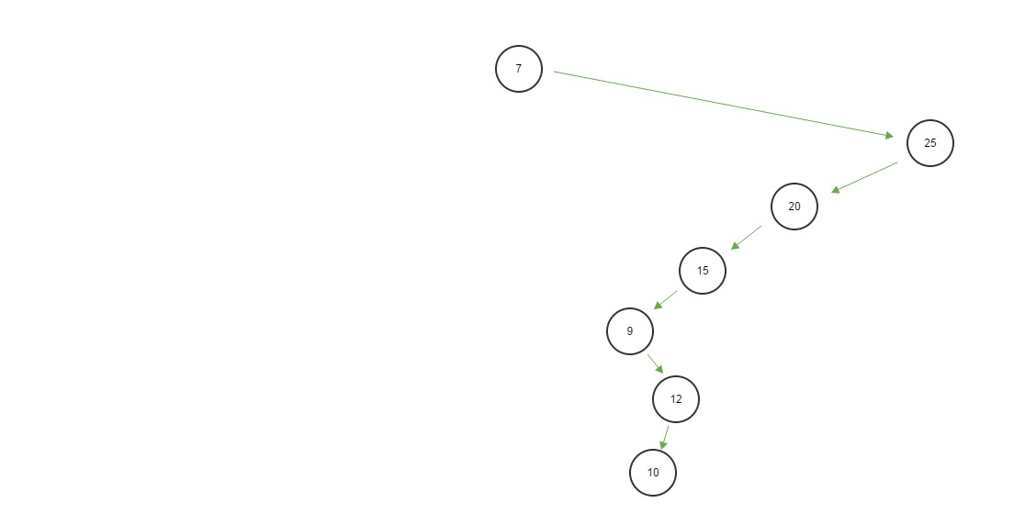 Tree exists

1. 7 → 25 → 15 → 20 → 16 → 10 Not a valid tree

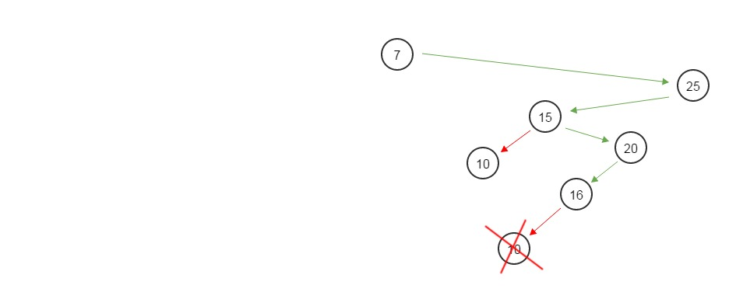

1. 25 → 20 → 18 → 22 → 16 → 10

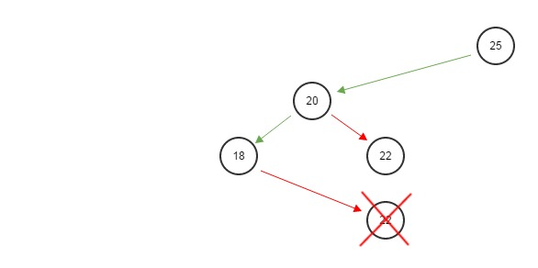

Therefore, this is not a valid tree.