The Clouds from AVHRR Extended User’s Guide

Version 5.4

Andrew Heidinger

NOAA/NESDIS Center for Satellite Applications and Research (STAR)

Denis Botambekov, William Straka III and Steve Wanzong

Cooperative Institute for Meteorological Satellite Studies (CIMSS)

Contents

Introduction to CLAVR-x 4

Description of the CLAVR-x Processing System 4

Installation of CLAVR-x 5

User Input in CLAVR-x 6

The CLAVRXORB File-List Run Control File 7

AVHRR Level-1b File Name Convention 7

VIIRS Level-1b File Name Convention 8

GOES, MSG, MTSAT, FY2D, COMS File Name Conventions 8

MODIS 1km Level1b File Name Conventions 8

MODIS 5km Level1b File Name Conventions. 8

The CLAVRXORB Default-Options Run-Control File 8

Level-1b Input Files 16

AVHRR 17

GOES-Imager 17

MODIS 17

VIIRS 17

Level-2 Output File 17

The Level-2 Include File 17

Level-2 File Contents 18

Level-2 Attributes. 30

Reading SDS Data from Level-2 Files 32

Reading Unscaled Data 32

Reading Scaled SDS Data 33

Algorithms 35

Cloud Detection 35

Cloud Phase and Type Estimation 35

AWG Cloud Height Algorithm (ACHA) 35

Daytime Cloud Optical and Microphysical Properties (DCOMP) 36

Product Examples 37

Ancillary Data Sets 48

NWP Data 48

GFS Grib Data 48

CFSR Reanalysis 48

NCEP Reanalysis 49

Daily SST Analysis Fields 49

Surface Emissivity 50

UMD Surface and Vegetation Type 50

Land Mask 50

Surface Elevation 51

Coast Mask 51

Volcano Mask 51

Snow and Ice Mask 52

# Introduction to CLAVR-x

The Clouds from AVHRR Extended System (CLAVR-x) is a processing system developed at NOAA/NESDIS and UW/CIMSS for generating quantitative cloud products in real-time from the Advanced Very High Resolution Radiometer (AVHRR). The CLAVR-x system has evolved into a climate processing system called the Pathfinder Atmopsheres Extended (PATMOS-x). In addition, the NESDIS GOES Surface and Insolation Project (GSIP) processing system was initially based on CLAVR-x and remains linked. This document will provide users information needed to configure and run CLAVR-x and to interpret its output.

CLAVR-x is FORTRAN-90 code written in the early 2000’s to meet the needs of NESDIS to provide cloudiness from the AVHRR to the National Centers for Environmental Prediction (NCEP). While it replaced the existing CLAVR system and products, the amount of code shared was minimal. CLAVR’s main mission was cloud detection and CLAVR did not generate a full suite of cloud products and its operation was limited to the afternoon orbiting AVHRR sensors prior to the launch NOAA-L (NOAA-16).

CLAVR-x become operational in NESDIS in 2002 and was updated significantly in 2006 after the launch of METOP-A. In 2013, CLAVR-x was updated again to support the generation of higher spatial resolution output for NCEP and incorporated many algorithm improvements from the GOES-R AWG effort. As will be explained later, CLAVR-x algorithms are now designed to operate in several processing systems to support NESDIS’s needs for cloud products in other applications and sensors.

# Description of the CLAVR-x Processing System

The CLAVR-x system consists of several executables. The main executable is called clavrxorb and it operates on the Level-1b data and generates Level-2 products. Other executables operate on the Level-2 files and sample or average them in space and/or time to make the other product times required of CLAVR-x. Figure 1 gives a schematic, taken from the CLAVR-x ICD, of the input and output data flowing in and out of the CLAVR-x system.

CLAVR-x runs physical algorithms and therefore uses significant amounts of ancillary data to specify the atmospheric and surface conditions. Figure 1 shows the different types of ancillary data.



Figure Schematic illustration of the input and output of CLAVR-x processing.

# Installation of stable versions of CLAVR-x

The CLAVR-x software system is hosted on a subversion repository accessible over the internet. This offers the following advantages:

* All users have access to the same version of the software
* Updating to the latest version of the software is transparent and straightforward
* It is easy to go back to previous versions
* SVN can generate snapshots of software system.

One may use the simple **svn** command line client which is installed by default on many Linux systems (see <http://subversion.tigris.org/getting.html#binary-packages>).

We provide installer scripts within clavr-x to download the stable versions:

1. Create a local source code folder into which you want to download the software
2. Download the folder with installer scripts:

svn checkout -q https://svn.ssec.wisc.edu/repos/cloud_team_clavrx/tags/clavrx_current/clavrx_scripts ./

1. Run ./install_clavrx_stable.sh , which downloads and compiles all needed modules. You may have to change hdf4 and hdf5 library paths in all config.mk files ( in subdirectories **dcomp, nlcomp** and **main_src**)
2. The executable binary ***clavrxorb*** can be now found in clavrx_bin folder.
3. Older versions can be download with ./install_clavrx_stable.sh **<version number>**

# 

Figure 2 Example session. Downlaod and start running installer script.

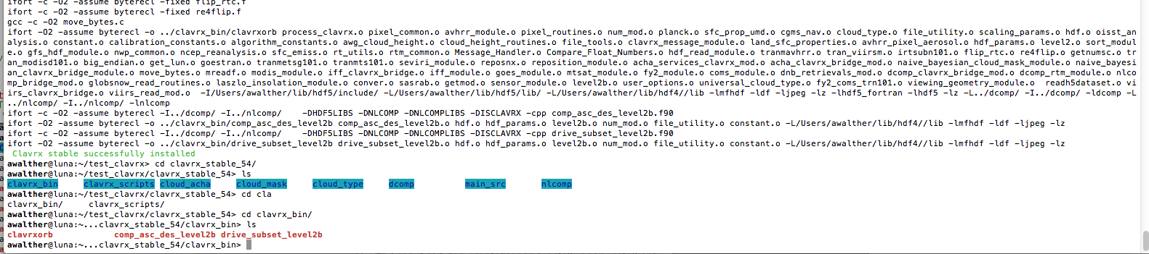

Figure 3 Example session showing the result of successful installation with installer script.

# Installation of trunk branch of CLAVR-x

Trunk and other development branches are solely for developers and advanced users. These versions of CLAVR-x may be not stable.

Users and developers may download trunk version by ./install_clavrx_trunk.sh ( see section “Installation of stable version “above)

Installer scripts for further development branches are not provided. Developers may adjust existing installer scripts for their need.

# User Input in CLAVR-x

There are two ways for a user to pass information to CLAVRXORB. One way is through command line arguments and this is described in the Appendix. The most common ways users pass information is through the two run-controls files, which are the file-list and default-options files. The default name for the file-list is called “clavrxorb_file_list” and the default name for the default-options files is “clavrxorb_default_options”. If CLAVRXORB is called without any arguments, it will expect these files to reside in the working directory. However, these files can be named arbitrarily and these names can be passed to CLAVRXORB through the command line arguments. Example of this would be as follows.

***$> clavrxorb –filelist my_goes_level1b_data –default my_goes_options***

The next two sections explain the contents of these files.

## The CLAVRXORB File-List Run Control File

CLAVR-x processing requires a list of input/output directories and input files. By default the system is looking for a file named “clavrxorb_file_list”. User can manually set the name from which the system would read required information by adding the following to the command line “ -filelist NAME_OF_THE_FILE”. File list should have the following structure (example in parentheses):

Table Description of the clavrxorb file-list text file.

|  |  |
| --- | --- |
| **Line #** | **Description** |
| 1 | Input directory location of Level 1b files (./level1b/) |
| 2 | Output directory location of Level 1b Prime files (./level1bx/) |
| 3 | Input directory location of Navigation files (./nav_in/) |
| 4 | Output directory location of Navigation files (./nav_out/) |
| 5 | Output directory location of CMR files (./cmr/) |
| 6 | Output directory location of SST files (./sst/) |
| 7 | Output directory location of Cloud files (./cld/) |
| 8 | Output directory location of Observation files (./obs/) |
| 9 | Output directory location of Geolocation files (./geo/) |
| 10 | Output directory location of RTM files (./rtm/) |
| 11 | Output directory location of Ash files (./ash/) |
| 12 | Output directory location of Level 2 files (./level2/) |
| 13 | Output directory location of Level 3 files (./level3/) |
| 14 | First Level-1b File Name * |
| 15+ | Subsequent File Names (one per line) |

### AVHRR Level-1b File Name Convention

When processing AVHRR, the user needs to provide the Level-1b name. The name can be arbitrary because no information is extracted from it. CLAVR-x assumes any file that ends in “.gz” or “.bz2” is compressed and any file without those suffixes is not compressed.

### VIIRS Level-1b File Name Convention

When processing VIIRS, the expected file names in file-list are the terrain-corrected geolocation files that begin with GMTCO. The names of the other needed files are constructed based on information from the GMTCO file.

### GOES, MSG, MTSAT, FY2D, COMS File Name Conventions

CLAVR-x uses band-separated “area” files when processing geostationary imager data. CLAVR-x expects the first file to be the name of the channel-1 file. It expects files of the following naming convention: satname_1_YYYY_DDD_HHMM.area where satname is the same of the satellite (e.g. goes13)

### MODIS 1km Level1b File Name Conventions

When processing 1 km MODIS data (MOD02km and MYD021km), the file name in the file-list is the name of the Level-1b file. The MODIS 1km Level-1b files do not contain 1 km geolocation data. The relevant geolocation files (MOD03 and MYD03) should be located in the “navigation input” directory on line 3 of the file-list. The name of the MODIS files are arbitrary and the information of their date are extracted from the global attributes.

### MODIS 5km Level1b File Name Conventions.

CLAVR-x processes the MODIS 5km subset files (MOD02SSH and MYD02SSH) generated by NASA GSFC and distributed by LAADSWEB. The geolocation information is imbedded in the files and therefore no separate file is needed.

## **The CLAVRXORB Default-Options Run-Control File**

As its name implies, the default-options file passes the user-specified chooses for many options including ancillary data, algorithm modes and files output. Many of these choices are sensor specific and therefore most users employ a sensor-specific default-options file. The default-options file allows users to turn on and off the channels. CLAVRXORB can run with all channels turned on – even those not present on the sensor being processed. Turning off channels will remove them from the output stream and may result in CLAVRXORB modifying the ACHA and DCOMP algorithm modes.

The table below describes the contents and most common usage of each parameter in this file.

Table 2 Description of the contents of the clavrxorb default options file

|  |  |  |  |
| --- | --- | --- | --- |
| **Line #** | **Parameter** | **Type** | **Description/Options** |
| 1 | ref_cal_1b | integer | Set to 0 to use the reflectance calibration information within the Level-1b data. Set to 1 to use the reflectance calibration information computed from parameters within the satellite instrument file. Set to 1 only for AVHRR climate processing (PATMOS-x) |
| 2 | therm_cal_1b | integer | Set to 0 to not use the thermal calibration information within the Level-1b data. Set to 1 to use the thermal calibration information computed from parameters within the satellite instrument file. Set to 1 only for AVHRR climate processing (PATMOS-x) |
| 3 | 1bx | integer | AVHRR Only. Set to 1 to not make a AVHRR Level-1bx file. Set to 0 for all other cases |
| 4 | nav_flag | integer | AVHRR only. Set to 0 to use navigation in the Level-1b file (recommnend). Set to 1 to read in a pre-existing navigation file (clevernav.f90). Set to 2 to use Fred Nagle’s repositioning routine (AVHRR climate processing only). |
| 5 | nav_file_flag | integer | Set to 0 to not write a navigation HDF4 file. Set to 1 to write navigation HDF4 file. The navigation HDF4 file includes pixel level latitude and longitude. Scan line numbers and scan line times are also included. The latitude and longitude variables may now be seen in the Level-2 HDF4 file. The “clavrxorb_file_list” file controls the output location. A normal user does not need this file. The flag should be set to 0. |
| 6 | cmr_file_flag | integer | This functionality has been removed from CLAVR-x. This flag should be set to 0. |
| 7 | obs_file_flag | integer | This functionality has been removed from CLAVR-x. The user can look to the Level-2 HDF4 file for the Level-1b information. Top of atmosphere reflectances at 0.65 μm and 3.75 μm, as well as brightness temperatures at 3.75 μm, 6.7 μm, 11 μm, and 13.3 μm are included in the Level-2 HDF4 file. This flag should be set to 0. |
| 8 | geo_file_flag | integer | This functionality has been removed from CLAVR-x. The user can look to the level2 HDF4 file for high-resolution ancillary data such as viewing angles, land cover, surface types, and surface elevation information. This flag should be set to 0. |
| 8 | cld_file_flag | integer | This functionality has been removed from CLAVR-x. The user can look to the Level-2 HDF4 file for the field of cloud properties information. The cloud mask, cloud type, cloud phase, cloud top temperature, cloud top pressure, cloud top height, and several others are included. This flag should be set to 0. |
| 10 | sst_file_flag | integer | This functionality has been removed from CLAVR-x. The user can look to the Level-2 HDF4 file for this information. This flag should be set to 0. |
| 11 | rtm_file_flag | integer | Set to 0 to not write a RTM HDF4 file. Set to 1 to write a RTM HDF4 file. The “clavrxorb_file_list” file controls the output location of the file. This file may still be generated, but the user should look to the Level-2 HDF4 file for modeled surface temperature, calculated clear sky reflectances and brightness temperatures, and emissivity. This flag should be set to 0. |
| 12 | ash_file_flag | integer | This functionality is unsupported in CLAVR-x, as it requires a specific branch of source code (VOLCAT). This flag should be set to 0. |
| 13 | level2_file_flag | integer | Set to 0 to not write a Level-2 CLAVR-x HDF4 file. Set to 1 to write a Level-2 CLAVR-x HDF4 file. The “clavrxorb_file_list” file controls the output location of the HDF4 file. This file will contain all of the output from the CLAVR-x run. The content of the HDF4 output is controlled at compile time by editing the level2.inc file. This flag needs to be set to 1. |
| 14 | level3_file_flag | integer | This functionality has been removed from CLAVR-x. This flag should be set to 0. |
| 15 | cld_mask_1b | integer | Set to 0 to not read in the cloud mask from a Level-1b file. Set to 1 to read in cloud mask from a Level-1b file and use in product derivation. Set to 2 to read in cloud mask from a Level-1b file, but do not use in product generation. In operations, it is set to zero for all satellites. However, it can be useful for testing official operational products such as the VIIRS IICMO (cloud mask). This flag should be set to 0. |
| 16 | cloud_mask_bayesian_flag | integer | Set to 0 to not use the Bayesian cloud mask software. If flag 0 is selected, the user must have a Level-1b cloud mask product available. Set to 1 to use the Bayesian cloud mask software. This flag should be set to 1. |
| 17 | sst_flag | integer | Set to 0 to not compute pixel level SST products. Set to 1 to compute pixel level SST products. This flag does not appear to be used, but is set to 1 in operations. This flag should be set to 1. |
| 18 | cld_flag | integer | Set to 0 to not compute pixel level cloud products. Set to 1 to compute pixel level cloud products. This flag should be set to 1. |
| 19 | aot_flag | integer | Set to 0 to not compute pixel level aerosol products. Set to 1 to compute pixel level aerosol products. In operations, this is set to 1 for all satellites. However, only the AVHRR satellite will return these products. For non-AVHRR satellites, the functions that calculate these products are commented out in the software. This flag should be set to 1. |
| 20 | erb_flag | integer | Set to 0 to not compute earth radiation budget properties. Set to 1 to compute earth radiation budget properties. Currently, there is no AVHRR algorithm. Along with the earth radiation budget, the insolation will also be calculated for the GOES, MTSAT, and Meteosat satellites. This flag should be set to 0 for AVHRR, and VIIRS. Set the flag to 1 for geostationary satellites. |
| 21 | ash_flag | integer | This functionality is unsupported in CLAVR-x, as it requires a specific branch of source code (VOLCAT). This flag should be set to 0. |
| 22 | oisst_flag | integer | Set to 0 not read in the daily NOAA Optimum Interpolation (OI) Sea Surface Temperature (SST) OISST analysis field. Set to 1 to read in the daily OISST analysis field. This flag should be set to 1. |
| 23 | oisst_option | integer | Set to 0 to allow the software look for the correct OISST analysis field. This flag should be set to 0. |
| 24 | gridcell_resolution | real | Number specifying grid resolution (degrees) of gridded Level-3 output. Values can be 0.25, 0.5, 1.0, or 2.5 degrees. This is an unsupported option as it pertains to the Level-3 gridded output. This can be set to 0.5. |
| 25 | gridcell_format | integer | Set to 0 for equal-area grid format. Set to 1 for equal-angle grid format. This is an unsupported option as it pertains to the Level-3 gridded output. This flag should be set to 0. |
| 26 | data_comp_flag | integer | Set to 0 to not use compression in the Level-2 output files. Set to 1 to use internal gzip compression in the output. Set to 2 for szip compression. |
| 27 | subset_pixel_hdf_flag | integer | Set to 0 to not subset pixels in the Level-2 HDF4 output file. Set to 1 to subset pixels in the Level-2 output using lat_min_diag and lat_max_diag (see below). In operations, this flag is set to 0. |
| 28 | nwp_flag | integer | Set to 0 to use no NWP (note, only OBS, NAV and GEO files will be produced). This option is not supported as the OBS, and GEO files are no longer created. Set to 1 to use NCEP GFS NWP fields. Set to 2 to use NCEP Reanalysis fields. Set to 3 to use NCEP Climate Forecast System Reanalysis (CFSR) fields. Set to 4 for GDAS reanalysis fields. In operations, the flag is set to 1. However, for case studies, option 3 is the preferred flag. |
| 29 | rtm_flag | integer | Set to 0 to use the CRTM. Set to 1 to Hal Woolf’s PFAAST RTM. In operations, this is set to 1, as PFAAST is the only supported RTM at this time. This flag should be set to 1. |
| 30 | modis_clr_alb_flag | integer | Set to 0 to not use the MODIS clear sky albedo composite. Set to 1 to use the MODIS clear sky albedo composite. This flag should be set to 1. |
| 31 | prob_clear_res_flag | integer | Set to 0 to not restore the probably clear pixels. Set to 1 to restore probably clear pixels. This flag should be set to 1. Not sure this is a valid option anymore in the current version of CLAVR-x. |
| 32 | lrc_flag | integer | Set to 0 to not perform local radiative center computation (LRC). Set to 1 to perform LRC computation. This flag should be set to 1. |
| 33 | proc_undetected_cld_flag | integer | Set to 0 to not process cloud products on undetected cloud pixels or pixels that do not have a type set. Set to 1 to process cloud products on undetected cloud pixels or pixels that do not have a type. This flag should be set to 0. |
| 34 | diag_flag | integer | Set to 0 to not write out diagnostic files. Set to 1 to write out diagnostic files. This flag should be set to 0. I’m not sure this is supported in the current version of CLAVR-x. |
| 35 | asc_flag_diag | integer | Set to -1 to write out ascending and descending data to the diagnostic files. Set to 0 to write out ascending data to the diagnostic files. Set to 1 to write out descending data to the diagnostic files. This is for developer use only. This flag should be set to 0. |
| 36 | lat_min_diag | real | Value of minimum nadir latitude for diagnostic files. It is also used in conjunction with the subset_pixel_hdf_flag to trim the Level-2 HDF4 file. This flag should be set to -90.0. |
| 37 | lat_max_diag | real | Value of maximum nadir latitude for diagnostic files. It is also used in conjunction with the subset_pixel_hdf_flag to trim the Level-2 HDF4 file. This flag should be set to 90.0. |
| 38 | ancil_data_dir | char(128) | Directory where the CLAVR-X ancillary data files are to be read. An example directory listing is as follows: /data/Ancil_Data/clavrx_ancil_data/ |
| 39 | gfs_data_dir | char(128) | Directory where the GFS data files are to be read. An example listing is as follows: /data/Ancil_Data/gfs/hdf/. The GFS data is converted from either GRIB1 or GRIB2 to a localized HDF4 file. This conversion takes place outside of CLAVR-x. |
| 40 | ncep_data_dir | char(128) | Directory where the NCEP Reanalysis data files are to be read. An example listing is as follows: /data/Ancil_Data/ncep-reanalysis/ |
| 41 | cfsr_data_dir | char(128) | Directory where NCEP CFSR data files are to be read. An example listing is as follows: /data/Ancil_Data/cfsr/hdf_05/ |
| 42 | oisst_data_dir | char(128) | Directory where the daily OISST data files are to be read. An example listing is as follows: /data/Ancil_Data/oisst_daily/ |
| 43 | snow_data_dir | char(128) | Directory where ancillary daily snow map files are to be read. An example listing is as follows: /data/Ancil_Data/snow/ |
| 44 | globsnow_data_dir | char(128) | Directory where the GlobSnow Snow Water Equivalent files are to be read. The data files encompass the years of 1979 to 2009. An example listing is as follows: /data/Ancil_Data/GlobSnow/ |
| 45 | dsc_data_dir | char(128) | Directory where dark sky composite files are to be read (GOES only). An example listing is as follows: /data/Ancil_Data/goes_dark_sky_composites/ |
| 46 | temp_dir | char(128) | A temporary files directory (ex. ./temporary_files) needs to be set up ahead of time. The CLAVR-x software creates temporary files within this directory. Most are deleted on completion. |
| 47 | smooth_nwp | integer | Smooth NWP data by linear interpolation. (0=no / 1= yes). This flag should be set to 1. |
| 48 | use_seebor | integer | Use SEEBOR Land Surface Emissivity database (0=no / 1= yes). This flag should be set to 1. |
| 49 | read_hires_sfc_type | integer | Read in the high-resolution surface type database (0=no [8km] / 1= yes [1km]). There are only 2 files available and both are hard coded into the CLAVR-x software. Each file is required to be within the sfc_data directory of the parent ancillary data directory (e.g. /data/Ancil_Data/sfc_data/). The 1 km file is named gl-latlong-1km-landcover.hdf. The 8 km file is named gl-latlong-8km-landcover.hdf. This flag should be set to 1. |
| 50 | read_land_mask | integer | Read in the land mask database (0=no / 1= yes). There is only 1 file available and it is hard coded into the CLAVR-x software. The land mask file is required to be within the sfc_data directory of the parent ancillary data directory (e.g. /data/Ancil_Data/sfc_data/). The filename is expected to be lw_geo_2001001_v03m.hdf. This flag should be set to 1. |
| 51 | read_coast_mask | integer | Read in the coast mask database (0=no / 1= yes). There is only 1 file available and it is hard coded into the CLAVR-x software. The coast mask file is required to be within the sfc_data directory of the parent ancillary data directory (e.g. /data/Ancil_Data/sfc_data/). The filename is expected to be coast_mask_1km.hdf. This flag should be set to 1. |
| 52 | read_surface_elevation | integer | Read in the surface elevation database (0=no / 1= read 1 km file / 2 = read 8 km file). There are only 2 files available and both are hard coded into the CLAVR-x software. Each file is required to be within the sfc_data directory of the parent ancillary data directory (e.g. /data/Ancil_Data/sfc_data/). The 1 km file is named GLOBE_1km_digelev.hdf. The 8 km file is named GLOBE_8km_digelev.hdf. This flag should be set to 1. |
| 53 | read_volcano_mask | integer | Read in volcano mask database(0=no / 1= yes). There is only 1 file available and it is hard coded into the CLAVR-x software. The volcano mask file is required to be within the sfc_data directory of the parent ancillary data directory (e.g. /data/Ancil_Data/sfc_data/). The filename is expected to be volcano_mask_1km.hdf. This flag should be set to 0. |
| 54 | solzen_min_limit, solzen_max_limit | 2 reals | Value of minimum and maximum solar zenith angle (in degrees) to be processed. The two numbers must be separated by a space. These two values should be 0.0 and 180.0. |
| 55 | snow_mask_flag | integer | Determine which snow mask to use (0=NWP, 1=4km snow map, 2=GlobSnow). Using the NWP snow mask should be the last option. The 4km snow map files are located in the directory from the snow_data_dir defined above. The GlobSnow files are located in the directory from globsnow_data_dir defined above. Operationally, the 4km snow map files are use. The flag should be set to 1. |
| 56 | dsc_flag | integer | Read in dark sky composites for geostationary satellite insolation products. (0=no, 1=yes). This flag should be set to 0. |
| 57 | channel 1-6_flags | 6 integers | Channel on flags of channels 1,2,3,4,5,6 (0=not present, 1=present) separated by a space. These are mapped to the MODIS band numbers. Other satellites are then mapped to the matching MODIS band by comparing the central wavelength of each band. It is easiest to simply use a flag of 1 for each channel. The software will determine if the channel exists. |
| 58 | channel 7-12_flags | 6 integers | Channel on flags of channels 7,8,9,10,11,12 (0=not present, 1=present) separated by a space. See above for description. The user should set these to 1. |
| 59 | channel 13-18_flags | 6 integers | Channel on flags of channels 13,14,15,16,17,18 (0=not present, 1=present) separated by a space. See above for description. The user should set these to 1. |
| 60 | channel 19-24_flags | 6 integers | Channel on flags of channels 19,20,21,22,23,24 (0=not present, 1=present) separated by a space. See above for description. The user should set these to 1. |
| 61 | channel 25-30_flags | 6 integers | Channel on flags of channels 25,26,27,28,29,30 (0=not present, 1=present) separated by a space. See above for description. The user should set these to 1. |
| 62 | channel 31-36_flags | 6 integers | Channel on flags of channels 31,32,33,34,35,36 (0=not present, 1=present) separated by a space. See above for description. The user should set these to 1. |
| 63 | channel i1-i5,DNB | 6 integers | Channel on flags of VIIRS channels i1,i2,i3,i4,i5,DNB (0=not present, 1=present) separated by a space. See above for description. The user should set these to 1. |
| 64 | dcomp_mode | integer | Set to 1 to use 0.6 μm/1.6 μm channel combination for the Daytime Cloud Optical Microphysical Parameters (DCOMP) Mode. Set to 2 to use 0.6 μm/2.2 μm DCOMP Mode. Set to 3 to use 0.6 μm/3.7 μm DCOMP Mode. DCOMP provides pixel level Cloud Optical Depth (COD) and Cloud effective Particle Size (CPS). In operations, GOES uses flag 3, AVHRR uses flag 1, MODIS uses 3, and VIIRS uses 1. |
| 65 | acha_mode | integer | Set to 0 to use 11 μm channel GOES-R ABI Cloud Height Algorithm (ACHA) Mode. Set to 1 to use 11 μm/12 μm channel combination ACHA Mode. Set to 2 to use 11 μm/13.3 μm ACHA Mode. Set to 3 to use 11 μm/12 μm/13 μm ACHA Mode. Set to 4 to use 8.5 μm/11 μm/12 μm ACHA Mode. Set to 5 to use 6.7 μm/11 μm/12 μm ACHA Mode. Set to 6 to use 6.7 μm/11 μm/12 μm ACHA Mode. In operations, GOES uses mode 6, AVHRR uses mode 1, MODIS uses mode 3, and VIIRS uses mode 4. The ACHA generates pixel level cloud-top height, cloud-top temperature, cloud-top pressure, and cloud layer products. |
| 66 | bayes_mask_file | char(128) | The naïve Bayesian cloud mask file. This file is satellite specific and is stored within the bayes directory of the parent ancillary data directory (e.g. /data/Ancil_Data/clavrx_ancil_data/). The Bayesian cloud mask files are kept up to date in the naive_bayes_mask CVS repository cvs.ssec.wisc.edu. |

An example default options file for GOES processing is shown below.

0 !ref_cal_1b flag (0 = do not use reflectance cal in Level 1b)

0 !therm_cal_1b flag (0 = do not use thermal cal in Level 1b)

0 !1bx flag (1 = fill in clavr-x bytes in Level 1b)

0 !nav flag (0=level-1b,1 = clevernav)

0 !write nav out (1 = write to a nav file)

0 !cmr file flag (0=no,1=make output file)

0 !obs file flag (0=no,1=make output file)

0 !geo file flag (0=no,1=make output file)

0 !cld file flag (0=no,1=make output file)

0 !sst file flag (0=no,1=make output file)

0 !rtm file flag (0=no,1=make output file)

0 !ash file flag (0=no,1=make output file)

1 !level2 file flag (0=no,1=make output file)

0 !level3 file flag (1 = make gridded output)

0 !cloud mask 1b (1 = read from 1b and don't recompute)

1 !bayesian cloud mask (0=no, 1 = yes)

1 !sst flag (0= no, 1 = yes)

1 !cld flag (0= no, 1 = yes)

1 !aot flag (0= no, 1 = yes)

1 !erb flag (0= no, 1 = yes)

0 !ash flag (0= no, 1 = yes)

1 !use oisst

0 !oisst option (0 = determine file, 1 = use oisst.current)

0.5 !grid resolution

0 !grid format: eq. area (0) / eq. angle (1)

1 !output compression flag (0=no,1=gzip,2=szip)

0 !subset pixel hdf flag (0=no / 1= yes)

1 !nwp flag (1=gfs,2=ncep reanalysis,3=cfsr)

1 !rtm flag (0=crtm,1=pfast)

1 !use modis clear ref (0=no,1=yes)

1 !prob_clear_res_flag (0=no,1=yes)

1 !lrc_flag (0=no,1=yes)

0 !process undetected cloud (0=no,1=yes)

0 !diagnostic output flag

-1 !node for diagnostic output (0=asc,1=des)

-90.0 !minimum latitude for diagnostic output

90.0 !maximum latitude for diagnostic output

/data1/Ancil_Data/clavrx_ancil_data/

/data1/Ancil_Data/gfs/hdf/

/data1/Ancil_Data/ncep-reanalysis/

/data1/Ancil_Data/cfsr/hdf/

/data1/Ancil_Data/oisst_daily/

/data1/Ancil_Data/snow/

/data1/Ancil_Data/GlobSnow/

/data1/Ancil_Data/Dark_Composites/

./temporary_files/

1 !smooth nwp flag (0=no, 1 = yes)

1 !seebor emiss flag (0=no, 1 = yes)

1 !read hires sfc type flag (0=no-8km, 1 = yes-1km)

1 !read land mask flag (0=no, 1 = yes)

1 !read coast mask flag (0=no, 1 = yes)

1 !read surface elevation flag (0=no, 1 = yes)

0 !read volcano mask flag (0=no, 1 = yes)

0.0 180.0 !solar zenith angle limits

1 !read snow mask flag (0=NWP, 1 = IMS, 2 = GlobSnow)

1 !read dark composite flag (0=no, 1 = yes)

1 1 1 1 1 1 !chan on flags of channels 1,2,3,4,5,6

1 1 1 1 1 1 !chan on flags of channels 7,8,9,10,11,12

1 1 1 1 1 1 !chan on flags of channels 13,14,15,16,17,18

1 1 1 1 1 1 !chan on flags of channels 19,20,21,22,23,24

1 1 1 1 1 1 !chan on flags of channels 25,26,27,28,29,30

1 1 1 1 1 1 !chan on flags of channels 31,32,33,34,35,36

1 1 1 1 1 1 !chan on flags of channels i5,i2,i3,i4,i5,DNB (VIIRS ONLY)

3 ! DCOMP MODIS MODE (1 = 0.6/1.6 . 2 = 0.6/2.2 3 = 0.6/3.7 )

6 ! ACHA MODE (0=11;1=11/12;2=11/13.3;3=11,12,13;4=8.5/11/12;

5=6.7,11,12;6=6.7,11,13.3)

goes_default_bayes_mask.txt

# Level-1b Input Files

## AVHRR

CLAVR-x operates on 16-bit packed binary AVHRR Level-1b files that are in official NESDIS format or in related AAPP format. CLAVR-x can process Global Area Coverage (GAC) data, Local Area Coverage (LAC) data, Full Resolution Area Coverage (FRAC) data or High Resolution Picture Transmission (HRPT) data. Data from every AVHRR is supported in CLAVR-x.

Level-1b AVHRR data is available from the NOAA CLASS site ([www.class.noaa.gov](http://www.class.noaa.gov)). When ordering from CLASS, it is important to turn off the option of adding the header to the data set. If one makes this mistake, the 122 byte (pre NOAA-klm) or 512 byte (NOAA-klm and beyond) header must be stripped off before processing by CLAVR-x. CLAVR-x can read files that have been sub-setted in the scan-line dimension by CLASS.

## GOES-Imager

CLAVR-x processed McIDAS Area file formatted data for GOES and all geostationary imagers (MTSAT, MSG, FY-2D and COMS). CLAVR-x requires band-separated area files with all channels having the same spatial resolution. Channels that are turned off are not read in. CLAVR-x can process any GOES-Imager band-separated data for any domain.

## MODIS

CLAVR-x processes the standard HDF-EOS formatted MODIS Level-1b data from NASA. CLAVR-x can process 1km MODIS data (MYD021KM or MOD021KM) but requires the additional MYD03 or MOD03 geolocation file. CLAVR-x can also process the 5 km resolution MODIS data (MOD02SSH and MYD02SSH). CLAVR-x can also process the Direct Broadcast MODIS data as long as it conforms to the NASA format. In addition, CLAVR-x supports the MAST MODIS data which is MODIS data surrounding the CloudSat track.

## VIIRS

CLAVR-x can process the standard HDF5 VIIRS SDR files from the IDPS. It also requires the terrain-corrected navigation files (GMTC0).

# Level-2 Output File

All output from the CLAVR-x system goes into a single Level-2 file. Other output files, as controlled by the default options file, are also available but are not expected to be used by CSPP users.

## The Level-2 Include File

The Level-2 file’s contents are controlled by the flags set to off (0) or on (1) in the “level2.inc” file. Roughly 200 parameters can be included in the Level-2 output though the maximum number of parameters is considerably less for any given sensor. Each line in the level2.inc file consists of two values as shown below for the Ch1 (0.65 micron reflectance).

Sds_Num_Level2_Ch1 = 15 , Sds_Num_Level2_Ch1_Flag = 1

The value on the left shows the flag index assigned to this variable internally to CLAVR-x and should not be altered. This number may change as variables are removed or added to list of output options. The value on the right, the “flag” value, should be set to 0 (off) or 1(on). Level-2b is a sampled and remapped file format used in the generation of the PATMOS-x climate data set. Table 3 provides a list of those parameters that must be turned on (1) in order to make a Level-2b file. There is no further restriction on the number of Level-2 parameters needed to generate a Level-2b file. A table of the mapping of the flags in the Level2.inc file to the CLAVR-x parameter is given in Table 6 which is located in Appendix 1.

Table List of Level2.inc flags that have to be turned on (set to 1) in the level2.inc file in order to be able to generate a Level-2b file.

|  |  |
| --- | --- |
| **Flag Name in Level2.inc** | **Description** |
| Sds_Num_Level2_Lat_Flag | Latitude Flag |
| Sds_Num_Level2_Lon_Flag | Longitude Flag |
| Sds_Num_Level2_Zen_Flag | Sensor Zenith Angle Flag |
| Sds_Num_Level2_Solzen_Flag | Solar Zenith Angle Flag |
| Sds_Num_Level2_Ch1_Flag | Channel 1 (0.65m Reflectance) Flag |
| Sds_Num_Level2_Ch31_Flag | Channel 31 (11 m Brightness Temperature) Flag |

## Level-2 File Contents

As described above, the contents of the Level-2 file are defined by the user through the flags in the level2.inc file. Table 4 gives a listing of all of the current variables that could be written to a level-2 file.

Table Description of the Level-2 output variables. The contents of any given Level-2 file are controlled by the flags set in the level2.inc file. The assuming missing value is -999. For un-scaled variables, the Range_Min and Range_Max are set to missing.

|  |  |  |  |  |  |
| --- | --- | --- | --- | --- | --- |
| Index | Name | Units | Range Min | Range Max | Long Name |
| 0 | longitude | degrees_east | -999 | -999 | longitude |
| 1 | latitude | degrees_north | -999 | -999 | latitude |
| 2 | scan_line_ time | hours | -999 | -999 | time for the scan line in fractional hours |
| 3 | scan_line_ number | none | -999 | -999 | scan line number |
| 4 | scan_ element_ number | none | -999 | -999 | scan element index of the pixel chosen for inclusion in level-2b |
| 5 | bad_scan_ line_flag | none | -999 | -999 | not specified |
| 6 | bad_pixel_ mask | none | -999 | -999 | mask that distinguishes good(0) from bad(1) pixels |
| 7 | gap_pixel_ mask | none | -999 | -999 | mask that distinguishes not in gap (0) from in-gap(1) pixels |
| 8 | diagnostic_1 | unknown | -999 | -999 | First diagnostic variable (contents will change) |
| 9 | diagnostic_2 | unknown | -999 | -999 | Second diagnostic variable (contents will change) |
| 10 | diagnostic_3 | unknown | -999 | -999 | third diagnostic variable (contents will change) |
| 11 | packed_pixel_meta_data | none | -999 | -999 | order_and_depth: bad_pixel_mask(1),solar_contamination_mask(1),ch6_on_pixel_mask(1),Bayes_Mask_Sfc_Type(3) |
| 12 | latitude_pc | degrees_north | -90.0 | 90.0 | latitude_parallax_corrected_using_cloud_height |
| 13 | longitude_pc | degrees_east | -180.0 | 180.0 | longitude_parallax_corrected_using_cloud_height |
| 14 | sensor_ zenith_angle | degrees | 0.00 | 90.0 | sensor zenith for each pixel measured in degrees from nadir |
| 15 | solar_zenith_angle | degrees | 0.00 | 180.0 | solar zenith for each pixel measured in degrees away from the sun (0=looking at sun) |
| 16 | relative_ azimuth_ angle | degrees | 0.00 | 180.0 | relative azimuth angle in degrees. 0 is the principal plane looking towards sun |
| 17 | solar_ azimuth_ angle | degrees | -180.0 | 180.0 | solar azimuth angle in degrees from north, pixel to sun, positive values are clockwise from north |
| 18 | sensor_ azimuth_ angle | degrees | -180.0 | 180.0 | sensor azimuth angle in degrees from north, pixel to sensor, positive values are clockwise from north |
| 19 | glint_zenith_angle | degrees | 0.00 | 180.0 | glint zenith for each pixel measured in degrees away from the specular image of sun |
| 20 | scattering_ zenith_angle | degrees | 0.00 | 180.0 | scattering zenith for each pixel measured in degrees away from direction of forward scattering |
| 21 | packed_land_cover | none | 0.00 | 180.0 | land cover, snow and coast values packed into one byte, see patmos-x docs to unpack |
| 22 | glint_mask | none | 0.00 | 180.0 | glint mask (0=no) (1=yes) |
| 23 | coast_mask | none | 0.00 | 180.0 | coast mask (0=no) (1=yes) |
| 24 | surface_type | none | 0.00 | 180.0 | UMD surface type: water=0,evergreen_needle=1,evergreen_broad=2,deciduous_needle=3,deciduous_broad=4,mixed_forest=5,woodlands=6,wooded_grass=7closed_shrubs=8,open_shrubs=9,grasses=10,croplands=11,bare=12,urban=13 |
| 25 | land_class | none | 0.00 | 180.0 | land classes and values:shallow ocean=0,land=1,coastline=2,shallow inland water=3,ephemeral water=4,deep inland water=5,moderate ocean=6,deep ocean=7 |
| 26 | snow_class | none | 0.00 | 180.0 | snow classes and values:no snow/ice=1,sea_ice=2,snow=3 |
| 27 | surface_ elevation | meters | -500.0 | 10000.0 | surface elevation above mean sea level |
| 28 | refl_0_65um_nom | % | -2.00 | 120.0 | top of atmosphere reflectance at the nominal wavelength of 0.65 microns |
| 29 | refl_0_86um_nom | % | -2.00 | 120.0 | top of atmosphere reflectance at the nominal wavelength of 0.86 microns |
| 30 | refl_1_60um_nom | % | -2.00 | 120.0 | top of atmosphere reflectance at the nominal wavelength of 1.60 microns |
| 31 | refl_3_75um_nom | % | -20.0 | 80.0 | top of atmosphere reflectance at the nominal wavelength of 3.75 microns |
| 32 | temp_ 3_75um_ nom | K | 180.0 | 340.0 | top of atmosphere brightness temperature at the nominal wavelength of 3.75 microns |
| 33 | temp_ 11_0um_ nom | K | 180.0 | 340.0 | top of atmosphere brightness temperature at the nominal wavelength of 11.0 microns |
| 34 | temp_ 12_0um_ nom | K | 180.0 | 340.0 | top of atmosphere brightness temperature at the nominal wavelength of 12.0 microns |
| 35 | refl_0_65um_nom_stddev_3x3 | % | 0.00 | 20.0 | standard deviation of the 0.63 micron reflectance computed over a 3x3 pixel array |
| 36 | temp_ 11_0um_ nom_stddev_3x3 | K | 0.00 | 20.0 | standard deviation of the 11 micron brightness temperature computed over a 3x3 pixel array |
| 37 | cloud_ probability | none | 0.00 | 1.00 | probability of a pixel being cloudy from the Bayesian cloud mask |
| 38 | cloud_mask | none | 0.00 | 1.00 | integer classification of the cloud mask including clear=0, probably-clear=1, probably-cloudy=2, cloudy=3 |
| 39 | adj_pix_ cloud_mask | none | 0.00 | 1.00 | integer classification of the adjacent pixel cloud mask including clear=0, probably-clear=1, probably-cloudy=2, cloudy=3 |
| 41 | cloud_mask_1b | none | 0.00 | 1.00 | integer classification of the cloud mask including clear=0, probably-clear=1, probably-cloudy=2, cloudy=3 from mask read from level-1b file |
| 42 | bayes_mask_sfc_type | none | 0.00 | 1.00 | integer classification of the surface type assumed in constructed the Bayesian cloud mask, 1=deep water,2=shallow ocean,3=land,4=snow,5=arctic,6=antarctic+greenland,7=desert |
| 43 | cloud_type | none | 0.00 | 1.00 | integer classification of the cloud type including clear and aerosol type,0=clear,1=probably clear,2=fog,3=water,4=supercooled water,5=mixed,6=opaque_ice,7=cirrus,8=overlapping,9=overshooting,10=unknown,11=dust,12=smoke |
| 44 | cloud_phase | none | 0.00 | 1.00 | integer classification of the cloud phase including clear and aerosol type,0=clear,1=water,2=supercooled water,3=mixed,4=ice,5=unknown |
| 45 | cloud_type_ 1b | none | 0.00 | 1.00 | integer classification of the cloud type including clear and aerosol type read from level-1b file |
| 46 | cld_press_ acha | hPa | 0.00 | 1100.00 | cloud-top pressure computed using the AWG cloud height algorithm |
| 47 | cld_temp_ acha | K | 180.0 | 320.0 | cloud-top temperature computed using the AWG cloud height algorithm |
| 48 | cld_height_ acha | km | 0.00 | 20.0 | cloud height computed using the AWG cloud height algorithm |
| 49 | cld_height_ top_acha | km | 0.00 | 20.0 | estimate of actual cloud-top height computed using the AWG cloud height algorithm |
| 50 | cld_height_ base_acha | km | 0.00 | 20.0 | estimate of actual cloud-base height computed using the AWG cloud height algorithm |
| 51 | acha_ processing_ order | none | 0.00 | 20.0 | integer classification of the order of processing with ACHA |
| 52 | acha_ inversion_ flag | none | 0.00 | 20.0 | flag stating whether ACHA was processed assuming an inversion(1) or not(0) |
| 53 | cld_height_ h2o | km | 0.00 | 20.0 | cloud-top height computed using the two-point h2o intercept |
| 54 | cld_height_ opaque | km | 0.00 | 20.0 | cloud-top height computed using assuming the cloud is opaque |
| 55 | cld_emiss_ acha | none | 0.00 | 1.00 | cloud emissivity at the nominal wavelength of 11 microns, determined from the AWG cloud height algorithm |
| 56 | cld_beta_ acha | none | 0.00 | 2.00 | cloud 11/12 micron beta value determined from the split-window method |
| 57 | cld_height_ uncer_acha | km | 0.00 | 10.0 | cloud height uncertainty computed using the AWG cloud height algorithm |
| 58 | cld_temp_ uncer_acha | K | 0.00 | 100.0 | cloud temperature uncertainty computed using the AWG cloud height algorithm |
| 59 | cld_temp_ acha_qf | none | 0.00 | 100.0 | quality flag for cloud-top temperature from ACHA not attempted=0, failed=1, low quality=2, high quality=3 |
| 60 | cld_emiss_ acha_qf | none | 0.00 | 100.0 | quality flag for 11.0 micron cloud emissivity from ACHA not attempted=0, failed=1, low quality=2, high quality=3 |
| 61 | cld_beta_ acha_qf | none | 0.00 | 100.0 | quality flag for cloud 11.0/12.0 micron beta from ACHA not attempted=0, failed=1, low quality=2, high quality=3 |
| 62 | cld_opd_acha | none | -0.200000 | 8.00 | cloud optical depth at the nominal wavelength of 0.65 microns, determined from ACHA |
| 63 | cld_reff_acha | micron | 0.00 | 160.0 | effective radius of cloud particles determined from ACHA; see attributes for channels used |
| 64 | acha_quality | none | 0.00 | 160.0 | quality flags for ACHA products 1:Processed (0=no,1=yes) 2:valid Tc retrieval (1=yes,0=no) 3:valid ec retrieval (1=yes,0=no) 4:valid beta retrieval (1=yes,0=no) 5:degraded Tc retrieval (1=yes,0=no) 6:degraded ec retrieval (1=yes,0=no) 7:degraded beta retrieval (1=yes,0=no) |
| 65 | acha_info | none | 0.00 | 160.0 | processing information for ACHA (0=no/1=yes) 1:Cloud Height Attempted 2:Bias Correction Employed 3:Ice Cloud Retrieval 4:Local Radiatve Center Processing Used 5:Multi-layer Retrieval 6:Lower Cloud Interpolation Used 7:Boundary Layer Inversion Assumed |
| 66 | cld_opd_ dcomp | none | -0.200000 | 160.0 | cloud optical depth at the nominal wavelength of 0.65 microns, determined from DCOMP |
| 67 | cld_reff_ dcomp | micron | 0.00 | 160.0 | effective radius of cloud particles determined from DCOMP; see attributes for channels used |
| 68 | cld_opd_ dcomp_unc | none | -0.200000 | 160.0 | uncertainty in the log10 cloud optical depth at the nominal wavelength of 0.65 microns, determined from DCOMP; see attributes for channels used |
| 69 | cld_reff_ dcomp_unc | micron | 0.00 | 160.0 | uncertainty in the log10 effective radius of cloud particle determined from DCOMP; see attributes for channels used |
| 70 | cld_opd_ dcomp_qf | none | 0.00 | 160.0 | quality flag for cloud optical depth from DCOMP not attempted=0, failed=1, low quality=2, high quality=3 |
| 71 | cld_reff_ dcomp_qf | none | 0.00 | 160.0 | quality flag for cloud effective radius from DCOMP not attempted=0, failed=1, low quality=2, high quality=3 |
| 72 | dcomp_ quality | none | 0.00 | 160.0 | quality flags for DCOMP products see documentation http://cimss.ssec.wisc.edu/clavr/ 1:Processed (0=no,1=yes) 2:valid COD retrieval (0=yes,1=no) 3:valid REF retrieval (0=yes,1=no) 4:degraded COD retrieval (0=no,1=degraded) 5:degraded REF retrieval (0=no,1=degraded) 6:convergency (0=no,1=yes) 7:glin |
| 73 | dcomp_info | none | 0.00 | 160.0 | processing flags for DCOMP see http://cimss.ssec.wisc.edu/clavr/ 1: info flag set ? (0=no,1=yes) 2: land/sea mask (0=land,1=sea) 3: day/night mask (0=Day,1=Night) 4: twilight (65-82 solar zenith) (0=no,1=yes) 5: snow (0=no,1= snow) 6: sea-ice (0=no,1=sea-ice) 7: phase (0=liquid,1=ice) 8: thick_cloud |
| 74 | insolation_ dcomp | W m-2 | 0.00 | 1500.00 | surface downwelling shortwave flux computed from the DCOMP cloud properties |
| 75 | insolation_ diffuse_ dcomp | W m-2 | 0.00 | 1500.00 | diffuse component of the surface downwelling shortwave flux computed from the DCOMP cloud properties |
| 76 | cld_opd_ nlcomp | none | -0.200000 | 160.0 | cloud optical depth at the nominal wavelength of 0.65 microns, determined from NLCOMP |
| 77 | cld_reff_ nlcomp | micron | 0.00 | 160.0 | effective radius of cloud particles determined from NLCOMP; see attributes for channels used |
| 78 | cld_opd_ nlcomp_unc | none | -0.200000 | 160.0 | uncertainty in cloud optical depth at the nominal wavelength of 0.65 microns, determined from NLCOMP |
| 79 | cld_reff_ nlcomp_unc | micron | 0.00 | 160.0 | effective radius of cloud particle determined from NLCOMP; see attributes for channels used |
| 80 | nlcomp_ quality | none | 0.00 | 160.0 | quality flags for NLCOMP products see documentation http://cimss.ssec.wisc.edu/clavr/ 1:Processed (0=no,1=yes) 2:valid COD retrieval (0=yes,1=no) 3:valid REF retrieval (0=yes,1=no) 4:degraded COD retrieval (0=no,1=degraded) 5:degraded REF retrieval (0=no,1=degraded) 6:convergency (0=no,1=yes) 7:gli |
| 81 | nlcomp_info | none | 0.00 | 160.0 | processing flags for NLCOMP see http://cimss.ssec.wisc.edu/clavr/ 1: info flag set ? (0=no,1=yes) 2: land/sea mask (0=land,1=sea) 3: day/night mask (0=Day,1=Night) 4: twilight (65-82 solar zenith) (0=no,1=yes) 5: snow (0=no,1= snow) 6: sea-ice (0=no,1=sea-ice) 7: phase (0=liquid,1=ice) 8: thick_clou |
| 82 | cloud_albedo_0_65um_ nom | none | 0.00 | 1.00 | cloud albedo at 0.65 microns nominal from DCOMP |
| 83 | cloud_ transmission_0_65um_ nom | none | 0.00 | 1.00 | cloud transmission 0.65 microns nominal from DCOMP |
| 84 | cloud_ fraction | none | 0.00 | 1.00 | cloud fraction computed over a 3x3 pixel array at the native resolution centered on this pixel |
| 85 | cloud_ fraction_ uncertainty | none | 0.00 | 1.00 | cloud fraction uncertainty computed over a 3x3 array |
| 86 | emissivity_ 11um_ tropopause | none | -0.500000 | 1.20000 | emissivity at the nominal wavelength of 11 microns, assuming the cloud was located at the Tropopause |
| 87 | aot_0_65um_nom | none | -0.200000 | 5.00 | optical thickness of atmosphere layer due to aerosol at the nominal wavelength of 0.65 microns |
| 88 | aot_0_86um_nom | none | -0.200000 | 5.00 | optical thickness of atmosphere layer due to aerosol at the nominal wavelength of 0.86 microns |
| 89 | aot_1_6um_ nom | none | -0.200000 | 5.00 | optical thickness of atmosphere layer due to aerosol at the nominal wavelength of 1.6 microns |
| 90 | aot_qf | none | -0.200000 | 5.00 | quality flag for optical thickness of atmosphere layer |
| 91 | olr | W m-2 | 50.0 | 350.0 | top of atmosphere outgoing longwave radiation |
| 92 | insolation_ sasrab | W m-2 | 0.00 | 1500.00 | surface downwelling shortwave flux computed from the SASRAB routine |
| 93 | insolation_ diffuse_ sasrab | W m-2 | 0.00 | 1500.00 | diffuse component of the surface downwelling shortwave flux computed from the SASRAB routine |
| 94 | ndvi_sfc | none | -0.500000 | 1.00 | normalized difference vegetation index, atmospherically corrected |
| 95 | ndvi_sfc_ white_sky | none | -0.500000 | 1.00 | normalized difference vegetation index, atmospherically corrected, modis white sky |
| 96 | surface_ temperature_retrieved | K | 220.0 | 340.0 | surface temperature retrieved using atmospherically corrected 11 micron radiance |
| 97 | surface_air_ temperature_nwp | K | 220.0 | 340.0 | surface air temperature from NWP ancillary data |
| 98 | surface_ radiation_ temperature_retrieved | K | 220.0 | 340.0 | surface radiation temperature retrieved using atmospherically corrected 11 micron radiance assuming a black surface |
| 99 | surface_ temperature_background | K | 220.0 | 340.0 | surface temperature assumed using ancillary data sources |
| 100 | surface_ relative_ humidity_ nwp | % | 0.00 | 110.0 | near-surface relative humidity from NWP ancillary data |
| 101 | surface_ pressure_ background | hPa | 700.0 | 1100.00 | surface pressure assumed using ancillary data sources |
| 102 | mean_ sealevel_ pressure_ background | hPa | 850.0 | 1100.00 | mean sealevel pressure assumed using ancillary data sources |
| 103 | k_index_nwp | K | -40.0 | 80.0 | k index computed from NWP ancillary data sources |
| 104 | cloud_water_path_nwp | g m-2 | 0.00 | 1200.00 | cloud water path computed from NWP ancillary data sources |
| 105 | cloud_ fraction_nwp | none | 0.00 | 1.00 | cloud fraction computed from NWP ancillary data sources |
| 106 | cld_press_ nwp | none | 0.00 | 1100.00 | cloud-top pressure computed from NWP ancillary data sources |
| 107 | number_ cloud_layers_nwp | none | 0.00 | 1100.00 | number cloud layers in column from NWP ancillary data sources |
| 108 | cloud_type_ nwp | none | 0.00 | 1100.00 | cloud type from NWP ancillary data sources, see PATMOS-x documentation for key |
| 109 | tropopause_ temperature_nwp | K | 160.0 | 260.0 | tropopause temperature from NWP ancillary data |
| 110 | lcl_nwp | km | 0.00 | 20.0 | lifting condensation level from NWP ancillary data |
| 111 | ccl_nwp | km | 0.00 | 20.0 | convective condensation level from NWP ancillary data |
| 112 | remote_ sensing_ reflectance | none | -2.00 | 10.0 | remote sensing reflectance (upward radiance/downward irradiance at surface) |
| 113 | quality_flags_1 | none | -2.00 | 10.0 | first set of packed quality flags, deprecated. Use *_qf variables. |
| 114 | quality_flags_2 | none | -2.00 | 10.0 | second set of packed quality flags, deprecated. Use *_qf variables. |
| 115 | refl_0_65um_nom_counts | none | -2.00 | 10.0 | instrument counts for the nominal 0.65 micron channel |
| 116 | refl_0_86um_nom_counts | none | -2.00 | 10.0 | instrument counts for the nominal 0.86 micron channel |
| 117 | refl_1_60um_nom_counts | none | -2.00 | 10.0 | instrument counts for the nominal 1.6 micron channel |
| 118 | total_ precipitable_water_nwp | cm | 0.00 | 10.0 | total precipitable water from NWP ancillary data |
| 119 | refl_3_75um_nom_atmos_corr | % | -20.0 | 80.0 | observed pseudo-reflectance at the nominal wavelength of 3.75 microns, atmospherically corrected, expressed as a percentage using PATMOS-x calibration |
| 120 | refl_0_65um_nom_atmos_corr | % | -2.00 | 120.0 | observed pseudo-reflectance at the nominal wavelength of 0.65 microns, atmospherically corrected, expressed as a percentage using PATMOS-x calibration |
| 121 | refl_0_86um_nom_atmos_corr | % | -2.00 | 120.0 | observed pseudo-reflectance at the nominal wavelength of 0.85 microns, atmospherically corrected, expressed as a percentage using PATMOS-x calibration |
| 122 | refl_1_60um_nom_atmos_corr | % | -2.00 | 120.0 | observed pseudo-reflectance at the nominal wavelength of 1.60 microns, atmospherically corrected, expressed as a percentage using PATMOS-x calibration |
| 123 | pixel_sst_ masked | K | 265.0 | 315.0 | sea surface skin temperature at the pixel with land mask and cloud mask applied |
| 124 | refl_0_65um_nom_unnormalized | % | -2.00 | 120.0 | top of atmosphere reflectance at the nominal wavelength of 0.65 microns unnormalized to the cosine of the solar zenith angle |
| 125 | refl_0_86um_nom_unnormalized | % | -2.00 | 120.0 | top of atmosphere reflectance at the nominal wavelength of 0.86 microns unnormalized to the cosine of the solar zenith angle |
| 126 | refl_1_60um_nom_unnormalized | % | -2.00 | 120.0 | top of atmosphere reflectance at the nominal wavelength of 1.60 microns unnormalized to the cosine of the solar zenith angle |
| 127 | refl_0_65um_nom_clear_ sky | % | -2.00 | 120.0 | top of atmosphere bidirectional reflectance modeled assuming clear skies at the nominal wavelength of 0.65 microns |
| 128 | temp_3_75um_nom_clear_sky | K | 180.0 | 340.0 | top of atmosphere brightness temperature modeled assuming clear skies at the nominal wavelength of 11.0 microns |
| 129 | temp_11_0um_nom_clear_sky | K | 180.0 | 340.0 | top of atmosphere brightness temperature modeled assuming clear skies at the nominal wavelength of 11.0 microns |
| 130 | temp_12_0um_nom_clear_sky | K | 180.0 | 340.0 | top of atmosphere brightness temperature modeled assuming clear skies at the nominal wavelength of 12.0 microns |
| 131 | refl_0_65um_nom_mean_3x3 | % | -2.00 | 120.0 | mean of the 0.65 micron nominal reflectance computed over a 3x3 pixel array |
| 132 | pixel_sst_ unmasked | K | 265.0 | 315.0 | sea surface skin temperature at the pixel with land mask applied and cloud mask not applied |
| 133 | wind_speed_10m_nwp | m/s | 0.00 | 50.0 | wind speed from the NWP ancillary data at 10m above ground level |
| 134 | wind_ direction_ 10m_nwp | degrees | 0.00 | 360.0 | wind direction from the NWP ancillary data at 10m above ground level |
| 135 | refl_0_65um_nom_dark | % | -2.00 | 120.0 | top of atmosphere reflectance at the nominal wavelength of 0.65 microns generated from a dark-sky compositing method |
| 136 | cloud_water_path | g m-2 | 0.00 | 1200.00 | integrated total cloud water over whole column |
| 137 | rain_rate | mm h-1 | 0.00 | 32.0 | derived rain rate |
| 138 | wind_speed_cloud_top_ nwp | m/s | 0.00 | 50.0 | wind speed from the NWP ancillary data at cloud-top level |
| 139 | wind_direction_cloud_top_nwp | degrees | 0.00 | 360.0 | wind direction from the NWP ancillary data at cloud-top level |

### Level-2 Attributes.

In addition to the Scientific Data Sets (SDS) listed in Table 4, the Level-2 files also contain meta-data stored as global attributes. In a Level-2 file , there are over 60 attributes. These record many of the choices made in the default options file and provide information on the time-span, the sensor, its calibration and versions of the algorithms. Table 5 gives the complete list of these attributes.

Table List and description of global attributes in a Level-2 fie.

|  |  |  |
| --- | --- | --- |
| **Attr. #** | **Attribute Name** | **Description** |
| 1 | SOURCE | Version of clavrxorb |
| 2 | CREATED | Time of file creation |
| 3 | PROCESSING_NOTE | Processing description string |
| 4 | HDF_LIB_VERSION | HDF4 library version |
| 5 | MACHINE | Machine name |
| 6 | PROGLANG | Version of FORTRAN used |
| 7 | CLOUD_MASK_VERSION | CVS ID string of cloud mask code |
| 8 | CLOUD_MASK_THRESHOLDS_VERSION | CVS ID string of cloud mask thresholds file |
| 9 | CLOUD_TYPE_VERSION | CVS ID string of cloud type code |
| 10 | ACHA_VERSION | CVS ID string of ACHA code |
| 11 | DCOMP_VERSION | CVS ID string of DCOMP code |
| 12 | FILENAME | Name of level-2 file |
| 13 | L1B | Name of level-1b file |
| 14 | RESOLUTION_KM | Approximate pixel resolution |
| 15 | START_YEAR | Year at start of data |
| 16 | START_DAY | Day of year at start of data |
| 17 | START_TIME | Time of day at start of data |
| 18 | END_YEAR | Year and end of data |
| 19 | END_DAY | Day of year at end of data |
| 20 | END_TIME | Time of day at end of data |
| 21 | ACHA_MODE | Mode used for ACHA products |
| 22 | DCOMP_MODE | Mode used for DCOMP products |
| 23 | WMO_SATELLITE_CODE | WMO code for this sensor |
| 24 | SENSOR_NAME | Name of this sensor |
| 25 | REFL_0_65UM_NOM_DARK_COMPOSITE_NAME | Name of dark sky composite used |
| 26 | NAIVE_BAYESIAN_CLOUD_MASK_NAME | Name of the naïve Bayesian threshold file |
| 27 | DATA_TYPE | The type of data (= pixel for level-2) |
| 28 | USE_1B_THERMAL_CALIBRATION_FLAG | Recorded from instrument file |
| 29 | USE_1B_REFLECTANCE_CALIBRATION_FLAG | Recorded from instrument file |
| 30 | RENAVIGATION_FLAG | Recorded from instrument file |
| 31 | USE_SST_ANALYSIS_FLAG | Recorded from instrument file |
| 32 | SST_ANALYSIS_SOURCE_FLAG | Recorded from instrument file |
| 33 | NWP_FLAG | Recorded from instrument file |
| 34 | MODIS_CLEAR_SKY_REFLECTANCE_FLAG | Recorded from instrument file |
| 35 | CH1_GAIN_LOW | Ch1 reflectance parameter (AVHRR only) |
| 36 | CH1_GAIN_HIGH | Ch1 reflectance parameter (AVHRR only) |
| 37 | CH1_SWITCH_COUNT | Ch1 reflectance parameter (AVHRR only) |
| 38 | CH1_DARK_COUNT | Ch1 reflectance parameter (AVHRR only) |
| 39 | CH2_GAIN_LOW | Ch2 reflectance parameter (AVHRR only) |
| 40 | CH2_GAIN_HIGH | Ch2 reflectance parameter (AVHRR only) |
| 41 | CH2_SWITCH_COUNT | Ch2 reflectance parameter (AVHRR only) |
| 42 | CH2_DARK_COUNT | Ch2 reflectance parameter (AVHRR only) |
| 43 | CH3A_GAIN_LOW | Ch3a reflectance parameter (AVHRR only) |
| 44 | CH3A_GAIN_HIGH | Ch3a reflectance parameter (AVHRR only) |
| 45 | CH3A_SWITCH_COUNT | Ch3a reflectance parameter (AVHRR only) |
| 46 | CH3A_DARK_COUNT | Ch3a reflectance parameter (AVHRR only) |
| 47 | SUN_EARTH_DISTANCE | Sun earth distance factor |
| 48 | C1 | Planck Constant #1 |
| 49 | C2 | Planck Constant #2 |
| 50 | A_20 | Rad to Temp Coeff for Ch 20 |
| 51 | B_20 | Rad to Temp Coeff for Ch 20 |
| 52 | NU_20 | Equivalent width of Ch 20 |
| 53 | A_31 | Rad to Temp Coeff for Ch 31 |
| 54 | B_31 | Rad to Temp Coeff for Ch 31 |
| 55 | NU_31 | Equivalent width of Ch 31 |
| 56 | A_32 | Rad to Temp Coeff for Ch 32 |
| 57 | B_32 | Rad to Temp Coeff for Ch 32 |
| 58 | NU_32 | Equivalent width of Ch 32 |
| 59 | SOLAR_20_NU | Mean solar energy in Ch20 |
| 60 | TIME_ERROR_SECONDS | Clock error assumed (AVHRR only) |
| 61 | NUMBER_OF_ELEMENTS | Number of elements on a scan |
| 62 | NUMBER_OF_SCANS_LEVEL1B | Number of scans in level-1b |
| 63 | NUMBER_OF_SCANS_LEVEL2 | Number of scans written to Level-2 |
| 64 | PROCESSING_TIME_MINUTES | Total processing time in minutes |
| 65 | NONCONFIDENT_CLOUD_MASK_FRACTION | Fraction of pixels with probably-clear or probably-cloudy cloud mask |
| 66 | ACHA_SUCCESS_FRACTION | Fraction of relevant pixels with successful ACHA retrieval |
| 67 | DCOMP_SUCCESS_FRACTION | Fraction of relevant pixels with successful DCOMP retrieval |

## Reading SDS Data from Level-2 Files

IDL and fortran routines exist to read the contents of any parameter in a Level-2 file and are available on request and from the CLAVR-x web site (<http://cimss.ssec.wisc.edu/clavr>). The goal was the make CLAVR-x data easy to read and to comply where possible (and to the best of our understanding) the CF standards.

### Reading Unscaled Data

The Level-2 SDS data are either un-scaled or scaled into one or two-byte integers. The scaling status is determined by reading the “SCALED” attribute for each SDS. A scaled value of 0 means the data are not scaled and 1 means that the data are scaled. The following text provides the variable information from the “hdp –h dumpsds “command for an un-scaled Level-2 variable (bad_pixel_mask). For un-scaled data, there are 7 attributes in addition to the ranks and dimensions of the data. The RANGE_MISSING value gives the value for the pixels whose value is missing and this value varies with the data type. The _FillValue and the RANGE_MISSING are the same for un-scaled data.

*Variable Name = bad_pixel_mask*

*Index = 4*

*Type= 8-bit signed integer*

*Ref. = 6*

*Rank = 2*

*Number of attributes = 8*

*Dim0: Name=scan_lines_along_track_direction*

*Size = 3906*

*Scale Type = number-type not set*

*Number of attributes = 0*

*Dim1: Name=pixel_elements_along_scan_direction*

*Size = 2048*

*Scale Type = number-type not set*

*Number of attributes = 0*

*Attr0: Name = SCALED*

*Type = 8-bit signed integer*

*Count= 1*

*Value = 0*

*Attr1: Name = units*

*Type = 8-bit signed char*

*Count= 4*

*Value = none*

*Attr2: Name = standard_name*

*Type = 8-bit signed char*

*Count= 14*

*Value = bad_pixel_mask*

*Attr3: Name = long_name*

*Type = 8-bit signed char*

*Count= 50*

*Value = mask that distinguishes good(0) from bad(*

*1) pixels*

*Attr4: Name = coordinates*

*Type = 8-bit signed char*

*Count= 18*

*Value = longitude latitude*

*Attr5: Name = RANGE_MISSING*

*Type = 32-bit floating point*

*Count= 1*

*Value = -128.000000*

*Attr6: Name = valid_range*

*Type = 8-bit signed integer*

*Count= 2*

*Value = -127 127*

*Attr7: Name = _FillValue*

*Type = 8-bit signed integer*

*Count= 1*

*Value = -128*

### Reading Scaled SDS Data

While CLAVR-x supports several scaling options, only SCALED=1 occurs in Level-2 files and this means the data is scaled linearly. For a scaled SDS, there are 14 attributes (as opposed to 7 for an un-scaled SDS). For a scaled SDS, RANGE_MIN, RANGE_MAX and RANGE_MISSING have the same units as the scaled data. The SCALED_MIN, SCALED_MAX and SCALED_MISSING refer to the scaled data. To be CF compliant, CLAVR-x added the _FillValue, add_offset and scale_factor attributes. For a scaled SDS, the _FILLVALUE is the same as the SCALED_MISSING value. The add_offset and scale_factor are derived from the RANGE and SCALED set of attributes. These allow the un-scaling equation to written simply as

***un-scaled_data = scale_factor * scaled_data + add_offet***

Due to CF compliance demands, the use of the add_offset and scale_factor are suggested as opposed to the other scaling parameters which will likely disappear in future CLAVR-x versions. An example “hdp –h dumpsds” output for a scaled SDS (solar zenith angle) is given below.

*Variable Name = solar_zenith_angle*

*Index = 15*

*Type= 8-bit signed integer*

*Ref. = 45*

*Compression method = DEFLATE*

*Deflate level = 6*

*Compression ratio (original:compressed) = 17.35:1*

*Rank = 2*

*Number of attributes = 15*

*Dim0: Name=latitude index*

*Size = 700*

*Scale Type = number-type not set*

*Number of attributes = 0*

*Dim1: Name=longitude index*

*Size = 700*

*Scale Type = number-type not set*

*Number of attributes = 0*

*Attr0: Name = SCALED*

*Type = 8-bit signed integer*

*Count= 1*

*Value = 1*

*Attr1: Name = units*

*Type = 8-bit signed char*

*Count= 7*

*Value = degrees*

*Attr2: Name = standard_name*

*Type = 8-bit signed char*

*Count= 18*

*Value = solar_zenith_angle*

*Attr3: Name = long_name*

*Type = 8-bit signed char*

*Count= 84*

*Value = solar zenith for each pixel measured in degrees away from the sun (0=looking at sun)*

*Attr4: Name = coordinates*

*Type = 8-bit signed char*

*Count= 18*

*Value = longitude latitude*

*Attr5: Name = RANGE_MISSING*

*Type = 32-bit floating point*

*Count= 1*

*Value = -999.000000*

*Attr6: Name = valid_range*

*Type = 8-bit signed integer*

*Count= 2*

*Value = -127 0*

*Attr7: Name = _FillValue*

*Type = 8-bit signed integer*

*Count= 1*

*Value = -128*

*Attr8: Name = RANGE_MIN*

*Type = 32-bit floating point*

*Count= 1*

*Value = 0.000000*

*Attr9: Name = RANGE_MAX*

*Type = 32-bit floating point*

*Count= 1*

*Value = 180.000000*

*Attr10: Name = SCALED_MIN*

*Type = 32-bit signed integer*

*Count= 1*

*Value = -127*

*Attr11: Name = SCALED_MAX*

*Type = 32-bit signed integer*

*Count= 1*

*Value = 127*

*Attr12: Name = SCALED_MISSING*

*Type = 32-bit signed integer*

*Count= 1*

*Value = -128*

*Attr13: Name = scale_factor*

*Type = 32-bit floating point*

*Count= 1*

*Value = 0.708661*

*Attr14: Name = add_offset*

*Type = 32-bit floating point*

*Count= 1*

*Value = 90.000000*

# Algorithms

## Cloud Detection

Heidinger et al. (2012) describes the cloud detection scheme employed in CLAVR-x. The CLAVR-x technique is a naïve Bayesian methodology. For the AVHRR, an analysis of co-located NOAA-18/AVHRR and CALIPSO/CALIOP observations was used to automatically derive the Bayesian classifiers globally. This methodology has been extended to all of the sensors supported by CLAVR-x. The resulting algorithm uses 12 Bayesian classifiers computed for 7 separate surface types. Relative to CALIPSO, the final AVHRR results show a probability of correct detection of roughly 90% over water, deserts and snow-free land, 75% over the Arctic and below 70% over the Antarctic. Comparisons of the AVHRR CLAVR-x results to those from ISCCP and MODIS GEWEX submissions indicate close agreement with zonal mean differences in cloud amount, being less than 5% over most zones. Most areas of difference coincide with regions where the Bayesian cloud mask reported elevated uncertainties. The ability to report uncertainties is a critical component of this approach though this information is not reported in the GEWEX data set.

## Cloud Phase and Type Estimation

The cloud typing routine classifies each pixel into one of seven categories (0-clear, 1-fog, 2-liquid water cloud, 3-supercooled water cloud, 4-opaque ice, 5-cirrus, 6 – multilayer cirrus). These were chosen because they represent a minimum set of types evident in the spectral signatures provided by the AVHRR. The multi-layer cirrus type is restricted to semi-transparent cirrus that overlies a warmer and lower-level cloud. The actual technique is described in Pavolonis et al. (2005). The multi-layer detection is described in Pavolonis and Heidinger (2004) and global results are shown and compared to other estimates in Heidinger and Pavolonis (2005).

## AWG Cloud Height Algorithm (ACHA)

Cloud temperature CT and emissivity CEM are retrieved by an optimal estimation approach based on split window observations (11 and 12 μm). This algorithm is described and evaluated in Heidinger and Pavolonis (2009). The relationship between brightness temperatures at 11 and 12 μm for a single layer cloud depends on cloud temperature (CT), cloud emissivity (CEM) and the cloud microphysics. We assume the cloud microphysics and estimate CT and CEM. Our choice for the assumed microphysical parameter has been guided by comparisons to MODIS CO2 slicing results. The a priori constraints are based on the cloud type classification and MODIS CO2 slicing results. For high, thin cirrus, we have found CT to be highly sensitive to the a priori constraint as well as CEM. Our analysis has also demonstrated that the CT accuracy allows for proper placement of ice clouds into the high cloud category. For low level cloud or optically thick high cloud, the method performs similar to a single channel 11 μm approach. Like TOVS Path-B, this approach allows for simultaneous estimation of CT and CEM day and night. This algorithm is one reason that PATMOS-x high cloud amounts show realistic day-night differences. CP and CZ are estimated from CT using the collocated NCEP Reanalysis profile.

The actual channel set used in ACHA varies with sensor. ACHA provides 7 modes of operation.

Table Description of the Options for the AWG Cloud Height Algorithm (ACHA)

|  |  |  |
| --- | --- | --- |
| ACHA MODE | Channels Used (Wavelength and MODIS Band Number) | Relevant Sensors |
| 0 | 11 m (Ch 31) | All |
| 1 | 11 and 12 m (Ch31,32) | AVHRR, VIIRS, MODIS, MTSAT, COMS, FY2D, GOES I-L, MSG |
| 2 | 11 and 13.3 m (Ch31, 33) | MODIS, GOES-M-P, MSG |
| 3 | 11,12 and 13 m (Ch31,32,33) | MODIS, MSG |
| 4 | 8.5, 11 and 12 m (Ch29, 31 and 32) | MODIS, VIIRS, MSG |
| 5 | 6.7, 11, 12 m (Ch27, 31 and 32) | MODIS, MSG, GOES I-L, MTSAT, COMS, FY2D |
| 6 | 6.7, 11, 13.3 m (Ch27, 31 and 33) | MODIS, MSG, GOES M-P |

## Daytime Cloud Optical and Microphysical Properties (DCOMP)

The COD and effective cloud particle radius (CRE) are retrieved for daytime observations by an optimal estimation approach using the 0.63 and 3.75 micron channels (Walther and Heidinger 2012). The forward operator is based on Mie theory and an adding/doubling radiative transfer model. For ice phase functions we use ice crystal habit distributions as described by Baum et al. (2005). The forward simulation output is stored in look-up-tables to speed up the retrieval. The surface reflectance over land for 0.63 μm is taken from white-sky albedo maps generated by the MODIS-ST group. The 3.75 μm surface reflectance and emissivity over land is provided by the SEEBOR emissivity database (Seemann et al., 2008). Over ocean, fixed values of surface reflectance and emissivity are assumed.

Atmospheric correction is done in a two-level scheme separated into above cloud and below cloud corrections. The first part computes the reflectance observable at the top of the cloud level. Atmospheric transmission below the cloud is incorporated by adjusting the surface albedo to an effective value. Simplified algorithms based on forward simulations are used to compute atmospheric transmission values for ozone and for water vapor. MODTRAN v4 code is used to compute regression coefficients as a function of absorber amount, which is provided by NCEP. In a similar manner for the 3.75 μm channel, atmospheric transmission is provided by PFAAST – a fast infrared radiative transfer model that uses the NCEP profiles. Based on Optimal Estimation, DCOMP makes use of the uncertainty estimates of input parameters and the forward model and then propagates these into uncertainty estimates for the retrieved parameters.

We derive liquid water path and ice water path using COD and CRE by LWP = 5/9 *COD*CRE for liquid cloud phase (Wood; Hartmann 2006) and IWP = [COD**(1/0.84)]/0.065 for ice water path (Figure 7 in Heymsfield et al. 2003). The Heymsfield relationship was derived empirically from aircraft measurements. The motivation for this choice is that the cloud-top effective radius for thick ice clouds has little correlation with the effective radius deeper into the cloud. Our analysis indicates that this empirical relationship based solely on COD gives values higher than those predicted by the method employed for water clouds.

Table Options for the AWG Daytime Cloud Optical and Microphysical Properties (DCOMP) Algorithm

|  |  |  |
| --- | --- | --- |
| **DCOMP MODE** | **Channels Used (Wavelength and MODIS Band Number)** | **Relevant Sensors** |
| 0 | N/A (turns off DCOMP) | All |
| 1 | 0.65 and 1.6 m (Ch1,6) | AVHRR, VIIRS, MODIS, MSG |
| 2 | 0.65 and 2.2 m (Ch1,7) | MODIS, MSG |
| 3 | 0.65 and 3.75 m (Ch1,20) | MODIS, MSG, GOES |

# Product Examples

Figure 2 shows an image from the 0.65 μm channel on the NOAA-19 AVHRR HRPT from September 8, 2013, 17:31 to 17:46 UTC. Level1B data are included in the CLAVR-x Level2 file. All subsequent images have been derived from the scene shown in Figure 2.

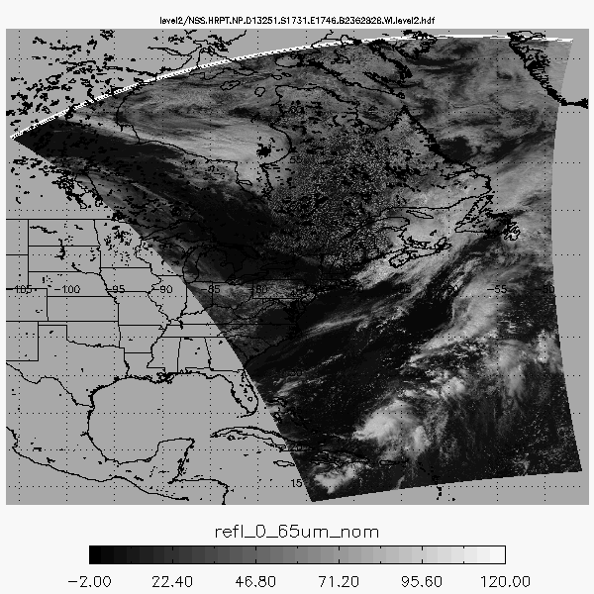

Figure 4 Example visible reflectance from NOAA-19 AVHRR HRTP from September 8, 2013. The time range of the image is from 17:31 to 17:46 UTC.

The following set of product images are generated from a CLAVR-x Level2 file derived the from NOAA-19 AVHRR HRPT data from September 8, 2013, 17:31 to 17:46 UTC. Figure 3 shows a false-color RGB image constructed from the 0.65 m reflectance (refl_0_65um_nom variable in the Level2 file), the 0.86 m reflectance (refl_0_86um_nom variable in the Level2 file) and the 11 m brightness temperature (temp_11_0um_nom variable in the Level2 file).



Figure False-color RGB constructed from the 0.65 m reflectance (refl_0_65um_nom), the 0.86 m reflectance (refl_0_86um_nom) and the 11 m brightness temperature (temp_11_0um_nom). Black regions represent pixels where no retrieval was performed (i.e. clear-sky), or where no data are present.

Figure 4 shows the CLAVR-x cloud mask for the scene in Figure 2. The cloud mask product (cloud_mask variable in the Level2 file) is a 4-level integer classification. However, the image below differentiates between clear land and clear water. The classifications from CLAVR-x are: CLEAR (value=0), PROBABLY-CLEAR (value=1), PROBABLY-CLOUDY (value=2), CLOUDY (value=3). The mask is derived from the cloud_probability variable, which is also output to the Level2 file. Users are encouraged to experiment with different thresholds of the cloud probability for their own application.

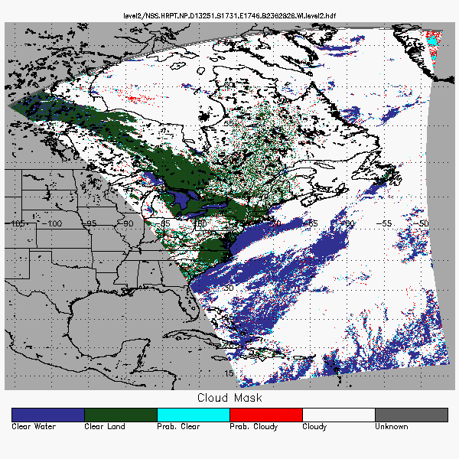

Figure 6 Example CLAVR-x cloud mask for the scene in Figure 2. The cloud mask (cloud_mask variable in the Level2 file) is a 4-level integer classification product. The classifications are: CLEAR (value=0), PROBABLY-CLEAR (value=1), PROBABLY-CLOUDY (value=2), CLOUDY (value=3).

Figure 5 shows the CLAVR-x cloud type classifications for the scene in Figure 2. The cloud type product (cloud_type variable in the Level2 file) is a 14-level integer classification. However, the image below shows only 10 designations. The integer cloud type classifications from CLAVR-x are: CLEAR=0, PROBABLY CLEAR=1, NEAR SURFACE CLOUD=2, WATER=3, SUPERCOOLED WATER=4, OPAQUE ICE=6, CIRRUS=7, MULTI-LAYER=8, DEEP CONVECTION=9, UNKNOWN=10, DUST=11, SMOKE=12, and FIRE=13. The current version of CLAVR-x does not support the generation of dust type, smoke type and fire type. SPEAK TO FUTURE CAPABILITY HERE!

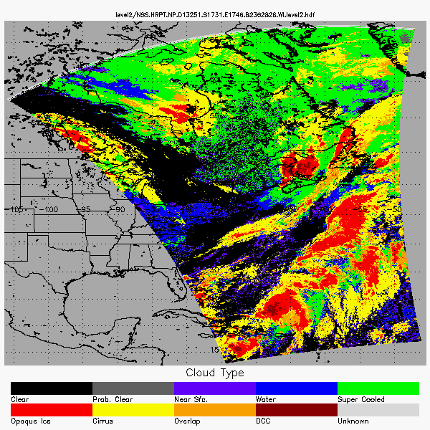

Figure CLAVR-x cloud type products from the Level-2 file (cloud_type variable in the Level2 file). The integer cloud type classifications are: CLEAR=0, PROBABLY CLEAR=1, NEAR SURFACE CLOUD=2, WATER=3, SUPERCOOLED WATER=4, OPAQUE ICE=6, CIRRUS=7, MULTI-LAYER=8, DEEP CONVECTION=9, UNKNOWN=10, DUST=11, SMOKE=12 and FIRE=13.

Figure 6 shows the CLAVR-x cloud-top temperature product for the scene in Figure 2. The cloud-top temperature (cld_temp_acha variable in the Level2 file) is one of the directly retrieved products from the AWG Cloud Height Algorithm (ACHA).

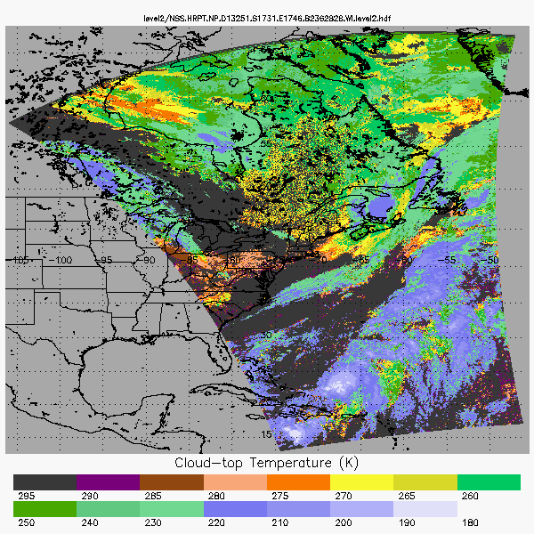

Figure CLAVR-x cloud-top temperature (cld_temp_acha variable in the Level2 file) derived from the AWG Cloud Height Algorithm (ACHA). Dark grey regions represent pixels where no retrieval was performed (i.e. clear-sky).

Figure 7 shows the CLAVR-x cloud-top pressure product for the scene in Figure 2. The cloud-top pressure (cld_press_acha variable in the Level2 file) is derived from the cloud-top temperature and the atmospheric temperature profile provided by the background NWP model.

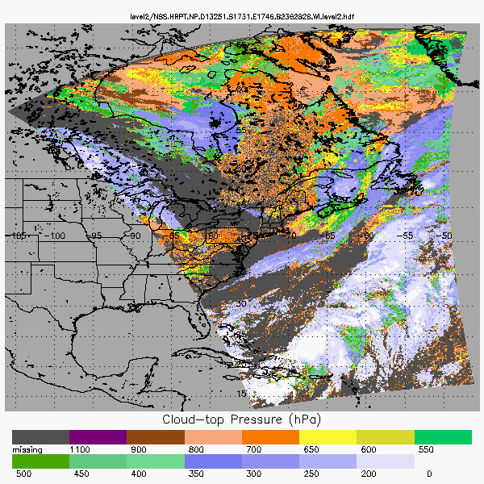

Figure CLAVR-x cloud-top pressure (cld_press_acha variable in the Level2 file) derived from the AWG Cloud Height Algorithm (ACHA). Dark grey regions represent pixels where no retrieval was performed (i.e. clear-sky).

Figure 8 shows the CLAVR-x cloud-top height product for the scene in Figure 2. The cloud-top height (cld_height_acha variable in the Level2 file) is derived from the cloud-top temperature and the atmospheric temperature profile provided by the background NWP model.

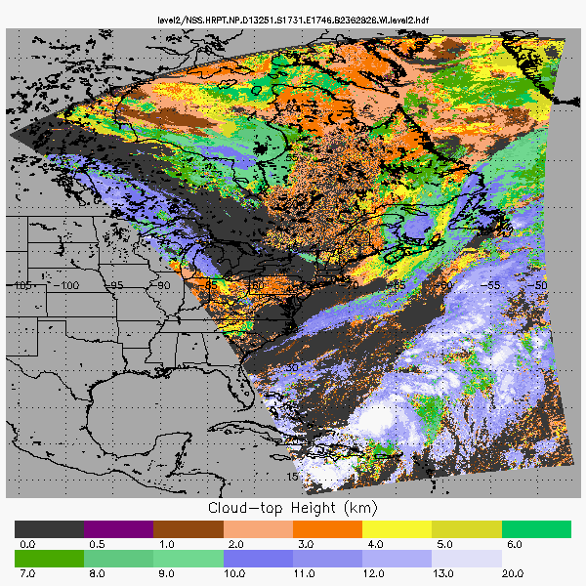

Figure CLAVR-x cloud-top height (cld_height_acha variable in the Level2 file) derived from the AWG Cloud Height Algorithm (ACHA). Dark grey regions represent pixels where no retrieval was performed (i.e. clear-sky).

Figure 9 shows the CLAVR-x 11 μm cloud emissivity product for the scene in Figure 2. The cloud emissivity (cld_emiss_acha variable in the Level2 file) is one of the directly retrieved products from the AWG Cloud Height Algorithm (ACHA).

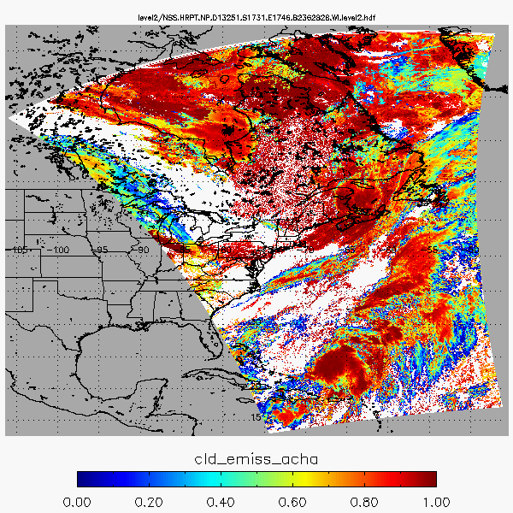

Figure CLAVR-x 11 μm cloud emissivity (cld_emiss_acha variable in the Level2 file) derived from the AWG Cloud Height Algorithm (ACHA). White regions represent pixels where no retrieval was performed (i.e. clear-sky).

Figure 10 shows the CLAVR-x cloud optical depth (COD) for the scene in Figure 2. CLAVR-x uses the GOES-ABI daytime microphysical properties (DCOMP) algorithm to retrieve this product. The COD (cld_opd_dcomp variable in the Level2 file) is one of the directly retrieved products from DCOMP.

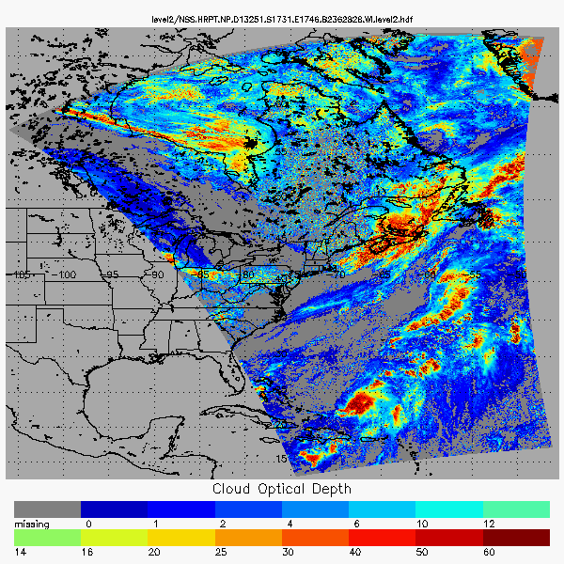

Figure CLAVR-x cloud optical depth (COD) from the AWG Daytime Cloud Optical and Microphysical Properties (DCOMP). Dark grey regions represent pixels where no retrieval was performed (i.e. clear-sky).

Figure 11 shows the CLAVR-x cloud effective radius (REF) for the scene in Figure 2. CLAVR-x uses the DCOMP algorithm to retrieve this product. The REF (cld_reff_dcomp variable in the Level2 file) is one of the directly retrieved products from DCOMP. It may sometimes be referred to as the cloud particle size (CPS).

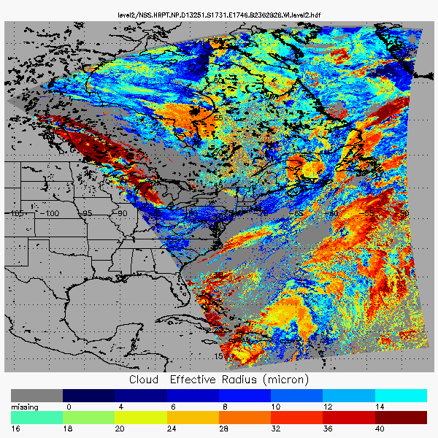

Figure 13 CLAVR-x cloud effective radius (REF) from the AWG Daytime Cloud Optical and Microphysical Properties (DCOMP). Dark grey regions represent pixels where no retrieval was performed (i.e. clear-sky).

# Ancillary Data Sets

CLAVR-x reads in the following ancillary data-sets to provide additional information needed to process each pixel properly: NWP, SST, emissivity, surface type, land mask, coast mask, surface elevation, volcano mask, snow/ice mask.

## NWP Data

The largest source of dynamic ancillary data comes from numerical weather prediction models (NWP). CLAVR-x supports 4 different types NWP data. CLAVR-x does not read Grib data directly. In order to increase portability, the GRIB or GRIB2 files are converted to HDF4 using a routine (convert_grib_hdf.f90) provided with CLAVR-x. This routine will place an “.hdf” suffix on the file names. NCEP_Reanalysis data is not reformatted into hdf. The choice of NWP data is controlled by the nwp_flag setting in the default options data. . If nwp_flag is “1”, then the GFS fields are used. If nwp_flag is “2” then the NCEP Reanalysis is used. If nwp_flag is “3” then the CFSR Reanalysis is used. The path to these files is also a variable in the default options file.

### GFS Grib Data

The GFS data used by CLAVR-x are the “pressure-layer grib files”. To ensure real-time-access, CLAVR-x was designed to process the 12 hr forecasts made from each 6 hour cycle. The name of the files varies on different servers. One source of real-time data is the nomads described servers at http://nomads.ncdc.noaa.gov/. For example, from nomads a typical file would be named gfs.t00z.pgrbf12. This file is a 12 hour forecast from the 00Z model run and is therefore valid at 12Z. From the NOAA port server, this file would be called gblav.06062200_F012. Note, the NOAAPORT names include the date in the name where the nomads server identifies the date in the directory. Even if the naming convention changes, CLAVR-x does not need to be modified. The naming of the GFS files is taken care of in the grib2hdf converter. CLAVR-x expects these files to reside in the gfs_data_dir directory specified in the default options file.

### CFSR Reanalysis

Another source for NWP data is provided by NCEP Climate Forecast System Reanalysis (CFSR) Data. The CFSR is the next generation of the NCEP Reanalysis (see below). CFSR data are very similar to the GFS data. For processing historical data, it is critical to have consistent ancillary data. For this reason, CLAVR-x can be run with reanalysis data. For generating PATMOS-x data, CFSR is used.

### NCEP Reanalysis

CLAVR-x still supports the original (an on-going) NCEP Reanalysis data. These data are available at the NOAA Climate Diagnostic Center (CDC) at <http://www.cdc.noaa.gov/cdc/reanalysis/reanalysis.shtml>. The files needed are the following:

* Air temperature from the Pressure Level Data
* Geopotential height from the Pressure Level Data
* Relative humidity from the Pressure Level Data
* Air Temperature from the Surface Data
* Pressure from the Surface Data
* Precipitable Water from the Surface Data
* Relative Humidity from the Surface Data
* U-wind from the Surface Data
* V-wind from the Surface Data

These files are stored in NETCDF format but can be read using the CLAVR-x HDF libraries as-is. The files are stored per parameter per year and CLAVR-x expects the naming conventions to be the same as that used by the CDC server. CLAVR-x expects these files to reside in the ncep_data_dir directory specified in the “clavrxorb_default_options” file.

## Daily SST Analysis Fields

To be able to produce a SST that is similar to the NESDIS operational SST, an SST analysis field is needed. CLAVR-x is designed to use the daily Reynolds OISST 100 km product. The weekly version of the OISST is described at <http://www.esrl.noaa.gov/psd/data/gridded/data.noaa.oisst.v2.html>, the daily is described at <http://www.ncdc.noaa.gov/oa/climate/research/sst/papers/whats-new-v2.pdf> . The data are available via ftp at <ftp://eclipse.ncdc.noaa.gov/pub/OI-daily-v2/IEEE/>. The data period is centered in the middle of the day (UTC) and is available the morning after.

For real-time operation, CLAVR-x uses the data from the previous day. For real-time operation the sst_analysis_option flag should be set to 1 and the latest OISST v2 analysis file should be named avhrr-only-v2.current in the OISST folder. Once a new OISST data-set is available, it should be renamed to avhrr-only-v2.current before being copied to the respective year folder in the OISST folder. For retrospective processing, the sst_analysis_option flag should be set to “0” and CLAVR-x will search the proper year subdirectory of oisst_data_dir specified in the “clavrxorb_default_options” file for the daily analysis that covers the time of the orbit.

### Surface Emissivity

To calculate whether a pixel is cloudy or not, CLAVR-x uses average emissivity on a monthly basis. The data in these files were obtained from SeeBor (Seemann, S.W., E. E. Borbas, R. O. Knuteson, G. R. Stephenson, H.-L. Huang, 2008: Development of a global infrared land surface emissivity database for application to clear sky sounding retrievals from multi-spectral satellite radiance measurements. *J. Appl. Meteor. Climatol.*, **47**, 108-123). The twelve files have names global_emiss_intABI_2005*ddd*.hdf, where *ddd* is the day of year that each month begins with.

### UMD Surface and Vegetation Type

The University of Maryland Surface Type system is used in CLAVR-x to classify each pixel into one of fifteen possible types. The resolution of the data is 1km, with the details of the dataset located here:

<ftp://ftp.glcf.umiacs.umd.edu/glcf/Global_Land_Cover/Global/gl-latlong-1km-landcover/gl0500bs.txt>

The original data file has only 14 surface types. A fifteenth surface type was added for regions that are snow covered all year round. The surface type file used by CLAVR-x is called gl-latlong-1km-landcover.hdf if read_hires_sfc_type=1 in clavrx_default_options. The file contains a 43200 by 21600 array of one byte numbers. The data start at the Date Line at the North Pole and move east and south. There is no scaling of the numbers. An 8km resolution version of this can also be used, called gl-latlong-8km-landcover.hdf, if read_hires_sfc_type=0 in clavrx_default_options.

The original data were obtained at the following URL.

<ftp://ftp.glcf.umiacs.umd.edu/glcf/Global_Land_Cover/Global/gl-latlong-1km-landcover/>

The follow citations describe the process of its generation:

*Hansen, M., R. DeFries, J.R.G. Townshend, and R. Sohlberg (1998), UMD Global Land Cover Classification, 1 Kilometer, 1.0, Department of Geography, University of Maryland, College Park, Maryland, 1981-1994.*

*Hansen, M., R. DeFries, J.R.G. Townshend, and R. Sohlberg (2000), Global land cover classification at 1km resolution using a decision tree classifier, International Journal of Remote Sensing. 21: 1331-1365.*

### Land Mask

In addition to the surface type data-set, CLAVR-x also reads in a land mask from goge2_0ll.hdf. The resolution is 1km and starts at the Prime Meridian at the North Pole. The file contains a 43200 by 21600 array of 16 bit signed integers.

The land mask was obtained from NOAA Global Land One-kilometer Base Elevation (GLOBE) Project. The gridded tiles that make up the ancillary dataset can be obtained at the following URL:

<http://www.ngdc.noaa.gov/mgg/topo/globe.html>

The follow citations describe the process of its generation:

GLOBE Task Team and others (*Hastings, David A., Paula K. Dunbar, Gerald M. Elphingstone,* *Mark Bootz, Hiroshi Murakami, Hiroshi Maruyama, Hiroshi Masaharu, Peter Holland, John Payne, Nevin A. Bryant, Thomas L. Logan, J.-P. Muller, Gunter Schreier, and John S. MacDonald), eds., 1999. The Global Land One-kilometer Base Elevation (GLOBE) Digital Elevation Model, Version 1.0. National Oceanic and Atmospheric Administration, National Geophysical Data Center, 325 Broadway, Boulder, Colorado 80305-3328, U.S.A. Digital data base on the World Wide Web (URL: http://www.ngdc.noaa.gov/mgg/topo/globe.html) and CD-ROMs.*

### Surface Elevation

Surface elevation is read from a file called GLOBE_1km_digelev.hdf if read_surface_elevation is set to 1 in clavrx_default_options; or GLOBE_8km_digelev.hdf if read_surface_elevation is set to 0. These data were derived from the GLOBE Project.

### Coast Mask

A coast mask is read from a file called coast_mask_1km.hdf if read_coast_mask_flag is set to 1 in clavrx_default_options; or coast_mask_8km.hdf if read_coast_mask_flag is set to 0. These data were derived from the land mask data files taken from the GLOBE Project. The values in the coast mask give the distance in kilometers to the nearest coast and the values in the files range from 0 to 10. For AVHRR GAC data, a pixel is considered coastal if the coast distance is 10 km or less. For AVHRR HRPT/LAC or FRAC data, a pixel is considered coastal is the coast distance is less than 5 km.

### Volcano Mask

A mask to pinpoint the location of volcanoes is read in by CLAVR-x if read_volcano_mask is set to 1 in clavrx_default_options. The file is named volcano_mask_1km.hdf. This file was produced using the Global Volcano List Excel Workbook from the Smithsonian Institution’s Global Volcanism Program: www.volcano.si.edu/world/globallists.cfm.

### Snow and Ice Mask

CLAVR-x has the option of reading one of two sources of snow and ice masks. For real-time use, read_snow_mask_flag is set to 1 in clavrx_default_options, and daily IMS snow mask files will be read in (e.g., snow_map_4km_120323.hdf). Data to create these files are obtained from the NOAA National Ice Center’s Interactive Multisensor Snow and Ice Mapping System (IMS): www.natice.noaa.gov/ims/. If read_snow_mask_flag is set to 2 (historical analyses), daily GlobSnow files will be read (e.g., GlobSnow_SWE_L3A_20101231_v1.0.hdf). Data to create these files are obtained from the Finish Meteorological Institute: www.globsnow.info/ index.php?page=Data.

Need all the Heidinger group refs here. Here are a whole bunch to save you some time (delete ones that are unused, add ones that are missing).

Heidinger, A.K., and M.J. Pavolonis, 2009. Gazing at Cirrus Clouds for 25 Years through a Split Window. Part I: Methodology. Journal of Applied Meteorology and Climatology, 48, 1100-1116.

Heidinger, A. K.; Pavolonis, M. J.; Holz, R. E.; Baum, Bryan A. and Berthier, S. 2010a. Using CALIPSO to explore the sensitivity to cirrus height in the infrared observations from NPOESS/VIIRS and GOES-R/ABI. Journal of Geophysical Research, Volume 115, 2010, Doi:10.1029/2009JD012152.

Heidinger, A.K., W.C. Straka III, C.C. Molling, J.T. Sullivan, and X. Wu, 2010b. Deriving an inter-sensor consistent calibration for the AVHRR solar reflectance data record. International Journal of Remote Sensing, 31:6493 – 6517.

Heidinger, A.K., A.T. Evan, M.J. Foster, and A. Walther 2012. A naïve Bayesian cloud-detection scheme derived from CALYPSO and applied within PATMOS-x. Journal of Applied Meteorology and Climatology, 51:1129 – 1144.

Heidinger, A.K., A. Walther, C.C. Molling, M. Foster, W.C. Straka III, in preparation. Deriving an Inter-sensor Consistent Calibration for the AVHRR Solar Reflectance Data Record for the 1.6 micron channel.

Molling, C.C., A.K. Heidinger, W.C. Straka III, and X. Wu, 2010. Calibrations for AVHRR channels 1 and 2: review and path towards consensus. International Journal of Remote Sensing, 31:6519 - 6540.

Pavolonis, M.J. and A.K. Heidinger, 2004. Daytime cloud overlap detection from AVHRR and VIIRS. Journal of Applied Meteorology, 43:762-778.

Pavolonis, M.J., A.K. Heidinger, and T. Uttal 2005. Daytime global cloud typing from AVHRR and VIIRS: algorithm description, validation, and comparisons. Journal of Applied Meteorology, 44:804-826.

Walther, A., and A.K. Hedinger, 2012. Implementation of the daytime cloud optical microphysical properties algorithm (DCOMP) in PATMOS-x. Journal of Applied Meteorology and Climatology, 51:1371 – 1390.

List of publications from PATMOS-x web site

Calibration References

Heidinger, A.K., Straka III, W.C., Molling, C.C., Sullivan, J.T. and Wu, X. 2010: Deriving an inter-sensor consistent calibration for the AVHRR solar reflectance data record. International Journal of Remote Sensing, in press

Molling, C.C., Heidinger, A.K., Straka III, W.C. and Wu, X. 2010: Calibrations for AVHRR channels 1 and 2: review and path toward consensus. International Journal of Remote Sensing., in press

Heidinger, A.K., Cao, C. and Sullivan, J.T. 2002: Using moderate resolution imaging spectrometer (MODIS) to calibrate advanced very high resolution radiometer reflectance channels. Journal of Geophysical Research 107, pp. 11.1-11.9.

Heidinger, A.K., Sullivan, J.T. and Rao, C.R.N. 2003: Calibration of visible and near-infrared channels of the NOAA-12 AVHRR using time series of observations over deserts. International Journal of Remote Sensing 24, Issue 18, pp. 3635-3649.

Algorithm References

Pavolonis, Michael J.; Heidinger, Andrew K. and Uttal, Taneil. 2005: Daytime global cloud typing from AVHRR and VIIRS: Algorithm description, validation, and comparisons. Journal of Applied Meteorology, Volume 44, Issue 6, 2005, pp.804-826.

Pavolonis, Michael J. and Heidinger, Andrew K.. 2004: Daytime cloud overlap detection from AVHRR and VIIRS. Journal of Applied Meteorology, Volume 43, Issue 5, 2004, pp.762-778.

Heidinger, A. K., and Pavolonis, M. J.,2009: Gazing at Cirrus Cloudsfor 25 Years through a Split-Window. Part I: Methodology in press, JAMC

Evan, A. T., A. K. Heidinger, and M. J. Pavolonis, 2006: Development of a new over-water advanced very high resolution radiometer dust detection algorithm Int. J. Remote Sens., 27(18), pp. 3903-3924

Applications of PATMOS-x

Foster, M. J., R. Bennartz, and A. K. Heidinger 2010: Estimation of Liquid Cloud Properties that Conserve Total-scene Reflectance Using Satellite Measurements, JAMC, in press.

Zhao, Tom X.-P.; Laszlo, Istvan; Guo, Wei; Heidinger, Andrew; Cao, Changyong; Jelenak, Aleksander; Tarpley, Dan and Sullivan, Jerry. 2008: Study of long-term trend in aerosol optical thickness observed from operational AVHRR satellite instrument. Journal of Geophysical Research, Volume 113 Doi:10.1029/2007JD009061

Evan, A. T., A. K. Heidinger, and Y. Liu, 2008: Cloudiness, State of the Climate in 2007, Horvitz, A., ed.,Bull. Am. Meteorol. Soc., 89 (7), pp. S23-S26.

Evan, A. T. 2008: Aerosols, State of the Climate in 2007, Horvitz, A., ed., Bull. Am. Meteorol. Soc., 89 (7), pp. S31-S32.

Evan, A. T., R. Bennartz, V. Bennington, H. Corrada-Bravo, A. K. Heidinger, N. M. Mahowald, C. S. Velden, G. Myhre & J. P. Kossin 2007: Ocean temperature forcing by aerosols across the Atlantic tropical cyclone development region. Geochem. Geophys. Geosyst., 9, Q05V04, doi:10.1029/2007GC001790, in press.

Evan, A. T., N. Mahowald & L. Remer, 2007: Aerosols, State of the Climate in 2006, Horvitz, A., ed., Bull. Am. Meteorol. Soc., 88 (6) pp. S23-S25.

Heidinger, A. K., A. T. Evan & B. Baum, 2007: Cloudiness, State of the Climate in 2006, Horivtz, A., ed.,Bull. Am. Meteorol. Soc., 88 (6),pp. S17-S18.

Evan, A. T. 2007: Comment on "How Nature Foiled the 2006 Hurricane Forecasts." EOS Trans., 88(26), pp. 271. [PDF] The original, longer document [PDF]

Evan, A. T., J. Dunion, J. Foley, A. Heidinger & C. Velden 2006: New evidence for a relationship between Atlantic tropical cyclone activity and African dust outbreaks. Geophys. Res. Lett., 33, L19813, doi:10.1029/2006GL026408.

Evan, A. T., A. K. Heidinger, and P. Knippertz 2006: Analysis of winter dust activity off the coast of West Africa using a new 24-year over-water advanced very high resolution radiometer satellite dust climatology, J. Geophys. Res., 111, D12210, doi:10.1029/2005JD006336.

Heidinger, Andrew K. and Pavolonis, Michael J.. 2005: Global daytime distribution of overlapping cirrus cloud from NOAA's Advanced Very High Resolution Radiometer. Journal of Climate, Volume 18, Issue 22, pp.4772-4784.

Heidinger, Andrew K.; Frey, Richard and Pavolonis, Michael. 2004: Relative merits of the 1.6 and 3.75 micron channels of the AVHRR/3 for cloud detection. Canadian Journal of Remote Sensing, Volume 30, Issue 2, pp.182-194.