**Professional Summary**

I am an experienced Project Manager and Continuous Improvement specialist with an MSc, based in Newbury. I have a proven track record of steering complex, high-value national and international projects across diverse industries. My expertise spans the entire project lifecycle, from inception through organisational change, digital transformation and documentation, with a strong focus on effective communications, good resource management, and risk mitigation.

Over the past 2.5 years at Cruelty Free International, I have served as Operations Manager, Project Manager, and CRM Manager for a new compliance service, engaging and supporting brands and suppliers in the removal of animal testing from their supply chains. My expertise lies in data-led optimisation, team building, and stakeholder management. Notably, I have consistently delivered projects on time and within budget, resulting in a 30% increase in operational efficiency and a 25% reduction in project costs as a Ops Manager. I am actively pursuing new opportunities.

**Core Competencies**

**Project and Stakeholder Management**

* Successfully managed and delivered multiple concurrent projects from inception to completion, valued up to £1.6M, including the coordination of and development of 2 CRM systems, 3 commercial products, 900+ software demos, 60 webinars, and 5 websites over the past 4 years. Prior this I also have coordinated over 300 ecological surveys.
* Led cross-functional teams of up to 15 members, delivering training and facilitating effective communication between sales, marketing, design, development, and customer support teams to align solutions with business needs.
* Cultivated an exceptional 95% client satisfaction rate by fostering a supportive team environment and maintaining transparent, positive stakeholder relationships.

**Process Optimisation & Automation**

* Conducted comprehensive process audits, optimising key operational workflows and created documentation for standard Operating Procedures, in addition to providing onboarding and user training.
* Implementation of Waterfall, Agile and Kaizen methodologies for project management, improving team efficiency by 40% and reducing project delivery time by 25%.
* Led cross-functional teams in streamlining supply chain management processes, resulting in a 20% reduction in operational costs.

**Data Management & Analysis**

* Led data integration projects, reducing manual efforts by 40% and enhancing data accuracy by 30% through expert management and analysis of large datasets.
* Designed, developed, and deployed custom Salesforce apps, meeting specific business requirements and contractual obligations while mitigating potential risks, leading to a 35% increase in user productivity.
* Demonstrated proficiency in advanced data management and analysis tools, including Structured Query Language for Objects (SOQL), Workbench, Data Import Wizard, Data Loader, Advanced Excel and R.

**Relevant Professional Experience**

**Business Operations Manager with Salesforce Expertise** | Cruelty Free International | December 2023 – September 2024

* Spearheaded the development and launch of a comprehensive commercial compliance service resulting in 3 new products, in addition to integrating brand management and SAP systems, to streamline operations and enhance supply chain compliance reporting.
* Established and led a dedicated team of compliance professionals, enhancing supplier engagement and audit processes, which resulted in comprehensive supply chain compliance documentation.
* Drove a significant digital transformation initiative by implementing a Salesforce CRM solution, achieving a 60% increase in client engagement and compliance tracking, and surpassing financial objectives by 30% through strategic budget management and process optimisation.

**Project Manager with Salesforce Responsibilities** | Cruelty Free International | December 2021 - December 2023

* Led cross-functional teams in streamlining supply chain management processes, increasing productivity, and achieving a 20% operational cost reduction.
* Implemented Agile methodologies and work management software Jira for data integration and audit projects, reducing manual efforts by 40% and enhancing data accuracy. In real terms, resulting in a reduction of resource demand by 25 hours per week.
* Cultivated an exceptional 95% client satisfaction rate by fostering a supportive team environment and maintaining transparent, positive stakeholder relationships.

**Project Manager** | Wolfram Research Europe | April 2021 - December 2021

* Successfully managed multiple projects valued at up to £1.6 million, consistently delivering results on time, in scope and within budget.
* Developed 900+ software demos, 60 webinars, and 5 websites, in addition to optimising Mathematica license activation processes and supporting process mapping.
* Utilised various software and tools including Mathematica, Excel, JS, HTML, Jira and AI tools to further to further support marketing and strategic initiatives.

**Ecological Surveyor** | Various Orgs Fixed Term and Freelance, Primarily Winchester Bat Consultancy and Thomson Ecological Consultants | June 2016 – April 2019

* Coordinated over 300 ecological surveys across diverse sites, managing project timelines, resource allocation, contractors and stakeholder communication to ensure successful delivery.
* Supported desktop studies, including the creation of impact assessments, mitigation recommendations and risk assessments. Proficient is data analysis and acoustic bat ID.
* Collaborated with cross-functional teams of field surveyors, data analysts, report writers, project leads.

**Further Information**

**Further Work Experience and References Available Upon Request** | 2007 – 2021 | Experience includes Direct Sales, Account Management, Kitchen design, Environmental and Team management. A graphic representation of my professional journey is provided below.

**Professional Journey**

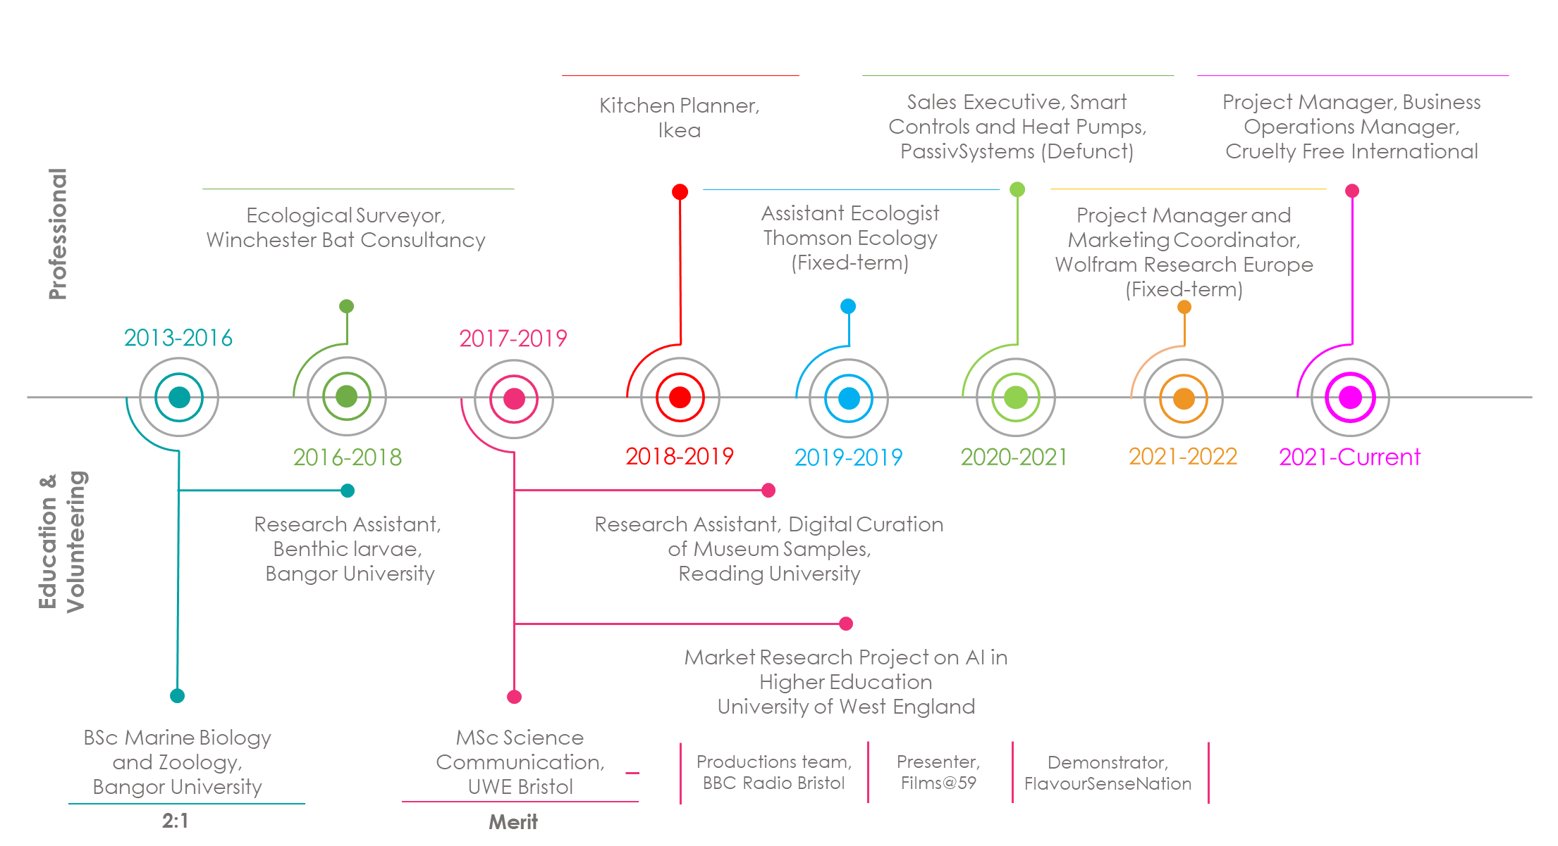

**Key Skills**

* Project & Stakeholder Management
* Data Management (Excel)
* Process optimisation& sustainability
* Resource Management
* Risk Management
* Stakeholder Communications
* Team Leadership
* Continuous Improvement
* Business Analytics
* Aptitude for learning

**Education & Certifications**

* Project Management Qualification (PMQ) | Association for Project Management | 2024 – In Progress.
* Salesforce Administrator Certification | Salesforce | 2024 – In progress
* Salesforce Trailhead Credentials: Ranger level with 100+ badges, demonstrating commitment to continuous learning and software proficiency.
* MSc Science Communication | University of West England, Bristol | 2019 - 2021
* BSc Marine Biology and Zoology | Bangor University | 2013 – 2016 236