**Professional Summary**

I am an experienced Project Manager and Continuous Improvement specialist based in Newbury, with a proven track record of delivering complex projects across diverse industries. My approach centres on fostering collaborative relationships, driving operational excellence, and implementing data-driven improvement, in addition to accepting I do not know everything but am willing to learn and try. I am someone who accepts change happens and places great emphasis on listening, learning, and adapting to ensure projects benefit from fresh insights and best practices.

**Core Competencies**

**Data Management & Integration**

* Led data integration projects, reducing manual efforts by 40% and enhancing data accuracy
* Integrated complex data systems, including ERP and audit processes
* Utilised analytical tools to support migration of complex ERP system, ensuring seamless integration

**Process Optimisation & Automation**

* Conducted comprehensive process audits, optimising key operational workflows and increasing productivity by 15%
* Implemented Agile methodologies for project management, improving team efficiency and adaptability
* Led cross-functional teams in streamlining supply chain management processes, resulting in a 20% operational cost reduction.

**Project Management & Collaboration**

* Successfully managed and delivered multiple concurrent projects from inception to completion, valued up to £1.6M, with a 90% on-time and within-budget completion rate.
* Led cross-functional teams of up to 15 members, delivering training, fostering collaboration and knowledge sharing
* Facilitated effective communication between sales, marketing, design, development, and customer support teams to align solutions with business needs.

**Salesforce Administration & Development**

* Implemented Salesforce CRM solution using Nonprofit Success Pack (NPSP), improving client scalability and supplier compliance tracking, whilst mitigating for potential risks
* Designed, developed, and deployed custom Salesforce apps to meet specific business requirements and contractual obligations
* Conducted training workshops to optimise Salesforce functionality, enhancing stakeholder adoption and utilisation of new systems

**Professional Experience**

**Business Operations Manager with Salesforce Expertise** | Cruelty Free International | December 2023 – September 2024

* Developed a comprehensive commercial compliance service and related products, including brand management and ERP integration.
* Led and built a team of compliance professionals to engage suppliers, gather evidence, and conduct audits, ensuring thorough reporting on supply chain compliance.
* Spearheaded digital transformation projects, implementing a Salesforce CRM solution that improved client engagement and compliance tracking by 60%.
* Exceeded financial targets by 30% for two consecutive years through effective budget management and process optimisation strategies

**Project Manager with Salesforce Responsibilities** | Cruelty Free International | December 2021 - Present

* Led cross-functional teams in streamlining supply chain management processes, increasing productivity, and achieving a 20% operational cost reduction.
* Implemented Agile methodologies for data integration projects, reducing manual efforts by 40% and enhancing data accuracy. In real terms, resulting in a reduction of resource demand by 25 hours per week.
* Cultivated an exceptional 95% client satisfaction rate through fostering an adaptable, collaborative team environment and maintaining transparent, positive stakeholder relationships across all levels of the organisation.

**Project Manager** | Wolfram Research Europe | April 2021 - December 2021

* Successfully managed multiple projects valued at up to £1.6 million, consistently delivering results on time, in scope and within budget.
* Developed 900+ software demos, 60 webinars, and 5 websites, optimising Mathematica license activation processes.
* Utilised analytical tools to support the migration of a complex ERP system, ensuring seamless integration.

**Further Work Experience and References Available Upon Request** | 2007 – 2021 | Experience includes Direct Sales, Account Management, Kitchen design, Environmental and Team management. A graphic representation of my professional journey is provided on the following page.

**Skills**

* Salesforce Development (NPSP)
* Data Management (Excel)
* Process Mapping and Automation
* Budget Management
* Risk Management
* Stakeholder Communication
* Team Leadership
* Continuous Improvement

**Professional Journey**

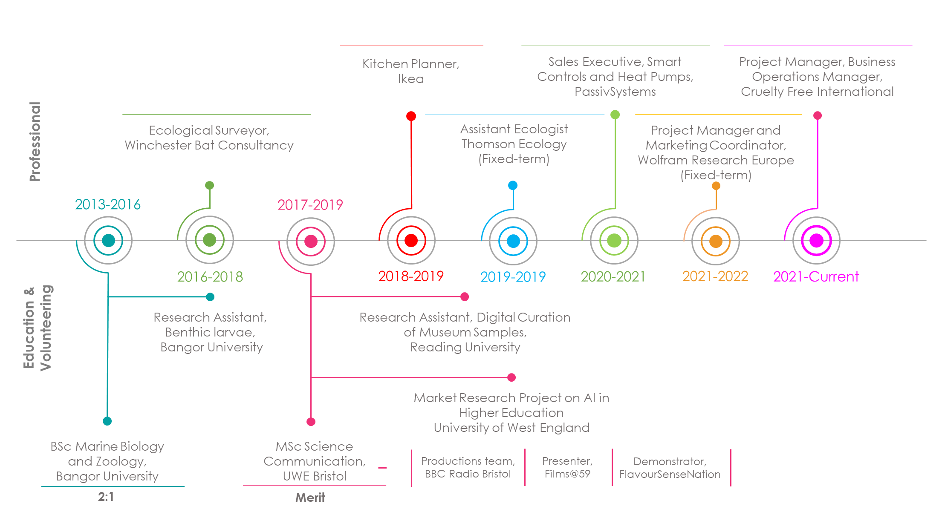

**Education & Certifications**

* Project Management Qualification (PMQ) | Association for Project Management | 2024 – In Progress.
* Salesforce Administrator Certification | Salesforce | 2024 – In progress
* Salesforce Trailhead Credentials**:** Ranger level with 100+ badges, demonstrating commitment to continuous learning and software proficiency.
* **MSc** Science Communication | University of West England, Bristol | 2019 - 2021
* **BSc** Marine Biology and Zoology | Bangor University | 2013 – 2016