Freight Rate Prediction Challenge
Model report: data split, validation and December forecast

Goal
The goal of this project is to predict the posted rate (in dollars) of freight loads. I trained a model on train_test.csv (48,000 labeled loads), used it to predict the 12,000 loads in validation.csv, and then used it to predict the posted rate for each day of December 2025 on one fixed lane (Lexington to Fort Wayne, 360 miles, Dry Van, 32,000 lb), where only the date changes.

Data overview

Item | What I found
Size | 48,000 rows and 14 columns
Date range | 2025-01-01 to 2025-10-31 (so December is a future period the model has never seen)
Target | posted_rate: mean $2,374, median $2,031, min $57, max $25,533 (right-skewed with a long tail)
Missing values | weight: 300 rows, market_index: 374 rows. All other columns were complete
Bad values | Some weights were negative (minimum -47,500), which is impossible for a load
Features | pickup / delivery city and coordinates, distance, equipment, weight, date, market_index, quote_signal

Cleaning
  - Missing values: I dropped the training rows with a missing weight or market_index. This removed 673 rows (about 1.4%), leaving 47,327 rows.
  - Negative weights: I took the absolute value of weight, because a negative weight looks like a sign error and the magnitudes were in a normal range.
  - Dates: I converted the date column to a datetime type.
  - Validation file: I could not drop rows there because every load needs a prediction. Missing weight (165 rows) and market_index (249 rows) were filled with the median from the training data.
  - Scaling: I standardized distance, weight, market_index and quote_signal with StandardScaler (fit on the training data and reused for the validation and December files).

Feature engineering
  - Date features: month and day_of_week taken from the date.
  - Equipment: one-hot encoded (first category dropped to avoid duplicated information).

  - Numeric features kept: distance, weight, market_index, quote_signal, and the pickup / delivery latitude and longitude.
  - Dropped: load_id (just an identifier) and the city name columns, since the coordinates already describe the locations.

Data split approach
I used the cleaned labeled data and split it randomly into 75% training (35,495 rows) and 25% validation (11,832 rows) with random_state = 42 so the result can be reproduced. The validation part was never used to fit the model. After checking the scores I used the same settings to produce the final predictions for validation.csv.
Why random: the loads are individual shipments spread over ten months, so a random split gives the model a fair mix of lanes, equipment types and weeks. Weakness: the final task includes a future month, so a time-based split (train on January to August, test on September and October) would be a stricter test. I list this as a next step in section 9.

Model
I used an XGBoost regressor because it works well on tabular data, handles non-linear relationships (for example rate versus distance) and does not need much tuning to give a reasonable first result.

Setting | Value
n_estimators | 100
learning_rate | 0.1
max_depth | 6
objective | reg:squarederror
random_state | 42
Predictions below $0.01 are clipped to $0.01 so every predicted rate stays positive, as the scorer requires.

Validation results

Metric | Result on 25% hold-out
Mean Absolute Error (MAE) | $126.69
Root Mean Squared Error (RMSE) | $624.13
The average rate is about $2,374, so an MAE of $126.69 means a typical prediction is off by roughly 5%. The RMSE is much larger than the MAE. RMSE punishes big mistakes more, so this

suggests that a small number of very expensive loads (the rate goes up to $25,533) are predicted poorly and pull the RMSE up, while most loads are predicted well.

December 2025 forecast
For the December chart I built one row per day from 2025-12-01 to 2025-12-31 with the fixed lane inputs (Lexington to Fort Wayne, 360 miles, Dry Van, 32,000 lb). Because market_index and quote_signal are not given for December, I set them to their training medians, and I used the median coordinates of the two cities. Only the date features (month and day of week) change from row to row.

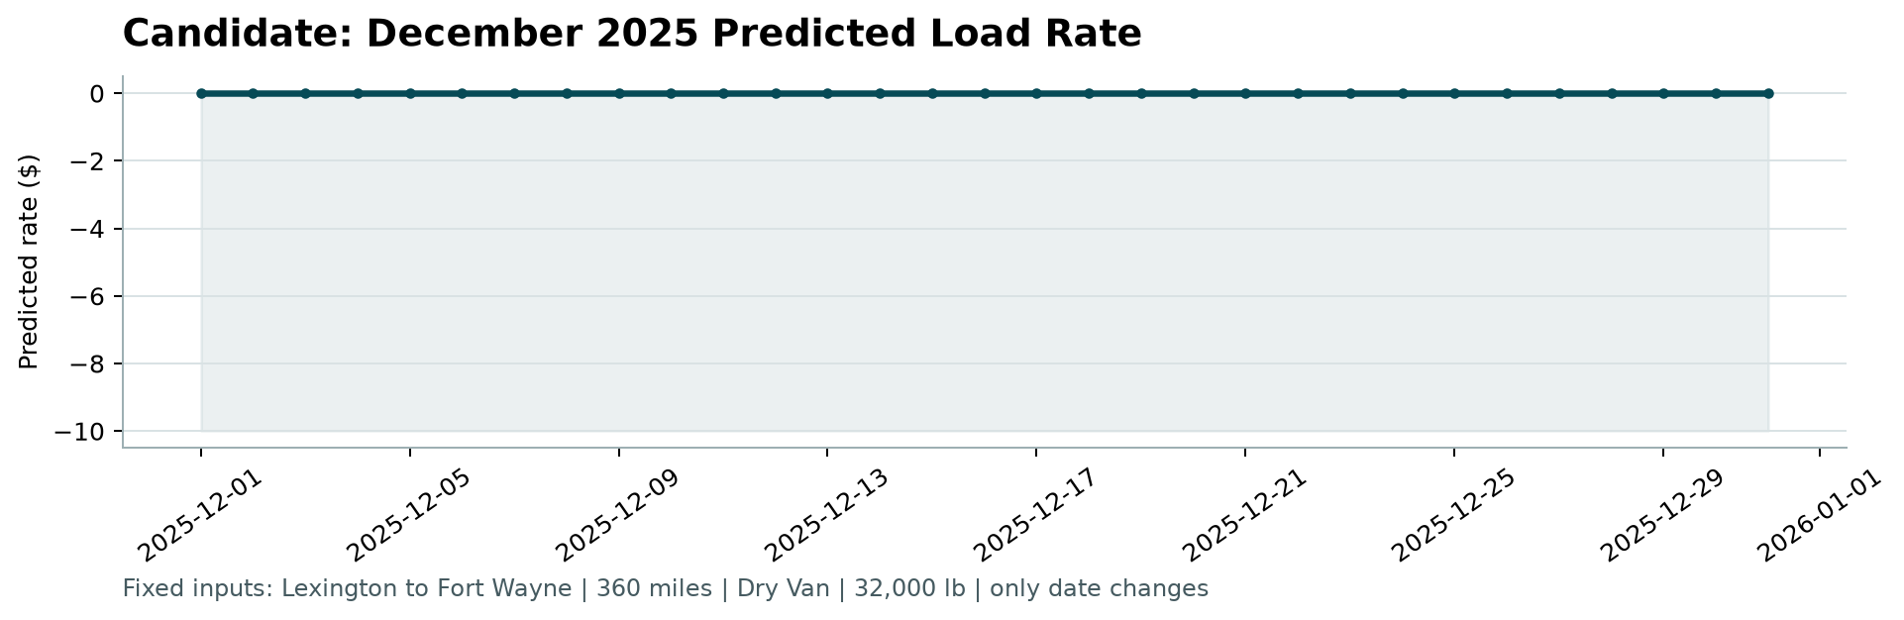
Figure 1: predicted load rate for each day of December 2025

Limitations and next steps
  - Future month: the training data ends on 2025-10-31, so the model has never seen month 12. Tree models cannot extrapolate, so December predictions will probably behave like the latest months seen, and the chart may look quite flat.
  - Assumed market values: holding market_index and quote_signal at their medians means the December chart shows a neutral market, not a real forecast of market conditions.
  - Split: a time-based split would test how well the model predicts later weeks. I would add it and compare the scores.
  - Scaling: tree models do not need standardized inputs, so the scaling step does not change XGBoost results. I kept it because it is harmless.
  - Improvements to try: a lane feature (pickup + delivery), rate per mile, a log transform of the target to reduce the effect of expensive outliers, and hyperparameter tuning with
cross-validation.

How to run
Install the requirements, run the notebook (or script) to create validation_predictions.csv and fill
data/december_chart_inputs.csv, then run the scorer:
python -m pip install -r requirements.txt
python score.py --predictions validation_predictions.csv --december-predictions data/december_chart_inputs.csv

