**This lab is worth 10% of your final AI4Games grade.**

**Due date September 26th 5pm**

**Lab 2**

This lab should build on your work from the previous lab. Implement a simple demo where the player controls a character with the four **arrow keys**. Up/Down control the speed of the character, and left/right perform a turning motion. The game world should be wrap around.

You will have five alien ships utilising **dynamic steering behaviours** as follows:

* One alien will use an aimless **Wander** behaviour.
* One alien will use a **Seek** behaviour to follow the player around.
* Two aliens will use an **Arrive** behaviour to follow the player around. They should have different max speeds.
* One alien will use a **Pursue** behaviour to follow the player around.

All NPCs are to implement player-in-range detection mechanism using a cone of vision.

You are to add a text box to each alien ship indicating what behaviour they are implementing. Allow the user to turn specific AIs on and off by pressing keys 1-5.

Note:

Don’t make the sprites so big that I can’t see the behaviours.

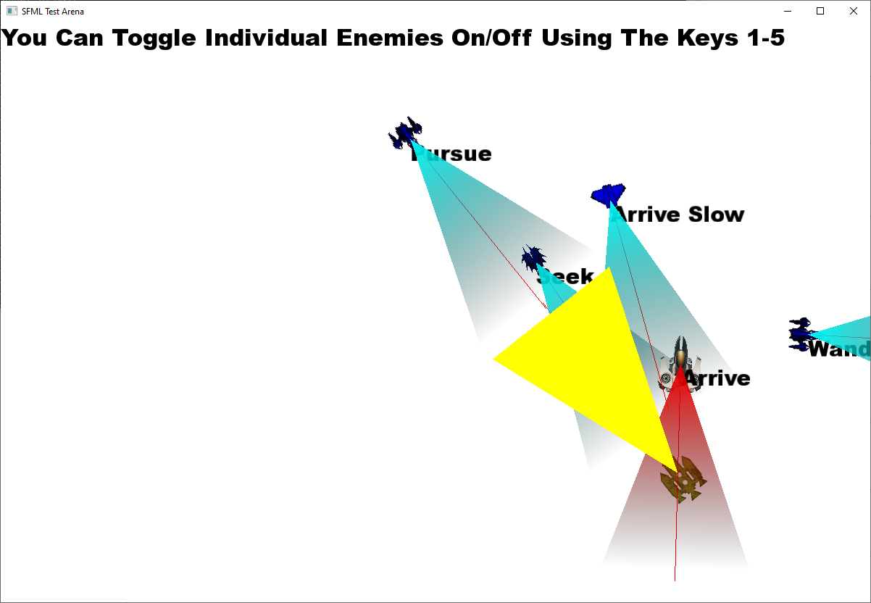

Marking Scheme:

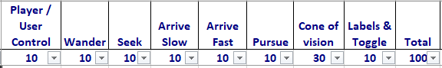

Full marks given for a good implementation, then marks get deducted for non-intelligent looking movement.