**Lab 1 – Kinematic Movement**

The purpose of this lab is to get your student machine setup and get back into the groove of low-level coding Game character movement from scratch.

**Setup**

Please ensure you have the following installed:

* Your preferred version of Visual Studio (I suggest 2022)
* SFML (I suggest we use at least version 3.0.0)
  + Please setup an environment variable called $SFML_SDK instead of hardcoding the SFML directories in the project settings i.e. SFML_SDK=C:\SFML-2.6.0 and when specifying the directories in the project properties use $(SFML_SDK)\include;%(AdditionalIncludeDirectories)
  + Tie the window size to the desktop size
* Doxygen ([www.doxygen.org](http://www.doxygen.org))
  + You will use this to document your projects

**To Do:**

**PART 1**

Create a simple C++ / SFML program which will draw two sprites/characters on the screen.

The two objects should begin moving in any direction (but then continue in that direction indefinitely). Note: The world in which they are moving is to be wrap-around.

I would expect to see:

* a **player** class and an **npc** class for the two characters.
* A main game loop which polls for input and updates the game objects

Show me.

**PART 2**

Designate one character as the player ship and the other the alien ship.

The player ship should respond to player inputs as follows: **Up Arrow** velocity increases, **Down Arrow** velocity decreases, **Left** and **Right Arrow** change its direction of motion accordingly. The ship should have a maximum speed which it cannot exceed. Additionally, the player character should always point in the direction that it is travelling.

At this stage your Player and NPC classes should be keeping track of the necessary movement attributes as mentioned in the notes.

Show me.

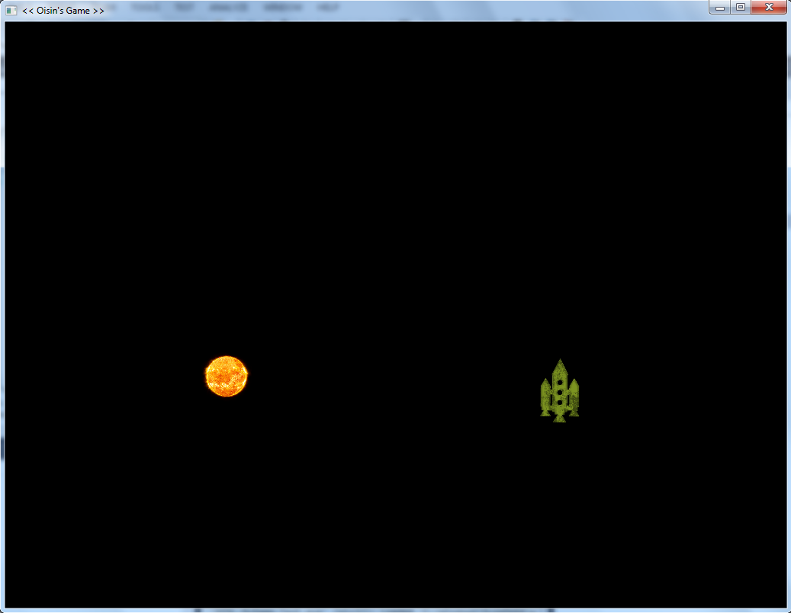

Figure 1. Sample output