This lab is worth 10% of your final AI4G grade.

Due Thurs Nov 6th 5pm

Lab 5

You are to implement the Goal-based Vector Field pathfinding algorithm (also known as the Flow Field pathfinding algorithm).

To demonstrate your algorithm, you should create a 50 X 50 tile-based world. Each tile can either be traversable or not traversable therefore allowing you to set some obstacles in the world. The user should then be allowed to pick the Goal and Start tiles e.g. via left and right mouse clicks. Your program should then display the path it would take to get from Start to Goal while avoiding the obstacles by following the flow field.

The cost field and vector field should be able to be displayed on each tile by means of some toggle keys. The cost value of each tile should be used to set the intensity of the colour of the tile thus implementing a heatmap.

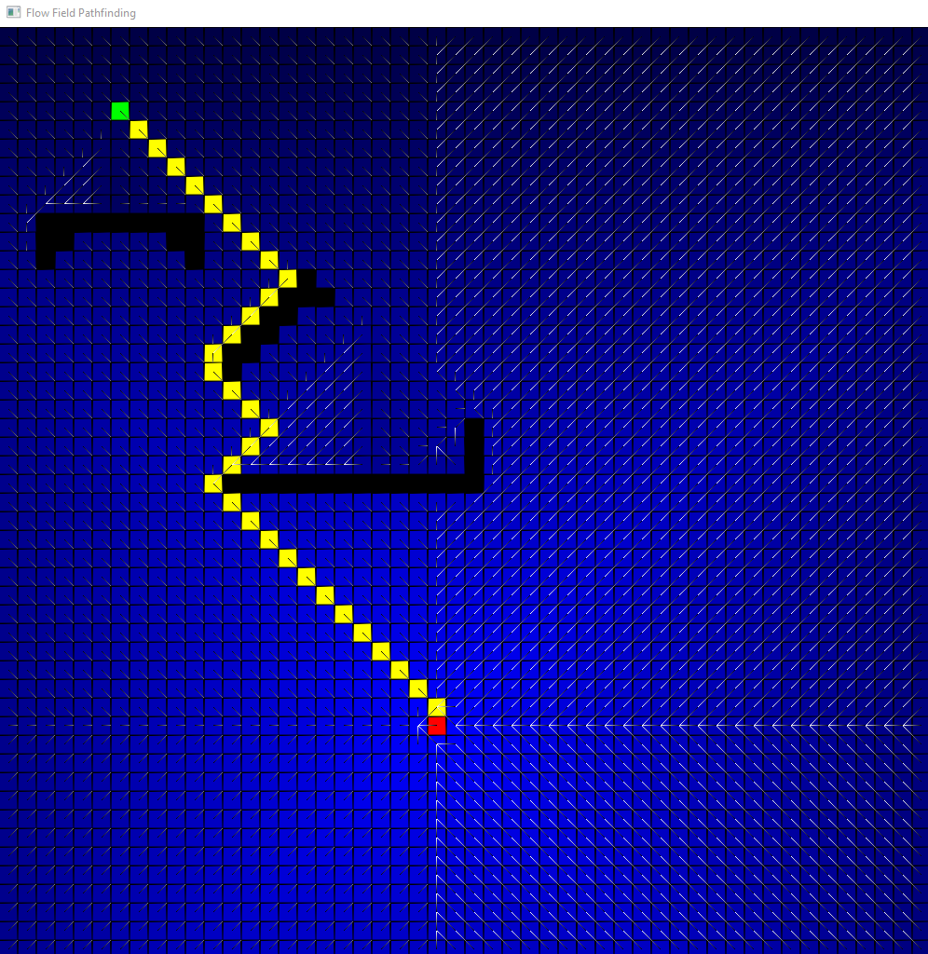

Marking Scheme:

If you do not implement the flowfield algorithm as described in the notes you will lose marks.

The extra 10 going for specific attention to efficiency, and/or visualisation. For example, you might have an NPC travelling from Start node to Goal node following the flowfield. You can include a Readme.txt to explain the Extra you have done.

Submission:

I will put up a link on Blackboard where you should upload the VS project. This should be a slimmed down version so we are not swamping the system with huge VS projects.

Important Note:

Do not Use AI for this. You are to demonstrate your progress in the labs on Fridays. If you can’t satisfactorily explain every single line of code I will assume it is not yours and you will receive a grade of 0. Failure to demonstrate results in loss of marks.

