API Security Risk Analysis Report
Prepared By: Jad Kraimesh
Position: Cyber Security Intern — Future Interns
API Tested: ReqRes API
Date: May 2026

1. Executive Summary
This report presents a read-only API Security Risk Analysis conducted on the ReqRes public demo API platform using Postman and Browser DevTools.
Modern SaaS applications rely heavily on APIs for communication between mobile applications, dashboards, cloud services, and third-party integrations. Because APIs often handle sensitive data and authentication processes, insecure APIs can expose organizations to security and privacy risks.
The purpose of this assessment was to inspect public API endpoints, analyze authentication requirements, review API responses and headers, and identify common API security observations including open endpoints, predictable API structures, excessive response exposure, and limited visible rate-limiting protections.
The analysis was performed ethically using only safe GET requests on publicly available demo endpoints. No exploitation attempts, bypass techniques, denial-of-service activity, or harmful actions were performed during this assessment.
The findings and recommendations documented in this report demonstrate how similar weaknesses could impact real-world SaaS applications if proper API security controls are not implemented.

2. Scope and Objectives
Scope of Analysis
- Public demo API only
- Read-only GET requests
- Ethical and non-intrusive testing
- API response inspection
- Header analysis
- Authentication observation
- Security risk identification
Objectives
- Analyze API endpoints using Postman
- Inspect API responses, headers, and status codes
- Identify common API security risks
- Classify risks using severity levels
- Explain business impact in simple language
- Recommend practical remediation steps

3. Tools Used
Postman
Used to send API requests, inspect JSON responses, review status codes, and analyze response headers.
Browser DevTools
Used to inspect request and response information directly within the browser environment.
ReqRes API
Public demo API platform used for safe and ethical testing.
GitHub
Used for project documentation and repository management.
Microsoft Word
Used to prepare the professional API Security Risk Analysis Report.

4. API Testing and Analysis
The following ReqRes API endpoints were tested during this assessment:
- GET https://reqres.in/api/users?page=1
- GET https://reqres.in/api/users/2
- GET https://reqres.in/api/unknown/2
The requests were performed using Postman in a controlled and read-only manner.
During testing, the API returned successful HTTP 200 OK responses along with structured JSON data containing user and resource information.
The analysis process included:
- inspecting response bodies
- reviewing HTTP headers
- checking authentication requirements
- analysing endpoint accessibility
- observing API structure visibility
The tested endpoints were publicly accessible and did not require authentication credentials or authorization tokens to retrieve data.
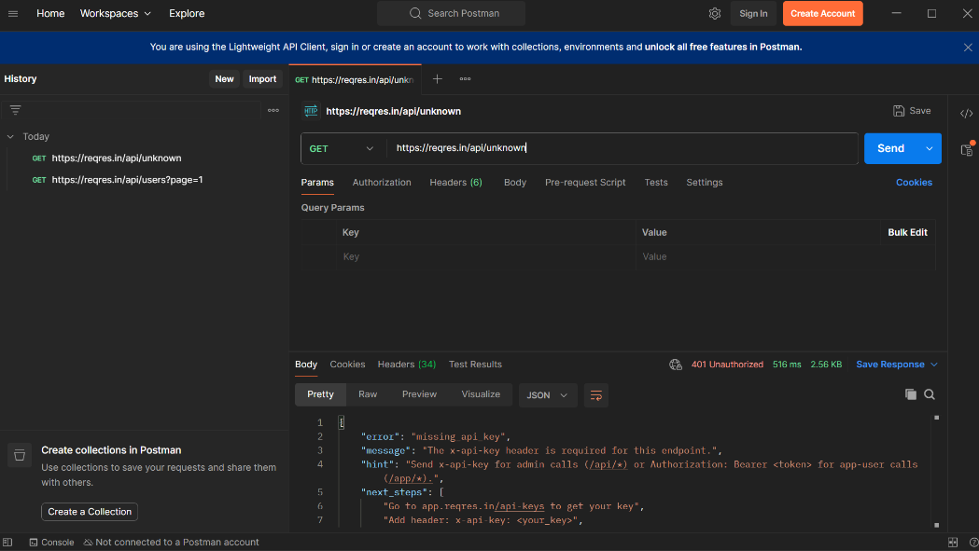
Figure 1: API request and response analysis showing authentication requirements.

5. Authentication and Header Analysis
Authentication and response headers were inspected during testing to identify possible security observations and access control behavior.
The tested ReqRes endpoints allowed public access to response data without requiring:
- API keys
- login credentials
- bearer tokens
- session authentication
While this behavior is expected for a public demo API, similar configurations in production environments could create risks involving unauthorized access to sensitive information.
Response headers and API responses were also reviewed to identify:
- exposed metadata
- API structure visibility
- response formatting
- server communication behavior
No visible rate-limiting controls were identified during the inspection process. In production environments, missing rate limiting may allow excessive automated requests or abuse of API endpoints.
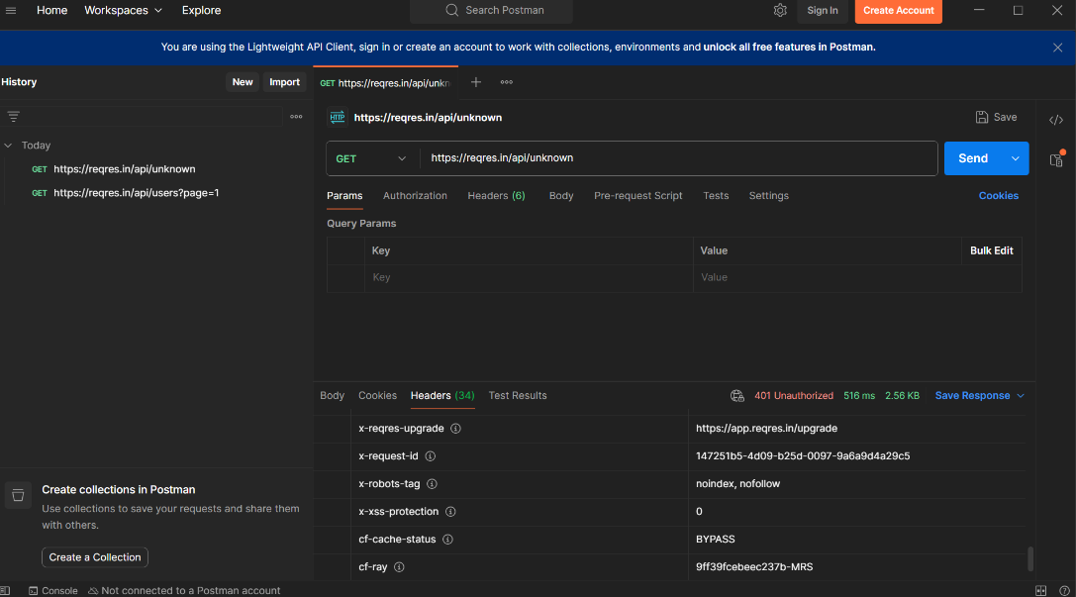
Figure 2: Response header inspection performed using Postman.
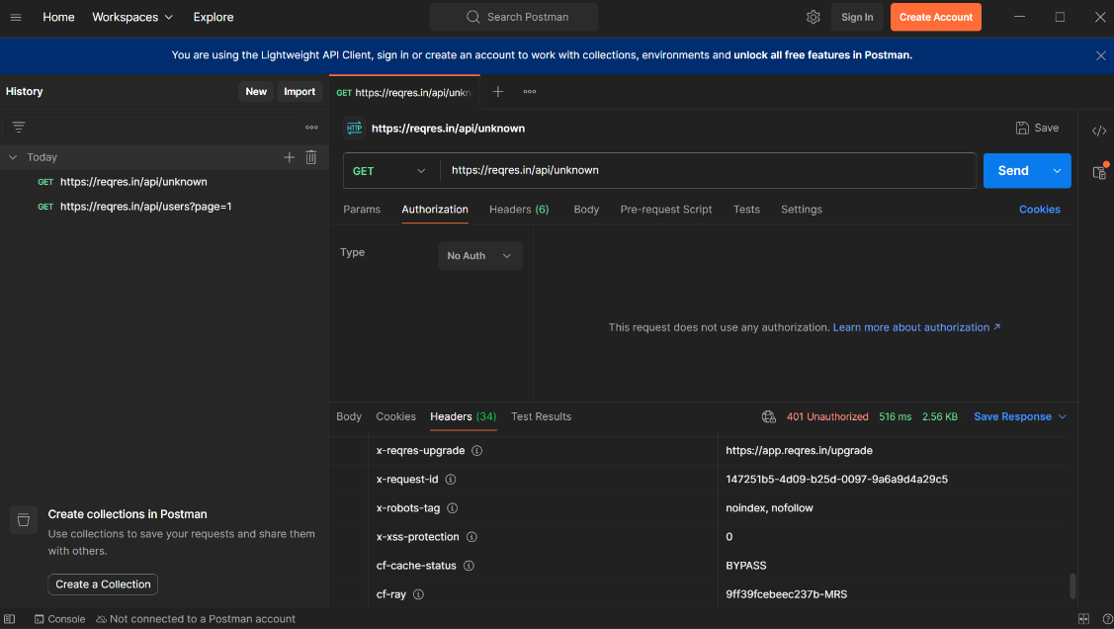
Figure 3: Authentication configuration and authorization analysis within Postman.

6. Security Findings
Finding | Severity | Business Impact | Recommendation
Publicly accessible API endpoints | Medium | API data may be accessed without login or authorization | Require authentication for sensitive endpoints
No authentication required | Medium | User-related information may be publicly exposed | Implement secure authentication such as JWT or OAuth
Predictable endpoint structure | Low | Attackers may enumerate endpoints and resources | Apply authorization validation and endpoint protection
Limited visible rate limiting | Medium | APIs may be vulnerable to automated abuse or excessive requests | Implement rate limiting and request monitoring
Response metadata exposure | Low | Additional API structure details may be exposed | Reduce unnecessary response metadata

PAGE 3
7. Business Impact Analysis
APIs play a critical role in modern SaaS applications and cloud-based platforms. Weak API security controls can create serious business and operational risks if sensitive endpoints are exposed publicly.
Open or weakly protected APIs may allow attackers to:
- collect user information
- automate requests against services
- enumerate endpoints
- abuse exposed functionality
- overload backend systems
Missing authentication and weak authorization mechanisms may also result in unauthorized access to sensitive business data, customer information, or internal application resources.
In real-world production environments, these issues could lead to:
- privacy violations
- reputational damage
- financial loss
- compliance concerns
- service disruption
Although the ReqRes API is intentionally public for educational purposes, the observations documented during this project demonstrate why strong API security practices are essential for SaaS platforms and modern applications.

8. Recommendations
Implement Authentication
Sensitive endpoints should require secure authentication methods such as:
- JWT authentication
- OAuth 2.0
- API keys
- secure session controls
Apply Authorization Validation
Applications should verify whether authenticated users are authorized to access specific resources and data.
Enable Rate Limiting
Rate limiting and throttling mechanisms should be implemented to reduce automated abuse and excessive request activity.
Reduce Excessive Data Exposure
APIs should return only the minimum required data to reduce unnecessary information exposure.
Improve Monitoring and Logging
Security monitoring and logging systems should be implemented to identify suspicious API behavior and abnormal request patterns.

9. Conclusion
This project demonstrated the importance of API Security Risk Analysis in modern SaaS environments.
Through ethical and read-only API testing using Postman and Browser DevTools, several common API security observations were identified including publicly accessible endpoints, missing authentication requirements, predictable endpoint structures, and limited visible rate-limiting protections.
The assessment also highlighted how weak API security controls in production environments could increase risks related to unauthorized access, API abuse, and sensitive data exposure.
Although the ReqRes API is intentionally designed for public testing and learning purposes, this project demonstrates the importance of implementing strong authentication, authorization, monitoring, and API protection mechanisms within real-world SaaS applications.
Overall, the project provided practical experience in API inspection, security analysis, documentation, and professional risk reporting within a modern cybersecurity context.

