**Name: Saurabh Jadav**

**Course: Software Testing**

**Assignments: Module 1 Software Testing Fundaments**

**1. What is SDLC?**

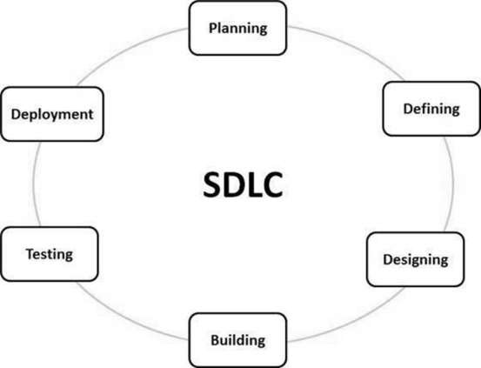

SDLC stands for Software Development Life Cycle. It describes as step-by-step phases to develop any software with high quality, shortest possible in-time and in-budget by defining phases like Planning, Analysis, Design, Implementation, Testing and Maintenance.

**2. What is software testing?**

Software Testing is a process to identify the Correctness, Completeness and Quality of a developed Software.

Software testing is a process to verify that the Software Product requirements are fulfilled or not and it should be defect free.

**3. What is agile methodology?**

Agile model believes that every project needs to be handled differently and the existing methods divided into small time frames to deliver specific feature of a release.

Agile methodology is a structured approach into manageable phases, focusing on continuous improvement. It is an iterative process that involves planning, execution, and evaluation. Each iteration typically lasts from about one to three weeks.

Agile Methods break the product into small incremental builds.

**4. What is SRS?**

SRS is software requirement specification. It describes the how software being developed, purpose and functionality of a Software.

SRS is a complete description of behaviors of the system to developed.

**5. What is oops?**

**Object-oriented programming** (OOP) is a computer programming model that organizes software design around objects, rather than functions and logic.

OOPS is a collection of objects used to develop structure software program into simple reusable code.

**6. Write Basic Concepts of oops?**

* Class
* Object
* Encapsulation
* Inheritance
* Polymorphism
  + Overloading
  + Overriding
* Abstraction

**7. What is Object?**

An object is a fundamental unit that represents a specific instance of a class.

Object will give the memory to the class.

**8. What is Class?**

A class is a blueprint for creating objects. It defines a type of object by specifying its data members and member functions.

**9. What is Encapsulation?**

Encapsulation means wrapping up of data into a single unit.

It is also called Data hiding.

**10. What is Inheritance?**

Inheritance defines as one class to inherit attributes and methods from another class.

Inheritance provides code re-usability. In place of writing the same code, again and again, we can simply inherit the properties of one class into the other class.

Types of Inheritance:

* Single Inh.
* Multilevel Inh.
* Multiple Inh.
* Hierarchical Inh.
* Hybrid Inh.

**11. What is Polymorphism?**

Polymorphism in oops, it is easy to represent one single form into various forms.

Polymorphism has two types:

Overloading: It allows a class to have multiple methods with the same name but different parameter lists.

Overriding: It describes as, when a subclass provides a specific implementation for a method that is already defined in its superclass.

**12. Draw Use case on Online book shopping?**

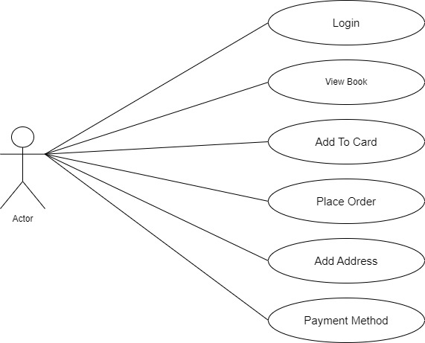

**13. Draw Use case on online bill payment system (Paytm)?**

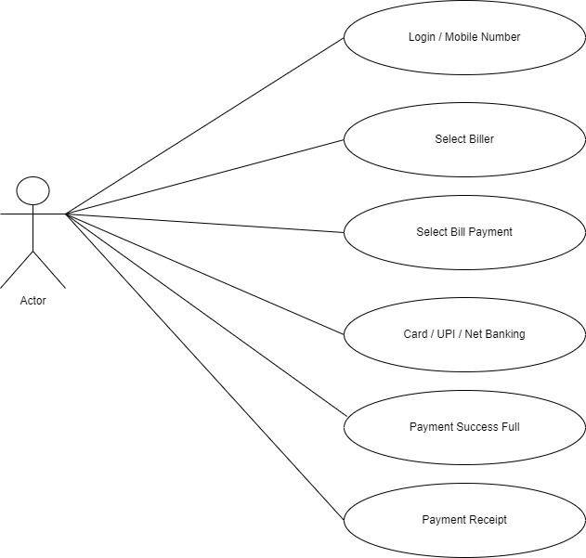

**14. Write SDLC phases with basic introduction?**

SDLC has total six phases which is describes below.

* **Planning** :- it describes as gathering information , total cost and time to require to develop any product/software.
* **Defining/Analysis :-** It is short document that define entire Life cycle of project.
* **Design:**- It is a visualization of software of product by designing.
* **Building :**- It is a programming code for software.
* **Testing :**- It is performing if there is no bug in the software or verify the quality, completeness and correctness of software.
* **Deployment/Maintenance :**- In simple terms it is sales after service, fixing bugs if occur or to update the existing software.

**15. Explain Phases of the waterfall model?**

The Waterfall model is a traditional and linear approach to software development, where each phase of the project is completed before the next phase begins.

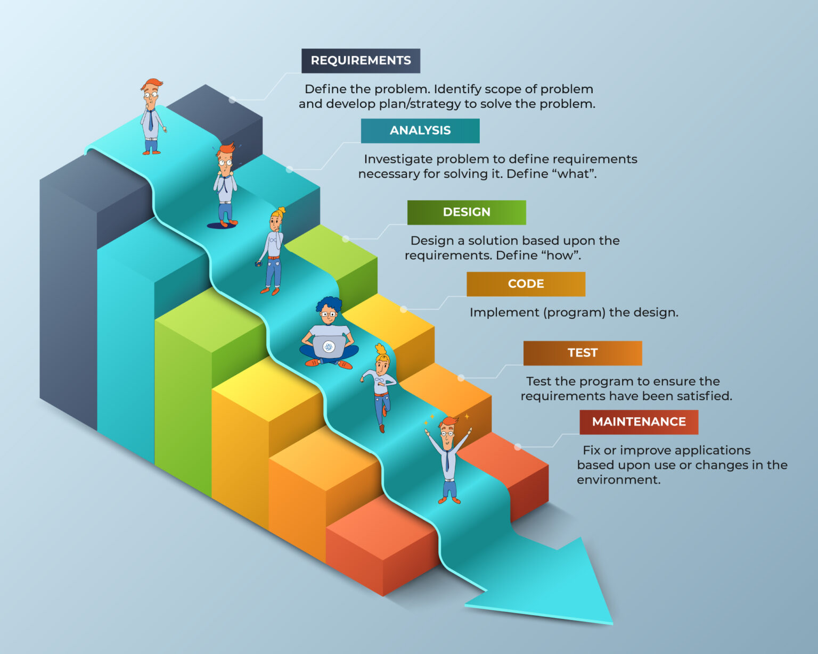  
It is a classical software lifecycle models like step by step “waterfall”, so it is called waterfall model.

Six phases of waterfall model describes below.

* **Requirement gathering** :- it describes as gathering information , total cost and time to require to develop any product/software.
* **Analysis:-** It is short document that define entire Life cycle of project.
* **Design:** - It is a visualization of software of product by designing.
* **Coding :**- It is a programming code for software.
* **Testing :**- It is performing if there is no bug in the software or verify the quality, completeness and correctness of software.
* **Maintenance :**- In simple terms it is sales after service.

**Applications (When to use?)**

* Requirements are very well documented, clear and fixed.
* Product definition is stable.
* Technology is understood and is not dynamic.
* There are no ambiguous requirements.
* Ample resources with required expertise are available to support the product.
* The project is short.

**Pros (Why Waterfall Model)**

* Simple and easy to understand and use
* Easy to manage due to the rigidity of the model. Each phase has specific deliverables and a
* review process.
* Phases are processed and completed one at a time.
* Works well for smaller projects where requirements are very well understood.
* Clearly defined stages.
* Well understood milestones.
* Easy to arrange tasks.
* Process and results are well documented.

**Cons (Why not Waterfall Model)**

* No working software is produced until late during the life cycle.
* High amounts of risk and uncertainty.
* Not a good model for complex and object-oriented projects.
* Poor model for long and ongoing projects.
* Not suitable for the projects where requirements are at a moderate to high risk of changing.
* So, risk and uncertainty is high with this process model.
* It is difficult to measure progress within stages.
* Cannot accommodate changing requirements.
* No working software is produced until late in the life cycle.
* Adjusting scope during the life cycle can end a project.

**16. Write phases of spiral model?**

The Spiral Model is a [Software Development Life Cycle (SDLC)](https://www.geeksforgeeks.org/software-development-life-cycle-sdlc/) model that provides a systematic and iterative approach to software development. In its diagrammatic representation, looks like a spiral with many loops. The exact number of loops of the spiral is unknown and can vary from project to project. Each loop of the spiral is called a phaseof the software development process.

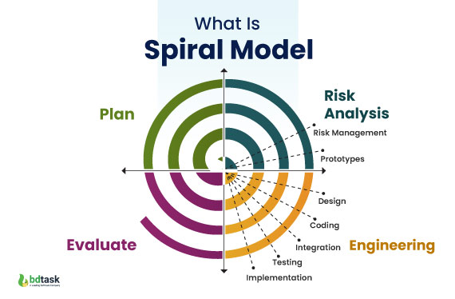

**Phases of the Spiral Model**

**1 Planning:** The next iteration of the spiral begins with a new planning phase, based on the results of the evaluation.

**2 Risk Analysis:** In the risk analysis phase, the risks associated with the project are identified and evaluated.

**3 Engineering:** In the engineering phase, the software is developed based on the requirements gathered in the previous iteration.

**4 Evaluation:** In the evaluation phase, the software is evaluated to determine if it meets the customer’s requirements and if it is of high quality.

**17. Write agile manifesto principles?**

**• Individuals and interactions** - in agile development, self-organization and motivation are important, as are interactions like co-location and pair programming.

**• Working software** - Demo working software is considered the best means of communication with the customer to understand their requirement, instead of just depending on documentation.

**• Customer collaboration** - As the requirements cannot be gathered completely in the beginning of the project due to various factors, continuous customer interaction is very important to get proper product requirements.

**• Responding to change** - agile development is focused on quick responses to change and continuous development.

**18. Explain working methodology of agile model, also write pros and cons?**

Agile development model is also a type of Iterative Incremental model. Software is developed in incremental, rapid cycles. This results in small incremental releases with each release building on previous functionality. Each release is thoroughly tested to ensure software quality is maintained. It is used for time critical applications.

**Pros : -**

* It Is a very realistic approach to software development.
* Promotes teamwork and cross training. Functionality can be developed rapidly and demonstrated.
* Resource requirements are minimum.
* Suitable for fixed or changing requirements.
* Delivers early partial working solutions.
* Good model for environments that change steadily.
* Minimal rules, documentation easily employed.
* Enables concurrent development and delivery within an overall planned context.
* Little or no planning required.
* Easy to manage.
* Gives flexibility to developers.

**Cons : -**

* Not suitable for handling complex dependencies.
* More risk of sustainability, maintainability and extensibility.
* An overall plan, an agile leader and agile PM practice is a must without which it will not work.
* Strict delivery management dictates the scope, functionality to be delivered, and adjustments to meet the deadlines.
* There is very high individual dependency, since there is minimum documentation generated.
* Depends heavily on customer interaction, so if customer is not clear, team can be driven in the wrong direction.

**19. Draw use case on Online shopping product using COD?**

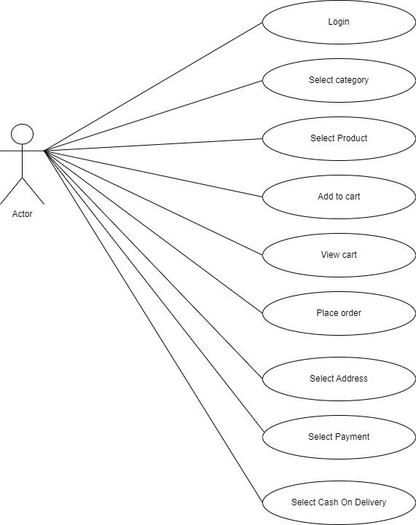

**20. Draw usecase on Online shopping product using payment gateway?**

