1) What is RDBMS?

* A relational database is a collection of information that organizes data in predefined relationships where data is stored in one or more tables (or "relations") of columns and rows, making it easy to see and understand how different data structures relate to each other. Relationships are a logical connection between different tables, established on the basis of interaction among these tables.
* RDBMS stands for Relational Database Management System. It's a type of database management system that stores, manage, query, retrieve data in a structured format using rows and columns, which are organized into tables.

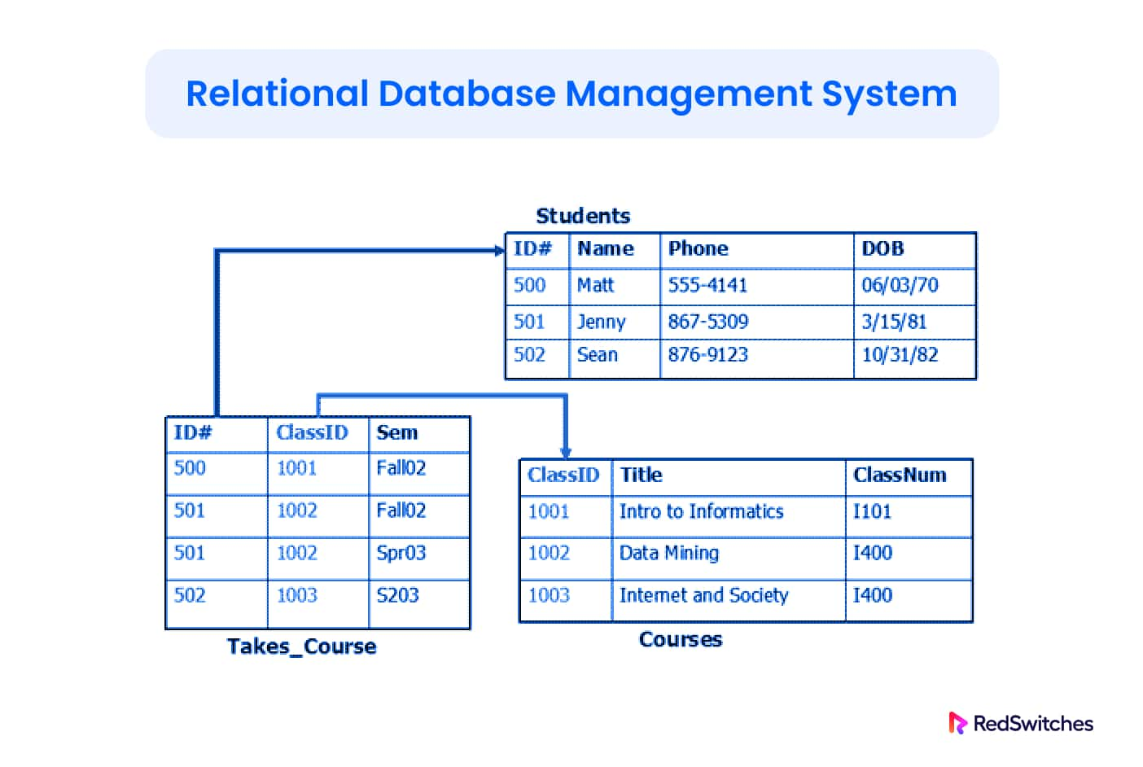

2) What is SQL?

* Structured query language (SQL) is a programming language for storing and processing information in a relational database. A relational database stores information in tabular form, with rows and columns representing different data attributes and the various relationships between the data values. You can use SQL statements to store, update, remove, search, and retrieve information from the database. You can also use SQL to maintain and optimize database performance.
* Structured query language (SQL) is a popular query language that is frequently used in all types of applications. Data analysts and developers learn and use SQL because it integrates well with different programming languages. SQL is also fairly easy to learn as it uses common English keywords in its statements.
* To use SQL in: MySQL, SQL Server, MS Access, Oracle, Sybase, Informix, Postgres, and other database systems.

3) Write SQL Commands?

* SQL commands are instructions. It is used to communicate with the database. It is also used to perform specific tasks, functions, and queries of data.
* SQL can perform various tasks like create a table, add data to tables, drop the table, modify the table, set permission for users.
* SQL Commands are mainly categorized into five categories:

**DDL**– Data Definition Language

**DQL**– Data Query Language

**DML**– Data Manipulation Language

**DCL**– Data Control Language

**TCL**– Transaction Control Language

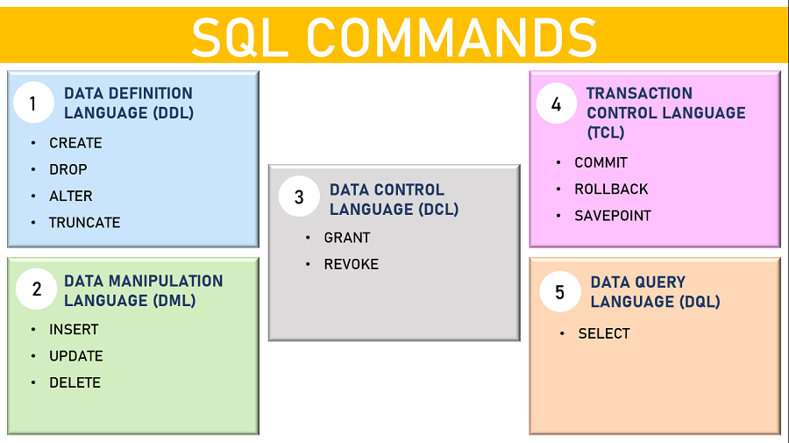

4) What is join?

* SQL JOIN operation combines data or rows from two or more tables based on a common field between them.
* SQL JOIN clause is used to query and access data from multiple tables by establishing logical relationships between them. It can access data from multiple tables simultaneously using common key values shared across different tables.
* E.g. Select column-name from table1 join-type table2 where table1.column-name=table2.column-name;

5) Write type of joins?

* Depending on your desired results, you can choose among four types of SQL JOINs: Inner JOIN, Left Outer JOIN, Right Outer JOIN, and Full Outer JOIN. Take a look at how each works, along with some sample SQL JOIN clauses:

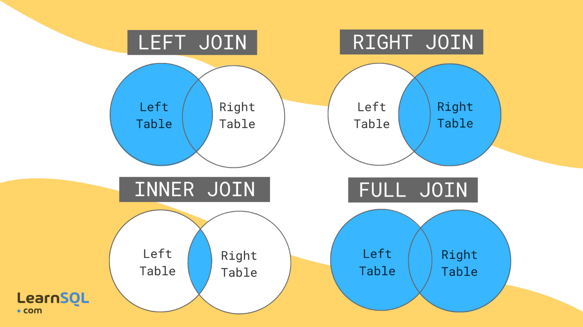

* Four types of join types listed below.

### **Inner Join :** Inner join combine two tables based on a shared key. For example, if you had a table with a column called "user id" and each user ID was unique to a user, you could join that table to another table with a "user id" column to find the information associated with each user. This example shows how to use an Inner join clause to join two tables:

e. g. SELECT * FROM table1 INNER JOIN table2 where table1.id = table2.id;

### **Left Outer Join :** Left join return all rows from the first table and only those in the second table that match. This example shows how to use a Left Outer join clause to join two tables:

e.g. SELECT * FROM table1 LEFT OUTER JOIN table2 where table1.id = table2.user_id;

### **Right Outer Join :** Right join are logically the opposite of Left joins—they return all rows from the second table and only the rows in the first table that match. This example shows how to use a Right Outer Join clause to join two tables:

e.g. SELECT * FROM table1 RIGHT OUTER JOIN table2 where table1.id = table2.user_id

### **Full Outer Join :** Full join combine left and right joins by returning all rows from both tables as long as at least one match exists between them. This example shows how to use a Full Outer JOIN clause to join two tables:

e.g. SELECT * FROM table1 FULL OUTER JOIN table2 where table1.id = table2.user_id

6) How Many constraints and describes itself?

* Constraints are used to specify rules for the data in a table.
* Constraints in SQL means we are applying certain conditions or restrictions on the database. This further means that before inserting data into the database, we are checking for some conditions. If the condition we have applied to the database holds true for the data which is to be inserted, then only the data will be inserted into the database tables.
* The following constraints are commonly used in SQL:

* NOT NULL - Ensures that a column cannot have a NULL value.

CREATE TABLE Colleges (

college_id INT NOT NULL,

college_code VARCHAR(20) NOT NULL,

college_name VARCHAR(50)

);

* UNIQUE - Ensures that all values in a column are different.

CREATE TABLE Colleges (

college_id INT NOT NULL UNIQUE,

college_code VARCHAR(20) UNIQUE,

college_name VARCHAR(50));

* PRIMARY KEY - A combination of a NOT NULL and UNIQUE. Uniquely identifies each row in a table.

CREATE TABLE Colleges (

college_id INT PRIMARY KEY,

college_code VARCHAR(20) NOT NULL,

college_name VARCHAR(50));

* FOREIGN KEY - Prevents actions that would destroy links between tables.

CREATE TABLE Orders (

order_id INT PRIMARY KEY,

customer_id int REFERENCES Customers(id));

* CHECK - Ensures that the values in a column satisfies a specific condition.

CREATE TABLE Orders (

order_id INT PRIMARY KEY,

amount int CHECK (amount >= 100));

* DEFAULT - Sets a default value for a column if no value is specified.

CREATE TABLE College (

college_id INT PRIMARY KEY,

college_code VARCHAR(20),

college_country VARCHAR(20) DEFAULT 'US');

* CREATE INDEX - Used to create and retrieve data from the database very quickly.

-- create table

For reference take from above table.

-- create index

CREATE INDEX college_index where Colleges(college_code);

7) Difference between RDBMS vs DBMS?

* A Database Management System (DBMS) is a software system that is designed to manage and organize data in a structured manner. It allows users to create, modify, and query a database, as well as manage the security and access controls for that database. DBMS provides an environment to store and retrieve data in convenient and efficient manner.
* Relational Database Management System (RDBMS) is a more advanced version of a DBMS system that allows access to data in a more efficient way. It is used to store or manage only the data that are in the form of tables.

|  |  |
| --- | --- |
| **RDBMS** | **DBMS** |
| Data stored is in table format | Data stored is in the file format |
| Multiple data elements are accessible together | Individual access of data elements |
| Data in the form of a table are linked together | No connection between data |
| Support distributed database | No support for distributed database |
| Data is stored in a large amount | Data stored is a small quantity |
| RDBMS supports multiple users | DBMS supports a single user |
| The software and hardware requirements are higher | The software and hardware requirements are low |
| Example: Oracle, SQL Server. | Example: XML, Microsoft Access. |

8) What is API Testing?

* Testing the business logic of any application is called API testing. QA will test the same logic and called API testing.
* API testing is a part of back end testing like database.
* The purpose of API Testing is to check the functionality, reliability, performance, and security of the programming interfaces.

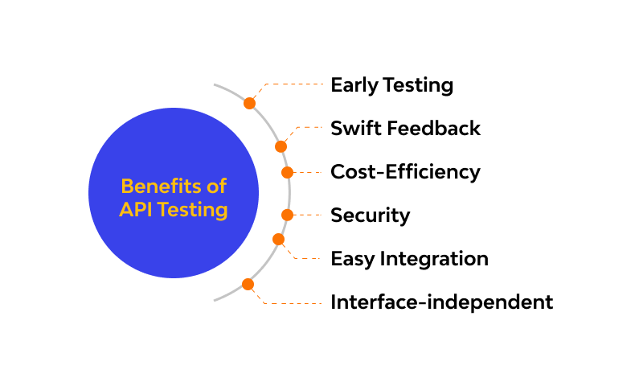

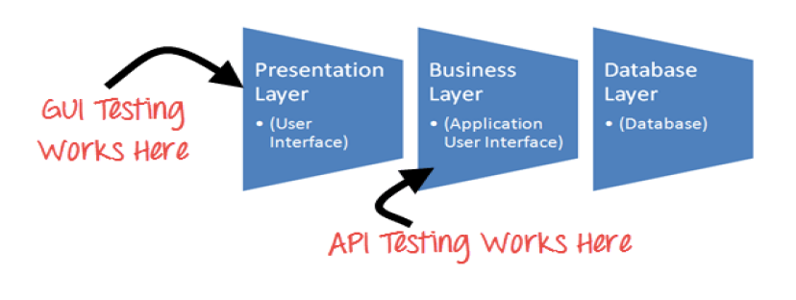

9) Types of API Testing?

* Mainly 3 types of API Testing are there which is listed below.
* **Open APIs:** These types of APIs are publicly available to use like OAuth APIs from Google. It has also not given any restriction to use them. So, they are also known as Public APIs.
* **Partner APIs:** Specific rights or licenses to access this type of API because they are not available to the public.
* **Internal APIs:** Internal or private. These APIs are developed by companies to use in their internal systems. It helps you to enhance the productivity of your teams.

**Other than this 2 communication API is also present :**

* **High-Level APIs:** High-level APIs are those that we can generally use in REST form, where programmers have a high level of abstraction. These API's mostly concerned about performing a limited functionality.
* **Low-Level APIs:** This kind of APIs has a lower level of abstraction, which means they are more detailed. It allows the programmer to manipulate functions within an application module or hardware at a granular level.
* There are two types of web APIs 1) Server Side API

2) Client Side API

10) What is Responsive Testing?

* The term responsive testing is a range of activities that involve it to check whether the website or any application is behaving in the right way after it is launched on different gadgets and screen sizes. The tests used to check whether the user interface changes dynamically in response to different screen resolutions, device orientations, and capabilities act as one of the major aims of testing. As we are dealing with the spread of mobile devices as well as different variations regarding screen sizes and resolutions, it is now almost impossible to content the users with the same perfect screen experience – let alone the additional type of devices with nature-based handcrafted user interfaces.
* To check the responsiveness of our website on multiple devices is simply called responsive testing.
* Responsive testing involves how a website or web application looks and behaves on different devices, screen sizes, and resolutions. The goal of responsive testing is to ensure that the website or web application can be used effectively on various devices, including desktops, laptops, tablets, and smartphones.
* **Advantages of Responsive Testing:**

➢ Improved User Experience

➢ Increased Accessibility

➢ Enhanced Search Engine Optimization

➢ Cost Saving

➢ Improved Conversion Rates

**Types of Responsive Website Testing**

➢ Visual Regression Testing

➢ Visual Layout Testing

➢ Cross browser testing

➢ Functional Testing:

➢ Performance Testing

➢ Usability Testing

11) Which types of tools are available for Responsive Testing?

**Responsive Testing Tools**

➢ LT Browser

➢ Lambda Testing

➢ Google Resizer

➢ am I responsive

➢ Pixel tuner

e.g. if we are testing on amIresponsive : **https://ui.dev/amiresponsive**



E.g. if we use google resizer then following steps:

* **Use the developer tools:** Open the developer tools by pressing F12, then go to the Elements tab. You can change the size of the window to see when changes happen.
* **Use device mode:** Open the developer tools by clicking on the Chrome menu, then selecting More tools > Developer Tools. You can toggle device mode on and off by clicking the device mode icon, which looks like a smartphone. Device mode simulates different devices, orientations, touch events, and zoom levels.

12) What is the full form of .ipa, .apk ?

* .ipa : International Phonetic Alphabet.The International Phonetic Alphabet (IPA) is an alphabetic system of phonetic notation based primarily on the Latin script. It was devised by the International Phonetic Association in the late 19th century as a standardized representation of the sounds of spoken language.
* .apk : APK stands for Android Application Package. It is the file format used to distribute and install apps on the Android operating system. An APK file includes all the code, resources, and other data necessary for the app to run on an Android device. These files can be used to install the app on any Android device, even if the app is not available on the Google Play Store.

13) How to create step for to open the developer option mode ON?

* **Step 1:** Go to Settings >About Phone.
* **Step 2:** Tap to detailed info and specs > Build Number.
* **Step 3:** Tap Build Number seven times. After the first few taps, you should see the steps counting down until you unlock the developer options. You may also have to tap in your PIN for verification.
* **Step 4:** Once developer options are activated, you will see a message that reads, You are now a developer.
* **Step 5:** Go back to the Settings pane then go to additional settings, where you will now find Developer options as an entry.

* **Step 6:** Tap it and toggle (USB debugging) the switch on if it is not already, and from there, you can proceed to make adjustments to your phone.

