**Assessment**

Task:- Create a two table Customer and Salesman and Query solve.

CREATE DATABASE assessment;

Create table :- Customer

CREATE TABLE Customer

(

customer_id int(200),

cust_name varchar(200),

city varchar(200),

grade int(200),

salesman_id int(200)

)

Insert into customer :-

INSERT INTO `customer` (`customer_id`, `cust_name`, `city`, `grade`, `salesman_id`)

VALUES ('3002', 'Nick Rimando', 'New York', '100', '5001'),

('3007', 'Brad Davis', 'New York', '200', '5001'),

('3005', 'Graham Zusi', 'California', '200', '5002'),

('3008', 'Julian Green', 'London', '300', '5002'),

('3004', 'Fabian Johnson', 'Paris', '300', '5006'),

('3009', 'Geoff Cameron', 'Berlin', '100', '5003');

INSERT INTO `customer` (`customer_id`, `cust_name`, `city`, `grade`, `salesman_id`)

VALUES ('3003', 'Jozy Altidor', 'Moscow', '200', '5007'),

('3001', 'Brad Guzan', 'London', NULL, '5005');

Output:-

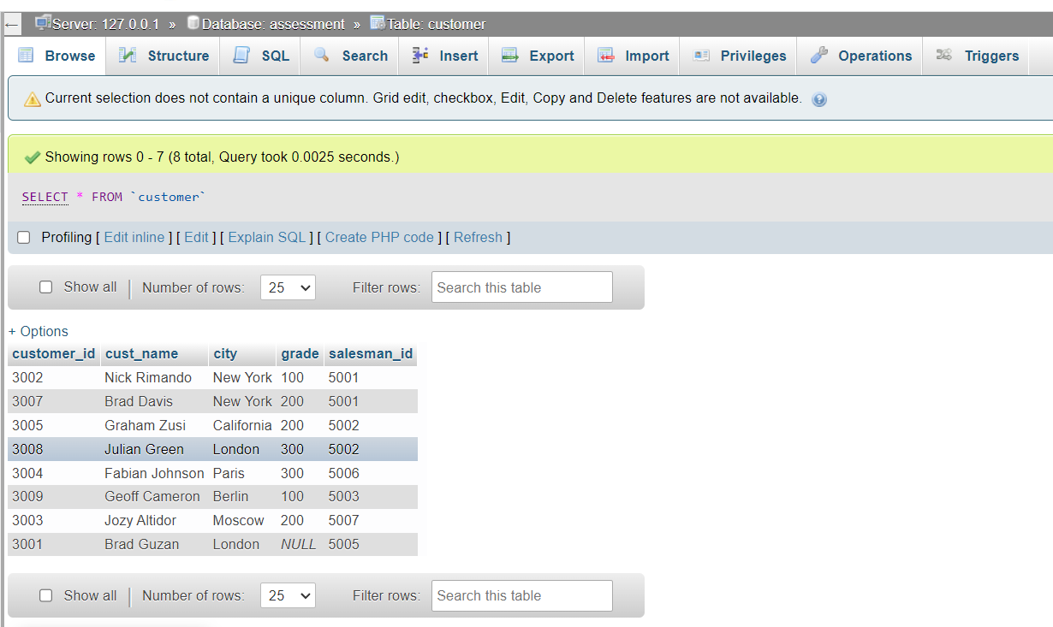

second table salesman:-

CREATE TABLE salesman

(

slesman_id int(200),

name varchar(200),

city varchar(200),

commission varchar(200)

)

insert table data form salesman table:-

INSERT INTO `salesman` (`slesman_id`, `name`, `city`, `commission`)

VALUES ('5001', 'James Hoog', 'New York', '0.15'),

('5002', 'Nail Knite', 'Paris', '0.13'),

('5005', 'Pit Alex', 'London', '0.11'),

('5006', 'Mc Lyon', 'Paris', '0.14'),

('5007', 'Paul Adam', 'Rome', '0.13'),

('5003', 'Lauson Hen', 'San Jose', '0.12');

Output :-

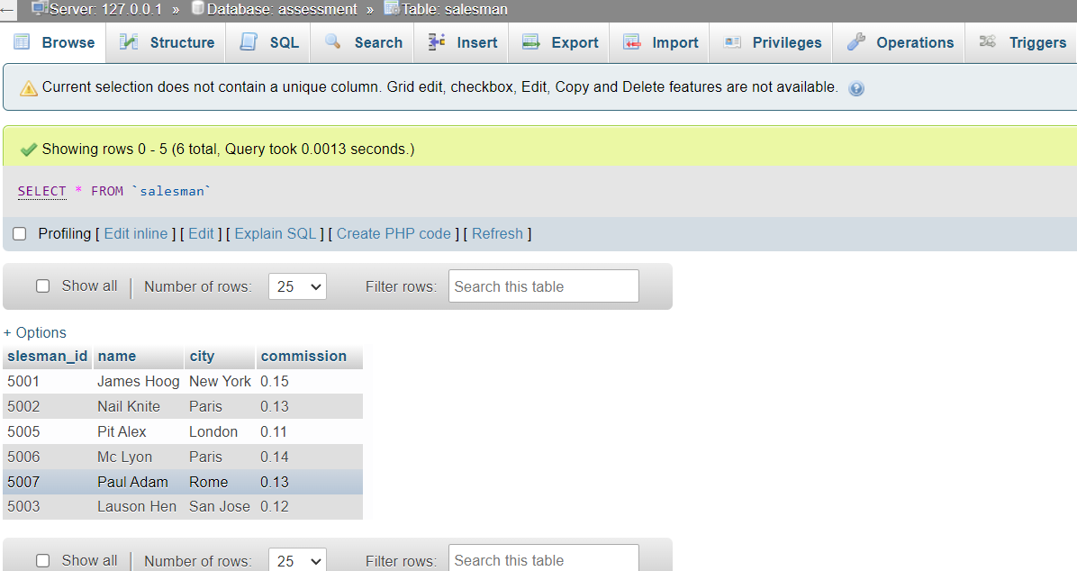

Query :- From the above given tables write a SQL query to find the salesperson(s) and the customer(s) represented here. Return the Customer Name, City, Salesman, commission.

Ans -> SELECT salesman.name, customer.cust_name, customer.city,salesman.commission

FROM salesman

INNER JOIN customer

ON salesman.city=customer.city;

Output:-

