**Assignment_module_05**

Task : - 01

Create Table Name: Student and Exam

ANS:-

CREATE DATABASE shubham;

create table :-

==>

CREATE TABLE student

(

Rollno int(200) AUTO_INCREMENT PRIMARY KEY,

Name varchar(200),

Branch varchar(200)

)

Insert data:-

INSERT INTO student(Name,Branch) VALUES('Jay','Computer Science');

INSERT INTO student(Name,Branch) VALUES('Suhani','Electronic Com');

INSERT INTO student(Name,Branch) VALUES('Kriti','Electronic Com');

Output :- Student table :

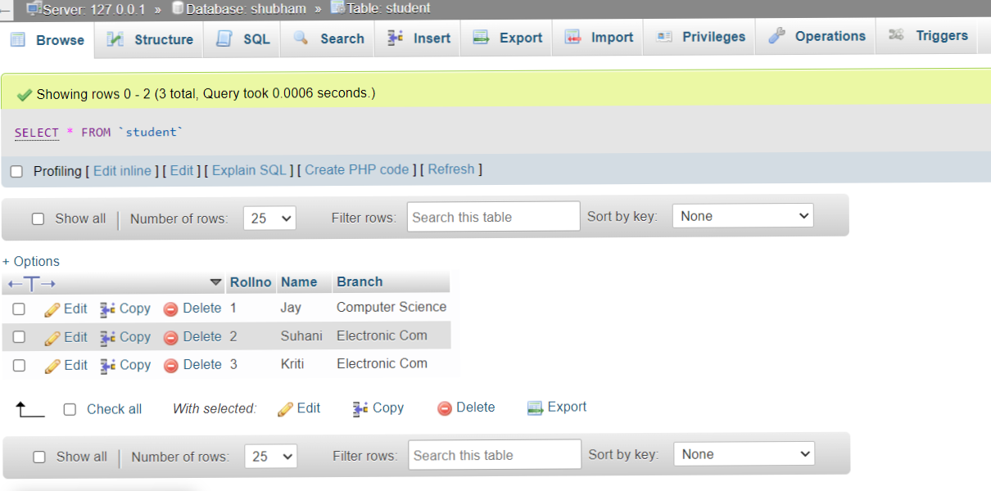

CREATE TABLE Exam(

Rollno INT(200),

S_code VARCHAR(200),

Marks INT(200),

P_code VARCHAR(200),

FOREIGN KEY(Rollno) REFERENCES student(Rollno)

)

Insert data from Exam table:-

INSERT INTO `exam` (`Rollno`, `S_code`, `Marks`, `P_code`)

VALUES ('1', 'CS11', '50', 'CS'), ('1', 'CS12', '60', 'CS'),

('2', 'EC101', '66', 'EC'), ('2', 'EC102', '70', 'EC'), ('3', 'EC101', '45', 'EC'), ('3', 'EC102', '50', 'EC');

Output:-

