**Assignment_module_05**

Task : - 03

Create table given below: Employee and Incentive

Table name :- Employee

CREATE TABLE Employee

(

Employee_id int(200) AUTO_INCREMENT PRIMARY KEY,

First_name varchar(200),

last_name varchar(200),

Salary int(200),

Joining_date varchar(200),

Department varchar(200)

)

Insert data form Employee :-

INSERT INTO `Employee` (`Employee_id`, `First_name`, `Last_name`, `Salary`, `Joining_date`, `Department`) VALUES

(1, 'John ', 'Abraham', '1000000', '01-JAN-13\r\n12.00.00 AM', 'Banking'),

(2, 'Michael', 'Clarke', '800000', '01-JAN-13\r\n12.00.00 AM', 'Insurance'),

(3, 'Roy\r\n', 'Thomas', '700000', '01-FEB-13\r\n12.00.00 AM', 'Banking'),

(4, 'Tom\r\n', 'Jose', '600000', '01-FEB-13\r\n12.00.00 AM', 'Insurance'),

(5, 'Jerry', 'Pinto', '650000', '01-FEB-13\r\n12.00.00 AM', 'Insurance'),

(6, 'Phillip', 'Mathew', '750000', '01-JAN-13\r\n12.00.00 AM', 'Services'),

(7, 'TestName1', '123', '650000', '01-JAN-13\r\n12.00.00 AM', 'Services'),

(8, 'TestName2', 'Lname%', '600000', '01-FEB-13\r\n12.00.00 AM', 'Insurance');

Output:-

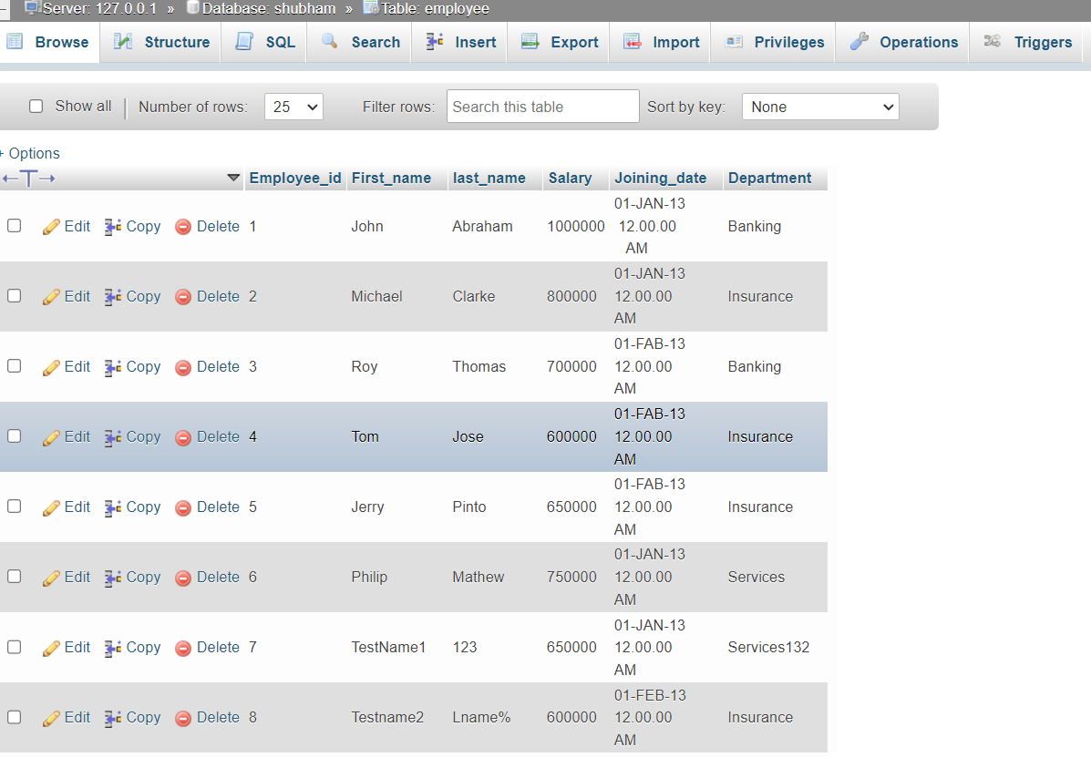

Table incentive:-

CREATE TABLE incentives

(

Employee_ref_id int(200),

Incentive_date varchar(255),

Incentive_amount varchar(255),

FOREIGN KEY(Employee_ref_id) REFERENCES employee (employee_id);

)

Insert data form incentives:-

INSERT INTO `incentives` (`Employee_ref_id`, `Incentive_date`, `Incentive_amount`)

VALUES ('1', '01-FEB-13', '5000'),

('2', '01-FEB-13', '3000'),

('3', '01-FEB-13', '4000'),

('1', '01-JAN-13', '4500'),

('2', '01-JAN-13', '3500');

Output:-

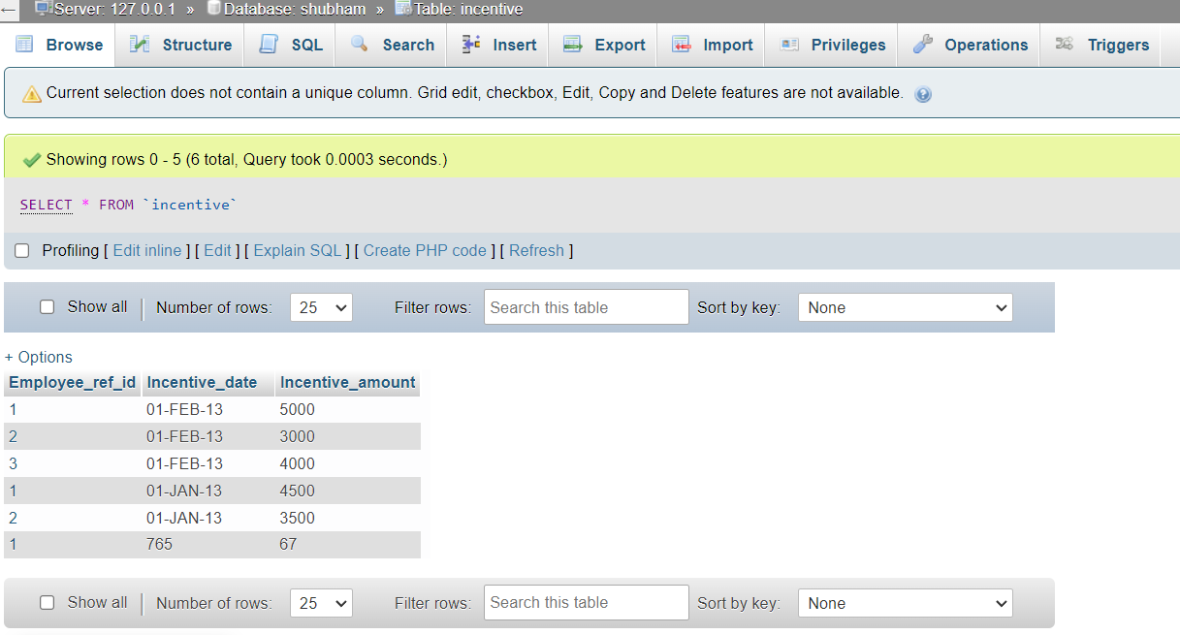

Query find:-

A -> Get First_Name from employee table using all name “Employee Name”?

Ans-> SELECT First_name FROM employee;

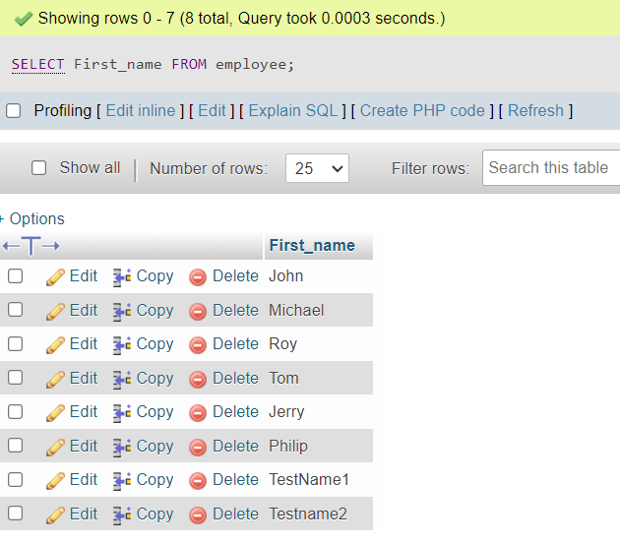

B -> Get FIRST_NAME, Joining Date, and Salary from employee table?

Ans -> SELECT First_name,Joining_date,Salary FROM `employee`;

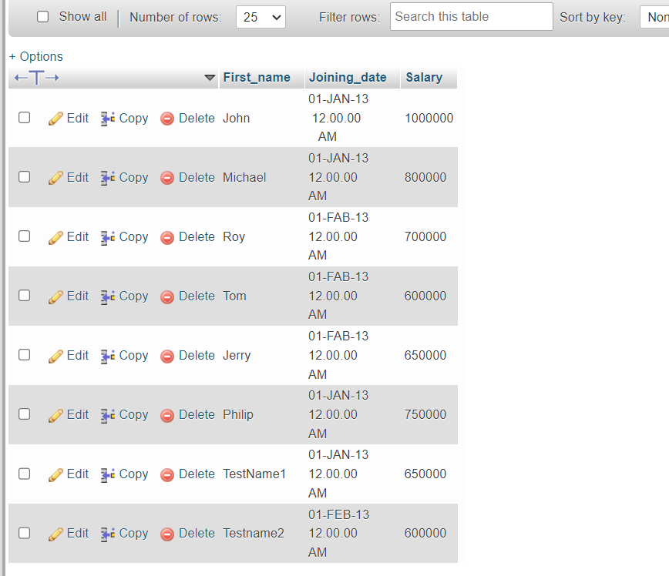

C -> Get all employee details from the employee table order by First_Name

Ascending and Salary descending?

Ans -> First_name Ascending:-

SELECT * FROM employee

ORDER BY First_name ASC;

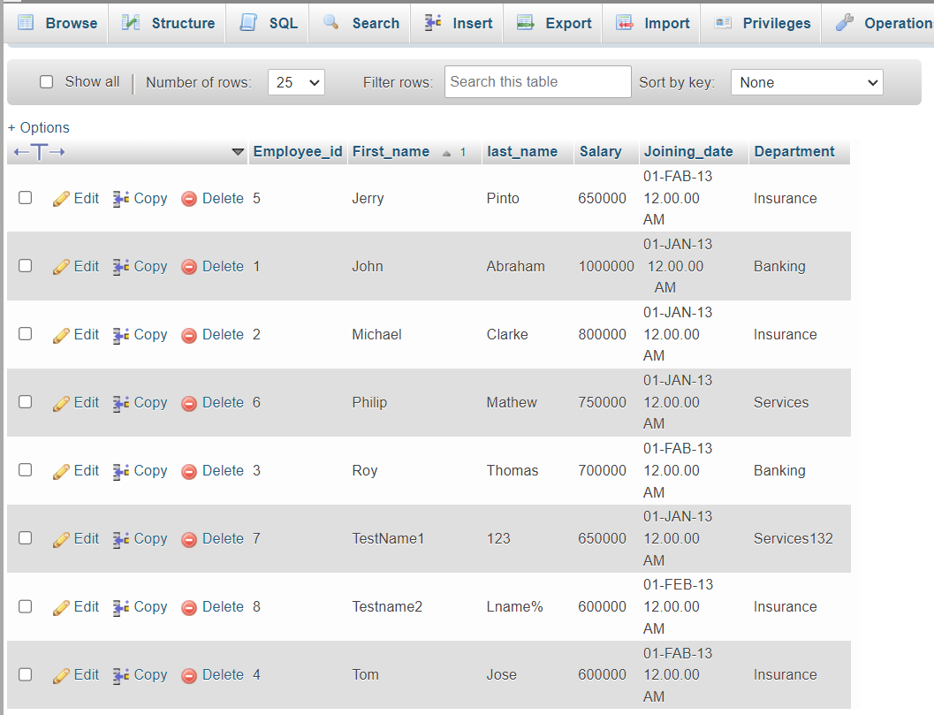

=> Salary descending:-

SELECT * FROM employee

ORDER BY Salary DESC;

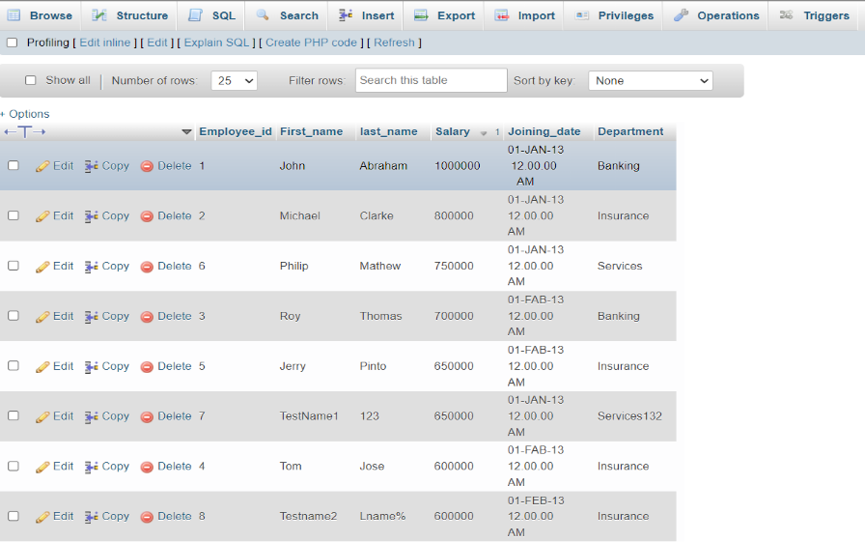

D -> Get employee details from employee table whose first name contains ‘J’?

Ans-> SELECT * FROM employee WHERE First_name LIKE 'J%';

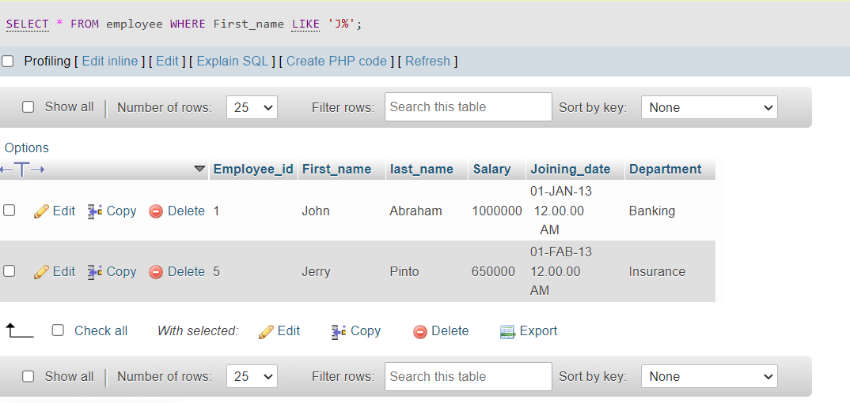

E -> Get department wise maximum salary from employee table order by salary ascending?

Ans-> SELECT Department, MAX(Salary) FROM employee GROUP BY Department ORDER by Salary ASC;

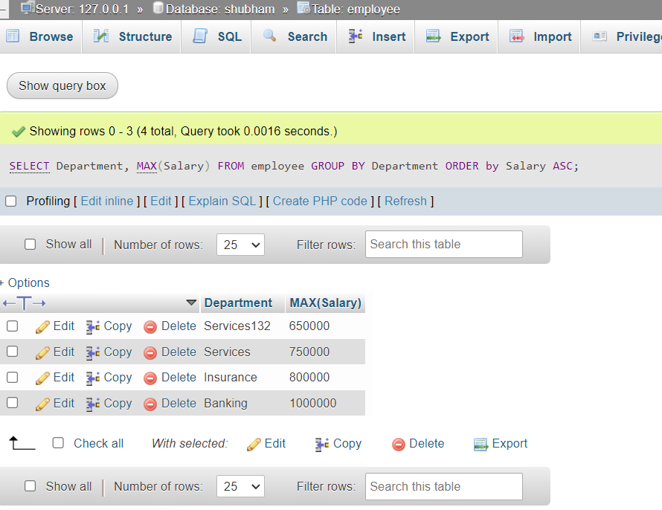

F -> Select first_name, incentive amount from employee and incentives table for those employees who have incentives and incentive amount greater than 3000?

Ans -> SELECT First_name,Incentive_amount FROM employee

INNER JOIN incentive ON Employee_id = Employee_ref_id and Incentive_amount >3000;

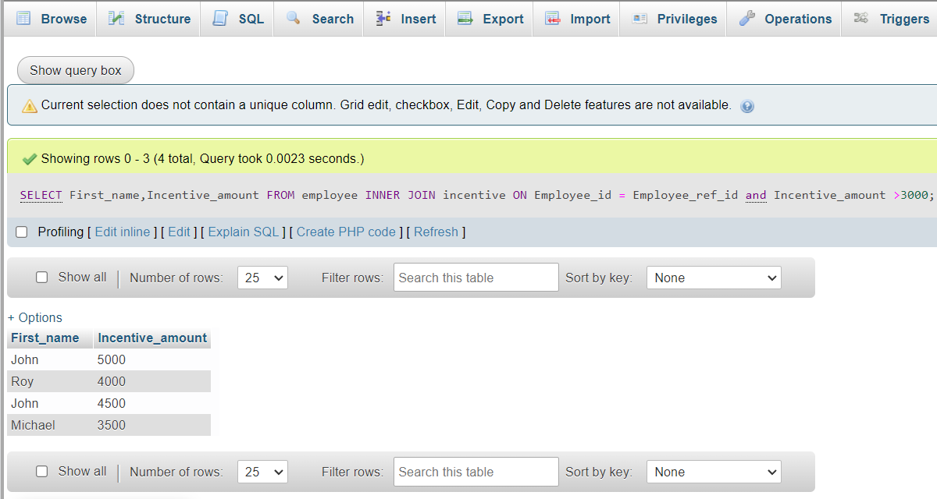

G-> Create After Insert trigger on Employee table which insert records in view

table?

CREATE TABLE t_view

(

Employee_id int(200) AUTO_INCREMENT PRIMARY KEY,

First_name varchar(200),

last_name varchar(200),

Salary int(200),

Joining_date varchar(200),

Department varchar(200),

date_time timestamp,

action_required varchar(200)

)

trigger:-

DELIMITER $$

CREATE TRIGGER t_view AFTER INSERT ON employee FOR EACH ROW

BEGIN

INSERTINTOt_view(Employee_id,First_name,last_name,Salary,Joining_date,Department,action_required)

VALUES(new.Employee_id,new.First_name,new.last_name,new.Salary,new.Joining_date,new.Department,'rec_inserted..!');

END

$$

Output:

After trigger create and then insert data form table

Employee table insert new data from table:-

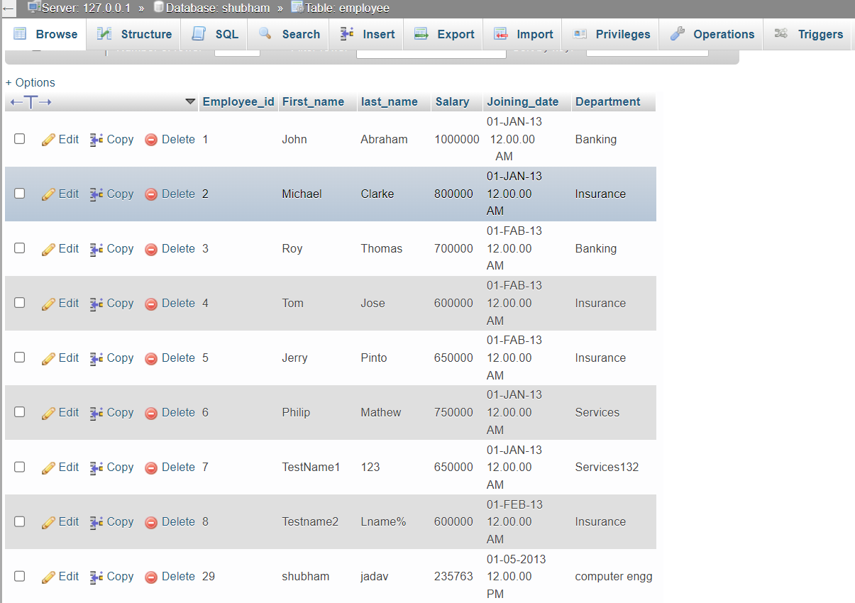

T_view table insert new data is show date_time and action is show new result:-

