**Assignment_module_05**

Task : - 04

Create table given below: Salesperson and Customer

Table Name:- Salesperson

CREATE TABLE Salesperson

(

SNo int(200) PRIMARY KEY,

Sname varchar(200),

City varchar(200),

Comm varchar(200)

)

Insert data form salesperson table:-

INSERT INTO `salseperson` (`SNo`, `Sname`, `City`, `Comm`)

VALUES ('1001', 'Peel', 'London', '.12'),

('1002', 'Serres', 'San Jose', '.13'),

('1004', 'Motika', 'London', '.11'),

('1007', 'Rafkin', 'Barcelona', '.15'),

('1003', 'Axelrod', 'New York', '.1');

Output:-

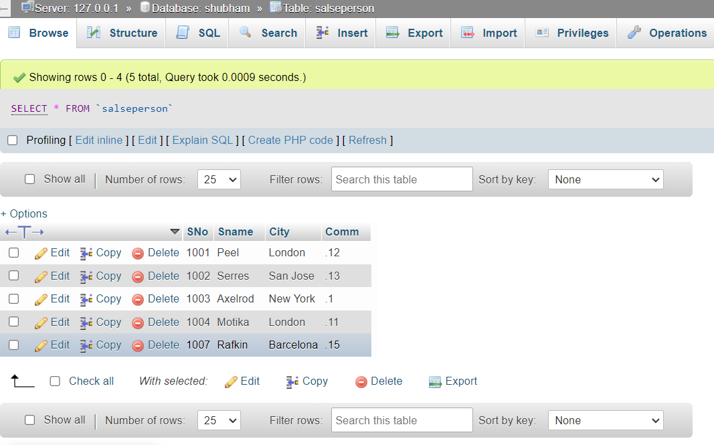

customer table:-

create table customer

(

Cnn int(200) primary key,

Cname varchar(200),

City varchar(200),

Rating int(200),

Sno int(200),

foregin key(Sno) reffernce Salseperson(SNo)

)

Insert data form customer table:-

INSERT INTO `customer` (`Cnm`, `Cname`, `City`, `Rating`, `Sno`)

VALUES ('201', 'Hoffman', 'London', '100', '1001'),

('202', 'Giovanne', 'Roe', '200', '1003'),

('203', 'Liu', 'San Jose', '300', '1002'),

('204', 'Grass', 'Barcelona', '100', '1002'),

('206', 'Clemens', 'London', '300', '1007'),

('207', 'Pereira', 'Roe', '100', '1004');

Output:-

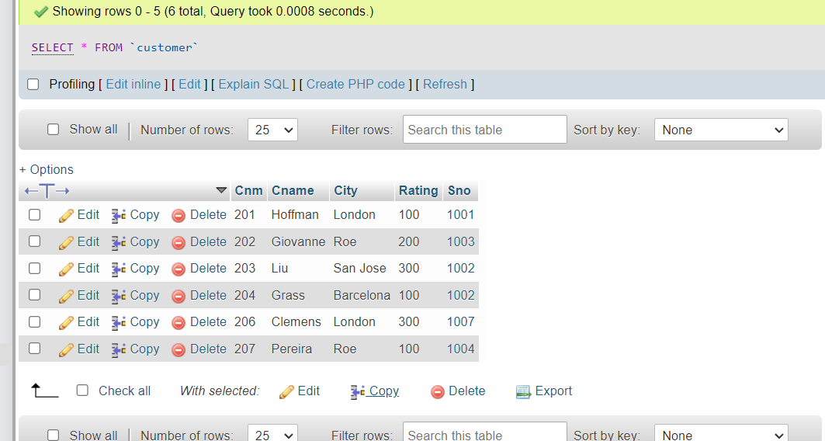

Query Find :-

A -> Names and cities of all salespeople in London with commission above 0.12 ?

Ans-> Select Sname, City

from salseperson

where Comm > .10 and

City = 'London';

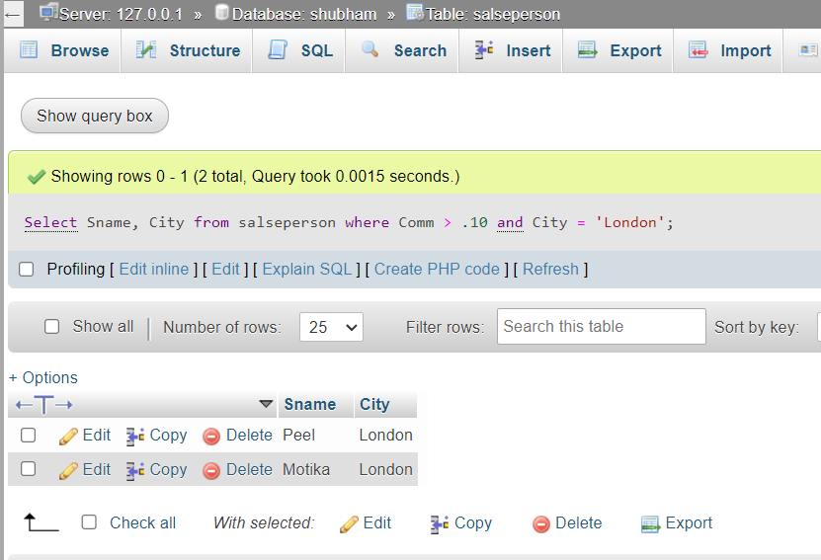

B -> All salespeople either in Barcelona or in London?

Ans-> Select Sname, City

from salseperson where City = 'Barcelona' or City = 'London';

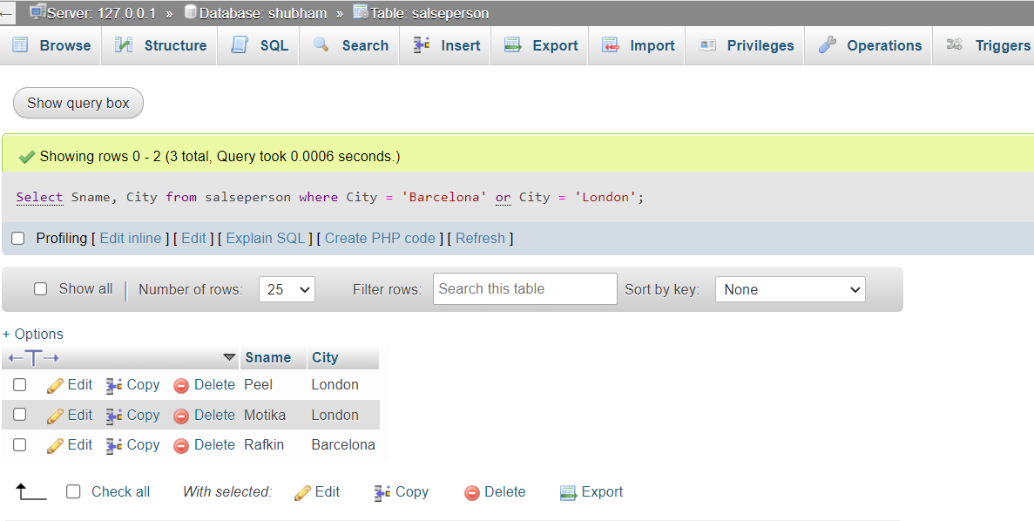

C -> All salespeople with commission between 0.10 and 0.12. (Boundary values should be excluded)?

Ans-> Select Sname, Comm

from salseperson

where Comm > 0.10 and Comm < 0.12;

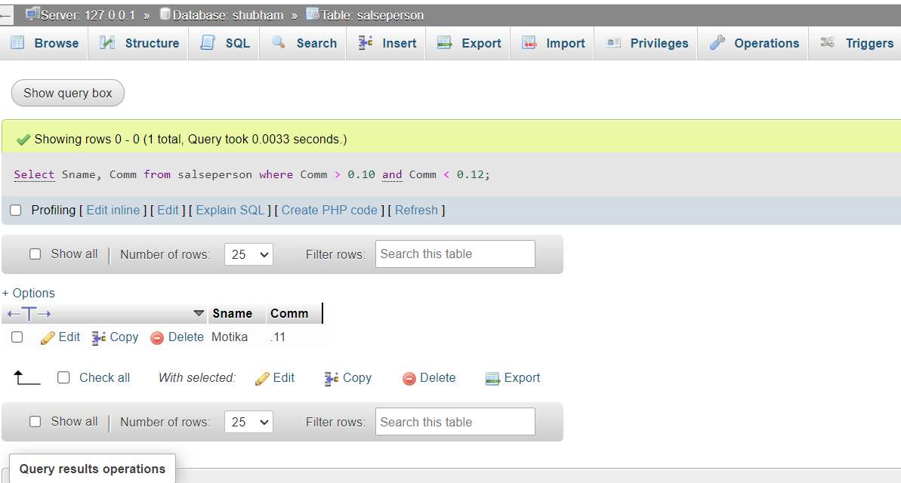

D -> All customers excluding those with rating <= 100 unless they are located in Rome?

Ans -> Select Cname from customer

where Rating <= 100 or

City = 'Roe';

