Experiment -1
Flight Reservation Using Zoho One (SaaS)
Aim
To create a Flight Reservation using Zoho One as a cloud-based Software as a Service (SaaS) application.
Procedure
- Access the Zoho One cloud platform using valid login credentials.
- Navigate to the Zoho Creator application from the Zoho One dashboard.
- Start a new application and name it Flight Reservation.
- Create a form to collect passenger, flight and booking information.
- Add necessary fields such as passenger name, email, flight number, travel date, payment method, booking date, contact number, seat number, departure time, and ticket amount.
- Select suitable field types, such as name, email, number, date, phone, single-line, time, and currency fields.
- Customize the form layout to make it simple and user-friendly for passengers to fill in.
- Configure the form settings and save the application.
- Publish the application to make the flight reservation form accessible to users.
- Fill in the form with sample passenger and flight booking details.
- Submit the booking information and check whether the records are saved correctly in the cloud database and displayed in the Booking View.
- Perform multiple booking entry tests to ensure the system operates properly as a Software as a Service (SaaS) application.

Implementation Input:
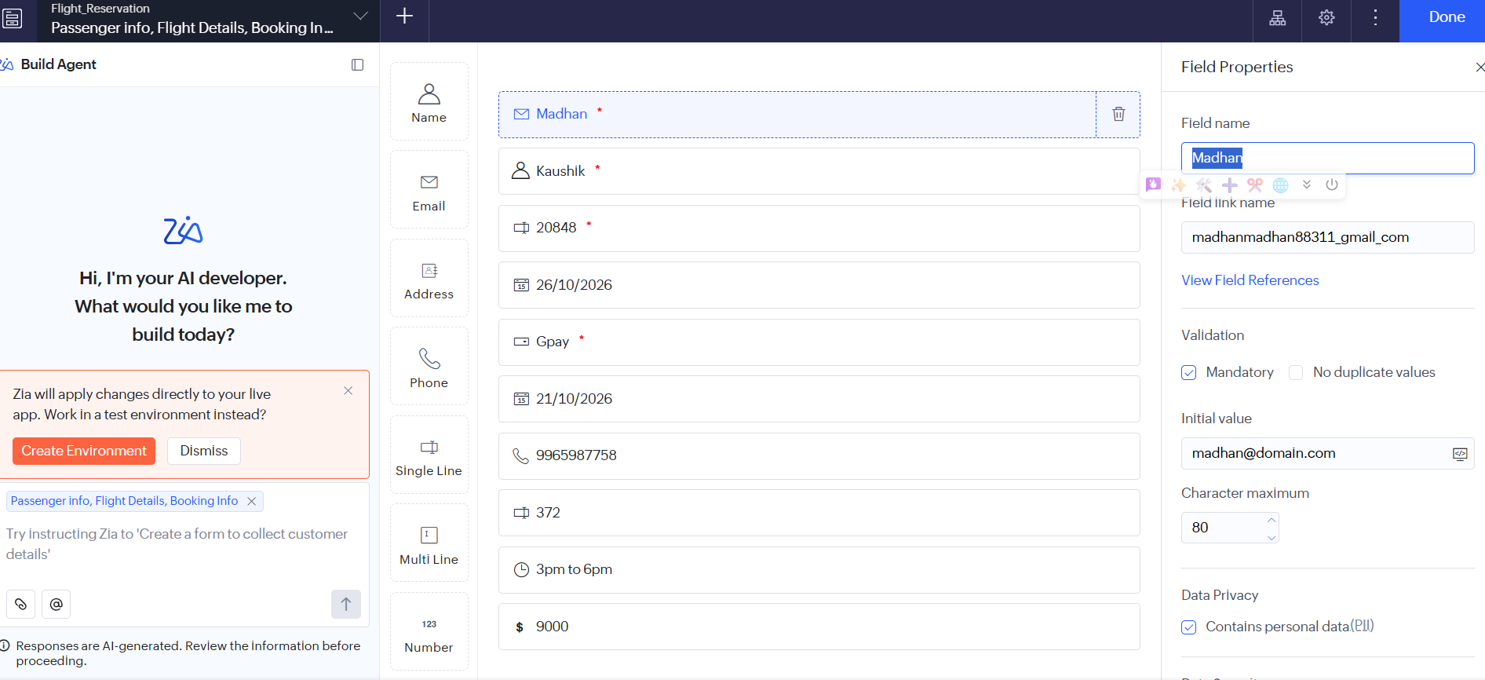
Output:
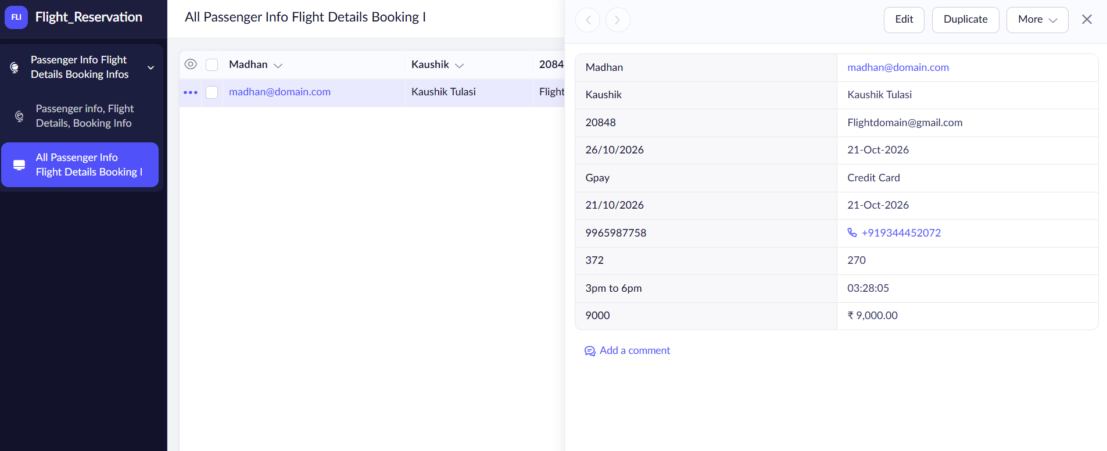

Result
Thus, a Flight Reservation was successfully created using Zoho One and demonstrated as a Software as a Service (SaaS) application.

