Experiment -1
Student Attendance System Using Zoho One (SaaS)
Aim
To create a Student Attendance System using Zoho One as a cloud-based Software as a Service (SaaS) application.
Procedure
- Access the Zoho One cloud platform using valid login credentials.
- Navigate to the Zoho Creator application from the Zoho One dashboard.
- Start a new application and name it Student Attendance System.
- Create a form to collect student attendance information.
- Add necessary fields such as staff name, student name, department, date, session, present students, and topics covered.
- Select suitable field types, such as name, dropdown, date, multi-select, and multi-line text fields.
- Customize the form layout to make it simple and user-friendly for staff to fill in.
- Configure the form settings and save the application.
- Publish the application to make the attendance form accessible to staff.
- Fill in the form with sample attendance details.
- Submit the attendance information and check whether the records are saved correctly in the cloud database and displayed in the Attendance View.
- Perform multiple attendance entry tests to ensure the system operates properly as a Software as a Service (SaaS) application.

Implementation Input:
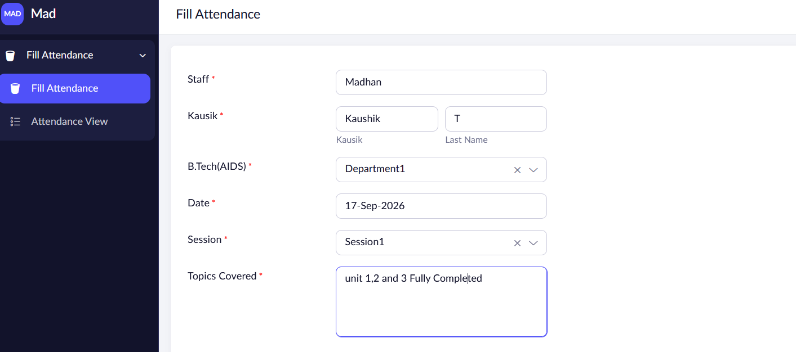
Output:
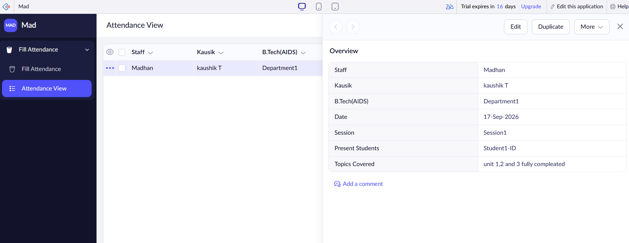

Result
Thus, a Student Attendance System was successfully created using Zoho One and demonstrated as a Software as a Service (SaaS) application.

