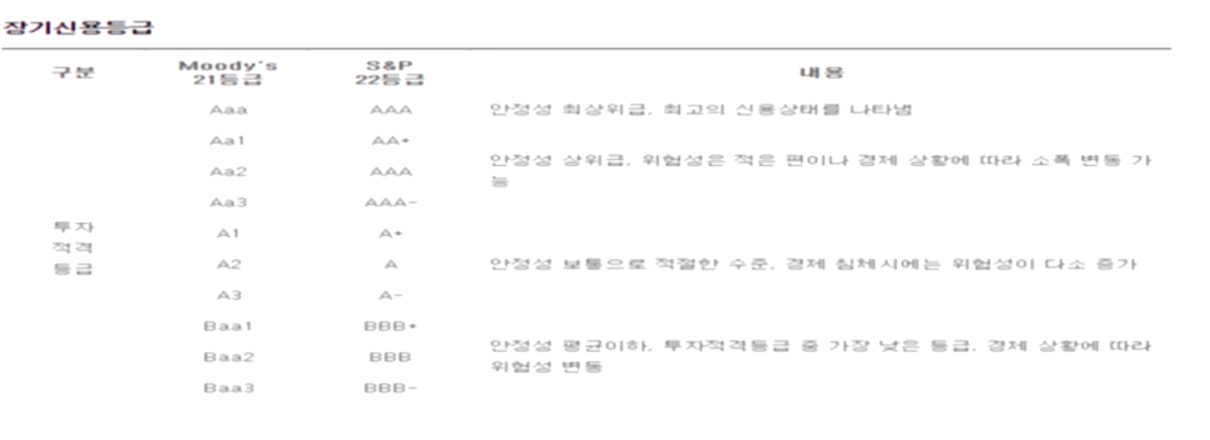

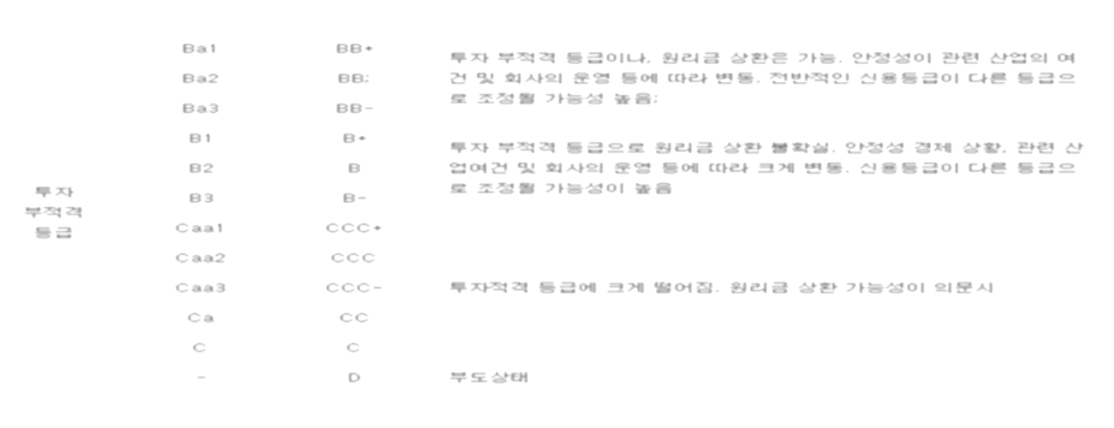

[**ICE BofA US High Yield Index Option-Adjusted Spread**](https://fred.stlouisfed.org/series/BAMLH0A0HYM2)

[**ICE BofA AAA US Corporate Index Option-Adjusted Spread**](https://fred.stlouisfed.org/series/BAMLC0A1CAAA)

[**ICE BofA AA US Corporate Index Option-Adjusted Spread**](https://fred.stlouisfed.org/series/BAMLC0A2CAA)

[**ICE BofA Single-A US Corporate Index Option-Adjusted Spread**](https://fred.stlouisfed.org/series/BAMLC0A3CA)

[**ICE BofA Single-B US High Yield Index Option-Adjusted Spread**](https://fred.stlouisfed.org/series/BAMLH0A2HYB)

[***ICE BofA BB US High Yield Index Option-Adjusted Spread***](https://fred.stlouisfed.org/series/BAMLH0A1HYBB)

[**ICE BofA BBB US Corporate Index Option-Adjusted Spread**](https://fred.stlouisfed.org/series/BAMLC0A4CBBB)

[**ICE BofA CCC & Lower US High Yield Index Option-Adjusted Spread**](https://fred.stlouisfed.org/series/BAMLH0A3HYC)

**ICE BofA AAA US Corporate Index Effective Yield (BAMLC0A1CAAAEY)**

**ICE BofA AA US Corporate Index Effective Yield (BAMLC0A2CAAEY)**

**ICE BofA US High Yield Index Effective Yield (BAMLH0A0HYM2EY)**

**ICE BofA Single-B US High Yield Index Effective Yield (BAMLH0A2HYBEY)**

**ICE BofA BB US High Yield Index Effective Yield (BAMLH0A1HYBBEY)**

**ICE BofA BBB US Corporate Index Effective Yield (BAMLC0A4CBBBEY)**

**ICE BofA CCC & Lower US High Yield Index Effective Yield (BAMLH0A3HYCEY)**

**ICE BofA US High Yield Index Total Return Index Value (BAMLHYH0A0HYM2TRIV)**

[**Leading Index for the United States**](https://fred.stlouisfed.org/series/USSLIND)

[**University of Michigan: Consumer Sentiment**](https://fred.stlouisfed.org/series/UMCSENT)

[**Consumer Price Index for All Urban Consumers: All Items in U.S. City Average**](https://fred.stlouisfed.org/series/CPIAUCSL)

[**30-Year Treasury Constant Maturity Rate**](https://fred.stlouisfed.org/series/DGS30)

[**20-Year Treasury Constant Maturity Rate**](https://fred.stlouisfed.org/series/DGS20)

[**10-Year Treasury Constant Maturity Rate**](https://fred.stlouisfed.org/series/DGS10)(장기채)

[**7-Year Treasury Constant Maturity Rate**](https://fred.stlouisfed.org/series/DGS7)

[**5-Year Treasury Constant Maturity Rate**](https://fred.stlouisfed.org/series/DGS5)

[**3-Year Treasury Constant Maturity Rate**](https://fred.stlouisfed.org/series/DGS3)

[**2-Year Treasury Constant Maturity Rate**](https://fred.stlouisfed.org/series/DGS2)

[**1-Year Treasury Constant Maturity Rate**](https://fred.stlouisfed.org/series/DGS1)

[**3-Month Treasury Constant Maturity Rate**](https://fred.stlouisfed.org/series/GS3M)

[**1-Month Treasury Constant Maturity Rate**](https://fred.stlouisfed.org/series/DGS1MO)

[**Overnight London Interbank Offered Rate (LIBOR), based on U.S. Dollar**](https://fred.stlouisfed.org/series/USDONTD156N)

[**1-Month London Interbank Offered Rate (LIBOR), based on U.S. Dollar**](https://fred.stlouisfed.org/series/USD1MTD156N)

[**3-Month London Interbank Offered Rate (LIBOR), based on U.S. Dollar**](https://fred.stlouisfed.org/series/USD3MTD156N)

[**12-Month London Interbank Offered Rate (LIBOR), based on U.S. Dollar**](https://fred.stlouisfed.org/series/USD12MD156N)

[**TED Spread**](https://fred.stlouisfed.org/series/TEDRATE)

[**Trade Weighted U.S. Dollar Index: Major Currencies, Goods (DISCONTINUED)**](https://fred.stlouisfed.org/series/DTWEXM)

[**Wilshire 5000 Total Market Full Cap Index**](https://fred.stlouisfed.org/series/WILL5000INDFC)

인플레이션? 이슈따라잡기 28

금융위기는 은행위기 1차오일쇼크 1990년대 저축내부조합위기 2008년 금융위기

불황(금리 인하, 저성장) 은 금융위기와 구분,

금융위기는 통화확장의 과정이 막히는것 , 금리급등과 연관

어떤 자산이 망할지 모르므로 가격을 떨어뜨려서 다팜 = 금리가 올라가는 것과 연관되어 있음 회사채 금리 급등

그래서 저금리에서 금융위기가 오는 사례를 보기 힘듬