|  |
| --- |
| Introduction to Multi-Agent Systems |
| Garbage Collector problem |
| Team 4 |

|  |
| --- |
| Angel Astudillo AguilarDaniel García ZapataDarío Perez PrincipiEmanuel Sánchez AimarPablo Reynoso Aguirre 2/2/2017 |

# Abstract

This report is based on the garbage collection project; which consists of a scenario in a city where garbage must be collected from buildings and send to recycling centres. This report details the implementation done in java using jade framework and our code.

# Implementation

In this section, we will detail the final implementation solutions break down between the agents and the interactions among them.

## Architecture

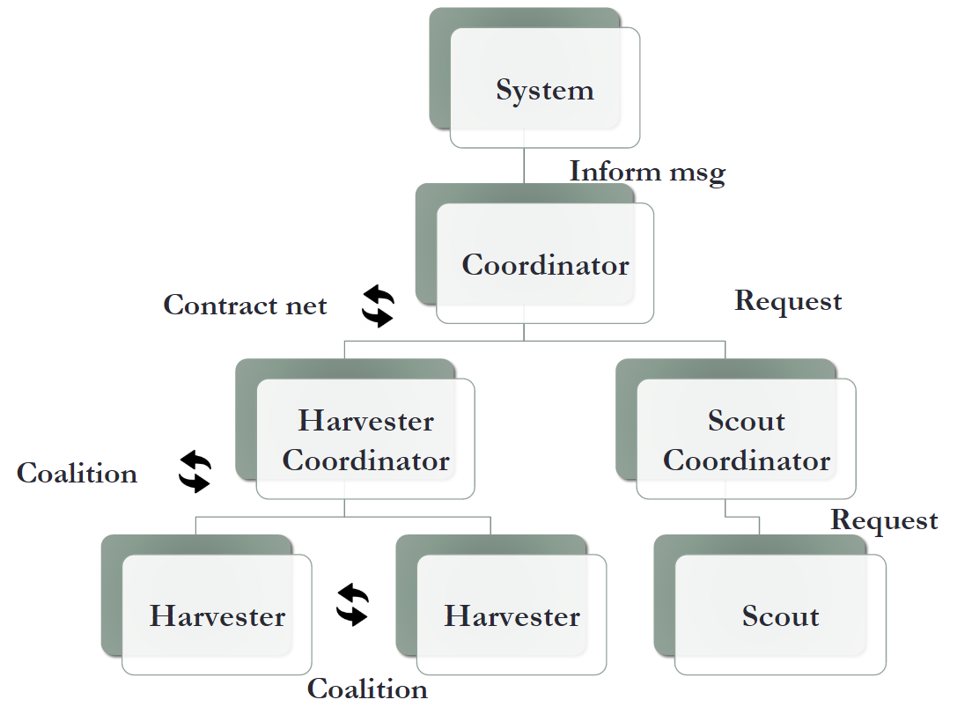

### Scouts

Scouts follow a predefined path, each one has a different path that will guarantee all the city will be swept. Each scout knows where they came from, their behaviour is to go straight ahead. In the case, it can’t, it looks if it can go to clockwise. The second option is to go counter-clockwise. The last option would be to go back to the way it came. They always react to the buildings they cross to see if there is garbage.

### Harvesters

The behaviour of the harvester is defined by a coalition that is formed by the harvester coordinator.

## FIPA Protocols

### Scouts and Scout Coordinator

The scouts are constantly looking for garbage. At the end of each step, the Scout Coordinator makes a request protocol to the scouts to inform if they found garbage in a building. In the case, they found it, they reply the message with the cell object, in any other case they reply with a null list.

### Coordinator and Scout Coordinator

The scout coordinator receives the location of the garbage found by each scout. After very step, the scout coordinator makes a list that contains the garbage found in that step. Then, it sends the list to the coordinator agent. The communication between them is made using the inform FIPA protocol.

### Coordinator and System Agent

### Coordinator and Harvester Coordinator

The coordinator agent is given a list of garbage that needs to be picked up. It is in this moment when the coordinator agent creates a Contract Net. The sole winner of the Contract Net is the Harvester Coordinator and it always accepts the proposal. Once the Harvester Coordinator has the contract it now performs a coalition to perform the task. The Contract net has five steps which are followed; in this implementation, the two agents always accepts the proposal, there is no reject. When the task is finished, the Coordinator agent keeps a list of garbage collected.

### Harvester Coordinator and Harvesters

When the harvester coordinator has been assigned to a contract, it starts the coalition protocol to delegate the task to the harvesters. If the contract can be performed by one harvester, then it forms a coalition of one; in any other case the coalition is formed between more harvesters up until three. When deciding the coalition, we consider all the permutations up until three agents. The value of the coalition is calculated using the distance from each harvester to the garbage; the distance from the garbage to different recycling centres with the amount of points the centre pays; the number of trips taken to the recycling centre is also considered. A harvester cannot bid for a coalition when it is already in one. Once the coalition is formed, the harvester coordinator calculates the optimal path using the algorithm Floyd Warshall, that simulates and calculates the shortest path considering adjacencies and distance matrixes as a representation of the map graph.[1]

# Main Differences from previous phases

## Coordinator Agent

* **Previous Phases:** In the previous phases, we considered the coordinator agent to react to two things. The first one is to transfer information through an inform from both the scout and harvester coordinator. The second one is to tell the system agent when the task has been completed.
* **Final Implementation:** In the implementation, the coordinator agent once it receives the garbage list from the scout coordinator, the coordinator agent would start a contract net with the harvester coordinator so this agent takes the control of collecting the agent. The decision for this is that we need feedback from the status of the recollection of the garbage so we can calculate the statistics. Contract net includes a feedback inform where we can collect the status of the garbage.

## Harvester Coordinator and Harvester Agent

* **Previous Phases:** In the previous phases, we established to integrate a contract net between the harvesters and the harvester coordinator, this contract net would be used for collecting garbage and would have been divided by type of garbage.
* **Final Implementation:** In the final implementation, we realised that it could be the case where the harvester cannot collect all the amount of garbage in a building. For this final implementation, we decided to change the Contract Net protocol into a Coalition protocol. The process would be the same but instead of a contract a coalition would be formed, in the case that one harvester could collect the garbage then a coalition of one would be established in any other case a coalition of two or more harvesters would be formed.

## Between Scout Agents

* **Previous Phases:** In the previous phases, we decided the scout agents would make a coalition to scan all the city. Then, the coalition would divide the different areas and swept these areas to find buildings with garbage.
* **Final Implementation:** In the final implementation, we decided to implement a reactive behaviour. They will follow a predefined path, each one has a different path that will guarantee all the city will be swept. While following this path, they react to the buildings when a garbage is found.

## Scout Coordinator

* **Previous Phases:** In the previous phases, the scout coordinator would have a representation of the map and city. The scout coordinator would calculate the optimal routes in areas where no garbage has been searched for.
* **Final Implementation:** In the final implementation, we decided to implement a reactive behaviour on the agents. They will follow a predefined path that will guarantee all the city will be swept. The scout coordinator does not have any method to calculate paths for the scout agents, in the final implementation.

# Statistics

* **Current benefits:** amount of points received for recycling garbage.
* **Average time for discovering garbage:** the amount of time spent from garbage appearance until a scout discovers it.
* **Average time for collecting garbage:** the amount of time spent from garbage discovered until the first harvest gets to that point.
* **Ratio of discovered garbage:** the ratio of the garbage that is already discovered by scouts from the total.
* **Ratio of collected garbage:** the ratio of the garbage that is already collected by harvesters, including that in the harvesters and that already recycled in recycling centres.

# Conclusions

The final implementation met our expectation in performance. Although there are different approaches to solve this problem, ours solves quite efficiently using an easy architecture. Using this approach, we got good statistics that minimises time while using optimal methods such as Floyd Warshall and maximising the points obtained from the recycled garbage. Further work would be to optimize methods such as a more optimal approach for the scouts to find garbage.

# Bibliography

Singh, A., & Mishra, P. K. Performance Analysis of Floyd Warshall Algorithm vs Rectangular Algorithm. International Journal of Computer Applications, 107(16). India, 2014.

1. Singh, A., & Mishra, P. K.