got recipes?

Logan Mooney, Alexis Glasgow, Thomas Harris, Tony Robinson, Safa Asadi

got recipes? is a modern take on the traditional meal-planning application. The goal of our app is to provide college students and young adults with an easy way to plan meals while using ingredients they already have at home. This app will make it easy for young, single adults to cook for themselves, while also reducing food waste. got recipes? is a mobile application that keeps track of what food people already have at home and gives recipe suggestions based off those ingredients. got recipes? also acts as grocery list -- once the user indicates that they bought an item, got recipes? adds the item to the user’s virtual pantry. Finally, got recipes? keeps track of the shelf life of each item in the user’s pantry. This feature encourages users to use food before it spoils, thus reducing waste.

# THE PROBLEM

A common problem that many college students and busy families run into

is the grocery store dilemma. Many times we will absent-mindedly go into a store

and purchase random items that don’t form a specific meal. Other times we’ll have

the perfect ingredients in our fridge, but we don’t know of recipes that use those ingredients. Sometimes, we go into the store and forget what we have in the pantry, so we spend extra money repurchasing things we already have. Many items spoil without being used up because we don’t know when our food expires.

A study focused on University residents and their eating habits, found “The majority of the participants did not consider the nutritional value while consuming a particular food item. They even admitted that they did not have good knowledge about the nutritional value of the food they commonly eat as part of their daily meals” (Kabir, 2018). This shows how little knowledge students have about what they are putting into their bodies. Furthermore, many households find that they are throwing away items because they went bad before being prepared. In this study it was found that households threw away greater quantities of unprepared food in the 48-hour recall period (268.6±610.1 g, 90% confidence interval: 175.5 to 361.7 g) compared to prepared food (121.0±132.4 g, 90% confidence interval: 100.8 to 141.3 g) (Chakona, 2018). This indicates that if people can turn the ingredients in their fridge into prepared food, they will be more likely to use them rather than having to throw them away.

# OUR SOLUTION

These problems can be solved with our mobile app, got recipes?. The app keeps track of what food people already have at home and gives suggestions for recipes that use those ingredients. Recipes will include calorie and nutrition facts to help busy students and families with healthier eating habits that also makes the best use out of your pantry. It also acts like a grocery list for when you are out shopping which helps with overspending or under purchasing items. Your virtual pantry saves items every time a grocery list item is crossed off on the app, so you always know what you have on hand.

# USERS

**Target Users**

The target users for our application are primarily college students and young adults. Other users who may find the app useful are working parents or single adults who have little time to cook and plan meals.

This is an appropriate target group because many college students are having to cook for themselves for the first time. They are also only cooking for one person, which presents many challenges. The app will help them use the food they have in their fridge before it goes bad and give suggestions for new recipes. Working parents or single adults may also find this useful. Working parents are often short on time, so it is useful to have an app to plan and track meals. Single adults, like college students, share the challenges that come with cooking for one person.



**Non-Target Users**

Anyone below college-age (~18), senior citizens, people who don’t cook for themselves

In order to verify these assumptions, our team conducted a series of interviews that focused on our target user groups. The results of our user research are detailed below.

# USER RESEARCH

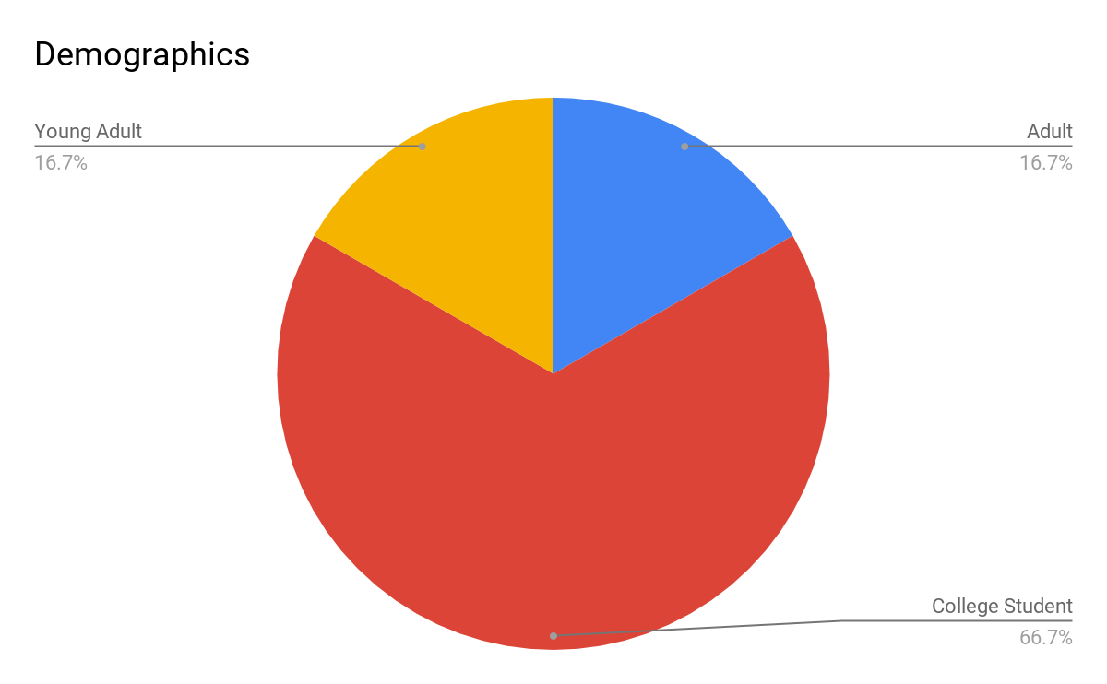

# Points scoredPoints scored

The above data confirmed our assumptions that college students and young adults would be the primary beneficiaries from this application. Older, single adults could also benefit from the app, but parents who cook for multiple people daily are not likely to use the app. Our research showed that parents rarely had food go bad in their fridges, but almost all college students suffered from frequent food spoilage. Every potential user that we interviewed cooked for themselves at least twice a week, but most users cooked for themselves almost every day or every day.

# PERSONA

**Meet Emma**

Emma is a 21 year old college student who is living off campus for the first time. She is an education major and spends half of her week student teaching at an elementary school. She lives in a house with 3 other roommates. Emma works at a restaurant downtown and will sometimes get her meals there, but she is trying to cook more to save money. Emma likes to cook, but finds she makes the same few things all the time. She only knows a few recipes, but doesn’t want to spend the time searching for new ones. She is also very frustrated with grocery shopping. She says, **“I don’t know how to ration out food so that it stays fresh. I’ve been wasting a lot of food because I don’t know how to cook for just one person”** (quote from an interview). Emma feels like by she is actually wasting money instead of saving it in her effort to cook more because she throws away so much food. At this point, she is ready to give up and keep eating out for meals.

# TASK ANALYSIS

**Are these mobile users, desktop users, people in the library, etc?**

The users would be mobile. Reason being that they are going to use this app on the move, keeping track of food they eat/get from stores.

**What geographic area are the users in? How does this impact them?**

Users can be almost anywhere with a internet or cellular connection. They need a connection to use an app so they can't be out of range. They also need to be able to shop at a grocery store or local market.

**What is the age range of the users? Does that impact things?**

This app is primarily for college aged individuals, but also works for young to older adults who don't have time to make meals due to money, time, etc.

**What are the implications of economic standing?**

Users at least need to be able to obtain bare minimum when grocery shopping. (Ex. Milk, Bread, deli meats)

**HTA for getting recipes from the app**

* + - Task 1: Getting recipes from app.
      * 1.1 open app
      * 1.2 open pantry/fridge
      * 1.3 log food found in pantry/fridge
      * 1.4 look at recipes provided for current food logged
      * 1.5 prepare meal based on what food you have and what recipe was chosen

**HTA for tracking food purchases on the app**

* + - Task 2: Tracking food purchases on the app.
      * 2.1 go to local grocery store
      * 2.2 open app while you are shopping
      * 2.3 search for food to satisfy a current recipe or get food and see what recipes will fit what you bought
      * 2.4 As you pick up food, scan it so that it can be logged into the app
      * 2.5 prepare meal based on what food you have and what recipe was chosen

# EXISTING SOLUTIONS

There are a few different apps for tracking food you have in your fridge, including RecipEase, MyKURA, and Out of Milk. There are also some apps for finding recipes based on what you currently have in your pantry, like SuperCook and MyFridge. However, we couldn’t find any apps that combined the two functions. Even RecipEase, which contained a function to search for recipes didn’t allow you to search based on what you had in your pantry.

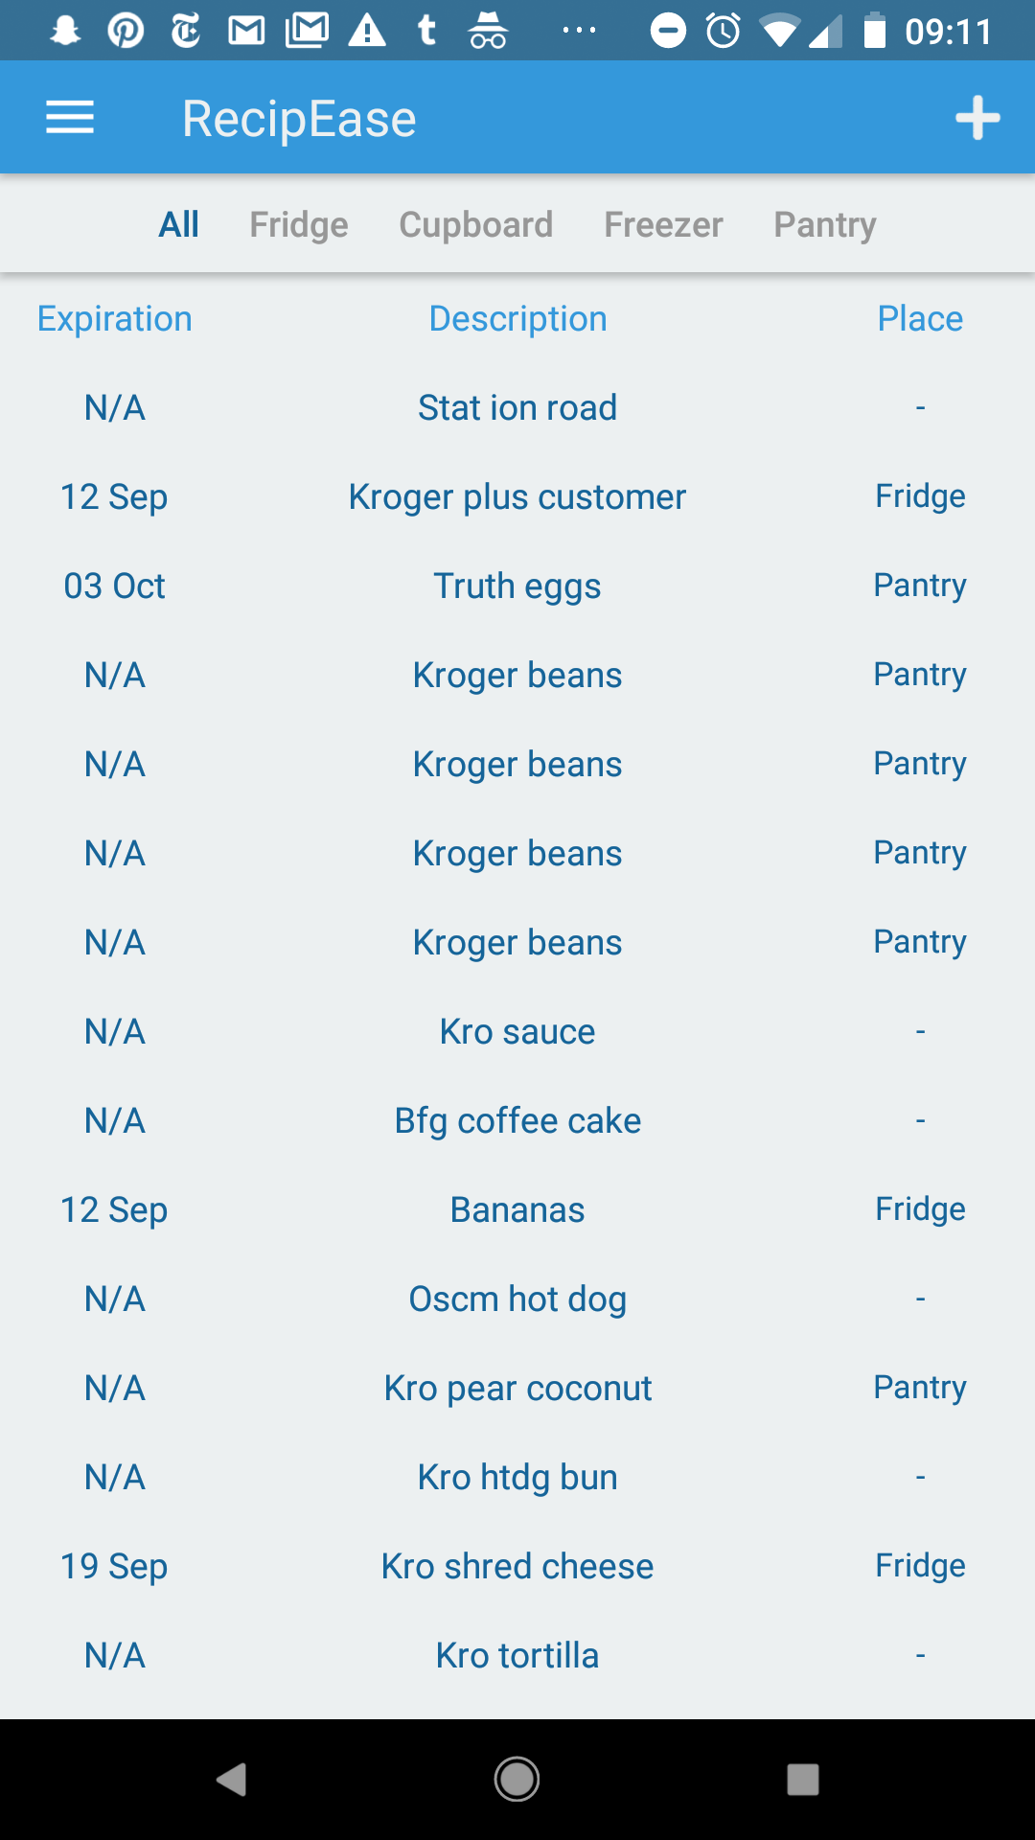

**Food Tracking Apps**

RecipEase

Each of the apps had a different method of entering items automatically. RecipEase takes a picture of your receipt and automatically adds the items to your pantry. It even tries to categorize items based on where they would belong (i.e. eggs in the fridge) and include expiration dates. This worked well for some items, but receipts generally include discounts and items that aren’t immediately identifiable (e.g. I bought soap that was listed as “pear coconut” and was placed in the pantry by the app).

There is also an option to enter items manually, which takes the form of a text box at the end of your current list where you can enter an item name like and go back later and add an expiration date and a location where the item is kept. I appreciated this method of manually entering information because it didn’t take the user away from the page they were looking at, and it would make it faster to add items to the list. Adding an expiration date to the item was also easy. The app pops up a calendar view to easily add a date. One issue I saw in the process is that adding an item to a location involved a very small drop down menu that wouldn’t be very easy to select from.

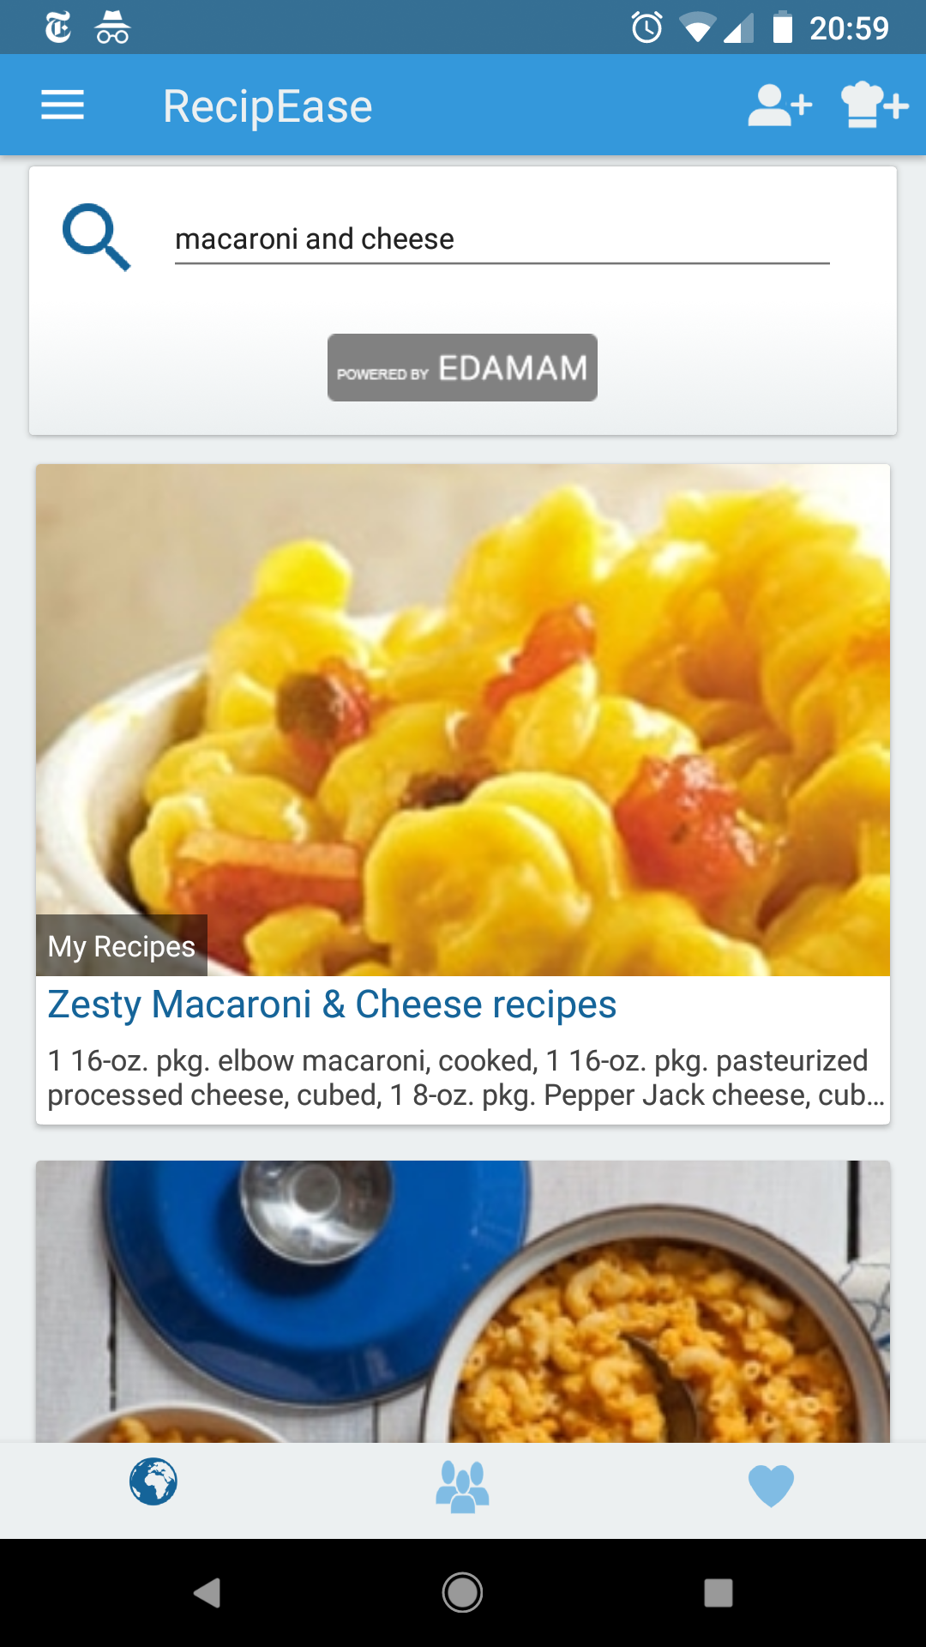

In terms of displaying information, the app is pretty bare bones. It simply has a list of the items you have in your pantry, shown with the expiration date and location. It includes tabs to view each item individually, allowing a user to see only the items in their freezer for example, which would help narrow down the items a user is looking at. It does seem like looking through this list would get cumbersome. There isn’t a way for users to quickly check whether they have a specific product without reading each individual item name. This is especially difficult if a user entered the item names automatically, as the names on receipts aren’t always intuitive.

Out of Milk

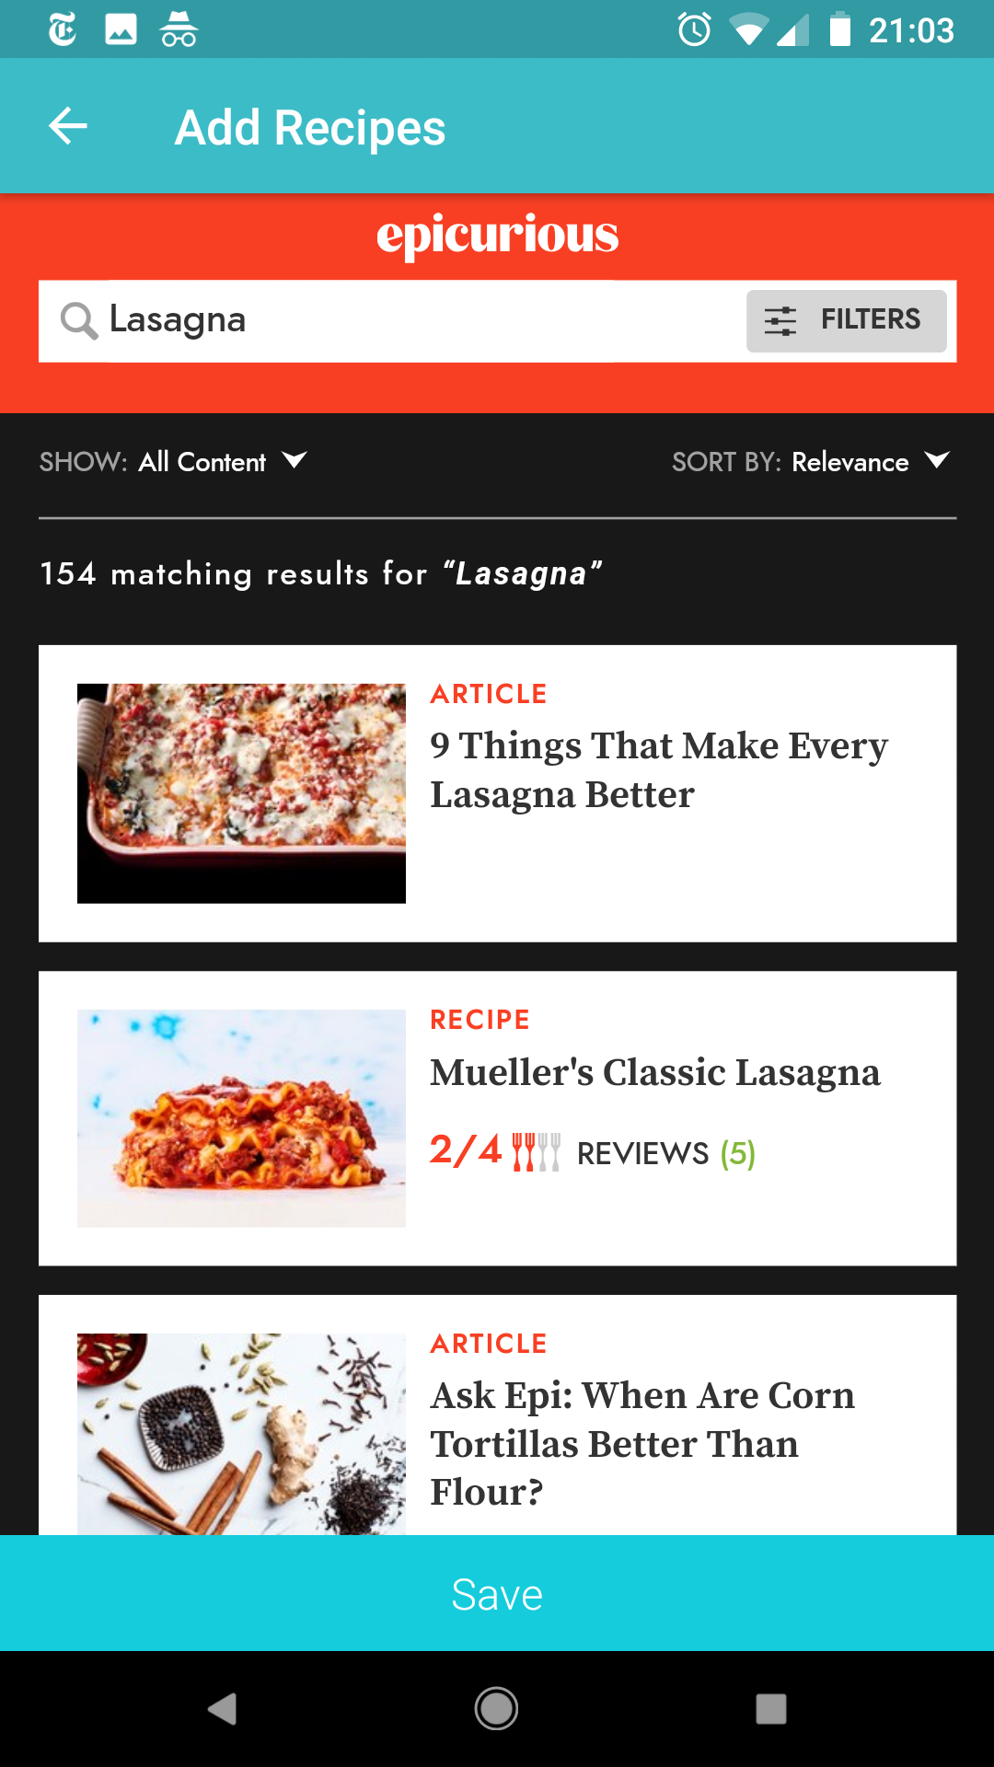

Out of Milk includes a barcode scanner in order to automatically enter items, which was very convenient. It also allowed users to quickly add items by just typing in the name rather than going through the whole form process. Unlike in RecipEase, this name was added at the top rather than the bottom, which made it more enjoyable to use since there was no scrolling required to access the add item function. The app also allowed a user to mark whether the item was “full” or “low”, which could be helpful in determining when to buy more.

Out of Milk also had a much more intuitive way of displaying information. Items were displayed by color-coded category rather than location, which would allow for a more intuitive way to find the ones you’re looking for. For example, if a user wanted to know if they had milk, they would search through the items in the dairy category rather than reading through everything in the fridge. Categories of common things like “eggs” were automatically included, though a user could also tap an item to be brought to a form where they could manually select it. 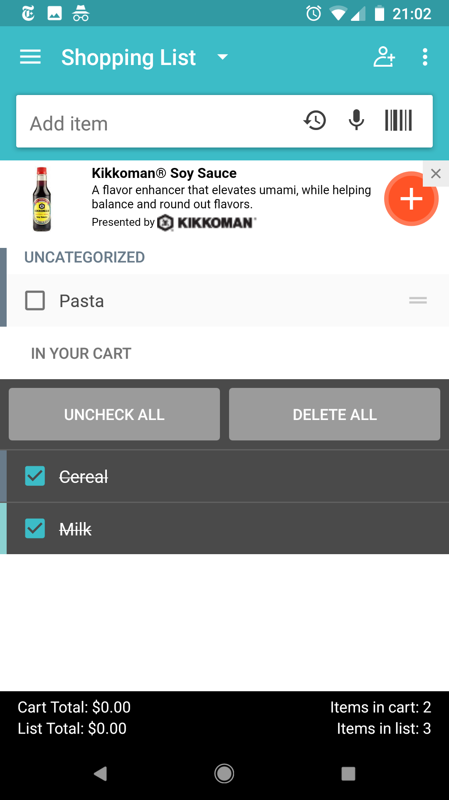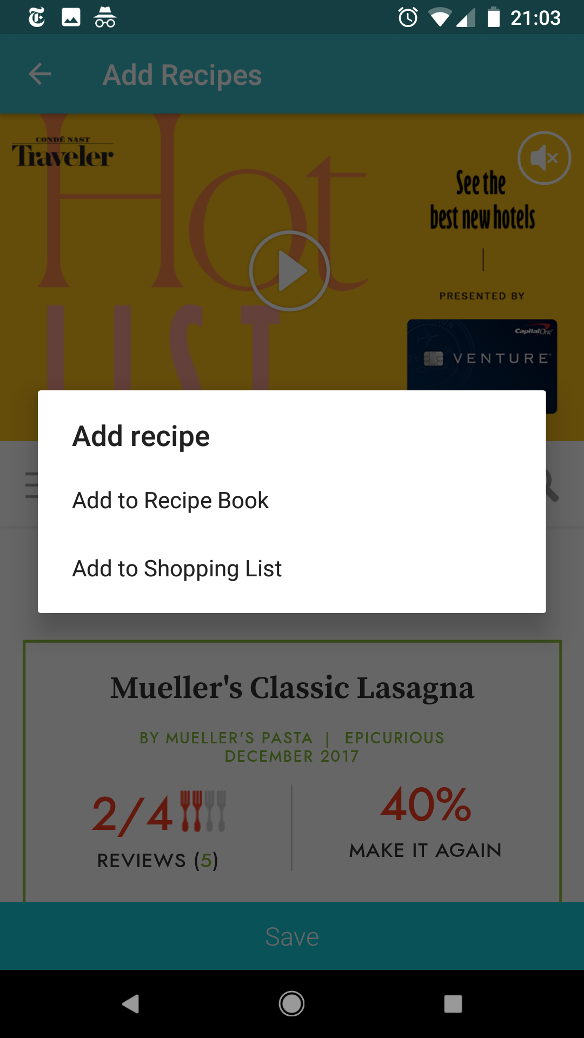

One feature that was particularly helpful in Out of Milk was the ability to automatically add items to a shopping list. Each item in your pantry list had a check box next to it that could be checked in order to send an item to your shopping list, which was also divided up by category to make shopping easier. It was also possible to add things to the shopping list in the same way as adding items to the pantry.

MyKURA

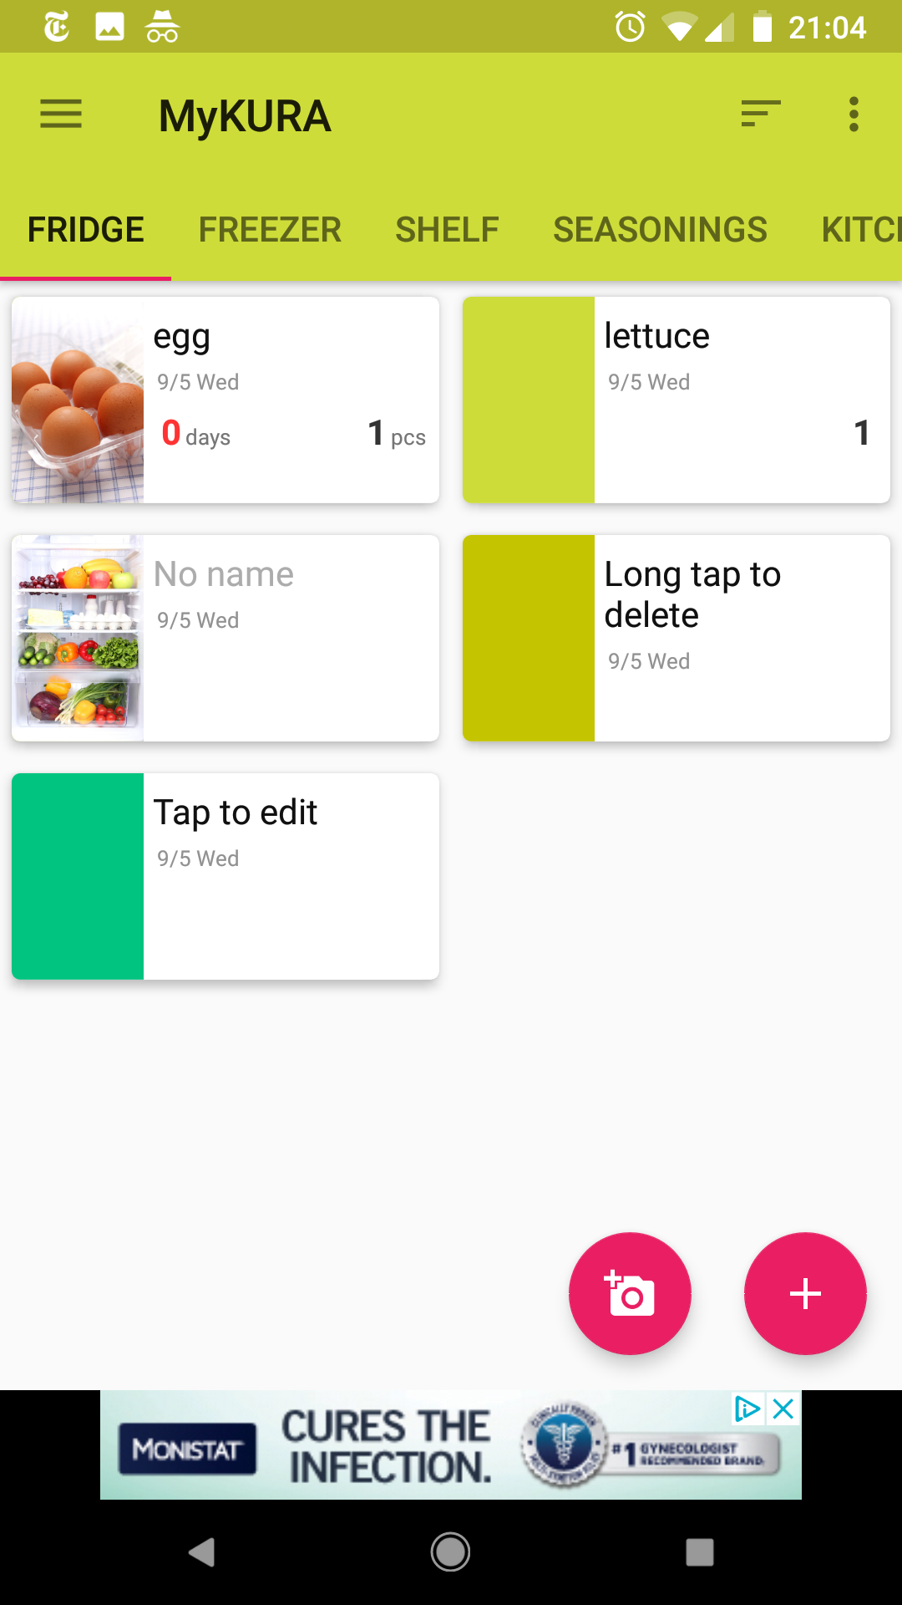

MyKURA was set up by location rather than category, like RecipEase, and it didn’t include a shopping list function. The one thing I really liked about it was that it included a function to take pictures of your items, which lets a user see the foods they have rather than just being able to read the names. Items can be added with only a picture, only a name, or both a picture and a name. Users can also manually color-code their food if they don’t want to include pictures.

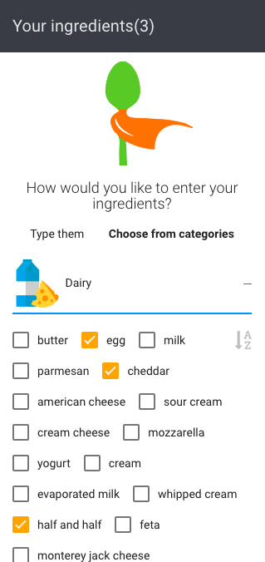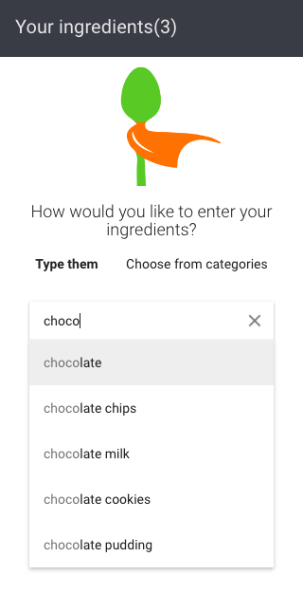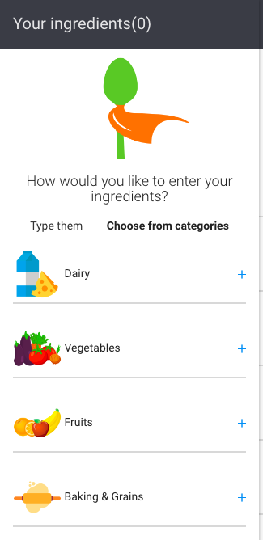

**Recipe Search Apps**

There are a few different apps to search for recipes based on the food you already have. To use them, a user scrolls through a list of items and checks the boxes next to the ones they already have. They then click submit and the app finds recipes that use only items they have or items they have plus a couple extras.

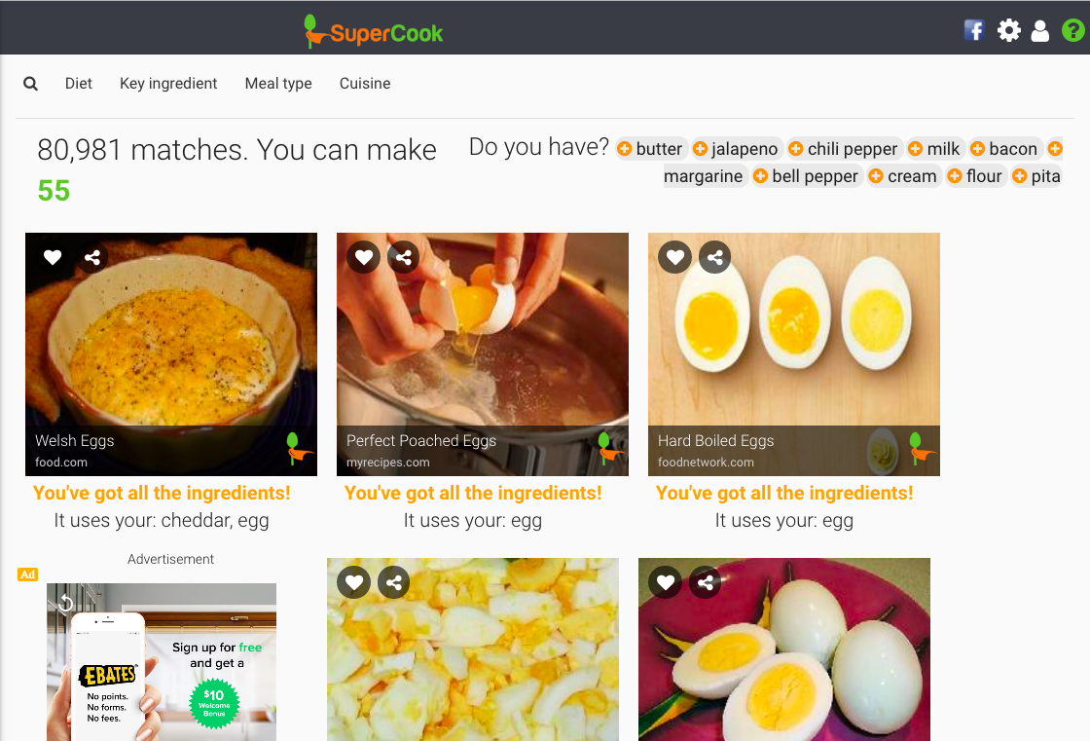

MyFridge allows a user to search for a specific category of recipe rather than just searching for any recipe that includes their ingredients, which was a nice feature.

**Conclusion**

There were some features in these apps that worked very well, and some that were cumbersome to use. After trying out the various apps available on the market now, I would include a feature to track the expiration dates of your foods as well as categorizing foods by type rather than location. Our goal to include both a shopping list function and a recipe search function would fill a niche I don’t see filled right now by allowing users to combine the functionality of something like Out of Milk with an app like MyFridge and reduce the time and memory necessary to use both of these apps separately.

# SUMMARY AND NEXT STEPS

From using the current fridge-tracking apps, we learned that intuitive and simple data entry is important. Users will quickly lose motivation to use the app if it uses a significant portion of their time when grocery shopping. We also learned that since most users used a shopping list while grocery shopping, we could make fridge tracking more transparent to the user by including a grocery list function which adds things to the pantry and can be added to from the pantry.

In the existing apps, we also saw different ways of displaying the data. The apps divided the items in a user’s fridge into different categories. The categories they used made a huge impact on the usability of the data presented. When items were divided up by the location where they were stored, there were long lists that were difficult to parse because a wide range of things are stored in any one location. Apps that used categories of foods instead were much easier to use, and they would also make shopping easier because they break things up in a way that is similar to the way grocery stores shelve their products.

In talking to the users, we got some helpful information about what they may be looking for in an app like this. Users asked about multi-user functionality, in order to accomodate roommates sharing a fridge who may each have their own personal items or couples living together who might not be keeping track of what the other is buying. During our research, we also found that a feature to track caloric intake was not necessary. None of the users interviewed tracked their calories, or had any desire for this feature. We feel that a calorie tracker is not necessary and will distract from the true purpose of the application.

A next important step in the design process will be creating a list of specific features we may want to include in our app, based on user interviews and features of existing apps. We will poll users on these features and see which would be helpful and which would just clog up the UI with unnecessary information. We may also want to show users some of the existing apps and get input on their usability and functionality in order to figure out which methods of data entry and display make sense to them and which are difficult for novice users to get the hang of.

Once we decide on the design of our application and the exact features we want to include, we will create a prototype of the application. We will continue our research with user testing. By allowing users to interact with our prototype, we can see where we need to make changes and improve. We can also validate our assumptions regarding what features are useful and which are not.

# REFERENCES

Chakona, Gamuchirai, and Charlie M. Shackleton. “Local Setting Influences the Quantity of Household Food Waste in Mid-Sized South African Towns.” Ed. Robert Nerenberg. PLoS ONE 12.12 (2017): e0189407. PMC. Web. 5 Sept. 2018.

Kabir, Ashraful, and Shahgahan Miah. “Factors Influencing Eating Behavior and Dietary Intake among Resident Students in a Public University in Bangladesh: A Qualitative Study.” PLOS Medicine, Public Library of Science, 2018, journals.plos.org/plosone/article?id=10.1371%2Fjournal.pone.0198801.