MUSI 4458-6304 Individual Assignment 3

Chaeryeong Oh

The project is available in https://jade570.github.io/korean_plants_sound/ : it generates the sound in real time as it shows which DNA & codon sequence it is playing at.

The intent of the composition
I wanted to sonify the DNA sequence and codon (amino acid/protein) sequence of Korean native plants. My initial intention was to use 6 native plants of different places (mountains) of Korea, each of them singing in different instrument and pitch, making a harmony. I ended up using one plant, which is Korean fir, which mostly lives in Halla mountain (the second tallest mountain in Korea and the tallest mountain in South Korea) of Jeju Island (the biggest island in Korea).

The style of the composition
I collected the DNA sequence of each plant from Korean National Institute of Biological Resources(https://species.nibr.go.kr/index.do), translated it into codon with biopython, and analyzed it in Predict Protein(https://predictprotein.org/). Then, using tone.js, I played FM synthesizer with analyzed data. I tried to use resources provided for the individual project 3 as much as possible:

Massiaen Mode: for each section of codon (from a new start codon to stop codon, and it is divided by a white space), the mode is changed.

Non-retrogradable rhythm: the combination of the codon may or may not compose a non-retrogadable rhythm. Depending on where the nucleotide (A, T, G, or C) is in, the rhythm changes. If A is the first sequence of a codon, it plays a note-note-rest triplet. If it is the second nucleotide, then it plays a note-rest-note triplet. If it is the last nucleotide, it plays rest-note-note triplet. Sequence like AXA (X as any nucleotide) will make non-retrogadable rhythm. G works the same way with different rhythm – in short, a DNA palindrome will make a rhythm palindrome.

Isorhythm – the concept of color and talea is why I started this project. Color and talea going independently inspired me of the concept of DNA sonification... but if I wanted that, I should have separated the rhythm rule and sound rule managed by different factors. I eventually got so stressed on making rules and made a big mistake… of putting these rules in the same factor – nucleotides.

I wanted to use this shown in web with interactive visuals, and I thought I would need a memory to work on the project. Since I have used tone.js before and I had a hard time understanding how to save data in Max, I started using tone.js. However, I found my lack of understanding in tone.js and it took more time than expected.

Deep dive into rule sets:
The rhythms are inspired by the structure of nucleotides.
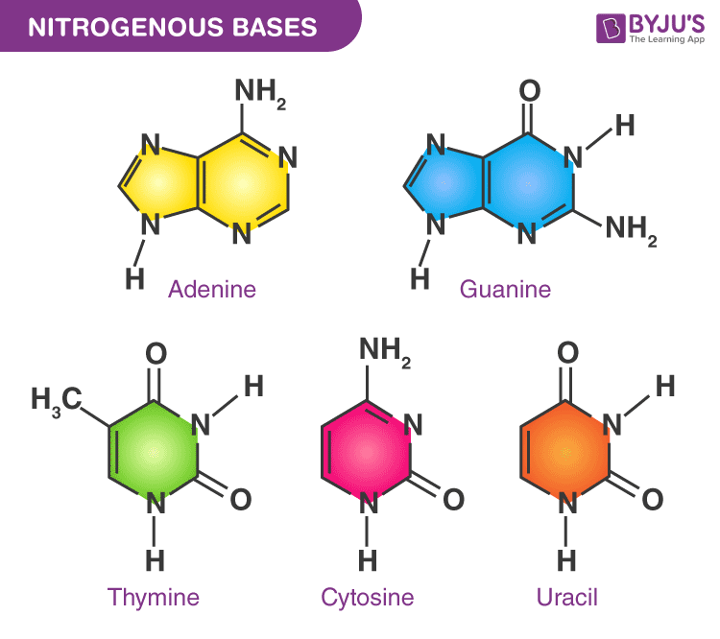
(image from https://byjus.com/neet/nucleotide/)
Pyrimidine nucleotides (Thymine, Cytosine) have one loop. I made these nucleotides sound without swing rhythm. Thymine has more side branches than Cytosine (1 8th note), so I added one more note in Thymine (2 16th notes).
Purine nucleotides (Adenine, Guanine) have one smaller loop with the main loop. I initially described this as a swing note. Because Guanine has more side branches, I added one more note. Adenine is described as a 16th note triplet with one rest, and Guanine is described as a group of 4 32nd notes with one rest. Depending on the sequence, I made the rhythm go on reverse. Then I noticed that it would be better to have another state to describe Adenine and Guanine being the 2nd nucleotide of the codon to be fully non-retrogradable, so note-rest-note (for 2nd Adenine) and note-rest-rest-note (for 2nd Guanine) is made.

The pitch change is inspired by the acidity of nucleotides. The pH of Adenine is 4.15, Thymine is 9.7, Guanine is 3.3, and Cytosine is 4.45. Setting Cytosine as the default acidity (0), I measured numbers relative to Cytosine’s acidity. Adenine will play 1 note lower in the current Massiaen mode. Thymine will play 3 notes higher. Guanine will play 2 notes lower.

As the mode is changed by each group of codon sequences, the tonic is also changed by the starting codon. Generally, UUG, AUG, and GUG could be a starting codon, which represents Methionine, Leucine, and Valine amino acid. UUG, AUG, GUG and the other codons result in 4 cases of start codons, so I set the possible tonic to be a component of a C diminished 7th chord, which of each having the same intervals. Since Methionine is the amino acid of the most possible start codon, I set this as C, Valine and Leucine as Eb and Gb, and the other cases as A.

For the protein analysis, I could get the prediction of how the protein is folded as (the secondary structure of the protein), the reliability of its prediction (how accurate/convincing the prediction is), and the flexibility of the chain.
For the secondary structure, I shaped the envelope of the synthesizer. I set the alpha helix shaped section as relatively long attack and release, beta sheet shaped section as a plucking sound, and the other(coil/undetermined) shape as the longest attack and release.
For the reliability of the prediction, I changed the velocity of the sound. The more convincing the prediction is, the louder the note is played.
For the flexibility of the chain, I changed the modulation index and the harmonicity of the FMsynth in tone js. The modulation index and harmonicity gets larger as the chain gets more flexible (smaller number means more flexibility). The modulationIndex is described as the ratio of the modulating signal frequency divided by the modulating signal amplitude. The harmonicity is described as the ratio between the frequency of the career oscillator and the modulating oscillator. I wanted the sound to be weirder and changing as the protein gets more flexible.
It would be nice if I could add other sounds with other DNA sequences, but I got stuck on how – will it still work as a song if I generate another melody in the same way? How could I add ambient background, chords, or percussions to make the song more musical?

