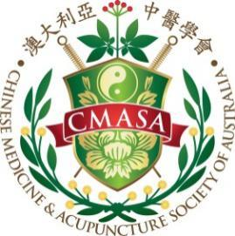

**Continuing Professional Development**

**Program Certificate of Attendance**

This is to certify that

LEI yao

has participated in following CPD seminar on the date of 26/FEB/2023

CPD 4 Professional issues points have been awarded.

Topic : Chinese medicine in Australia : Past,Present and Future

Speaker: Dr. Carlton

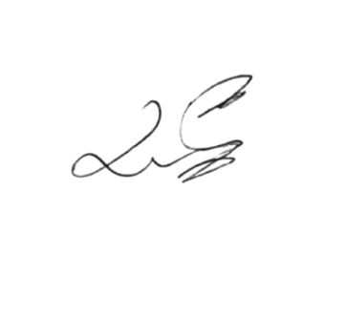

President of CMASA -WA Dr. LIYA YI (CM)

Chinese Medicine & Acupuncture Society of Australia

1 F 23 John Street, Cabramatta 2166 NSW Australia

Tel: +61-2-97276831 Fax: +61-2-97278981

Email: [cmasatcm@hotmail.com](mailto:cmasatcm@hotmail.com) Website: www.cmasa.org.au