Milestone 7
- Team: Tech Buzzwords
- Members: Dylan Fox, Eric Oropezaelwood, Munkhbayan Togtokh, Jade Wibbels, Yun Ting Chen, Julio Lopez
- Project Management: https://trello.com/b/tYqGPiRn/team-1-3308

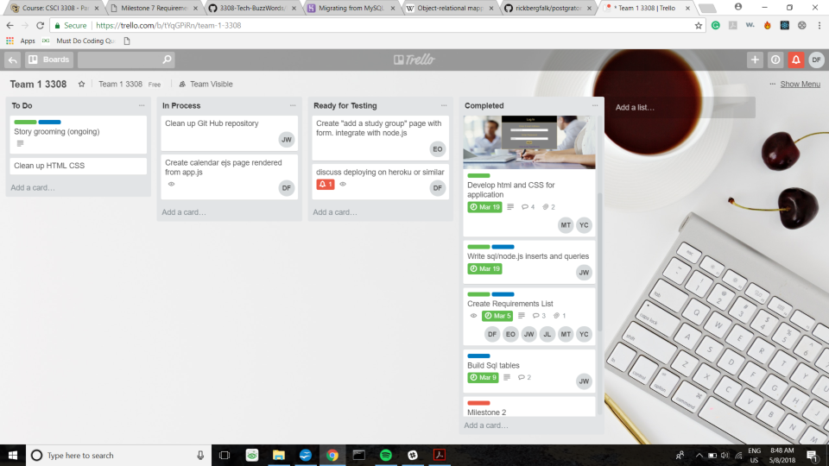
- Link to Github: https://github.com/JadeWibbels/3308-Tech-BuzzWords

- Contributions:
  - Dylan:
    - Primary Contributions:
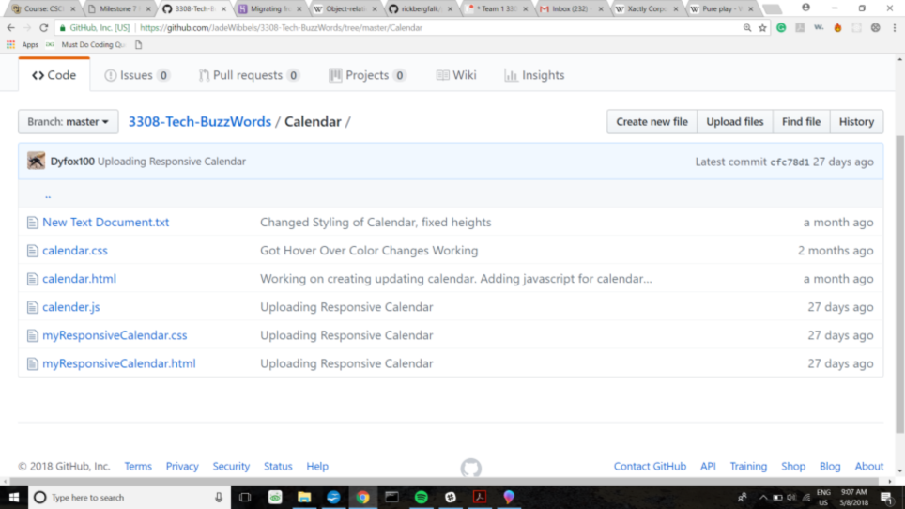
      - Writing Calendar JS, see picture below.
      - Writing README
      - Researching / testing Google Calendar API (that we didn't end up using).

    - Secondary:

      - Assisted with some bug fixes and writing the back end in NodeJS
      - Co-Authored Milestones 5 and 7
      - Modified app to incorporate Login Failed Screen.

  - Eric Oropezaelwood:
    - Primary:

      - Assisted with calendar research
      - Developed add group page
      - Co-Authored Milestones 1 and 6

  - Munkhbayan Togtokh:
    - Primary Contributions:
      - Developed HTML and CSS for most webpages
      - Developed cohesive styling for web app
      - Directed the workflow of the front end
      - Designed and integrated the features into the final project
    - Secondary Contributions:
      - Took additional workload to finish project on time
      - Redesigned and integrated pages developed by other teammates, e.g. add group page, login failed screen, etc.
      - Fixed bugs on the front end
      - Assisted teammates

  - Jade Wibbels:

    - Primary Contributions:
      - Created scripts to create local data bases required to run program
      - Wrote app.js and used node.js to link all html and pages to the databases

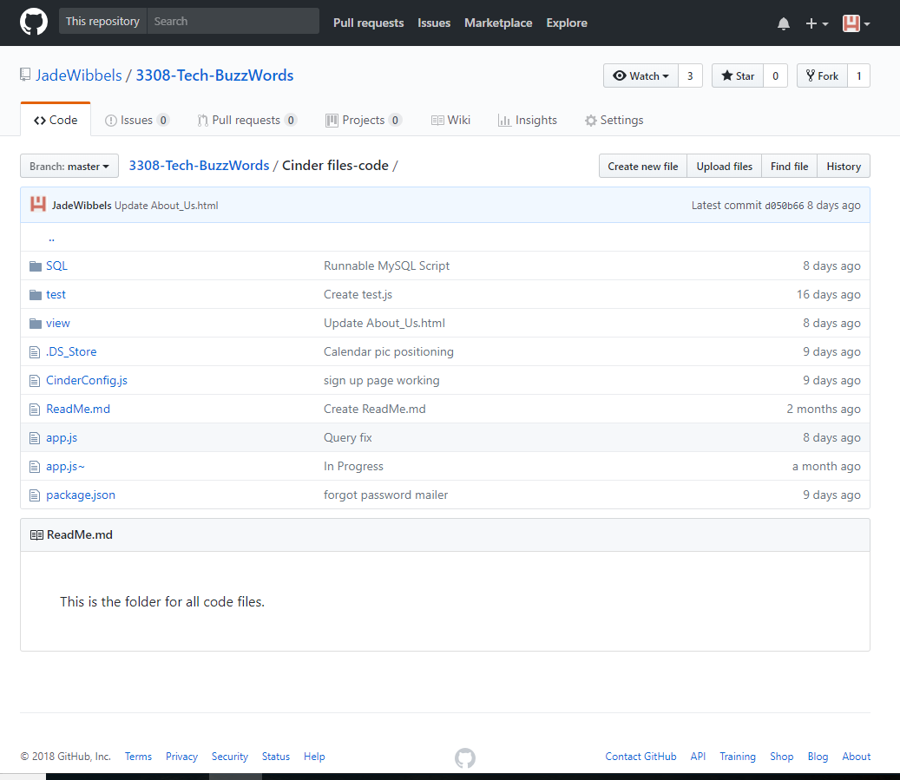
    - Secondary:

      - Wrote node.js and MySQL for : Forgot password capabilities, log in, add new user, add study group, find study group etc.
      - Co-Authored all milestones for project
      - Set up Trello, and Git hub for team

  - Yun Ting Chen:
    - Primary:
      - Developed HTML and CSS for forgot password and Signup page.
      - Designed CSS animation signup page
    - Secondary:
      - JQuery for Signup page
      - Fixed bugs for front end
      - Collaborate with back-end node.js

  - Julio Lopez:
    - Primary:
      - Assisted with calendar research
      - Co-authored Milestone 1 and 2

- Deployment: See deployment instructions in README on github linked above.

- Github Structure: All final production code is in 3308-Tech-BuzzWords/Cinder files-code/. The app.js script in this directory runs the back end and serves html/css/js pages from the /view sub directory. The /SQL directory is for making the database.
