Final Project:

Western Hangman:

Project Details

By Jaden Bridges

* Architectural Description
  + Once the program runs, it will begin with clearing the display. It will use draw a rectangle spanning the entire bitmap display with a dark orange color.
  + The next step includes drawing the entire setting on the bitmap display. This consists of drawing the sun by drawing a yellow circle, drawing the land by drawing a rectangle, drawing the set which involves several different rectangles being drawn, and drawing the letter boxes where the letters guessed correctly will be displayed.
  + Afterwards, the program will choose a word for the user to guess. This involves generating a random number from 0 to 49 and choosing a word from a text file that contains 50 words.
  + Next, the game will play an intro song for the user. It will also display an introduction to explain to the user about how to play the game.
  + The game will then accept an input from the user for one letter. Once it gets a letter, it will check it with the letters that make up the chosen word.
    - If the letter guessed is not part of the word, a body part will be added to the noose. All guessed letters will be added to a list in the top right corner for the user to see.
    - If the letter guessed is part of the word, the correct letters will be added to the corresponding spots in the word boxes.
  + If the user guesses incorrectly too many times and gets all 6 body parts on the noose. Then, the game will display a lose message and the program will end.
  + 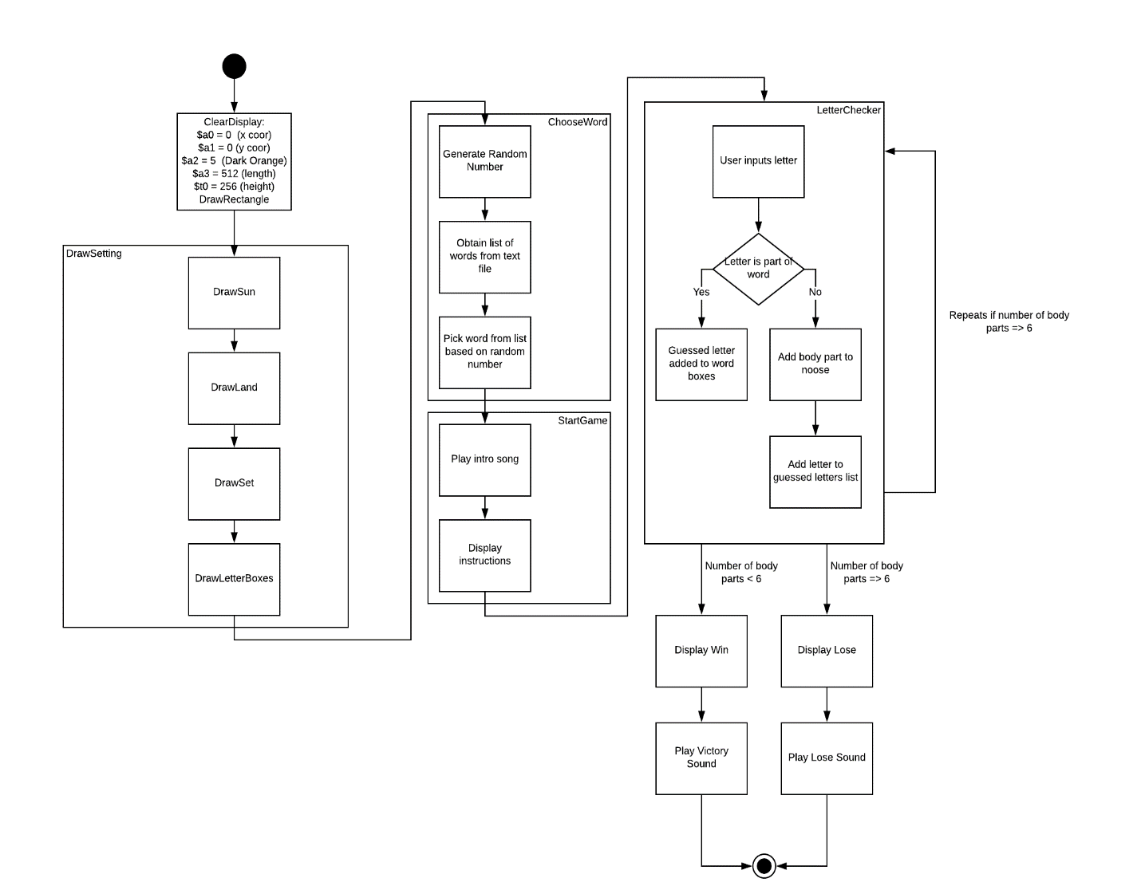If the user guesses all the letters of the word correctly, then the victory message will be displayed with a fanfare and the game will end.
* Test/Verification/Build Plan
  + After some procedures, I run the entire code in my program and wait until the freshly written procedure is reached in order to see how it performs. In order to test other parts of the code with less delay, I have commented out some parts that may take longer. This makes the testing process faster. I make sure to write the procedures such that arguments must be set before the procedure is called. This is to enable me to adjust the procedure such that it performs to my expectations. If I want to make sure the values are being produced correctly, I will print the string or integer to confirm it is right.
* Debug/Issues
  + One of the biggest challenges was obtaining a single word from a list of words in an external text file. I was able to solve this by taking all of the ascii characters from the text file and manipulating them such that only one word is obtained. In order to get one random word, I had to generate a random number between 0 to 49 and use it to adjust the address of the string label for all of the words accordingly.
  + Currently, the game is only able to support upper case letters when playing. This means that each guessed letter must be typed as a capital letter.
  + I also spent time building the setting of the bitmap display. I was able to write a procedure that built a rectangle which used length and height. This helped me a lot to draw the different parts of the set.
  + One fun feature I implemented is the intro song. This procedure plays the song from The Good, The Bad, and The Ugly using the MIDI sounds and plays when the set is finished being drawn.