SQL version of Who Lives

The U.S. Census Bureau estimates that residents were living in metro New Orleans as of July 2018, a percent increase from April 2010.[1] The metro area now has percent of its 2000 population of 1,337,726. In this brief, we examine demographic data released by the U.S. Census Bureau and identify important changes in metro area parishes since 2000 (or the best benchmark available).

## Race/Ethnicity

According to the U.S. Census Bureau’s 2018 population estimates, there are now 92,245 fewer African Americans living in New Orleans (Orleans Parish) compared to 2000, but there are also 8,631 fewer whites. Meanwhile, the number of Hispanics grew by 7,137.[2]

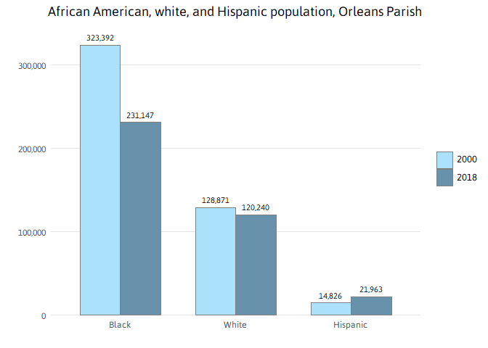

In Orleans Parish, the share of the 2018 population that is African American — while lower than in 2000 when it was 67 percent — continues to represent the majority of city residents at 59 percent. The share of Hispanics in the city increased from 3 percent in 2000 to 6 percent in 2018; the share of Asians increased from 2 percent to 3 percent; and the share of whites increased from 27 percent to 31 percent. Meanwhile, Hispanic, Asian, and African American populations increased as a share of the total population in Jefferson, St. Bernard, St. Charles, St. John the Baptist, and St. Tammany parishes, each. In fact, the number and share of Hispanics have increased in all eight parishes in the metro area.

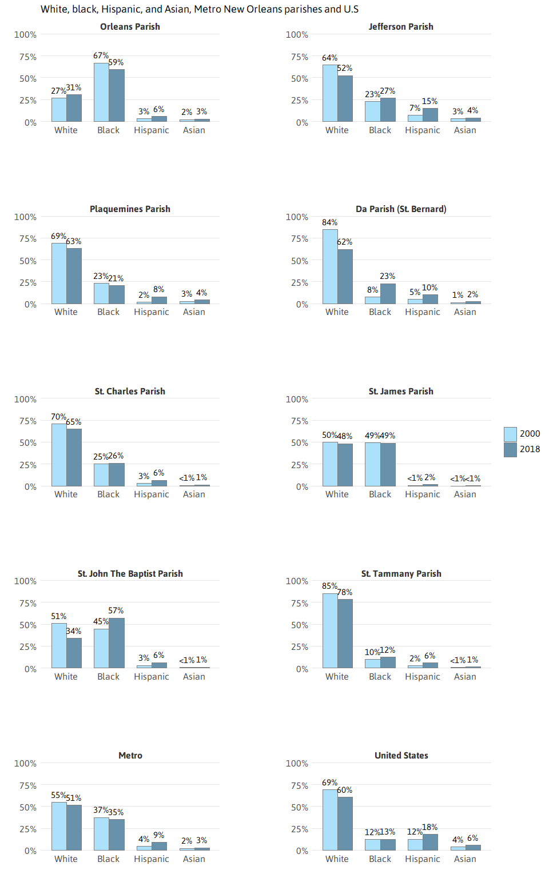

The number of African Americans living in New Orleans grew every year post-Katrina (from 2006 to 2017) but decreased for the first time post-Katrina from 231,753 in 2017 to 231,147 in 2018.

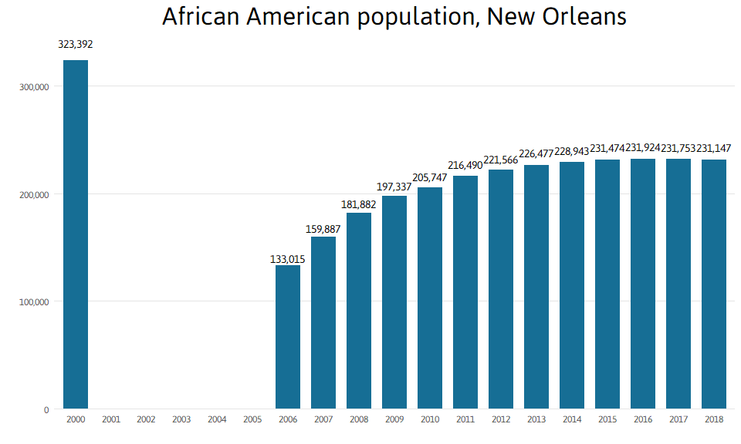

Between 2000 and 2018, the number of Hispanics in Jefferson Parish increased by 32,081 reaching over 15 percent of the total parish population. Orleans Parish and St. Tammany Parish gained 7,137 and 13,581 Hispanics, respectively, such that the Hispanic share of the population was 6 percent in Orleans and 6 percent in St. Tammany in 2018.

As of July 2018, there were 114,295 Hispanics in the metro area, representing 9 percent of the metro population. This is up from 2000 when there were 58,545, representing 4 percent of the metro population. Despite these recent gains, the Hispanic share of the population in metro area parishes is far below the average for the United States, which has grown from 12 percent to 18 percent of the total U.S. population over these 18 years.

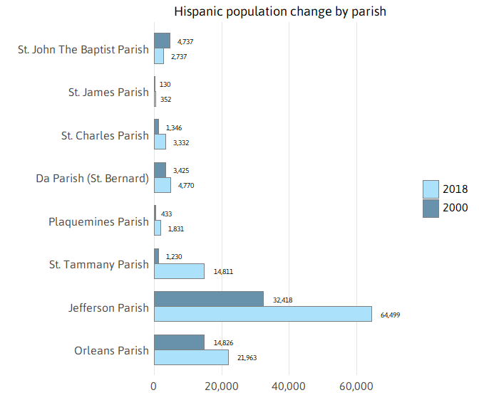

The number of Hispanics in New Orleans metro has grown every year since 2006. Indeed while the overall metro population has grown percent since 2010, the Hispanic population has grown NaN percent such that Hispanics account for percent of the metro’s population growth since 2010.

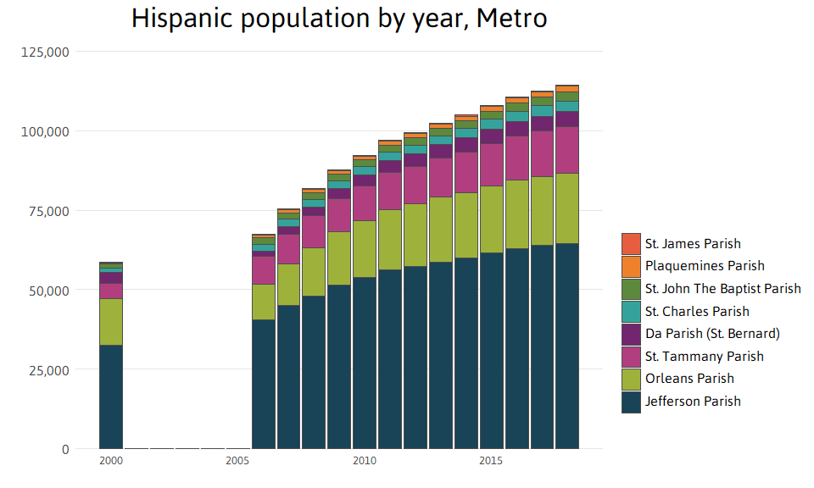

Hispanic is an umbrella term comprising multiple nationalities and ethnicities. Researchers have shown that most Hispanics prefer to identify by nationality rather than by pan-ethnic terms such as “Hispanic” and “Latino.”[3] The nationalities of Hispanics residing in metro New Orleans is quite distinct from the national Hispanic profile.

In 2018, the largest Hispanic group in metro New Orleans was Honduran, representing 29 percent of the Hispanic population. In comparison, Hondurans represent only percent of the national Hispanic population. These figures point to metro New Orleans as a hub of Honduran migration.

Not to be ignored, the Mexican population represents 20 percent of the Hispanic population in metro New Orleans. Nevertheless, the Mexican population is much less prominent in the metro than nationally, where it represents percent of the Hispanic population.

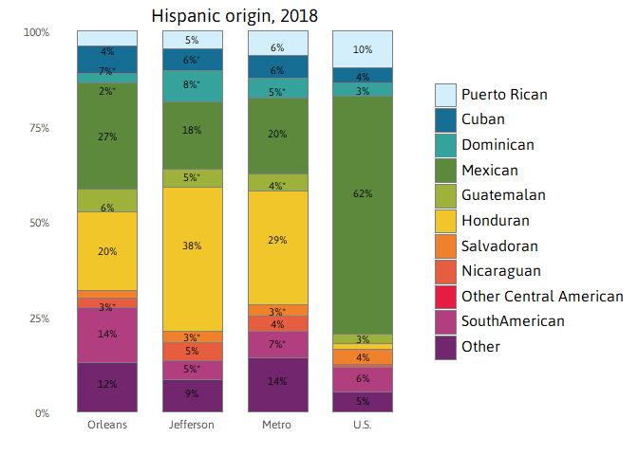

## Population by age and household types

The progression of the baby boomers through the age groups, along with falling birth rates, have brought massive changes to the metro — and indeed the whole country — with many more changes yet to come.[4] Looking at the total population in the metro by five-year age groups for 2000 and 2018, the baby boomers are like a demographic tidal wave. Consequently, the median age of the metro has risen to 38 in 2018 from 34.8 in 2000.

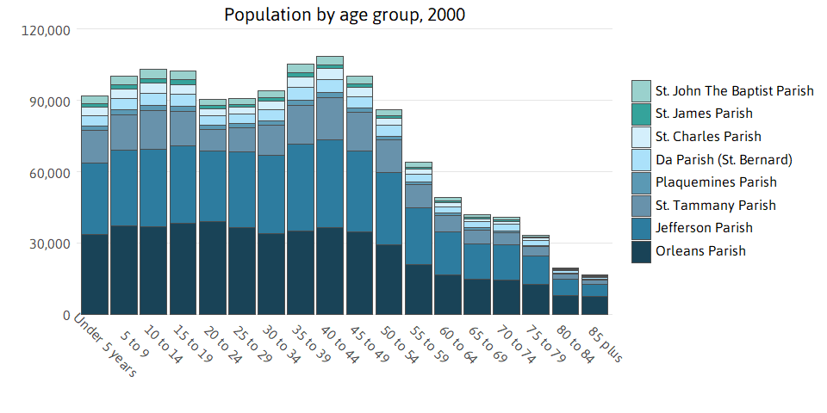

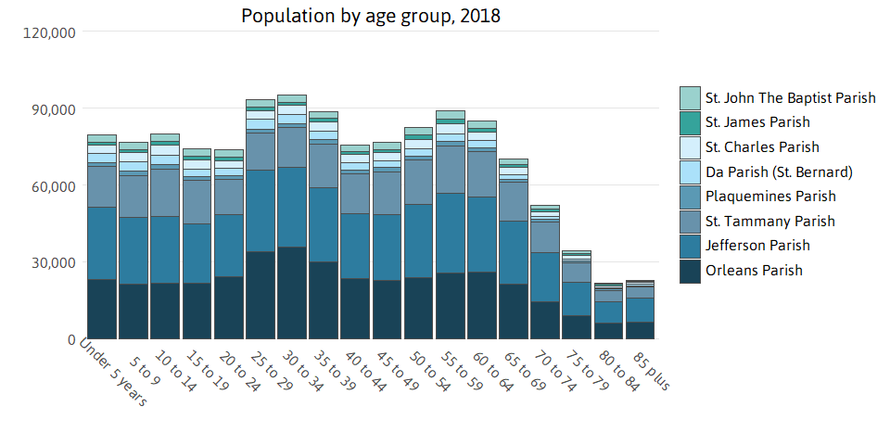

Meanwhile, the share of households with children is shrinking while the share of individuals living alone is growing — both across the metro and nation. As of 2018, percent of households in metro New Orleans included children, down from percent in 2000. Between 2000 and 2018, the percent of St. Tammany households with children declined from 40 percent to 30 percent; the percent of Jefferson households with children declined from 33 percent to 25 percent; and the percent of Orleans households with children declined from 30 percent to 17 percent.

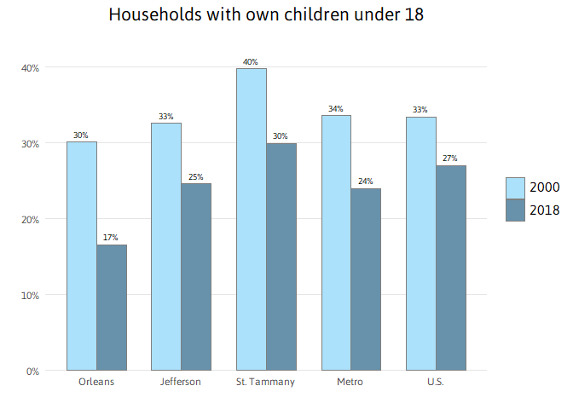

As households with children have declined, the share of single-person households has grown in the metro and nationwide. The metro area share of individuals living alone grew from percent in 2000 to percent in 2018 — similar to the trend for Jefferson Parish. The increase was larger in Orleans Parish, which jumped from 33 to 49 percent.

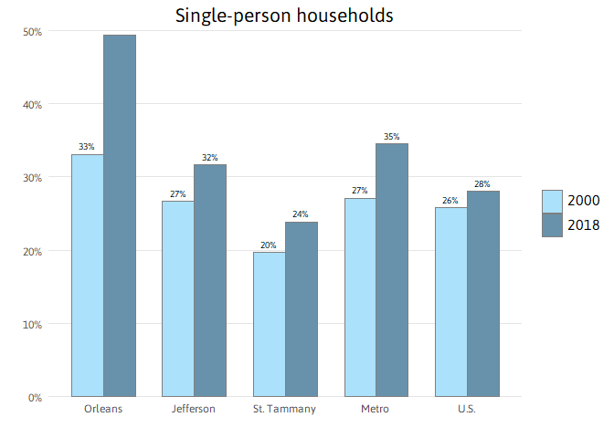

While the metro has regained much of the post-Katrina population losses, youth population is substantially lower than pre-Katrina levels. The metro had 358,092 children under 18 years in 2000 and only 283,691 in 2018. Much of this loss was driven by Orleans Parish, where the under 18 population declined to 78,660 from 129,408. The under 18 population is now 22 percent of the metro population, down from 27 percent in 2000.

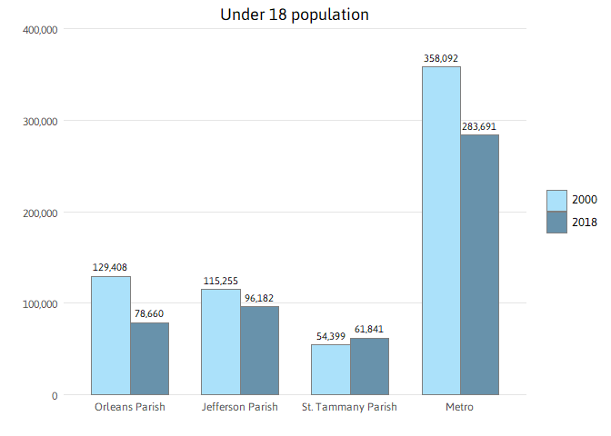

## Educational attainment, income, and internet access

Educational attainment is an important determinant of household incomes, workforce skills, and regional resiliency.[5] The proportion of adults 25 years and older with less than a high school education declined across all three of the largest parishes, leading to a metrowide decrease from percent in 2000 to percent in 2018. In the city of New Orleans, the share of adults with less than a high school degree fell from 25 percent to 13 percent but is still higher than the U.S. average of 12 percent.

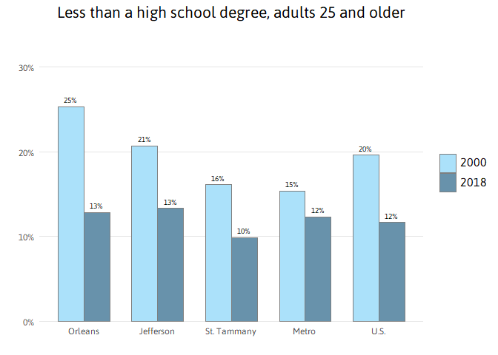

The metro area decline in the share of adults with less than a high school degree has been coupled with an increase in the share with a bachelor’s degree or higher. In New Orleans, 37 percent of adults 25 and older had a college degree in 2018 — higher than the U.S. average of 33 percent, and up from 26 percent in 2000. The overall metro area share of adults with a bachelor’s degree grew from to percent — lower than the national average.

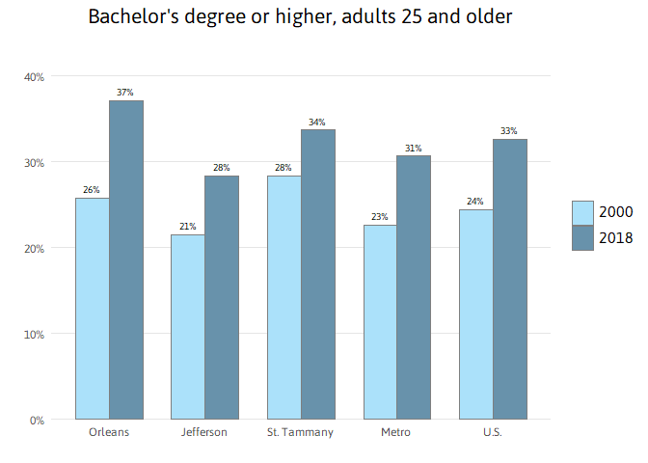

The 2018 median household income of for the metro and $38,423 for the city are significantly lower than the U.S. median of $61,937. In Jefferson Parish, median household income declined 8 percent between 1999 and 2018, even after adjusting for inflation, falling to $50,766.

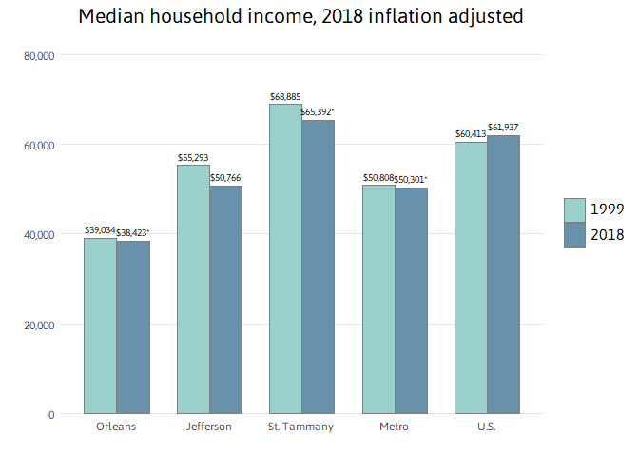

Internet access is an important indicator of access to information. Studies have shown that without broadband, computer access, and encompassing technology training services, workers and students are at a disadvantage in the job market and education system.[6] Only 61 percent of households in Orleans Parish and only 69 percent of households in Jefferson Parish are connected to the Internet through a home-based internet service, such as broadband (cable, DSL, or fiber), satellite, or dial-up service, compared to 74 percent nationwide. St. Tammany is above the national average at 78 percent of households connected to the Internet by a home-based service internet connection. Internet access without a subscription refers to households who only have access through group access locations such as school, work, a library, or coffee shop.

An increasingly common way to access the Internet is through a smartphone or some other cellular device. While, in general, smartphone access contributes positively to lessening the Digital Divide, having access only through a smartphone restricts ability to fully leverage the Internet to complete common tasks such as writing and researching a resume, registering your kids for school, analyzing data about your neighborhood, or creating content for an internet business. 17 percent of households in Orleans Parish only have access through a smartphone. This is compared to 12 percent nationwide.

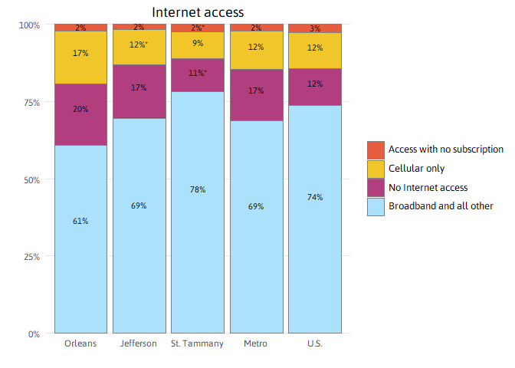

## Poverty and access to vehicles

Individuals living below the poverty level indicate the economy is not providing all residents with the ability to meet their most basic needs, including food, housing, and transportation. The poverty rate in New Orleans is statistically unchanged comparing 1999 to 2018. Meanwhile, the Jefferson Parish poverty rate increased from 14 to 15 percent between 1999 and 2018. Across the U.S., the poverty rate increased from 12 to 13 percent between 1999 and 2018.

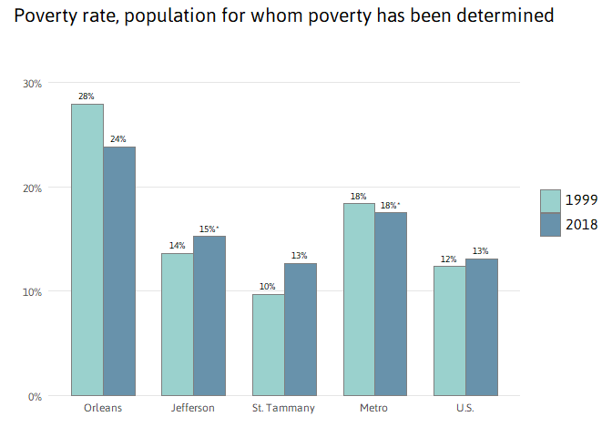

Like the overall poverty rate, the child poverty rate in New Orleans is statistically unchanged from 1999. In Jefferson Parish, the child poverty rate jumped from 20 percent in 1999 to 26 percent in 2018 — greatly surpassing the U.S. child poverty rate, which rose from 17 to 18 percent between 1999 and 2018.

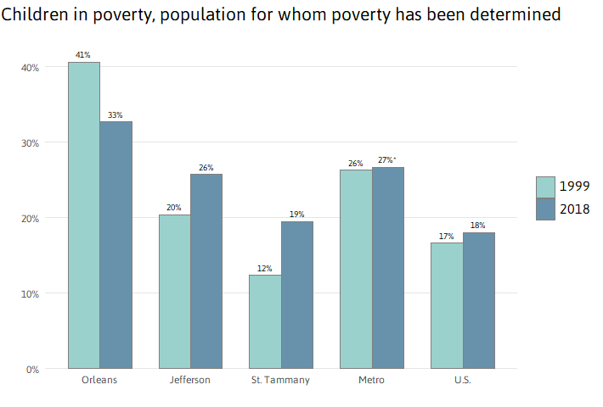

Post-Katrina, the share of New Orleans households without access to a vehicle dropped from 27 percent in 2000 to 19 percent in 2018. Nonetheless, at 19 percent, New Orleans’ share is more than twice as high as in neighboring parishes and the nation, indicating the importance of a robust public transportation system and comprehensive evacuation plan.

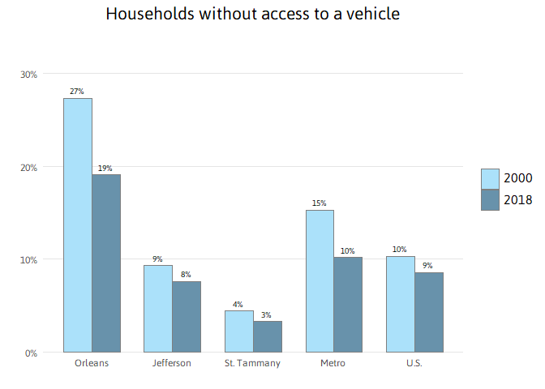

## Foreign-born population and geographic mobility

A rising foreign-born share of the population may reflect expanding economic opportunities for both high-skilled and low-skilled workers.[7] That share of the population has grown in all three of the most populous metro parishes since 2000, led by a 5.9 percentage point gain in Jefferson Parish. By 2018, fully 13.4 percent of Jefferson Parish population was foreign-born, statistically the same as the U.S. share. In Orleans Parish the foreign-born share of the population increased by 1.2 percentage points between 2000 and 2018 while St. Tammany Parish increased by 2 percentage points.

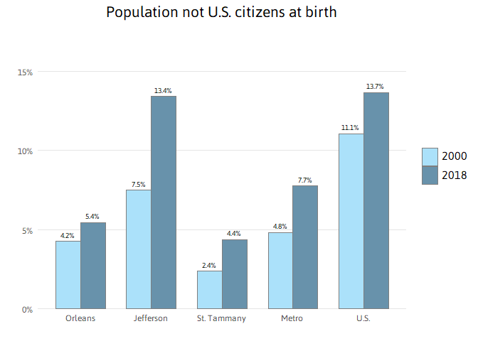

Like the foreign-born population, a rising share of the population who moved into Orleans Parish in the past year may reflect expanding economic opportunities. The most frequent reason people move long distances, such as from one state to another state, is for job opportunities.[8] In addition, the young and well-educated are more likely than others to move long distances.[9] In 2018, 6 percent of the population in Orleans Parish had moved into the parish in the past year, up from 3 percent in 2004. Over 61 percent of the new movers into Orleans Parish came from outside the state of Louisiana. In Jefferson Parish, the share of the population who were new movers into the parish was 5 percent in 2004, and has not significantly changed.

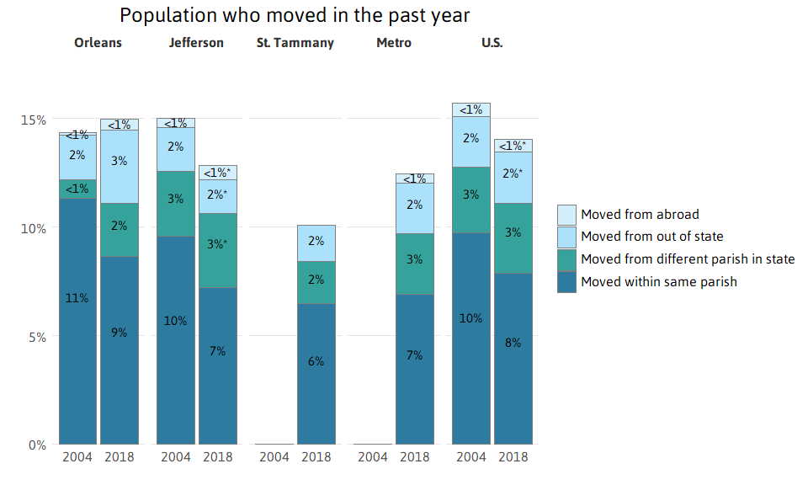

## Homeownership

Homeownership rates across the U.S. have fallen since 2000 from 66 to 64 percent in 2018. Homeownership rates have decreased slightly in St. Tammany from 80 percent to 79 and in Jefferson from 64 to 60 percent between 2000 and 2018. In contrast, homeownership rates in New Orleans have held steady, but at a much lower 48 percent.

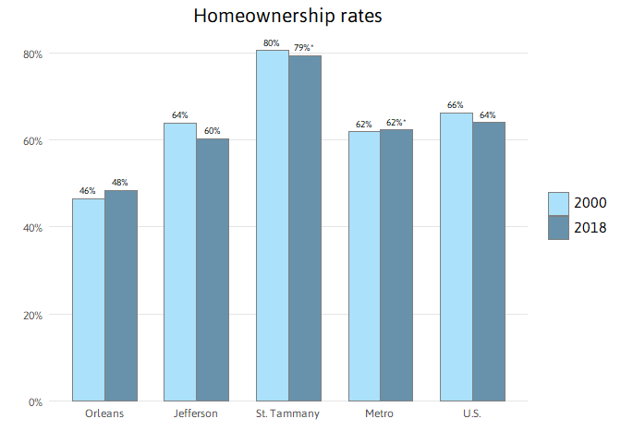

Homeowners without a mortgage own their homes free and clear of any type of loan. A high share of such homeowners usually indicates residents living in the same house for long periods of time, and helps shield neighborhoods from foreclosures. The proportion of metro area homeowners without a mortgage has increased from to percent between 2000 and 2018, driven by changes in Orleans and Jefferson. The share of homeowners without a mortgage jumped from 33 to 49 percent in Orleans and from 35 to 47 percent in Jefferson. One reason for the surge may be that homeowners who returned after Katrina used insurance or Road Home proceeds to pay off their mortgage principal. In fact, Orleans and Jefferson received the first and second largest number of Road Home Option 1 grants among all Louisiana parishes.[10]

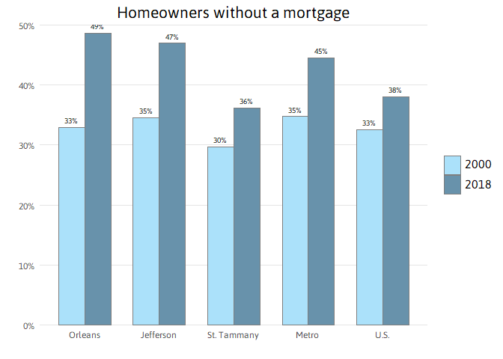

## Housing costs and affordability, housing stock, and commuting

High housing costs can limit a region’s ability to attract and retain the workforce essential for a healthy economy.[11] Severe housing cost burdens of more than 50 percent of household income indicate a serious problem in housing affordability. In 2004, the share of severely cost-burdened renters in New Orleans and the U.S. was 24 percent. In the 14 years since, that share has spiked to 37 percent in Orleans while rising to only 25 percent nationally. In Jefferson Parish, the share of renters paying more than 50 percent of household income on housing and utilities is 28 percent in 2018.

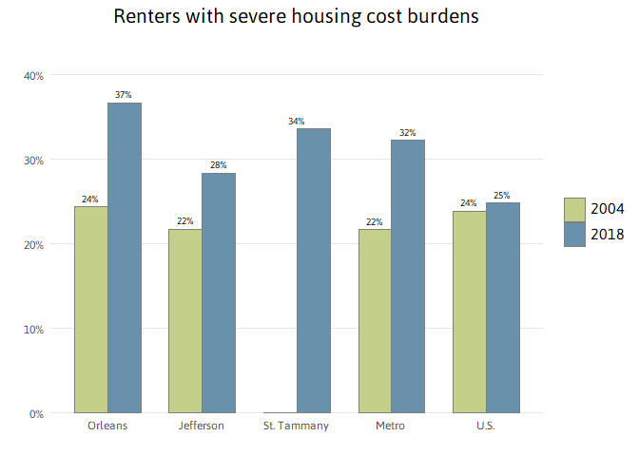

The share of homeowners paying more than 50 percent of household income on their mortgage, taxes, utilities, and insurance is virtually unchanged in metro area parishes since 2004. There is a clear gap between the rate of housing cost burden for renters vs. homeowners, and that gap has widened.

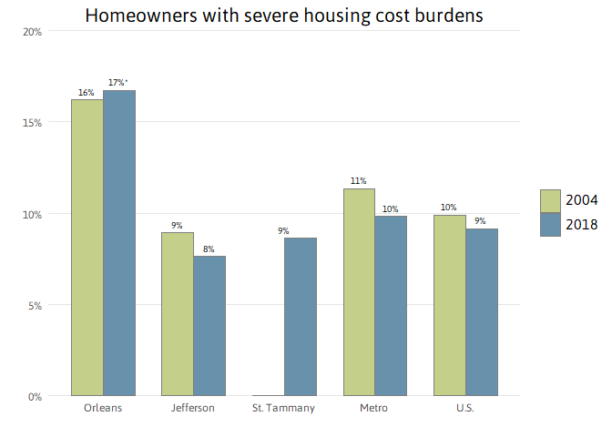

The surge in the share of severely cost-burdened renters in New Orleans is reflective of the surge in the median gross rent (rent plus utilities) in the city. From 2004 to 2018, monthly rent plus utilities rose from $742 to $993 in New Orleans, a 34 percent increase after adjusting for inflation. Meanwhile, median gross rents increased percent metrowide compared to only 16 percent nationwide.

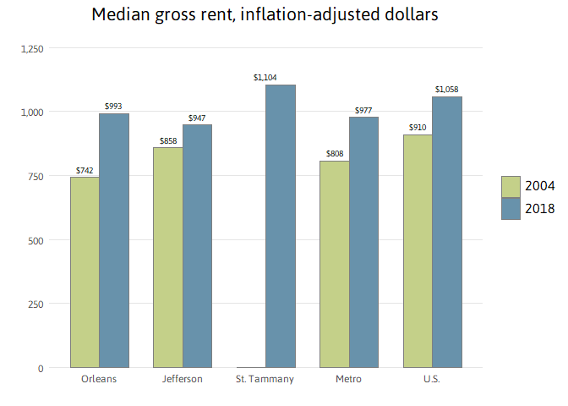

America’s aging housing stock represents both a potential problem and an opportunity. Older homes are less energy-efficient and more expensive to maintain.[12] Moreover, research has shown that lead poisoning in children is correlated strongly with residing in pre-1950 homes.[13] Conversely, in New Orleans, many older homes are protected by preservation laws that have helped retain the historic character of the city.

In Orleans Parish, fully 41 percent of all housing units are in pre-1950 structures. Meanwhile, in Jefferson Parish, 78 percent of the housing stock was built in the 1950s, 1960s, 1970s, and 1980s, and just 15 percent of housing stock has been built since 1990. In contrast, in St. Tammany, the majority of housing units are in structures that have been built since 1990.

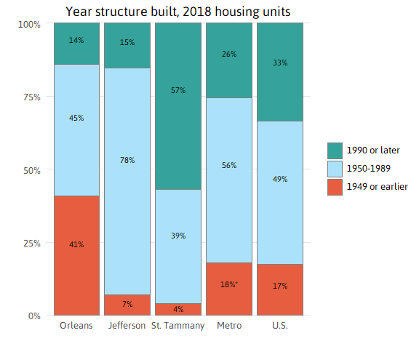

A metro region is partially defined by the commuting patterns of its residents. Commuting has been studied more and more as the costs and burdens (physical, mental, familial, etc.) are uncovered. In addition, studies have shown that younger generations are less likely to drive cars, more likely to bike, and more likely to move into urban cores.[14]

The share of commuters in New Orleans using public transportation declined sharply from 13 percent in 2000 to 7 percent in 2018, while the share in Jefferson Parish has fallen from 2 percent in 2000, to 1 percent of commuters using public transportation in 2018. But the share of bike commuters in New Orleans rose to 4 percent, giving the city the fifth highest share of bike commuting of the largest 70 cities nationwide.[15] Meanwhile, the metro share of carpoolers fell from percent in 2000 to percent in 2018, as did the Orleans Parish share from 16 percent to 8 percent.

The percentage of workers who commute by driving alone has increased within the metro region since 2000 from percent to percent, driven by a 60 to 68 percent rise in Orleans Parish. This goes against the national trend, where the share in driving alone remained steady between 2000 and 2018 and where public transit use has also remained steady.

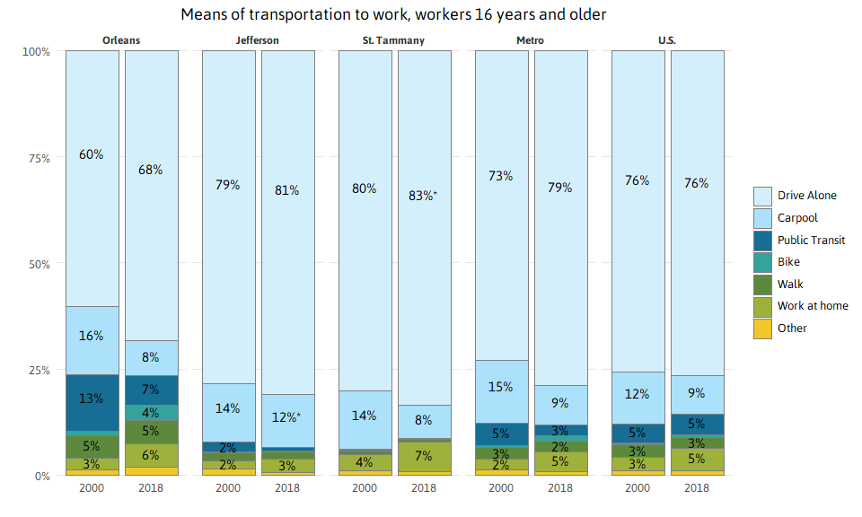

## Data Sources / Methodology

Data on race/ethnicity and age is from the Census Bureau vintage 2017 population estimates and Census 2000 Summary File 1 (SF1). Other demographic data is from the Census 2000 Summary File 3 (SF3) and American Community Survey 2004, and 2018 (single-year files).

Statistical tests of significance were computed at the 95% confidence level for all data from the American Community Survey and Census 2000 SF3. An “*” indicates that differences between two time periods or geographies are not significant, and therefore are the result of sampling variability rather than real change in characteristics of the population.

The significance tests require both estimates and their standard errors. Standard errors for the ACS estimates were calculated using formulas from section 7, “Understanding Error and Determining Statistical Signifigance” available at: <https://www.census.gov/content/dam/Census/library/publications/2018/acs/acs_general_handbook_2018.pdf>.

Standard errors for Census 2000 SF3 data were calculated using formulas from Chapter 8 of the Technical Documentation available at: <http://www.census.gov/prod/cen2000/doc/sf3.pdf>.

Standard errors for Census 2000 and Census 2010 SF1 data are zero.

## Endnotes

[1] The eight-parish New Orleans metro includes Jefferson, Orleans, Plaquemines, St. Bernard, St. Charles, St. James, St. John the Baptist, and St. Tammany. From 2003-2012, the New Orleans metro was comprised of 7 parishes, excluding St. James. This brief has updated all 2000 metro data to reflect an 8-parish definition, however previous versions of this report will have used the 7-parish metro definition and accompanying numbers.

[2] Throughout this brief “African American,” “Asian,” and “white” refer to individuals who report to be only one race and not Hispanic. However, “Hispanics” can be of any race(s).

[3] Taylor, P., Lopez M. H., Martinez, J., and Velasco, G. (2014). When Labels Don’t Fit: Hispanics and Their Views of Identity. Retrieved October 3, 2014 from <http://www.pewhispanic.org/2012/04/04/when-labels-dont-fit-hispanics-and-their-views-of-identity>.

[4] Plyer, A. and Ortiz, E. (2011). Drivers of housing demand: Preparing for the impending elder boom. Retrieved July 8, 2013, from <http://> www.datacenterresearch.org/reports_analysis/drivers-of-housing-demand.

[5] Julian, T. and Kominski, R. (2011). Education and synthetic work-life earnings estimates. Retrieved February 8, 2019 from <https://www.census.gov/library/publications/2011/acs/acs-14.html>; U.S. Department of Housing and Urban Development. (2012). Conceptualizing and measuring resilience. Retrieved September 18, 2012 from <http://www.huduser.org/portal/periodicals/em/winter12/highlight2.html#title>.

[6] Vigdor J. and Ladd, H. (2010). Scaling the Digital Divide: Home Computer Technology and Student Achievement. Retrieved February 8, 2019 from <http://citeseerx.ist.psu.edu/viewdoc/download?doi=10.1.1.849.6663&rep=rep1&type=pdf>.

[7] De Jong, G.F., Graefe, D.R., Hall, M., and Singer, A. (2001). The geography of immigrant skills: Educational profiles of metropolitan areas. Retrieved AFebruary 8, 2019 from <https://www.brookings.edu/research/the-geography-of-immigrant-skills-educational-profiles-of-metropolitan-areas/>.

[8] Based on surveys conducted by the U.S. Census Bureau, employment-related reasons are the most frequent reason for inter-county moves of greater than 50 miles. For example, among people in the United States who moved over 500 miles, 52 percent moved for an employment-related reason compared to 23 percent for a family-related reason and 22 percent for a housing-related reason. Employment-related reasons include a new job or job transfer, to look for work, to be closer to work, retirement, and other job-related reasons. See U.S. Census Bureau. (n.d.). Geographic Mobility: 2011 to 2012 (Table 27). Retrieved February 8, 2019 from <https://www.census.gov/topics/population/migration/data/tables/cps.2012.html>.

[9] Based on surveys conducted by the U.S. Census Bureau, people 25 to 29 years old were more likely than other age groups to be movers from a different county, state, region, or country. And people with a professional or graduate degree were also more likely than other educational groups to be movers from a different county, state, region, or country. See U.S. Census Bureau. (n.d.). Geographic Mobility: 2011 to 2012 (Table 1). Retrieved September 23, 2013 from <https://www.census.gov/topics/population/migration/data/tables/cps.2012.html>.

[10] State of Louisiana Office of Community Development. (2013). The Homeowner Assistance Program Week 375 Situation & Pipeline Report.

[11] Plyer, A., Ortiz, E., and Pettit, K. (2009). Post-Katrina housing affordability challenges continue in 2008, worsening among Orleans Parish very low income renters. Retrieved September 17, 2013 from <http://www.datacenterresearch.org/reports_analysis/housing-affordability>.

[12] Joint Center for Housing Studies of Harvard University (2013). The US Housing Stock: Ready for Renewal. Retrieved October 10, 2014 from <http://www.jchs.harvard.edu/sites/jchs.harvard.edu/files/harvard_jchs_remodeling_report_2013.pdf>.

[13] Roberts, J.R., Hulsey, T.C., Curtis, G.B., and Reigart, J.R. (2003). Using Geographic Information Systems to Assess Risk for Elevated Blood Lead Levels in Children. Retrieved October 10, 2014. <http://www.ncbi.nlm.nih.gov/pmc/articles/PMC1497528/pdf/12766217.pdf>

[14] Davis, B., Dutzik, T. (2012). Transportation and the New Generation: Why Young People Are Driving Less and What It Means for Transportation Policy. Retrieved October 10, 2014 from <http://www.uspirg.org/sites/pirg/files/reports/Transportation%20%26%20the%20> New%20Generation%20vUS_0.pdf.

[15] The League of American Bicyclists. (2017). Where We Ride: Analysis of Bicycle Commuting in American Cities. Retrieved December 21, 2018 from <http://www.bikeleague.org/sites/default/files/2015ACSlargecities.pdf>