COSC364-25S1
Internet Technology and Engineering
RIPv2 Assignment

Apr 14, 2025

Shunzhi Zhang（31340795）
Yumeng Shi（74341182）

Table of Contents
1 Summary 3
1.1 Reflection 3
1.2 Contributed 3
2 Testing 3
2.1 Unit Test 3
2.2 Integration Test 3
3 Configuration File 4
4 Source Code 4

1 Summary
This programming project is a routing daemon developed in Python 3, utilizing a socket interface on the Linux operating system to implement Routing Information Protocol Version 2 (RIPv2). It includes modules for configuration processing, packet handling, routing algorithms, and server functionality. The project features a user-friendly interface and is well-structured to facilitate the addition of new functions and future maintenance.

1.1 Reflection
The project is well-structured, featuring a modular design with distinct functions and modules such as routing_table.py, routing_algorithms.py and config_processer.py etc. This modular approach is effectively applied in the Server function, which running the overall functionality logic. The separation of concerns into different modules makes the code easier to read, maintain, and debug. Each module handles a specific aspect of the router's operation, contributing to a clear and organized architecture. This design choice not only enhances the maintainability of the code but also facilitates easier debugging and potential future enhancements.

For functional implementation, we use the same structure as the routing table to initialize original routing information, ensuring configuration data is stored efficiently and avoiding duplicate file reads. We also have a neighbour mapping utility to match neighbour ports and IDs, as these 2 transferer of variables are frequently used.

For time management, we utilize Python's time interface to generate current time and next second. We employ Python's random module to create a next_periodic_update_time with a variance of 30 seconds ± 5 seconds. When current_time is greater than or equal to next_second, it indicates that one second has passed. Similarly, when current_time is greater than or equal to next_periodic_update_time, it's time to trigger an update..

1.2 Contributed

For the entire project, we agreed that each of us contributed equally, with a 50% share each.

Yumeng Shi:
Planning
Testing – Unit Tests
Coding – Main Server Function, Routing Table, and Algorithm
Report writing

Shunzhi Zhang:
Planning
Coding – Configuration Processing and RIP Packet
Testing – Integration Tests
Configuration File Development

2 Testing

2.1 Unit Test
Testing individual components of the code in isolation to ensure they behave as expected.

Config Processer
We test all the router configuration files used for integration tests with the big model(should not raise any error). We create bad configuration files (have error raise) with invalid input ports, invalid router IDs, invalid output ports, and empty files.

----------------------------------------------------------------------------------------------------------------
def test_router1():
config_filename = 'router1.txt'
config = read_config(config_filename)
assert config == {'router_id': 1, 'input_ports': [1111, 1112, 1113], 'output_ports': [[2221, 1, 2], [6661, 5, 6], [7771, 8, 7]]}
print("router1 pass.")
def test_router2():
config_filename = 'router2.txt'
config = read_config(config_filename)
assert config == {'router_id': 2, 'input_ports': [2221, 2222], 'output_ports': [[1111, 1, 1], [3331, 3, 3]]}
print("router3 pass.")
def test_router3():
config_filename = 'router3.txt'
config = read_config(config_filename)
assert config == {'router_id': 3, 'input_ports': [3331, 3332], 'output_ports': [[2222, 3, 2], [4441, 4, 4]]}
print("router3 pass.")
def test_router4():
config_filename = 'router4.txt'
config = read_config(config_filename)
assert config == {'router_id': 4, 'input_ports': [4441, 4442, 4443], 'output_ports': [[3332, 4, 3], [7772, 6, 7], [5551, 2, 5]]}
print("router4 pass.")
def test_router5():
config_filename = 'router5.txt'
config = read_config(config_filename)
assert config == {'router_id': 5, 'input_ports': [5551, 5552], 'output_ports': [[4442, 2, 4], [6662, 1, 6]]}
print("router5 pass.")
def test_router6():
config_filename = 'router6.txt'
config = read_config(config_filename)
assert config == {'router_id': 6, 'input_ports': [6661, 6662], 'output_ports': [[1112, 5, 1], [5552, 1, 5]]}
print("router6 pass.")
def test_router7():
config_filename = 'router7.txt'
config = read_config(config_filename)
assert config == {'router_id': 7, 'input_ports': [7771, 7772], 'output_ports': [[1113, 8, 1], [4443, 6, 4]]}
print("router7 pass.")
----------------------------------------------------------------------------------------------------------------
invalid_input_port.txt
router-id 1
input-ports 1111111, 1112, 1113
output-ports 2221-1-2-3, 6661-5-6, 7771-8-7
def test_invalid_input_port():
config_filename = 'invalid_input_port.txt'
try:
config = read_config(config_filename)
except ValueError as e:
expected_message = "ERROR: Invalid input port 1111111. Must be in range 1024-64000."
assert str(e) == expected_message, f"Unexpected error message: {e}"
print("Correct error raised:", e)
----------------------------------------------------------------------------------------------------------------
invalid_router_id.txt
router-id abc
input-ports 1111, 1112, 1113
output-ports 2221-1-2, 6661-5-6, 7771-8-7
def test_invalid_router_id():
config_filename = 'invalid_router_id.txt'
try:
config = read_config(config_filename)
except ValueError as e:
expected_message = "ERROR: router_id must be an integer."
assert str(e) == expected_message, f"Unexpected error message: {e}"
print("Correct error raised:", e)
----------------------------------------------------------------------------------------------------------------
invalid_output_port.txt
router-id 1
input-ports 1111, 1112, 1113
output-ports 2221-1-2-3, 6661-5-6, 7771-8-7
def test_invalid_output_port():
config_filename = 'invalid_output_port.txt'
try:
config = read_config(config_filename)
except ValueError as e:
expected_message = "ERROR: Invalid output-port format"
assert str(e) == expected_message, f"Unexpected error message: {e}"
print("Correct error raised:", e)
----------------------------------------------------------------------------------------------------------------
empty.txt

def test_empty():
config_filename = 'empty.txt'
try:
config = read_config(config_filename)
except ValueError as e:
expected_message = "ERROR: Configuration file is empty."
assert str(e) == expected_message, f"Unexpected error message: {e}"
print("Correct error raised:", e)
----------------------------------------------------------------------------------------------------------------

RIP packet
Test functionality of different components related to RIP, include header, entry ,full packet and poisoned packet been build.
----------------------------------------------------------------------------------------------------------------
def test_RIP_header():
router_id = 1
exp_header = [COMMAND_REQUEST, VERSION, router_id]
header = RIP_header(router_id)
assert header == exp_header
print("test_RIP_header pass.")
def test_RIP_entry():
table = {
3: {'next_hop': 5, 'cost': 2, 'garbage': False},
4: {'next_hop': 4, 'cost': 3, 'garbage': False},
5: {'next_hop': 5, 'cost': 4, 'garbage': True} # This entry should be ignored
}
exp_entries = [[3, 2], [4, 3]]
entries = RIP_entry(table)
assert entries == exp_entries
print("test_RIP_entry pass.")
def test_rip_packet():
router_id = 1
table = {
3: {'next_hop': 5, 'cost': 2, 'garbage': False},
4: {'next_hop': 4, 'cost': 3, 'garbage': False}}
exp_packet = {
'header': [COMMAND_REQUEST, VERSION, router_id],
'entry': [[3, 2], [4, 3]] }
packet = rip_packet(router_id, table)
assert packet == exp_packet
print("test_rip_packet pass.")
def test_set_poisoned_reverse():
#Send to router 5, with a router 3 use next hop 5, should set to 16
router_ID = 1
table = {
3: {'next_hop': 5, 'cost': 2, 'garbage': False},
4: {'next_hop': 4, 'cost': 3, 'garbage': False},
5: {'next_hop': 5, 'cost': 4, 'garbage': False}}
port_id = 5
exp_packet = {
'header': [COMMAND_REQUEST, VERSION, router_ID],
'entry': [(3, 16), (4, 3), (5, 4)]}
poisoned_packet = set_poisoned_reverse(router_ID, table, port_id)
assert poisoned_packet == exp_packet
print("test_set_poisoned_reverse pass.")
----------------------------------------------------------------------------------------------------------------
Routing Table
Test all the function in routing table. Ensure that each function behaves as expected when managing the routing table, including adding, removing, flagging, and updating routes.
----------------------------------------------------------------------------------------------------------------
def test_new_route():
routing_table = {}
destination = 3
next_hop = 5
cost = 2
new_route(destination, next_hop, cost, routing_table)
assert destination in routing_table
assert routing_table[destination]['next_hop'] == next_hop
assert routing_table[destination]['cost'] == cost
assert not routing_table[destination]['garbage']
print("test_new_route pass.")
def test_remove_route():
routing_table = {3: {'next_hop': 5, 'cost': 2, 'garbage': False}}
destination = 3
remove_route(destination, routing_table)
assert destination not in routing_table
print("test_remove_route pass.")
def test_flag_garbage():
routing_table = {3: {'next_hop': 5, 'cost': 2, 'garbage': False}}
destination = 3
flag_garbage(destination, routing_table)
assert routing_table[destination]['garbage']
print("test_flag_garbage pass.")
def test_set_infinity():
routing_table = {3: {'next_hop': 5, 'cost': 2, 'garbage': False}}
destination = 3
set_infinity(destination, routing_table)
assert routing_table[destination]['cost'] == METRIC_INFINITY
print("test_set_infinity pass.")
----------------------------------------------------------------------------------------------------------------

Routing Algorithm
We build up an easy model G1 to test the basic functional for routing algorithm, for add new route and update when a shorter route been founded.
1
2

3
4

G1
First test with router 1 received the packet from 2, We expected the new route from 1 to 3 added.
----------------------------------------------------------------------------------------------------------------
table1 = {
2: {'next_hop': 2, 'cost': 1, 'garbage': False, 'last_update_time': time.time()},
4: {'next_hop': 2, 'cost': 1, 'garbage': False, 'last_update_time': time.time()}}
packet2 = {'header': [2, 2, 2], 'entry': [[1, 1],[3, 5],[4, 1]]}
def test_add_new_route():
router_ID = 1
new_routing_table, update = routing_algorithms(router_ID, table1, packet2)
assert update == True
assert new_routing_table[3]['cost'] == 6
assert new_routing_table[3]['next_hop'] == 2
assert new_routing_table[3]['garbage'] == False
print("test_add_new_route passed.")
----------------------------------------------------------------------------------------------------------------
Also we test the Scenario for a shorter path been found, in this case the path from router1 to router 4 should been update through router 2 and give a shorter cost 2.
----------------------------------------------------------------------------------------------------------------
table11 = {
2: {'next_hop': 2, 'cost': 1, 'garbage': False, 'last_update_time': time.time()},
4: {'next_hop': 4, 'cost': 3, 'garbage': False, 'last_update_time': time.time()},
3: {'next_hop': 2, 'cost': 6, 'garbage': False, 'last_update_time': time.time()}}
packet22 = {'header': [2, 2, 2], 'entry': [[1, 1],[3, 5],[4, 1]]}
def test_update_existing_route():
router_ID = 1
new_routing_table, update = routing_algorithms(router_ID, table11, packet22)
assert update == True
assert new_routing_table[4]['cost'] == 2, "Expected cost to be 6"
assert new_routing_table[4]['next_hop'] == 2, "Expected next_hop to be 6"
assert new_routing_table[4]['garbage'] == False, "Expected garbage to be False"
print("test_update_existing_route passed.")
----------------------------------------------------------------------------------------------------------------

2.2 Integration Test
To ensure that components work together as expected and to test the server's functionality, including timer and socket interface. We utilize the example network provided in the assignment handout for our integration tests.

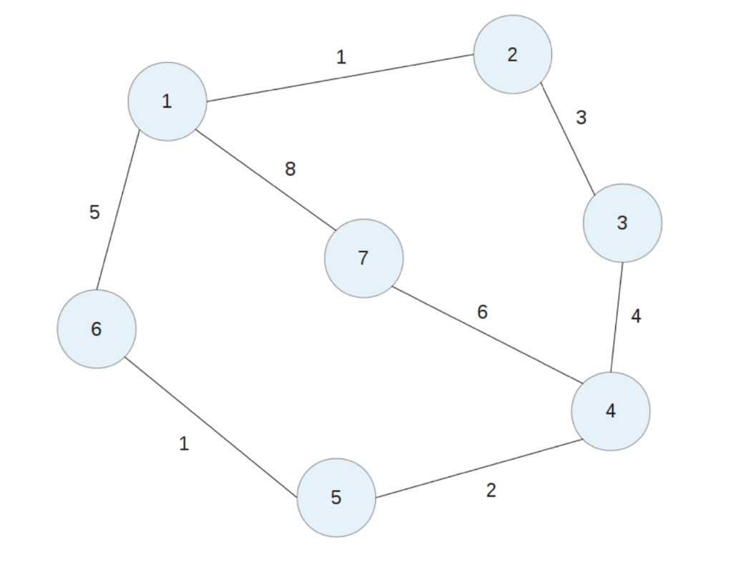

Example PARTLY TEST:
Run router 1:
Router 1 will start with an empty Initial Routing Table and will send RIP packets every 30 seconds to the ports specified in the configuration file: 2221, 6661, and 7771. Since no other routers are active, the routing table will remain empty until it receives further RIP packets.
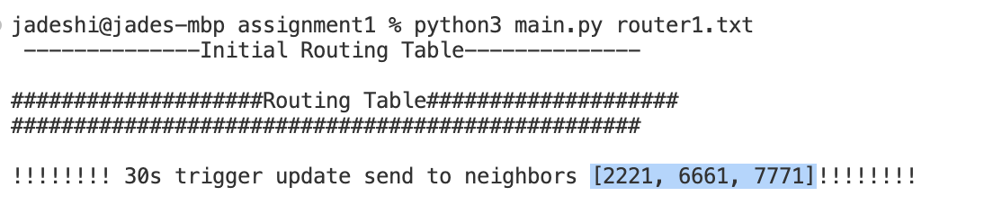

Run router 2:
Router 2 should start with an empty Initial Routing Table and send RIP packet every 30 seconds to the port it read from configuration file: 1111, 3331.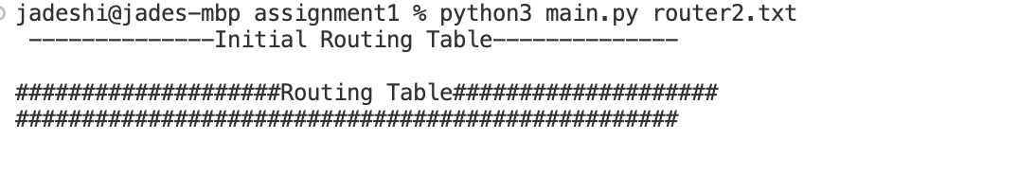
With in next 30 seconds, Router 2 will receive a RIP packet from port 1111 (Router 1). It will process and decode this packet, then run the routing algorithm to update its own routing table.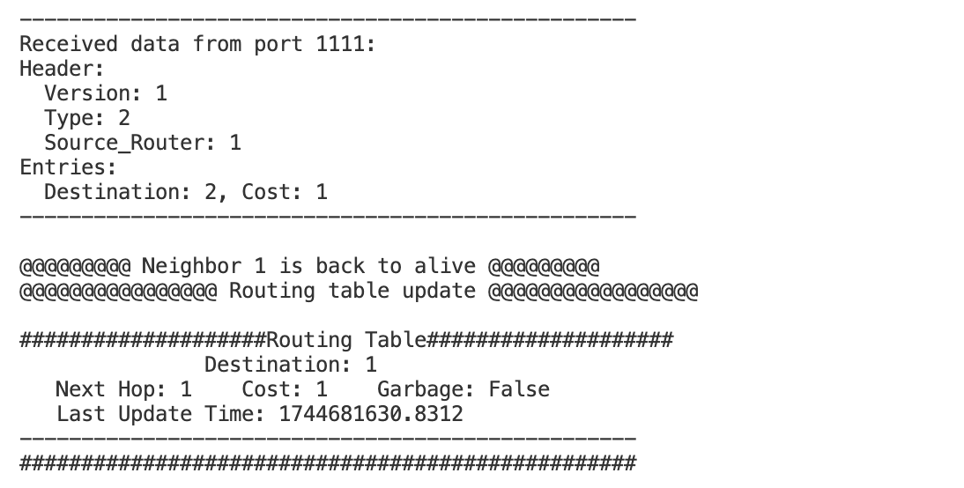

Same as router 2, router 1 will receive a RIP packet from port 2221(router2) and will process and decode this packet to update the routing table.
The top 3 “ trigger update send to neighbours” are before router 2 opened, it keep periodically sent to each output port read from configuration file.
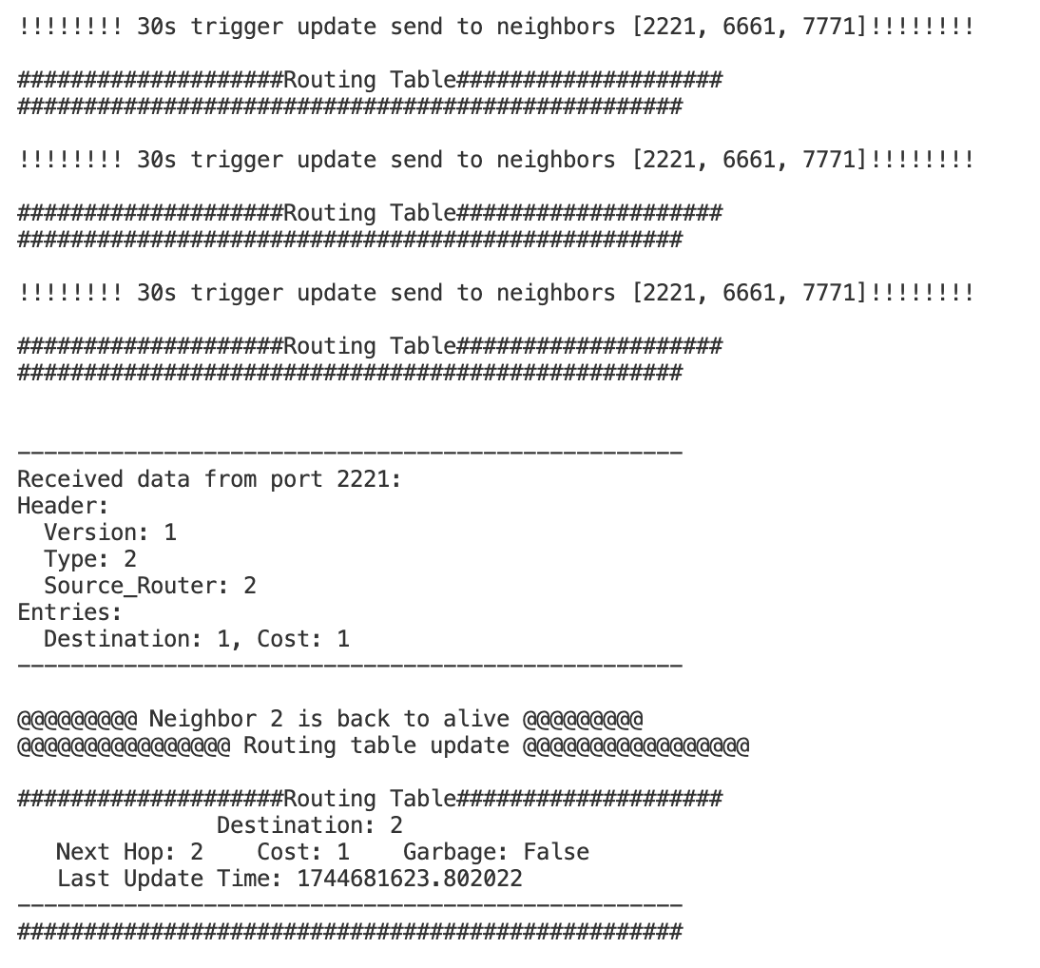

In each router’s routing table update time should be the last time when received the RIP packet and the Garbage should be always False since they both alive.

Run router 3:
When Router 3 is activated, it sends a RIP packet to Router 2. Router 2 processes this packet, updates its routing table with the new path to Router 3, and includes this information in its next periodic update (30 seconds later) to Router 1. Consequently, Router 1 updates its table to include the path to Router 3.
This is the data we read from router 1 processed RIP packet and update it self’s routing table with 3.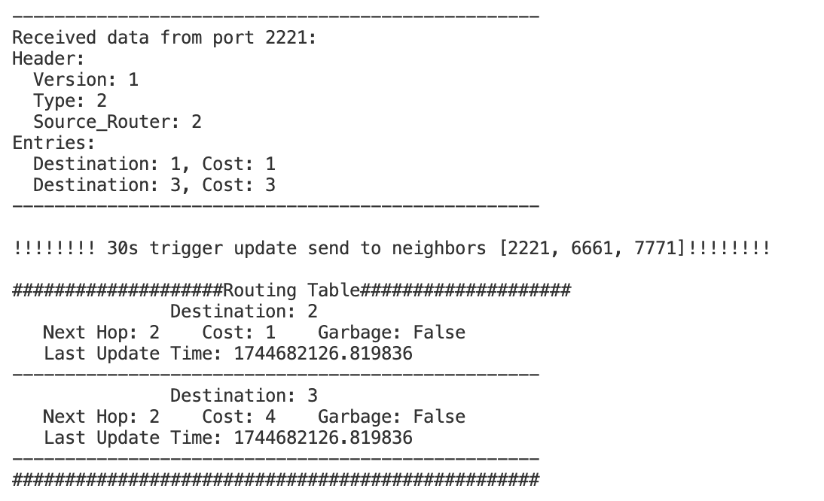

In the next periodic update, Router 1 will send a poisoned packet to Router 2, as it learned the route to Router 3 from Router 2. Router 2 will receive a RIP packet from port 1111 with the cost to Router 3 set to 16. Simultaneously, Router 3 will learn the path to Router 1 and send a poisoned packet to Router 2.
In the data read from router2 below, router 2 receives packets from both Router 3 and Router 1, where the cost to reach destinations 1 and 3 is set to 16. This matches our expectations, confirming that Router 2 has been effectively poisoned.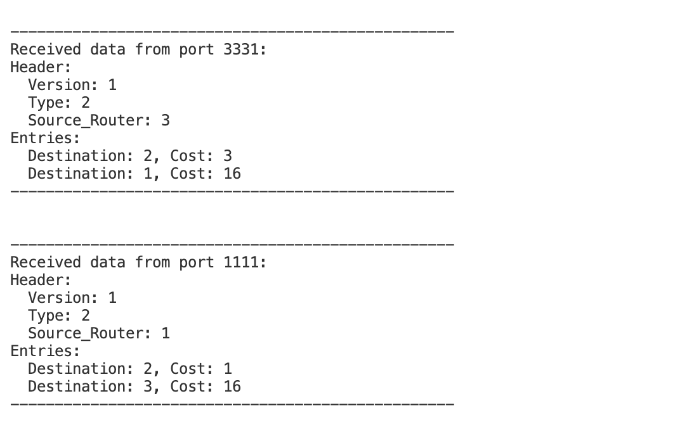
Shut down router 2 , to see how the reaction router 1 and router 3 will drop this route.
For router 3:
Since there was no update RIP received from router 2 so both route to router 2 and 1 ‘s update time will frozen until:
After 120s router 2 been shut , router 3 will set the cost to router 2 and router 1 to 16.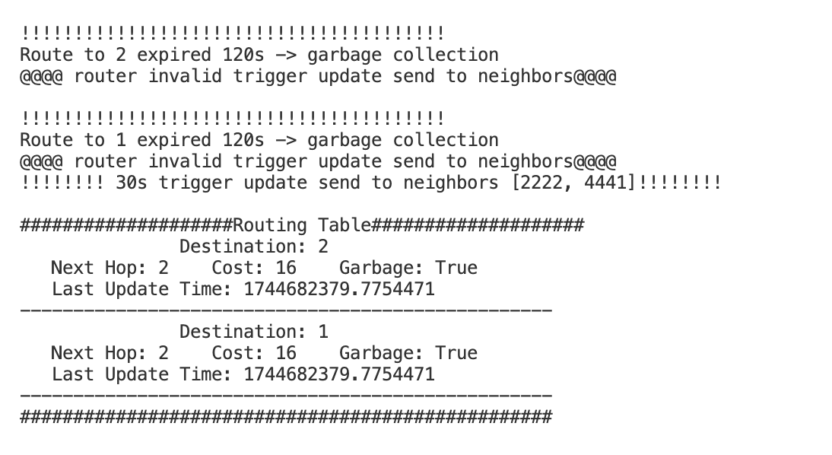

After 180s router 2 been shut , router 3 will remove router 2 and router 1 from it routing table. So it ended with an empty routing table, because it need go through router 2 then can reach router 1.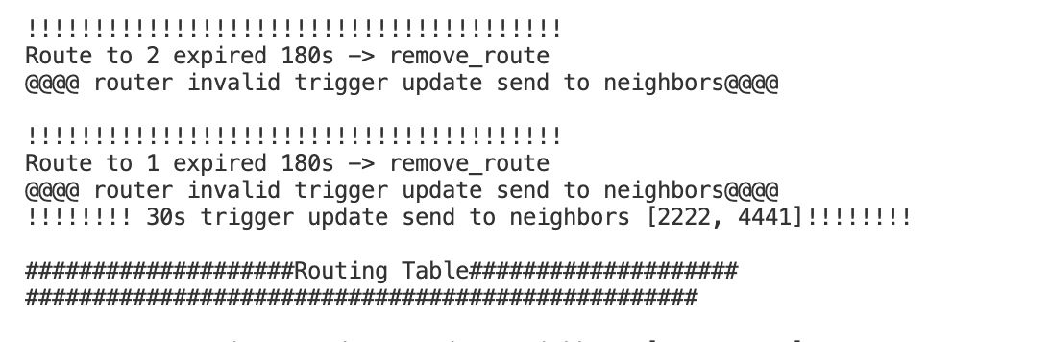
This will also happened to router 1.

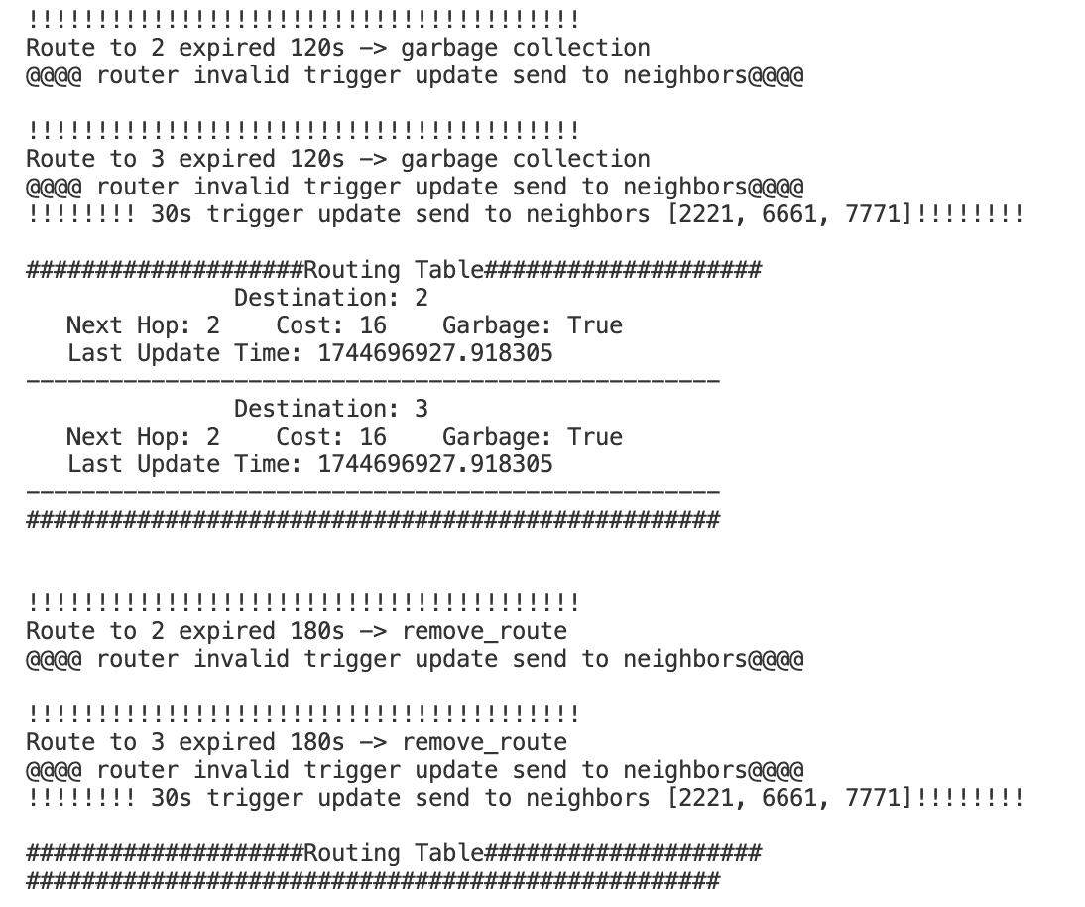

Run router 2 back:
Router1 will find the route from origin_routing_info and add the router 2 back, later router 2 find the way to router 3 so router 1 also add router 3 back.
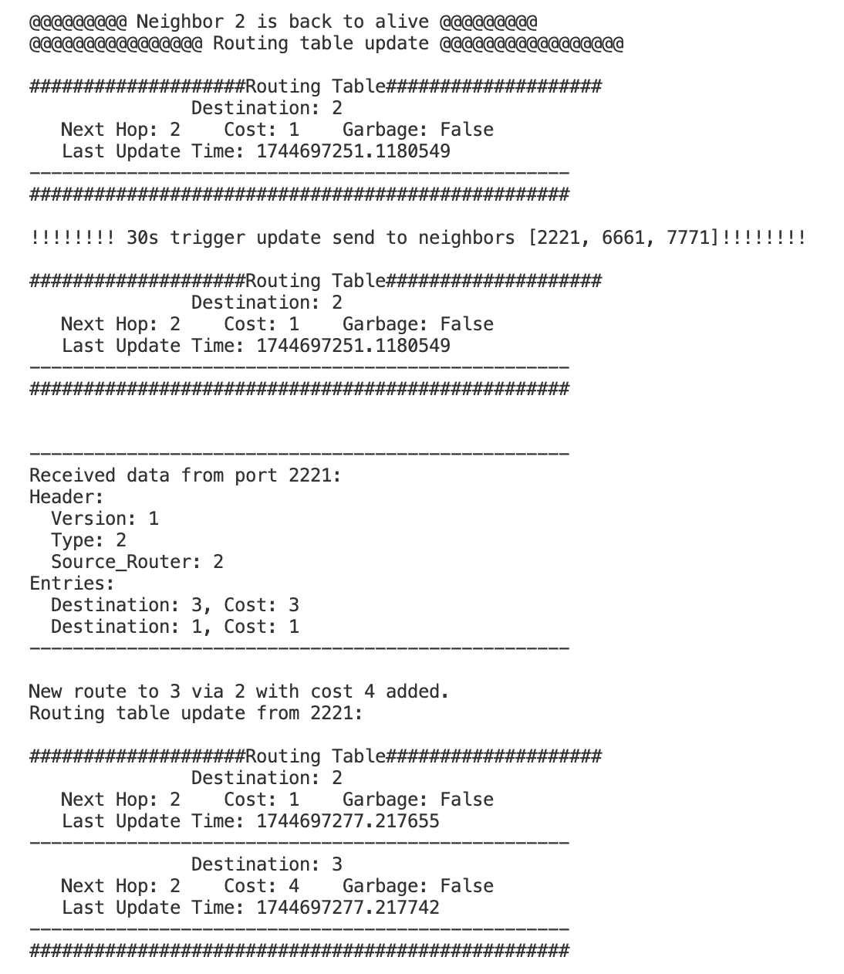

Example OVERALL TEST:
We run all 7 router in sequence 1-7 and take some time to make the routing table converge.
All the router have 100% correctness for the final converging and give a solid result.
We take 2 router for example
The final routing table in router 1 :
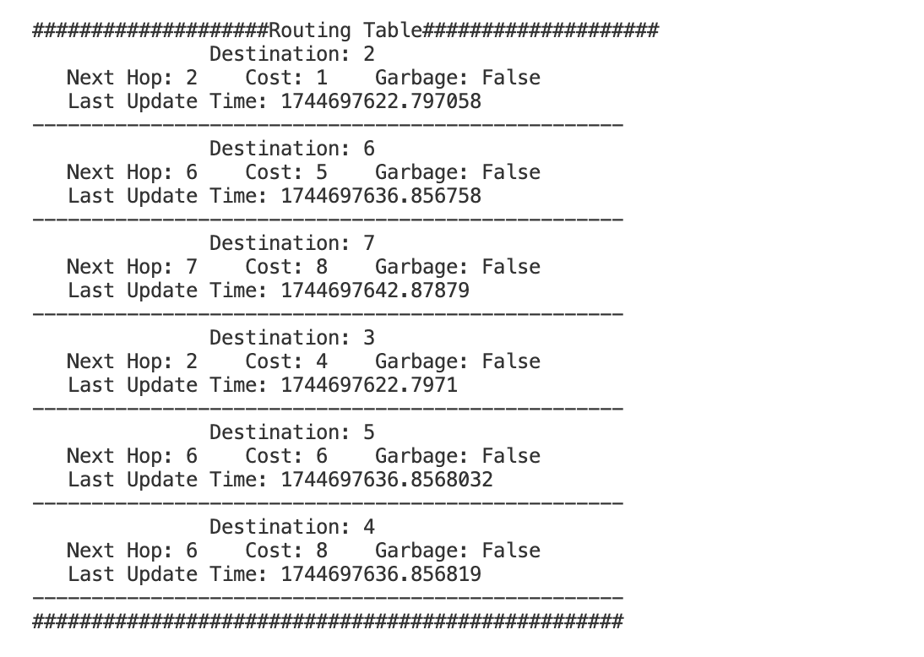
The final routing table in router 4 :
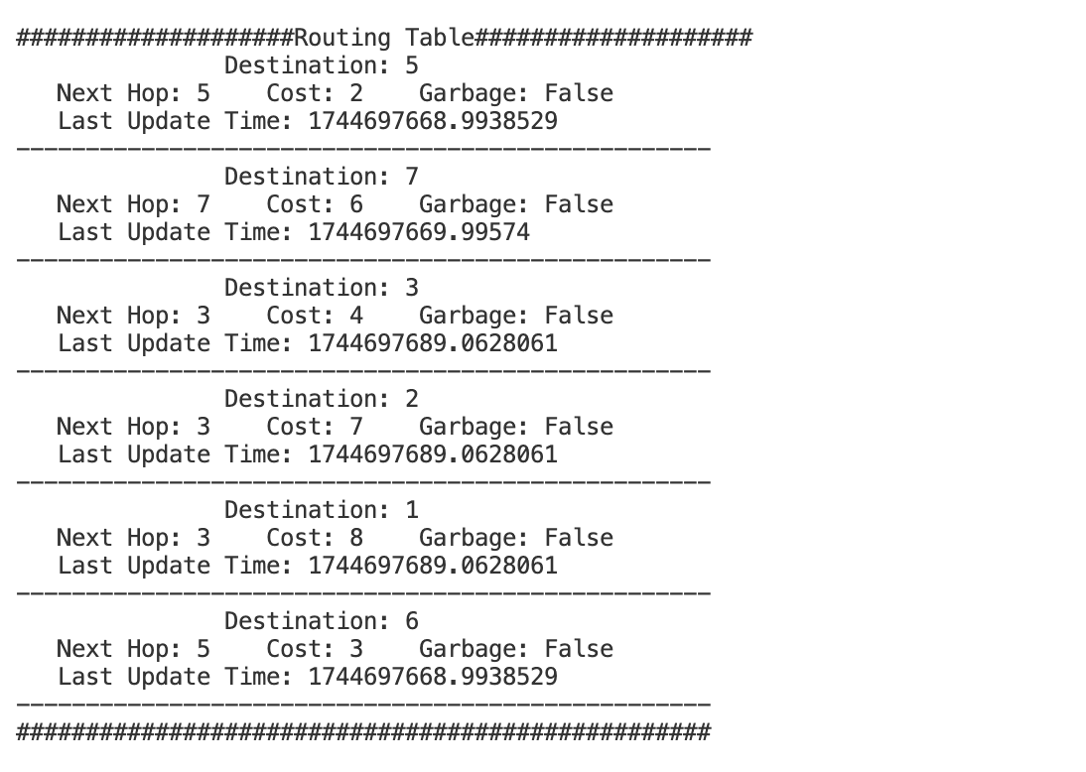

Next we turn off router 2 , wait for 180s until this router been fully removal from the routing table in neighbours.

For router 1 since it cut the original way to router 3.It will fin a new route router 1 - 6 – 5 – 4 – 3, with cost 5+1+2+4 = 12. Also, the reachability to router 2 been removal.
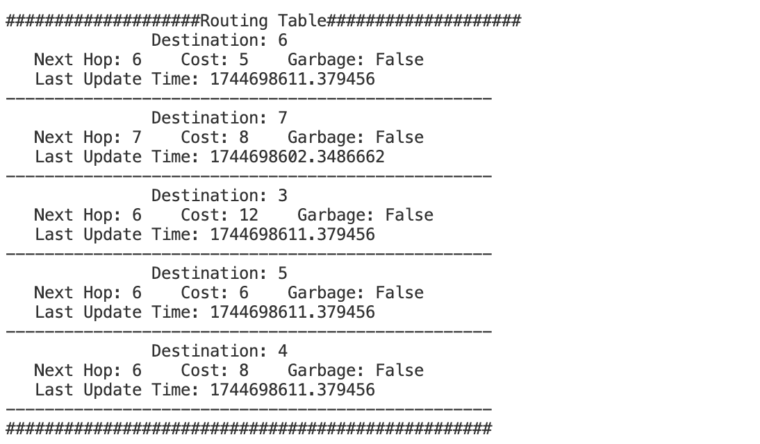
For router 4 , it use router 3 as a out gate then trivial through router 2 to router 1. From router 2 been cut ,it need to learn a new path to touter 1. It will find a better route with next hop router 5 ,and cost 2+1+5 =8. Plus, the reachability to router 2 been removal.
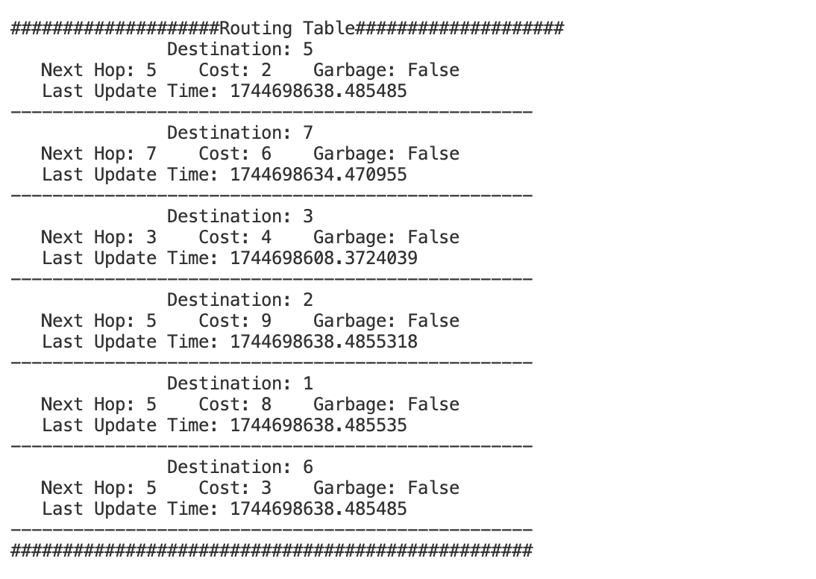

We conducted comprehensive tests by adding and removing each router to evaluate partial and complete routing relationships. This approach provided valuable insights for debugging, and ultimately, we achieved a 100% pass rate in the final tests.

3 Configuration File

We use .txt syntax for the configuration file which achieved humans read and edited. Followed is a sample of configuration file for router 1.
----------------------------------------------------------------------------------------------------------------
router-id 1
input-ports 1111, 1112, 1113
output-ports 2221-1-2, 6661-5-6, 7771-8-7
----------------------------------------------------------------------------------------------------------------

4 Source Code

