Abstract
This project is a top-down 2D twin-stick shooter. The player controls an aircraft, fires projectiles at enemies, avoids dangerous terrain, and survives for a set time to win. The game uses the GamesEngineeringBase framework provided by the course. The main logic is written in C++, while values and image resources are loaded from text configuration files.

1. Game Introduction and Full Flow
When the game starts, it first loads Resources/gameplay.txt, Resources/Sprites/sprites.txt, Resources/tiles.txt, and the image files. If any file is missing or has an incorrect format, the game displays a resource error.
After the resources load successfully, the player presses Enter to start Level 1. Level 1 uses a fixed 42 by 42 map. Each tile is 32 by 32 pixels, so the full map is 1344 by 1344 pixels, which is larger than the 1024 by 768 window. The player can move with WASD or the left stick. The game automatically fires normal bullets at the nearest enemy. The player can also use the left mouse button or right stick to fire an eight-direction projectile, and press Space to use the AOE attack.
Enemies keep spawning, and the spawn interval becomes shorter over time. Normal enemies move directly towards the player, while the turret stays still and fires enemy projectiles. After killing enemies, the player can receive an attack-speed upgrade or an upgrade to the number of AOE targets. Water cannot be crossed, roads increase movement speed, lava can be crossed but causes continuous damage, and health boxes restore health.
After Level 1 reaches 120 seconds, the game does not pause and a portal appears in the centre of the fixed map. The player enters Level 2 by touching the portal. Level 2 uses an infinite map generated from a random seed, and the camera always follows the player. The player wins when Level 2 reaches 120 seconds. The result screen shows the score and an A, S, SS, or SSS grade. If the player's health reaches zero in either level, the game shows the defeat screen.
The main loop follows this order: read input, calculate the time difference, update the game, draw the frame, and finally present it in the window.
while (running) {
canvas.checkInput();
const float dt = timer.dt();
gameUpdate(dt);
if (!running) break;
paintAll();
canvas.present();
}

2. Technique One: Fixed Scene, Player Movement and Virtual Camera

2.1 Theory
World coordinates and screen coordinates need to be separated. World coordinates describe the real position of an object on the full map, while screen coordinates describe where it is shown in the current window. If world coordinates are used directly for drawing, the player disappears after moving outside the window, and a map larger than the window cannot be displayed correctly.
A virtual camera can be understood as a window moving over a large map. Assume that the object's world coordinate is P_w and the world coordinate of the camera's top-left corner is C. The screen coordinate P_s is:
\(P_s = P_w - C\)
When the camera follows the player, it can first be placed half a window above and to the left of the player:
$$cameraX = playerX - windowWidth / 2, cameraY = playerY - windowHeight / 2$$
The camera position must also be limited on the fixed map. The camera cannot move outside the map, otherwise black areas without map data will appear on the screen. The infinite map has no fixed boundary, so the camera can always keep the player in the centre.
Player movement uses a two-dimensional vector. When two keyboard directions are pressed together, the vector length becomes greater than 1. Without correction, diagonal movement would be faster than horizontal movement. Therefore, an input longer than 1 is normalised. A stick input below 1 keeps its size, so the player can move slowly when the stick is pushed lightly.

2.2 Implementation
Player stores the current position, previous-frame position, velocity, health, collision radius, and attack data. The position is updated as follows:
const float length = std::sqrt(input.x * input.x + input.y * input.y);
if (length > 1.0f) {
input.x /= length;
input.y /= length;
}
velocity = {input.x * speed * terrainMultiplier,
input.y * speed * terrainMultiplier};
position.x += velocity.x * dt;
position.y += velocity.y * dt;
terrainMultiplier is 1 by default. It becomes 1.5 when the player's centre is on a road, so the base speed increases from 180 pixels per second to 270 pixels per second.
Camera::follow calculates the camera position from the player position. Fixed mode limits the camera to the map area, while infinite mode does not apply this limit.
position = {target.x - viewport.x * 0.5f,
target.y - viewport.y * 0.5f};
if (mode == CameraMode::Fixed) {
position.x = ClampValue(position.x, 0.0f, maxX);
position.y = ClampValue(position.y, 0.0f, maxY);
}
Before drawing the player, enemies, projectiles, and portal, the code always calls worldToScreen. In this way, movement and collision only deal with world coordinates, and rendering only needs to care about the camera.
Updating the player and camera needs only a fixed number of calculations per frame, so the time complexity is O(1).

3. Technique Two: NPC Spawning, Types and Behaviour

3.1 Theory
If every enemy type has a completely separate implementation, a large number of NPCs will cause much repeated code. A simpler method is to let all enemies share one data structure and update loop, then use the enemy type and configuration data to decide health, speed, collision radius, damage, and image.
The basic way to track the player is to calculate the direction vector of 'player position minus enemy position':
$$direction = playerPosition - enemyPosition$$
Dividing this direction by its length gives a unit direction. Multiplying it by enemy speed and dt makes the enemy move directly towards the player. This method has no pathfinding, but it is simple and has a low cost.
Random spawning needs to handle positions both inside and outside the screen. An inside position can be chosen randomly inside the camera rectangle. For an outside position, the code first randomly selects the top, bottom, left, or right edge, and then places the position a short distance beyond that edge. The spawn point also keeps a safe distance from the player, so an enemy does not appear directly on top of the player.

3.2 Implementation
The project uses a fixed-length Enemy array that stores up to 256 enemies. A fixed array avoids dynamic memory allocation every frame and is also easy to save in a fixed order. When an enemy is spawned, the first empty slot is used. The slot can be reused after the enemy dies or moves too far away from the player.
The current properties of the four enemy types are shown below:
Type | Appearance | Health | Speed | Contact damage | Behaviour
Goblin | Orc animation | 35 | 85 | 10 | Normal tracking
Sprinter | Bat animation | 18 | 145 | 7 | Fastest speed but low health
Brute | Flaming stone statue animation | 120 | 48 | 20 | High health and damage but slow movement
Turret | Turret body and rotating barrel | 65 | 0 | 12 | Stays still and fires every 1.8 seconds

The enemy spawn interval has four stages:
Current level time | Spawn interval
0 to 30 seconds | 1.60 seconds
30 to 60 seconds | 1.20 seconds
60 to 90 seconds | 0.85 seconds
After 90 seconds | 0.55 seconds

This meets the requirement that enemy frequency increases over time. Each spawn has a 30% chance to appear inside the screen; otherwise it appears outside. The code tries to find a safe position up to 32 times. If it cannot find one, that spawn is skipped, avoiding the spawn loop making the game stuck.
The main movement code for normal enemies is shown below:
const Vector2 delta = {
session.player.position.x - enemy.position.x,
session.player.position.y - enemy.position.y
};
const float distance = std::sqrt(delta.x * delta.x + delta.y * delta.y);
if (distance > 0 && stats.speed > 0) {
const float travel = ClampValue(stats.speed * dt, 0, distance);
enemy.position.x += delta.x / distance * travel;
enemy.position.y += delta.y / distance * travel;
}
The turret speed is configured as zero, so it does not enter the movement calculation. It stores its own shooting cooldown. When the cooldown ends, it calculates the direction towards the player and creates an enemy projectile. The barrel angle is drawn with atan2, so the turret body stays still while the barrel points towards the player.
Enemy updates scan the full fixed array, so their complexity is O(E), where E is the enemy capacity. Finding the nearest enemy is also O(E).
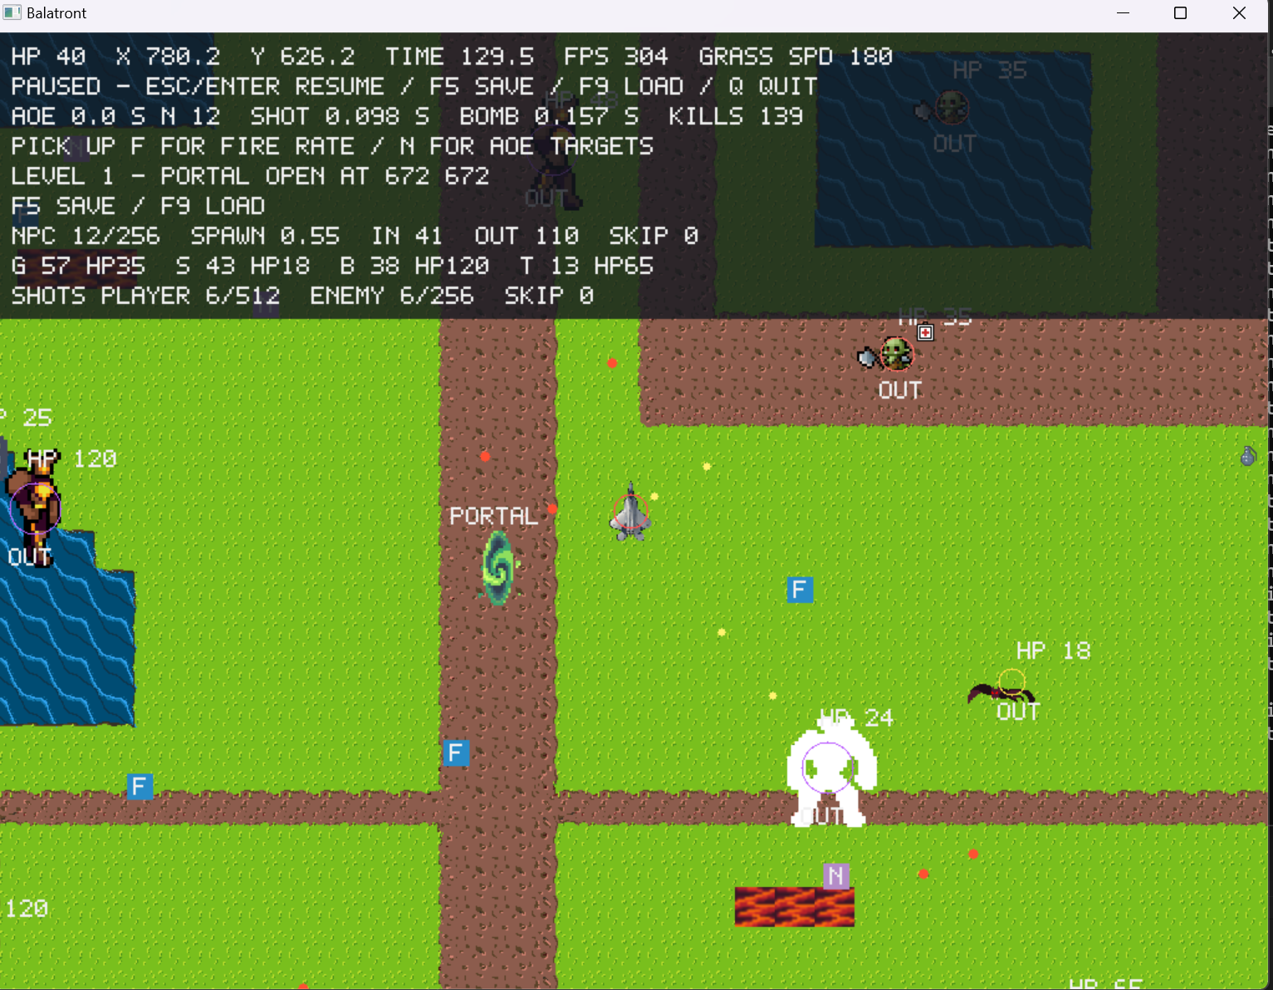
Figure 1 shows the Level 1 portal, four enemy types, enemy health, collision circles, and the IN and OUT spawn markers. IN and OUT show whether an enemy was inside or outside the camera when it spawned. They do not show its current position.

4. Technique Three: Collision System

4.1 Theory
Characters and projectiles in the game can be approximated as circles. To test whether two stationary circles collide, only the squared distance between their centres and the squared sum of their radii need to be compared:
$$distance² ≤ (radiusA + radiusB)²$$
Checking only the current-frame position can cause a problem. When a projectile moves very quickly, it may be on the left of an enemy in one frame and already on the right in the next frame. It passes through the enemy between the frames, but neither endpoint overlaps. This problem is usually called tunnelling.
This project uses continuous swept-circle collision detection. The relative movement of two objects during one frame is changed into 'a line segment moving towards a circle', and then the quadratic equation between the segment and circle is solved. If the result is between 0 and 1, a collision happened during that frame. The returned fraction can also decide which enemy a projectile hit first.
Terrain collision uses a circular player against a square tile. The closest point on the water-tile rectangle to the player's centre is found first. The distance from this point to the centre is then compared with the player radius. If the distance is smaller than the radius, the player has touched the water.

4.2 Implementation
The main calculation of the continuous collision function is shown below:
const Vector2 offset = {from.x - targetFrom.x, from.y - targetFrom.y};
const Vector2 motion = {
to.x - from.x - (targetTo.x - targetFrom.x),
to.y - from.y - (targetTo.y - targetFrom.y)
};
const float c = offset.x * offset.x + offset.y * offset.y - radius * radius;
const float a = motion.x * motion.x + motion.y * motion.y;
const float b = offset.x * motion.x + offset.y * motion.y;
const float discriminant = b * b - a * c;
fraction = (-b - std::sqrt(discriminant)) / a;
The same CircleSweep function is used in the following cases:
1. Contact between the player and an enemy.
2. A normal player projectile against an enemy.
3. An eight-direction player projectile against an enemy.
4. A turret projectile against the player.
5. The player collecting an upgrade or health box.
6. The player entering the portal.
After taking normal damage, the player has 0.35 seconds of invulnerability. This prevents full damage from being applied every frame while the player overlaps an enemy. Lava is continuous damage, so health is reduced by damage per second multiplied by dt. It also triggers the player's damage flash effect.
Water collision during player movement is handled separately on the X and Y axes. Each movement is also divided into small steps no longer than one quarter of a tile. This makes it harder for the player to cross water directly after the movement speed increases, and it allows the player to slide along the shoreline.
Enemy contact with the player and enemy-projectile collision checks are O(E+P_e). The current player-projectile collision checks scan all enemies for every projectile, giving the following complexity:
$$O((automaticProjectiles + manualProjectiles) × enemies)$$
Here, P_a is the number of automatic projectiles and P_m is the number of eight-direction projectiles. This implementation is direct and easy to prove correct, but it becomes a performance bottleneck when many enemies and projectiles are active together.

5. Technique Four: Eight-Direction Attack, AOE and Upgrades

5.1 Theory
The eight-direction attack changes a continuous stick direction into one of eight fixed directions. A full circle is divided equally into eight parts, so each part has an angle of π/4. First, atan2(y,x) is used to calculate the input angle. Half a sector is added as a rounding offset, and the result is divided by π/4 to get the sector number.
The AOE in this game attacks the N enemies with the highest maximum health at that time. The implementation repeatedly finds the highest-health enemy that has not already been selected. All targets are selected before damage is applied. This prevents an earlier target from dying and releasing an array slot before the later targets are decided.

5.2 Implementation
The project reads both the stick and mouse. Stick input has priority when it exists. If there is no stick input and the left mouse button is held, the direction is calculated from the mouse position minus the player's screen position.
const float angle = std::atan2(y, x);
int sector = int(std::floor((angle + 0.392699082f) / 0.785398163f));
if (sector < 0) sector += 8;
outWay = directions[sector % 8];
The eight-direction projectile currently deals 25 damage and has a base firing interval of 0.8 seconds. The automatic attack finds the active enemy nearest to the player. Its normal projectile currently deals 12 damage and has a base interval of 0.5 seconds. Both linear attacks are affected by the attack-speed upgrade.
The AOE is triggered with Space. Its base cooldown is 12 seconds, each target takes 40 damage, and it initially selects 3 enemies. The selection process is shown below:
while (targetCount < requested && targetCount < GameConfig::MaxAoeTargets) {
int best = -1;
for (unsigned int i = 0; i < GameConfig::MaxEnemies; ++i) {
const Enemy& enemy = enemies.at(i);
if (!enemy.active || selected[i]) continue;
if (best < 0 || enemy.health > enemies.at(best).health) best = int(i);
}
if (best < 0) break;
selected[best] = true;
indices[targetCount++] = static_cast<unsigned int>(best);
}
One upgrade drops for every 5 enemy kills. Attack-speed and AOE target-count upgrades appear alternately. An attack-speed upgrade multiplies the current attack interval by 0.85, with a minimum of 0.08 seconds. Each AOE upgrade adds 1 target, up to a maximum of 256.
In the worst case, AOE selection scans the enemy array N times, giving O(NE) complexity. A normal nearest-target search is O(E).

6. Technique Five: 32-Pixel Tiles, Fixed Map and Infinite Map

6.1 Theory
A tile map divides the map into equal-sized cells, and each cell stores only one tile ID. The matching image is selected from this ID during drawing. Assume that the map width is W and its height is H. If each cell stores one byte, the map data needs about WH bytes instead of storing all 32W × 32H pixels.
Data-driven design means that the map layout is not hard-coded in C++. The program only reads the format, while the real map IDs are stored in a text file. Therefore, the map can be changed without changing the code.
An infinite map cannot keep every cell in memory because its coordinates have no boundary. This project uses deterministic generation from 'coordinate plus seed'. The same seed and coordinate always give the same result. Therefore, terrain does not change when the player leaves an area and returns, and the game does not need to create more and more map text files.
When roads connect across regions, neighbouring regions must use the same boundary data. Water and lava areas can be made from several combined ellipses, with parts removed from the edges to create irregular outlines. Shore tiles are then selected by checking whether the neighbours above, below, left, and right are water.

6.2 Implementation
The fixed-map file header stores the width, height, tile width and height, and layer number. It is followed by 42 by 42 tile IDs. The loader checks the count, commas, value ranges, and extra data, and loads 0.png through 24.png.
tileswide 42
tileshigh 42
tilewidth 32
tileheight 32
layer 0
0,0,0,7,13,13,4,...
When the visible area is drawn, the code first converts the camera range into tile rows and columns. It scans only the cells covered by the screen instead of the whole fixed map. Each cell then writes its tile pixels into the window buffer.
The current terrain types are:
Terrain | Effect
Grass | Normal movement
Road | Player speed becomes 1.5 times normal
Water and shoreline | The player cannot pass, but enemies can
Lava | Passable, but deals 6 damage per second

The infinite map is divided into regions of 64 by 64 tiles. Coordinate hashes decide road turning points, pool centres, pool radii, lava areas, and short branches. It uses the same 25 tile images, but the layout is generated from a seed, so Level 2 is different in every new game.
The infinite-map query does not store the full world. A single coordinate query uses a fixed amount of calculation and can be treated as O(1). The map work in each frame depends on the number of visible tiles and window pixels, giving O(V), where V is the part of the map covered by the screen. The current implementation does not cache generated results, so the same visible tiles are calculated again in later frames. This part can be improved further.
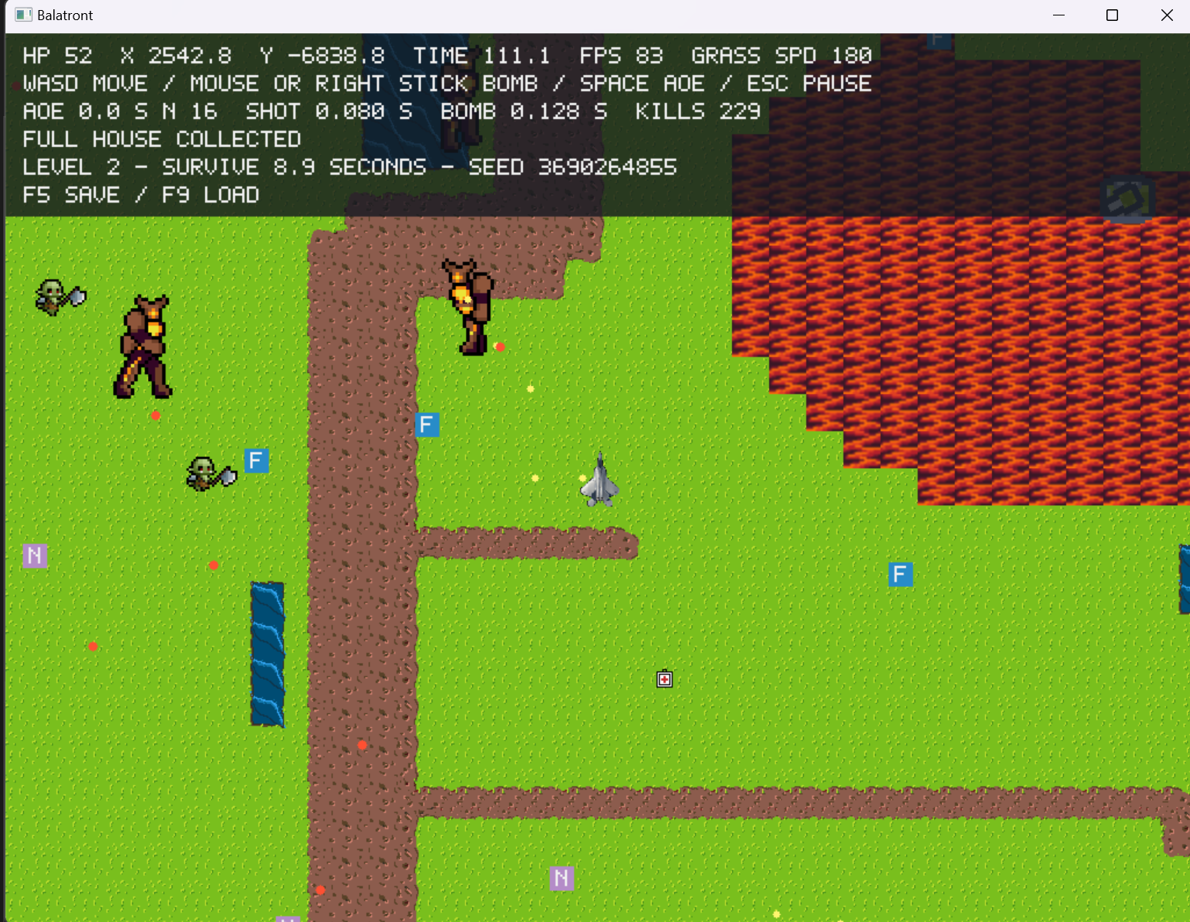
Figure 2 shows the infinite map in Level 2. The screen contains crossing main roads, short roads with endpoints, irregular lava, water, upgrades, and health boxes. The HUD also displays the player coordinates, terrain speed, remaining time, FPS, kill count, and random seed.

7. Technique Six: Two-Minute Levels, Two Maps, FPS and Score

7.1 Theory
Level timing should use game simulation time. Simulation time does not increase while the game is paused, so pausing for one minute does not directly complete a level. Level changes can be treated as a simple state flow: Level 1 running, Level 1 portal open, Level 2 running, and victory or defeat. This project includes kills, number of upgrades, and remaining health in the final score.

7.2 Implementation
After 120 seconds, the LevelFlow of Level 1 sets portalOpen to true. The game continues after the portal appears, and the player can still move, shoot, and take damage. Swept-circle collision is used to test whether the player enters the portal, so crossing the portal quickly can still trigger it.
When Level 2 starts, the player's current health, upgrades, and attack cooldowns are kept. Enemies, projectiles, and drops from Level 1 are cleared. A new random map seed is then set and the level time is reset to zero. The state changes to Victory when Level 2 reaches 120 seconds.
The final score formula is:
$$Score = Kills × 10 + Buffs × 100 + HP × 5$$
The grade rules are:
Score | Grade
Below 1500 | A
1500 to 2999 | S
3000 to 4999 | SS
5000 or above | SSS

unsigned int Game::countPoint() const {
return combat.kills * 10 + combat.upgradesCollected * 100
+ static_cast<unsigned int>(session.player.health + 0.5f) * 5;
}
FPS is calculated once every two seconds to reduce changes in the displayed value every frame. FPS, level time, and score data are shown in the HUD, and the score is shown again on the result screen. The victory screen shows a grade, while the defeat screen does not.
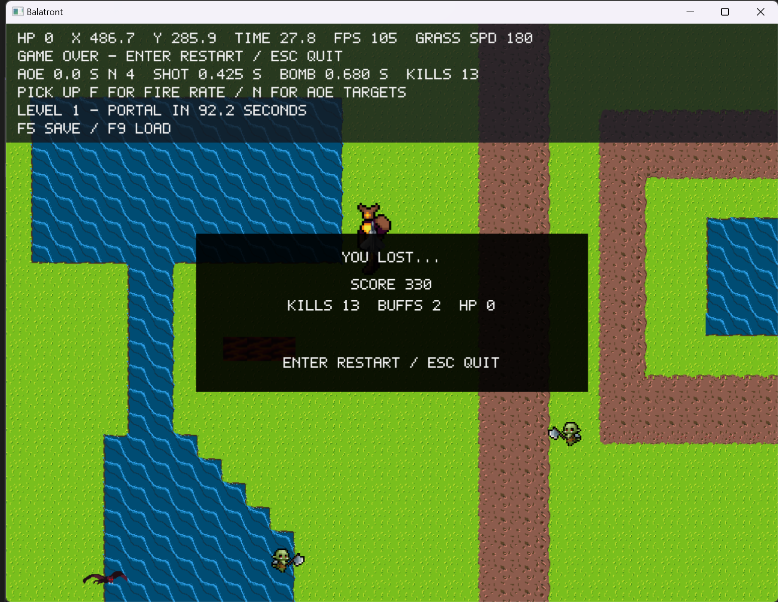
Figure 3 shows the defeat screen after the player's health reaches zero. It displays the score, kill count, number of upgrades, and remaining health, but it does not display a grade.
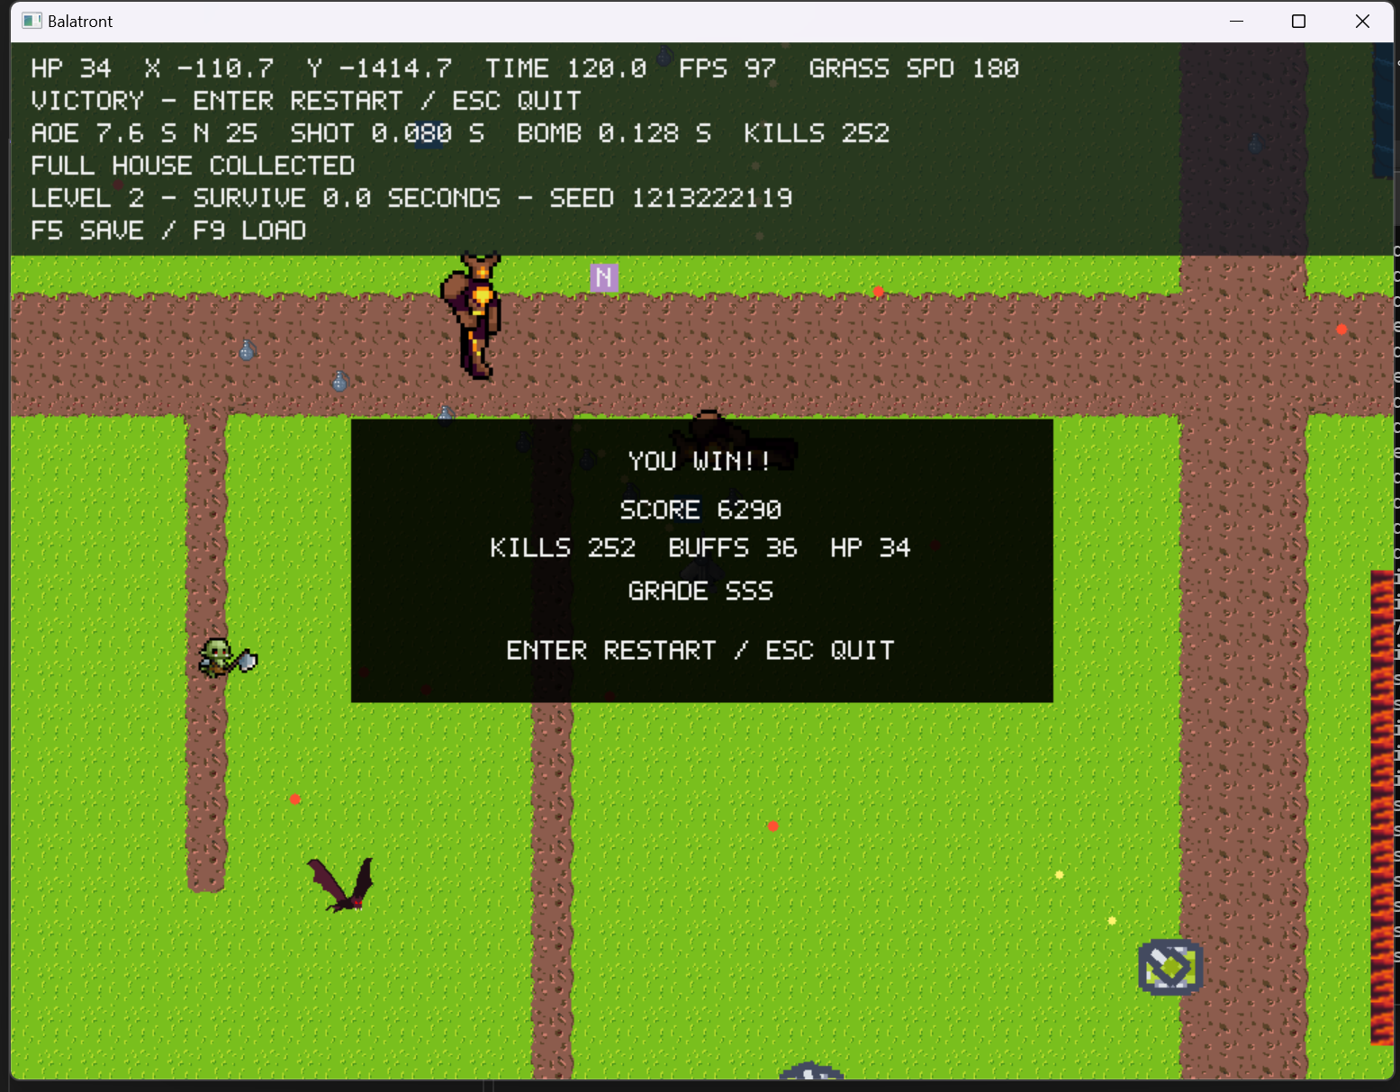
Figure 4 shows the victory screen after Level 2 reaches 120 seconds. This run finished with 252 kills, 36 upgrades, 34 health, a final score of 6290, and an SSS grade.

8. Save at Any Time and Reload at the Same Point
The player can press F5 to save and F9 to load while the game is running or paused. The save file records the level number, level time, portal state, current and previous player positions, health, invulnerability time, upgrades, camera, enemy array, three projectile arrays, drops, health boxes, attack cooldowns, fixed-map cells, and infinite-map seed.
Archive writes integers, floating-point values, Boolean values, and vectors in a fixed order. The file header stores an identifier and format version, while the end of the file stores a checksum. Loading checks value ranges, array capacities, level states, and the checksum, preventing a damaged file from being loaded into the game.
Saving first writes to savegame.tmp. After writing finishes, the old save is renamed to savegame.bak, and the temporary file is finally renamed to savegame.dat. If writing is interrupted, the old save still has a chance to remain. After loading succeeds, the game enters the paused state. The player presses Esc or Enter to continue, preventing an attack from happening immediately in the first frame after loading.
Saving scans the fixed-capacity enemy, projectile, and drop arrays, so its complexity is O(E+P+U). The file size has an upper limit and does not keep increasing with the number of saves.

9. Visual Studio Performance Analysis
The following CPU and GPU performance data were collected with the x64 Release build configuration.
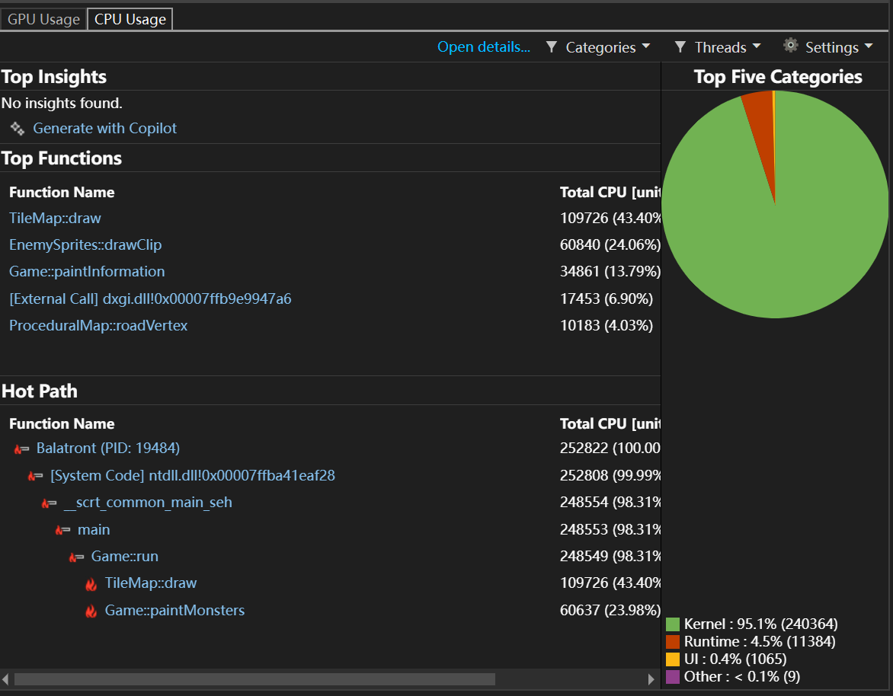
Figure 5. Visual Studio CPU usage analysis results
The CPU analysis shows that TileMap::draw uses 43.40%, EnemySprites::drawClip uses 24.06%, and Game::paintInformation uses 13.79%. The main CPU costs come from drawing the map, enemy sprites, and HUD.
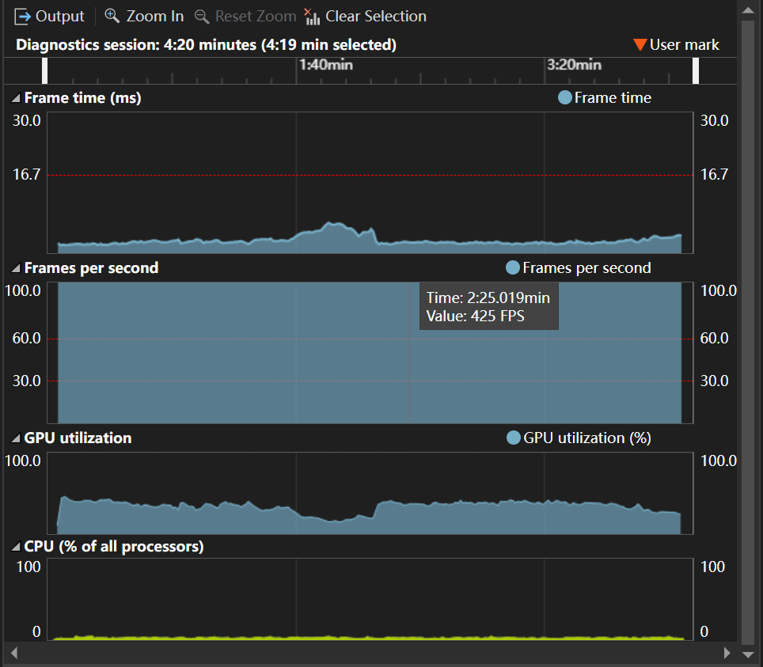
Figure 6. Visual Studio GPU usage analysis results

10. Project Limitations
The collision system has no spatial partitioning. Every player projectile may check all enemies, so performance drops when there are many enemies and projectiles. A better method would divide the world into a grid and check only enemies in cells near the projectile. In addition, controller input depends on the Xbox Controller interface provided by the course framework. A different controller may not work if the system cannot recognise it as a compatible controller. Although CPU and GPU data have now been collected for a full game, repeated tests on the same device with the same Release build configuration are still missing. The final report should also include the computer specification and record average and minimum FPS at fixed times.

11. What I Would Do If I Started Again
If I developed this project again, I would first decide the core data structures, resource formats, and level flow, and then add features step by step. The player, enemies, projectiles, and drops could still use fixed arrays because their maximum sizes are clear and they are easy to save. However, I would add a simple spatial grid earlier, so collision detection checks only nearby objects from the beginning and the core loop does not need to be changed later.
For rendering, I would first make a resource manager that can cache scaled sprites. Static images and normal animations would generate their final sizes when loaded, so drawing only copies the pixels that need to be shown. Per-pixel rotation would only be used for images that really need to rotate, such as the turret barrel.
Finally, I would clearly define the version and field ranges of the save data in the first version. Resource configuration, map format, and save format would remain separate, and the game code would only read these data. When balance values, art resources, or maps are changed, there would be no need to search several C++ files for hard-coded values.

12. Conclusion
This project completes a 2D twin-stick shooter that can run from the start to a victory or defeat result. The game includes a fixed map and an infinite map, a virtual camera, four NPC types, an increasing spawn frequency, direct tracking and turret attacks, full collisions between the player, enemies, terrain, and projectiles, an eight-direction linear attack, an AOE attack based on maximum health, two upgrades, two 120-second levels, FPS and score displays, and saving and loading at the same point. The implementation uses fixed arrays to control entity capacity, continuous swept-circle tests to reduce tunnelling by fast objects, text files to drive values and maps, and coordinate hashes to generate an infinite world without storing all of its data. The main limitation is the collision and software-drawing cost caused by many enemies and projectiles late in the game. Spatial grids, sprite caching, and map-region caching are possible directions for later optimisation.

