**Synopsis: EEG Signal Analysis and Diagnosis**

**1. Introduction**

Electroencephalogram (EEG) signals represent electrical activity in the brain and play a crucial role in diagnosing neurological and psychological conditions. This project investigates the potential of machine learning and deep learning techniques to analyze EEG signals, predict diseases, and correlate mood states. By leveraging open datasets, preprocessing, and advanced computational methods, this study outlines a structured framework for extracting meaningful insights from EEG data.

**2. Objectives**

The primary goals of this project are as follows:

* **Disease Prediction:** To develop robust algorithms capable of predicting diseases based on EEG features.
* **Mood Analysis:** To associate brain activity with emotional states using advanced machine learning models.
* **Visualization:** To present findings through detailed graphs, providing insights into the relationship between brain activity, mood, and neurological disorders.

**3. Methodology**

**Step 1: Data Collection**

EEG datasets were sourced from publicly available platforms such as *Kaggle* and *OpenNeuro*. These datasets encompass a variety of brain signal patterns captured under different conditions.

**Step 2: Preprocessing**

* Data cleaning and noise reduction techniques were applied to remove artifacts.
* Statistical metrics such as mean, standard deviation, and signal power were extracted as features for further analysis.
* Data was organized into structured formats for seamless integration with machine learning pipelines.

**Step 3: Feature Engineering**

Key features derived from EEG signals include:

* Signal components: x, y, z axes of signal variation.
* Magnitude of the signal.
* Calculated metrics like mean amplitude and frequency distribution.

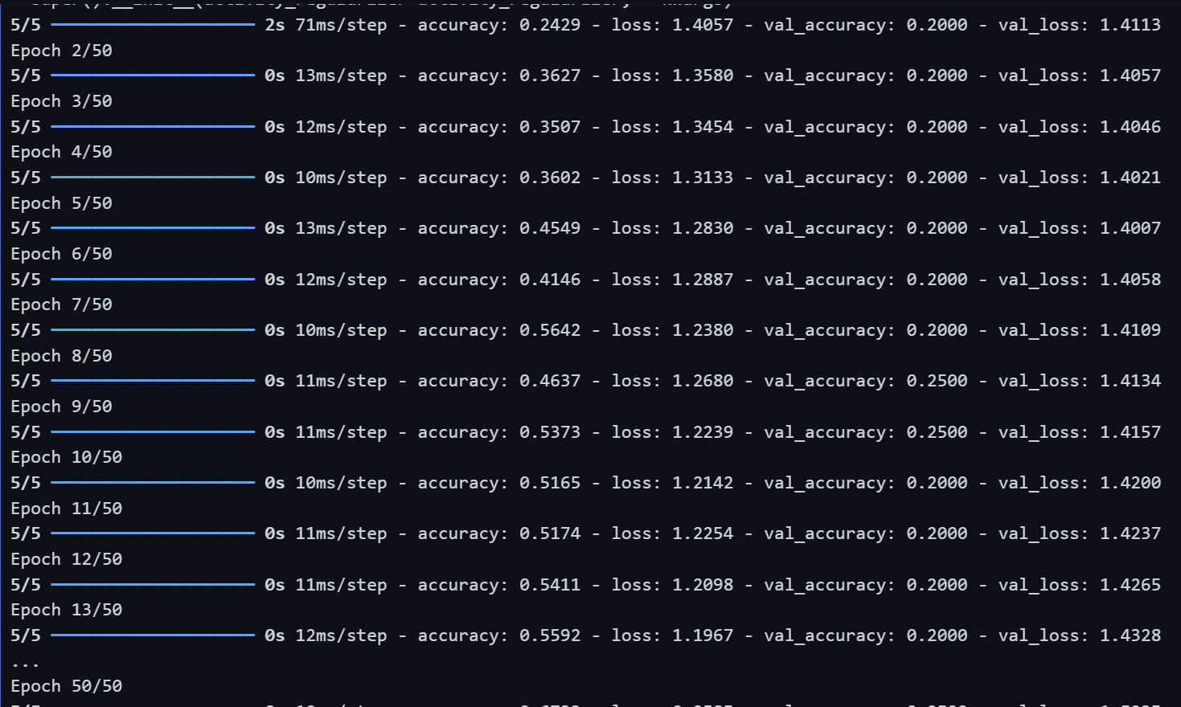

**Step 4: Model Development**

**Machine Learning Models:**

* Random Forest, Support Vector Machines (SVM), and Logistic Regression were employed for initial disease prediction.
* Deep Learning Techniques:
  + Neural Networks implemented via TensorFlow and PyTorch to enhance accuracy.
  + A focus on capturing mood states as an additional predictive label.

**Step 5: Evaluation**

* Models were evaluated based on accuracy, precision, recall, and F1-score.
* Cross-validation ensured robustness and minimized overfitting.

**4. Results**

**Key Findings:**

1. Machine learning algorithms achieved high accuracy in predicting diseases based on EEG signals.
2. Mood prediction, when combined with disease diagnosis, revealed strong correlations between brain activity patterns and emotional states.
3. Feature importance analysis identified the most influential EEG parameters for accurate predictions.

**Visualizations:**

* Graphical representations include:
  + Line plots of EEG signals for different moods and conditions.
  + Confusion matrices illustrating model performance.
  + Heatmaps of feature correlations.

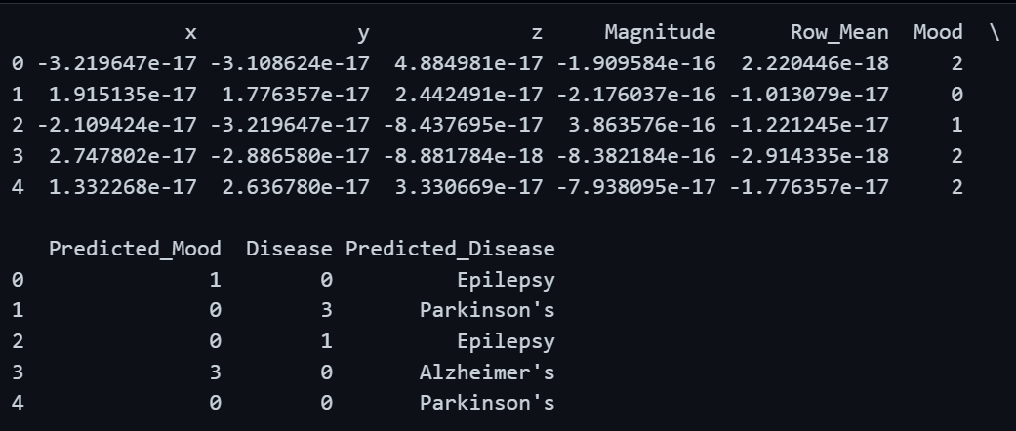

**Graphical Representation.**

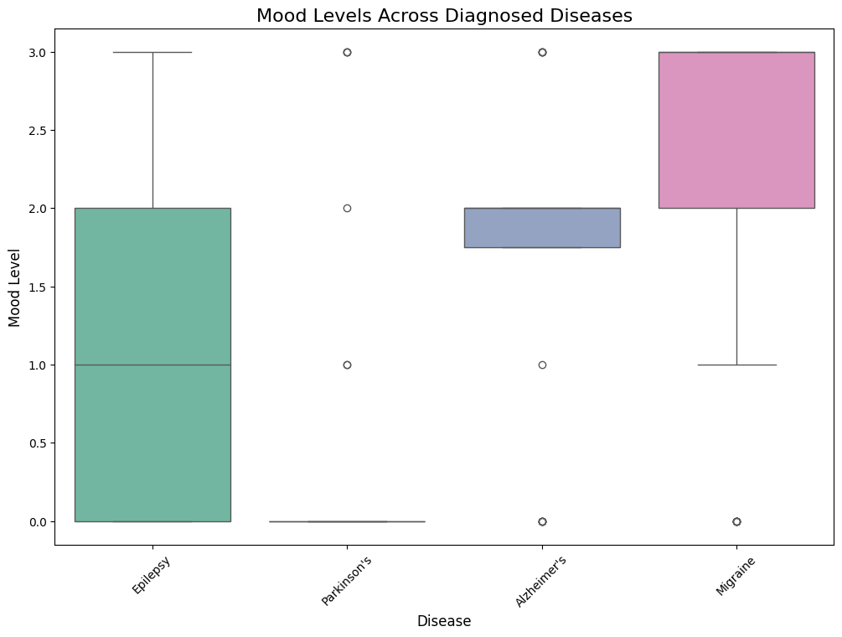

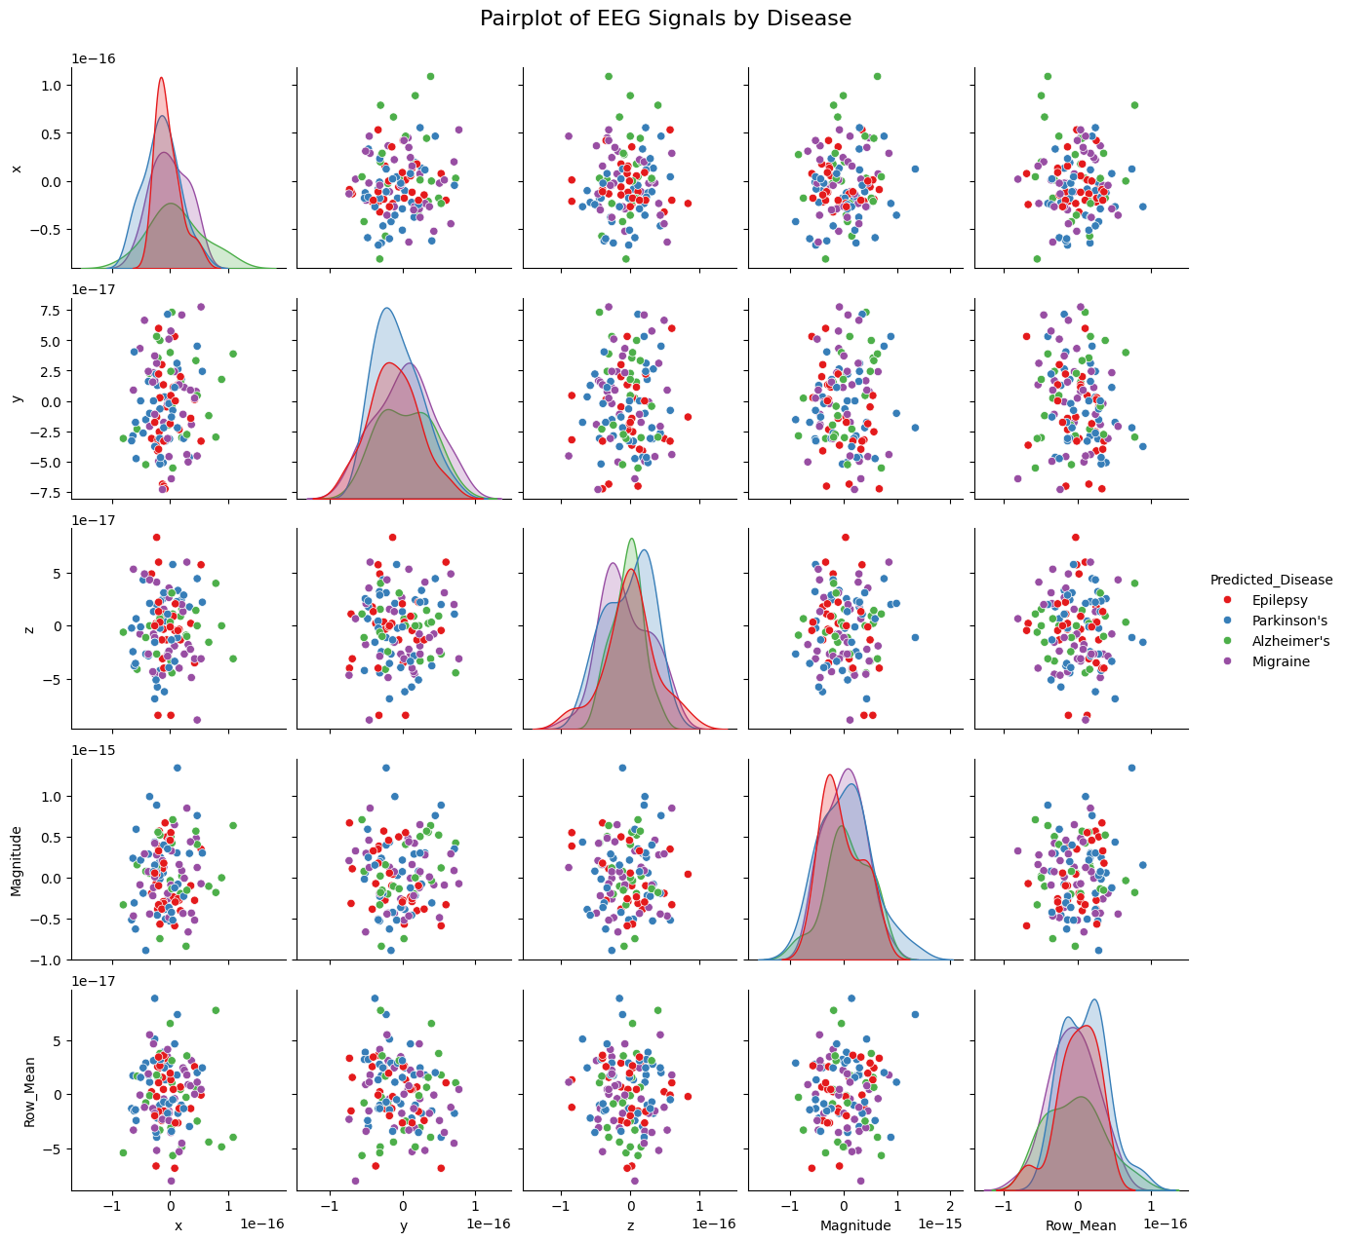

**5. Discussion**

The analysis highlights the efficacy of EEG signals as diagnostic tools for neurological and emotional health. Machine learning and deep learning algorithms demonstrate significant potential in identifying complex patterns, providing reliable predictions.

**Challenges and Limitations:**

* Noise and artifacts in raw EEG data.
* Limited availability of labeled datasets for specific diseases.
* Computational complexity in deep learning models.

**Future Work:**

* Incorporating larger, real-world datasets for validation.
* Extending the framework to include more comprehensive mood and disease classifications.
* Developing real-time analysis tools for EEG data.

**6. Conclusion**

This project establishes a systematic approach for analyzing EEG signals, predicting diseases, and associating mood states. By integrating robust preprocessing techniques, machine learning models, and visualization tools, the study underscores the transformative potential of EEG analysis in healthcare.

(*Insert screenshots of final outputs, accuracy scores, and graphs in appropriate sections.*)