Homework 02
  - Justin Adrowski

Problem 1:

A) Assume t0 holds the value 0x0000FFF, t1 holds the value 0xEFF01270, t2 holds the value 0x00000001 and t3 holds the value 0x0000001F. What is the value of t2 after the following instructions:
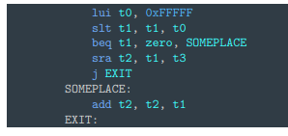
I1, t0 = 0xfffff000
I2, (two’s comp) => fffff000 = -4096, eff01270 = --269027728 => t1 < t0, t1 = 0x00000001
I3, t1 != 0, next line
I4, shift t1 to the right by 31 bits, store in t2 => gets rid of 1 bit, t2 = 0x00000000
I5, exit (no someplace block

B) Translate C loop into RISC-V with following register maps. All vars = 4byte. How many instructions executed if N = 1, 10, 100, 1000?
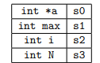
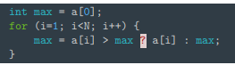

addi t2, zero, 0
addi t1, zero, 0
lw s1, 0(s0)
addi s2, x0, 1
for_loop:
bge s2, s3, end_of_for
slli t4, s2, 2
add t1, s0, t4
lw t2, 0(t1)
slt t3, s1, t2
beq t3, zero, max_stay
add s1, x0, t2
max_stay:
addi s2, s2, 1
j for_loop
end_of_for:

N = 1 => 5 Instructions
N = 10 => 77 instructions (86 if max updates every time)
N = 100 => 797 instructions (896 if max updates every time)
N = 1000 => 7997 instructions (8996 if max updates every time)

C) More RISCV Assembly from C code 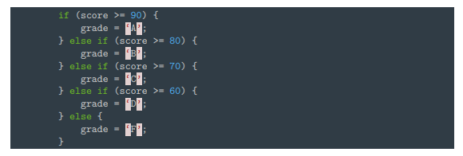
li t0, 90
bge a0, t0, SET_A
li t0, 80
bge a0, t0, SET_B
li t0, 70
bge a0, t0, SET_C
li t0, 60
bge a0, t0, SET_D
j SET_F
SET_A: li t1, 'A'
j DONE
SET_B: li t1, 'B'
j DONE
SET_C: li t1, 'C'
j DONE
SET_D: li t1, 'D'
j DONE
SET_F: li t1, 'F'
DONE:

Problem 2: RISC-V Assembly Language Design

Bitwise Invert in RISC-V
Xori t1, t2, -1

Rotate Left immediate (negative immediate implies right rotate)
andi t2, t3, 31 # get shift left amount if sign_ext_imm is negative
li t4, 32
sub t4, t4, t2
sll t0, t1, t2
srl t1, t1, t4
or t0, t0, t1
This implementation doesn’t produce any exceptions that I can think of.

Labels in RISC-V
1 – there’s no room for a full address, let alone three, in a 32-bit instruction.
2 – only the lw and sw instructions can access memory since they only require one memory access port. Having the capability to perform instructions with labels, accessing up to three memory points in one instruction would require a lot more hardware capabilities that would be expensive.

Problem 3: RISC-V Programming

C Code implemetaton of strchr
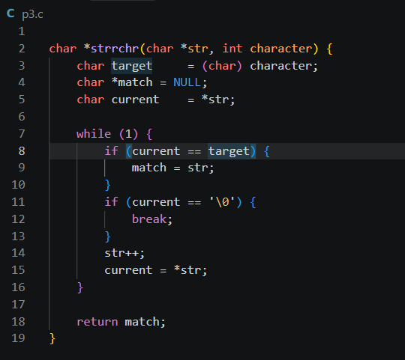

b) RISC-V function implementation
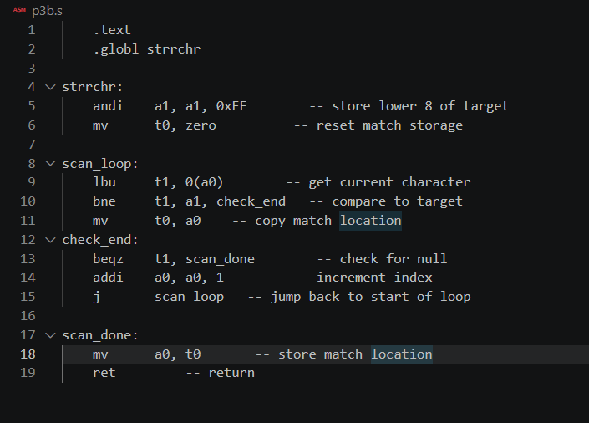

RISC-V Test Driver
