Homework 03
  - Justin Adrowski

Problem 1)

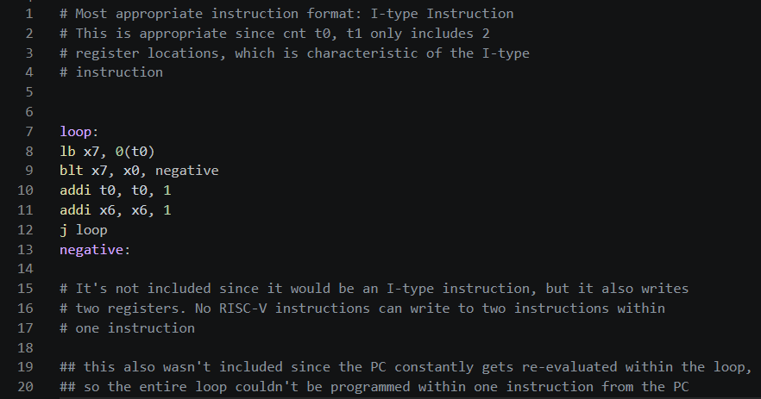

Field-by-field
1)

Or t0, s0, a0
R-type
Funct7 | Rs2 | Rs1 | Funct3 | rd | opcode
0 | a0 = 10 | s0 = 8 | 6 | t0 = 5 | 51
0000000 | 01010 | 01000 | 110 | 00101 | 0110011
0x00A462B3
2)

addi t1, zero, 127
I-type
Imm | Rs1 | Funct3 | rd | opcode
127 | 0 | 0 | t1 = 6 | 19
000001111111 | 00000 | 000 | 00110 | 0010011
0x07F00313
3)

lw t2, 64(t0)
I-type
Imm | Rs1 | Funct3 | rd | opcode
64 | t0 = 5 | 2 | t2 = 7 | 3
000001000000 | 00101 | 010 | 00111 | 0000011
0x0402A383
4)

sltu t3, t2, t1
R-type
Funct7 | Rs2 | Rs1 | Funct3 | rd | opcode
0 | t1 = 6 | t2 = 7 | 3 | t3 = 28 | 51
0000000 | 00110 | 00111 | 011 | 11100 | 0110011
0x0063BE33
5)

beq t3, zero , loop
SB-type
Imm(12,10:5) | Rs2 | Rs1 | Funct3 | Imm(4:1,11) | opcode
-8 | Zero = 0 | t3 = 28 | 0 | -8 | 99
1,111111 | 00000 | 11100 | 000 | 1100,1 | 1100011
0xFE0E0CE3
6)

J begin
UJ-type
Imm(20, 10:1, 11, 19:12) | rd | opcode
-20 | 0 | 111
11111110110111111111 | 00000 | 1101111
0xFEDFF06F

C) lui sequence
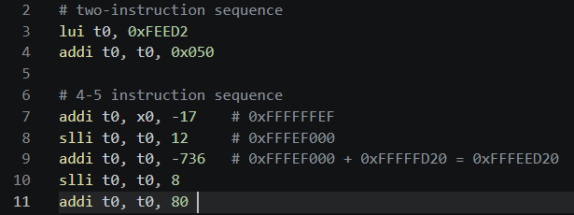

# two-instruction sequence
1)

lui t0, 0xFEED20
U-type
Imm(31:12) | rd | opcode
FEED20 | t0=5 | 111
111111101110110100100000 | 00101 | 0110111
0xFEED202B7
2)

addi t0, t0, 0x050
I-type
Imm | Rs1 | Funct3 | rd | opcode
0x050 | 5 | 0 | t0 = 5 | 19
000001010000 | 00101 | 000 | 00101 | 0010011
0x05028293

# five-instruction sequence

addi t0, zero, -17
I-type
Imm | Rs1 | Funct3 | rd | opcode
-17 | 0 | 0 | t0 = 5 | 19
111111101111 | 00000 | 000 | 00101 | 0010011
0xFEF00293

slli t0, t0, 12
I-type
Imm | Rs1 | Funct3 | rd | opcode
12 | 5 | 1 | t0 = 5 | 19
000000001100 | 00000 | 001 | 00101 | 0010011
0x00C01293

addi t0, t0, -736
I-type
Imm | Rs1 | Funct3 | rd | opcode
-736 | 5 | 0 | t0 = 5 | 19
110100100000 | 00101 | 000 | 00101 | 0010011
0xD2028293

slli t0, t0, 8
I-type
Imm | Rs1 | Funct3 | rd | opcode
8 | 5 | 1 | t0 = 5 | 19
000000001000 | 00000 | 001 | 00101 | 0010011
0x00801293

addi t0, t0, 80
I-type
Imm | Rs1 | Funct3 | rd | opcode
80 | 5 | 0 | t0 = 5 | 19
000001010000 | 00101 | 000 | 00101 | 0010011
0x05028293

Problem 2)

Iterative Implementation
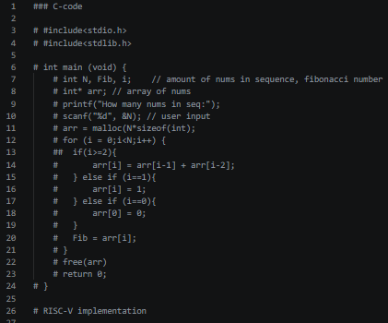

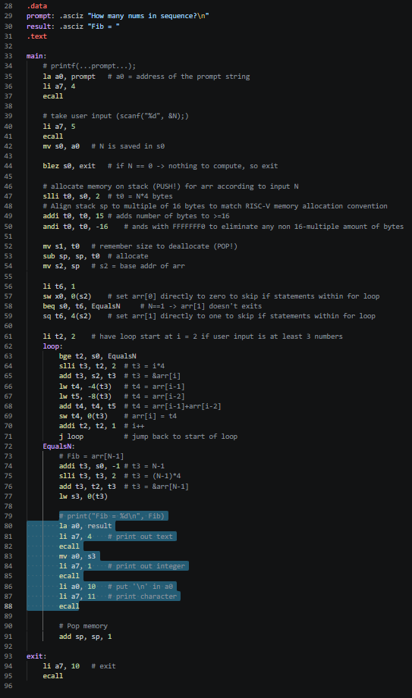

Recursive Implementation
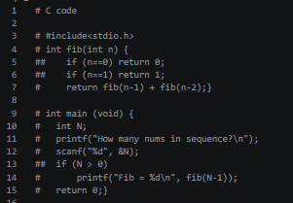
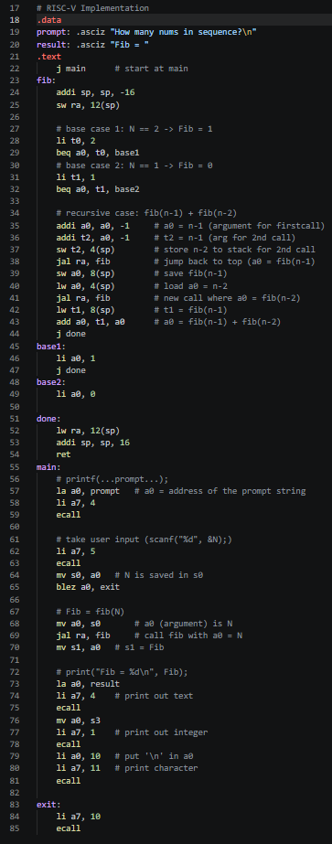

Number of instructions
- Iterative
# of instructions
N==0 => 9 instructions
N==1 => 32 instructions (takes first beq branch)
N==2 => 18+16 = 34 instructions (takes first pass of bge branch)
N >= 3 => 18 + 16 + (N-1)*9 instructions (passes over bge N-1 times and executes the next 8 instructions N-1 times, so add 9 onto the 18+16 (N-1) times.
- Recursive
# of instructions
N == 0 => 8 instructions
N = 1 => 32 instructions
N = 2 => 31 instructions
N >= 3 => 28*F(N) + 29*F(N-1) + 5

