CprE 381, Computer Organization and

Assembly-Level Programming

Lab 2 Report

Student Name ______________Justin Adrowski_________________

Submit a typeset pdf version of this on Canvas by the due date. Refer to the highlighted language in the lab document for the context of the following questions.

[Part 3 (a)] Draw the interface description (i.e., the “symbol” or high-level blackbox) for the RISC-V register file. Which ports do you think are necessary, and how wide (in bits) do they need to be?
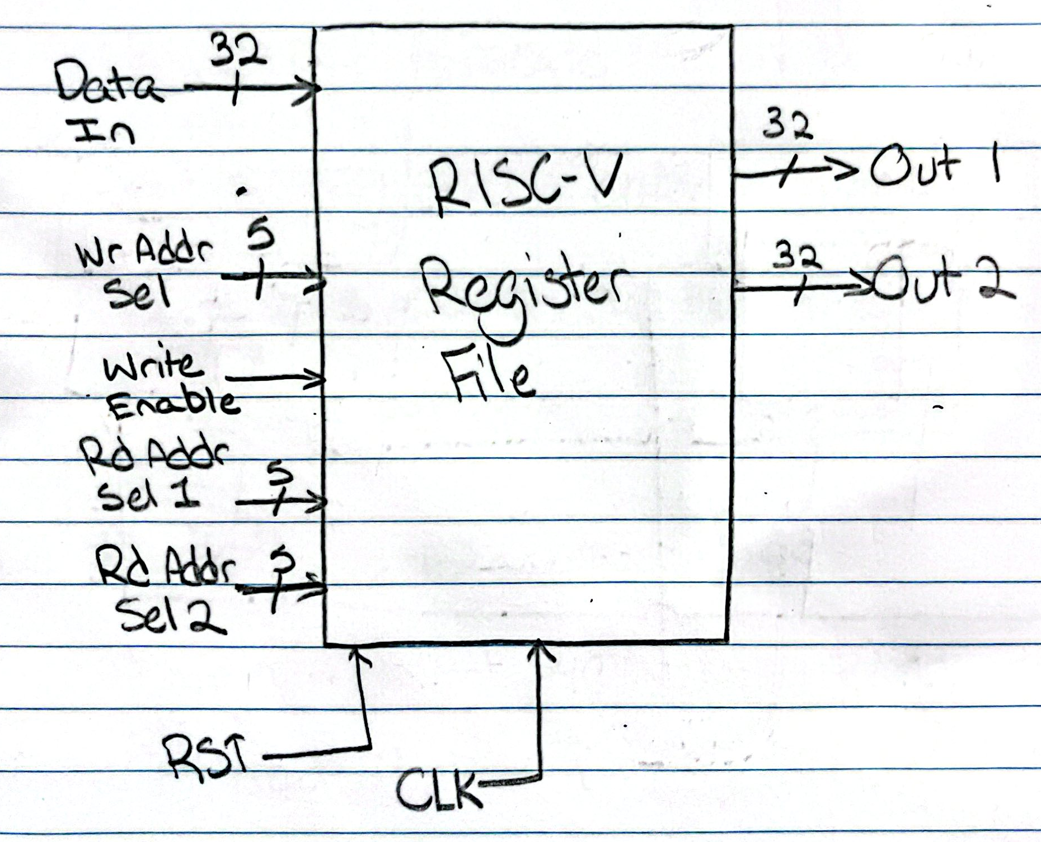

I indicate port widths in the diagram

[Part 3 (b)] Create an N-bit register using this flip-flop as your basis.
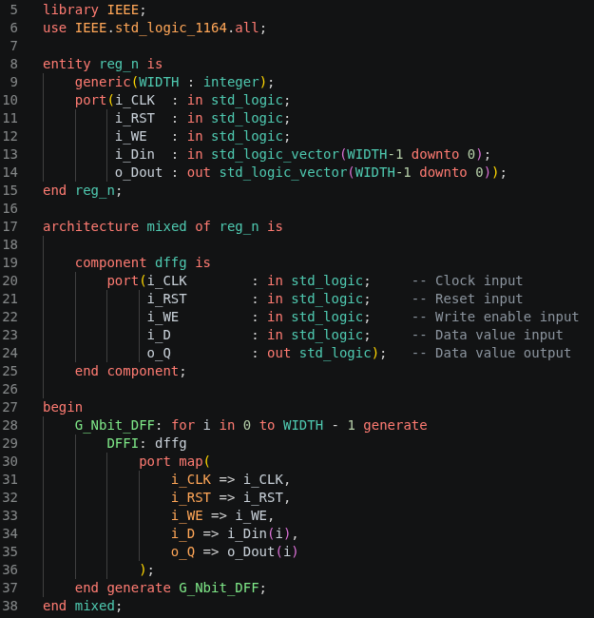

[Part 3 (c)] Waveform.

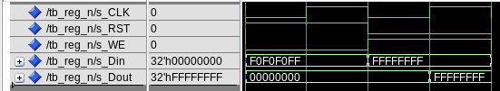
The output only changes once the write_enable line goes high, the reset is low, and the clock low-to-high edge occurs, showing that it passes functionality.

[Part 3 (d)] What type of decoder would be required by the RISC-V register file and why?

A 5-to-32 decoder since we need access to 32 registers for RISC-V, and need the address bit-field to only be five bits long.

[Part 3 (e)] Waveform.

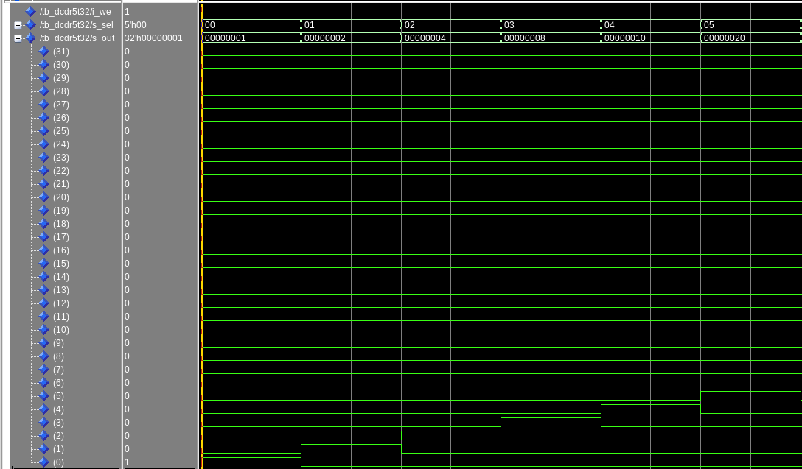
The output of the decoder is always only 1 or no high bits, and the high bit always corresponds to the index of the select input, so it works.

[Part 3 (f)] In your write-up, describe and defend the design you intend on implementing for the next part.

For my 32 bit 32-to-1 mux design. I made three entities. First, I augmented the 2-to-1 mux design from the previous lab to be 32-to-1. Then, based on the architecture of my mux, I realized I had to utilized a 32x32 array object as an input if I wanted to correctly implement an N-bit 32-to-1 mux. So, I did get some help from online to learn how to go this, and made another file called mux_arr.vhd, where I declare package mux_arr as a type vector array with a natural range of std_logic_vectors.
Lastly, I put these together in mux32t1_n.vhd, where I declare a new input, i_array to hold all the values. Then in the final mapping, within an for loop from 0 to 31, iterating i, I generate an i-th 32-bit wide bits_for_mux signal. Each bits_for_mux contains the ith bit of each read register. Next, within the same i-th iteration of the main loop, for j registers (will be 32), I map the ith bit of the j-th register to the j-th bit of bits_for_mux. Finally, I instantiate an i-th mux32-1 gate, where I map the i-th bits_for_mux to the i_inputs of the mux gate. This occurs 32 times until each mux would output the 32 bits of the selected register given the i_sel value that goes into each mux instance.

[Part 3 (g)] Waveform.
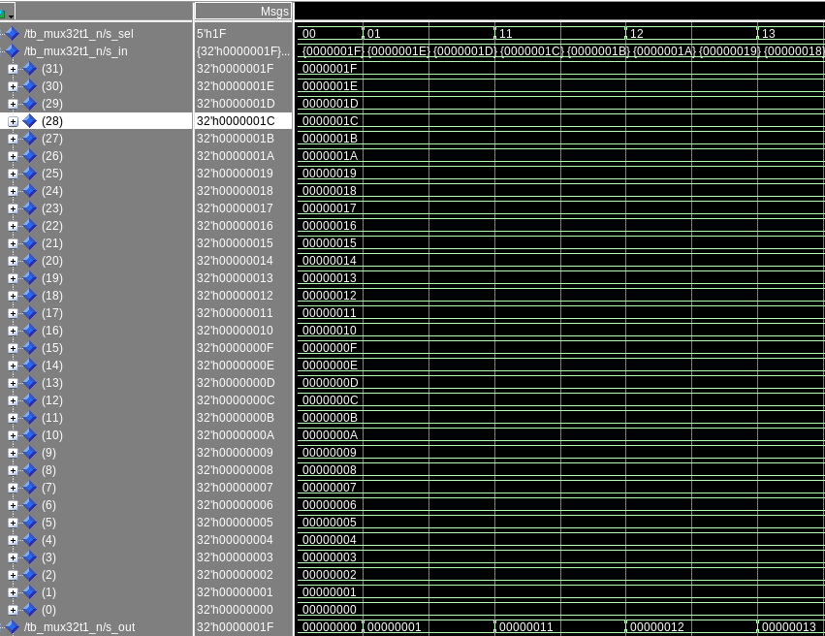
As seen from the middle wave, s_in, I instantiated each registers value to be the register number itself. The select input is at the top, so whatever number is at the top, the same number should appear at the bottom, and as seen from the wave, this is what happened, so it worked.

[Part 3 (h)] Draw a (simplified) schematic (i.e., components within the high-level blackbox) for the RISC-V register file, using the same top-level interface ports as in your solution describe above and using only the register, decoder, and mux VHDL components you have created.
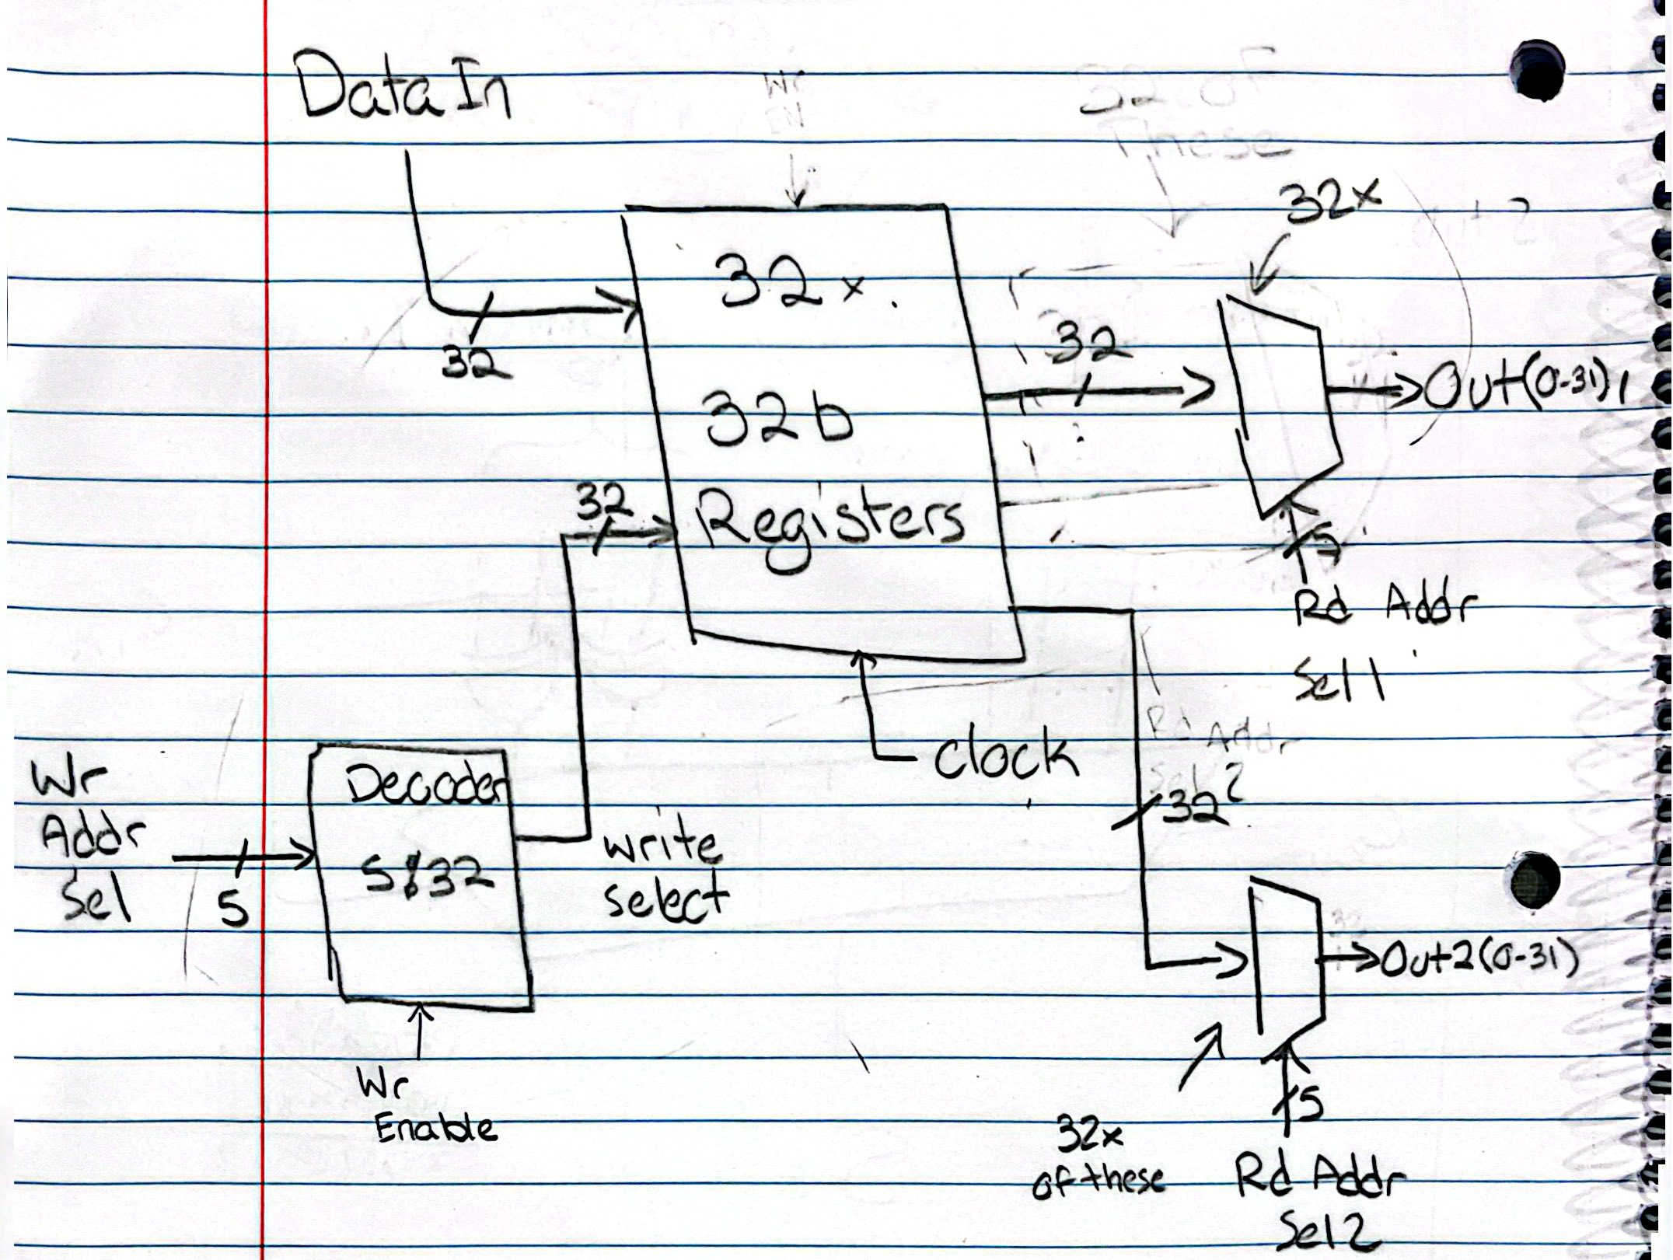

[Part 3 (i)] Waveform.
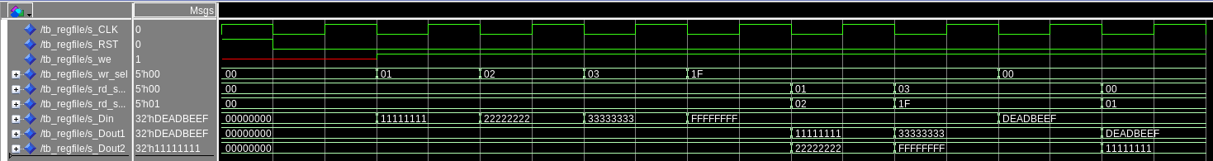
As seen from the waveform, in the first 5 clock cycles, data is written to registers 01, 02, 03, & 1F. Then, in the next 4 clock cycles, these registers are selected in both read1, and read2, where the value is displayed in Dout1 or Dout2. The previously written data matches the later read data, so the register file works.

[Part 4 (b)] Draw a symbol for this RISC-V-like datapath.

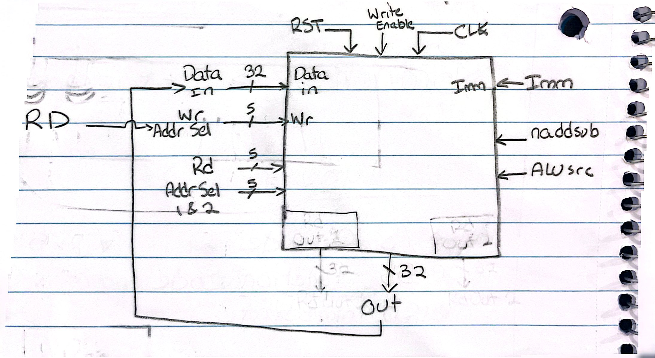

[Part 4 (c)] Draw a schematic of the simplified RISC-V processor datapath consisting only of the component described in part (a) and the register file from problem (1).
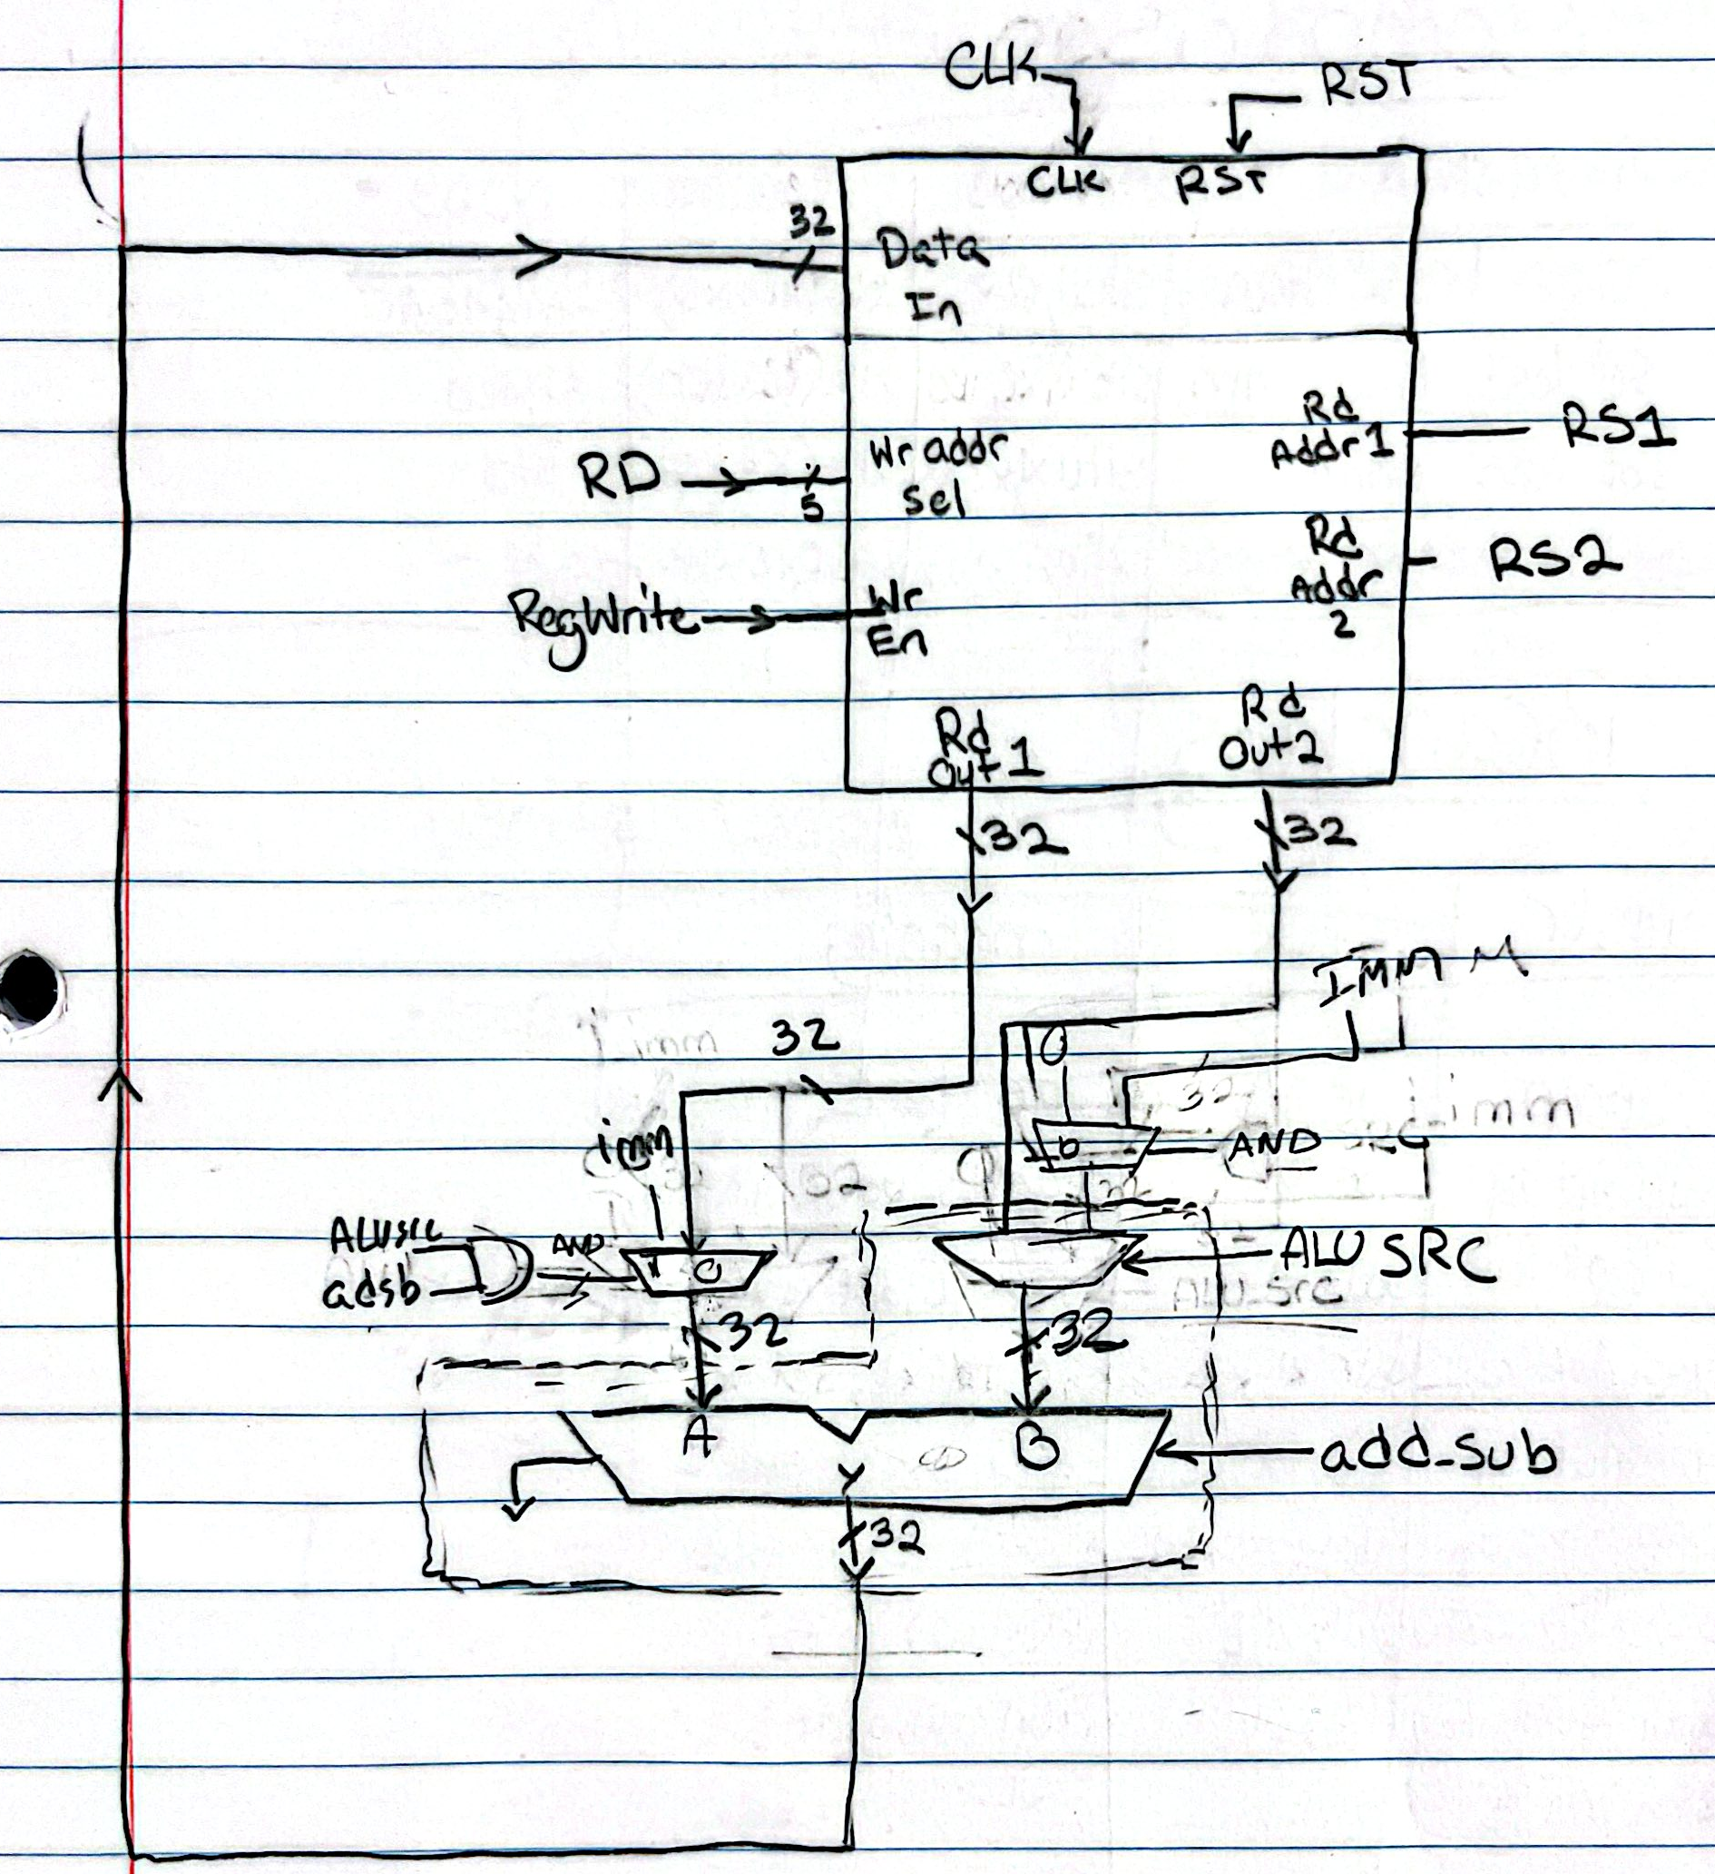

[Part 4 (d)] Include in your report waveform screenshots that demonstrate your properly functioning design. Annotate what the final state of the register file should be and provide a mapping of the registers used in your drawing to the register names.
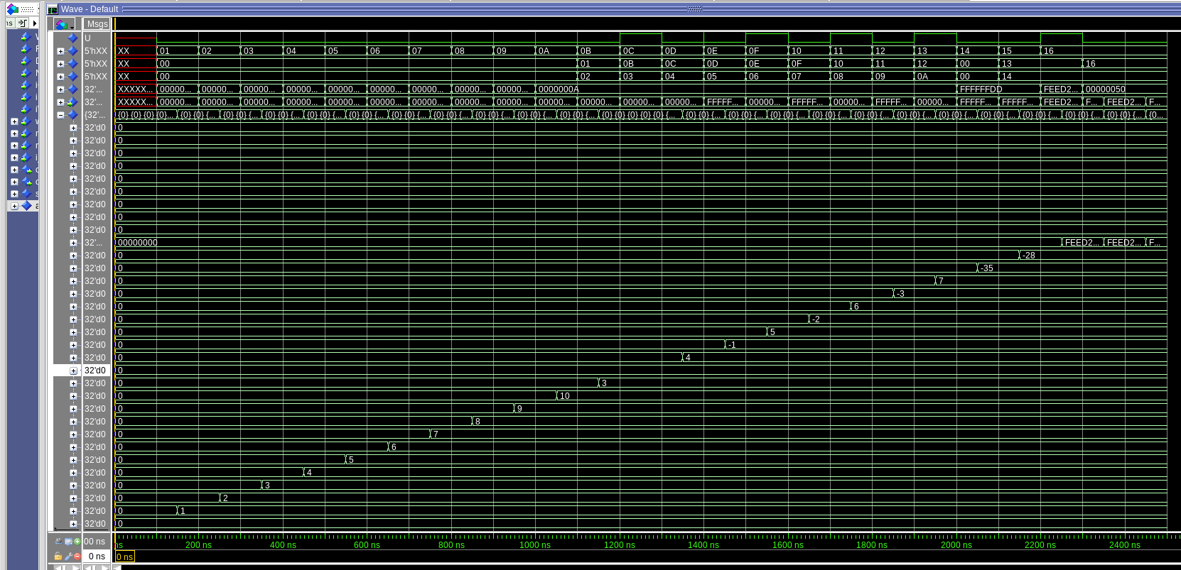
Following the RISC-V Assembly shown in the lab doc, the function is to load 1-10 into registers 1 through 10, then rotate between adding and substracting sequential register values from one all the way up until 10. This results in the following register values, x11 = 3, x12 = 0, x13 = 4, x14 = -1, x15 = 5, x16 = -2, x17 = 6, x18 = -3, x19 = 7. Then the next instruction performs a store -35 in x20, then this -35 is added to x19, and stored in x21, so x21 = -28. Finally the last two instructions store FEED2050 in x22. All of these values end up being seen in the registers when reading the intermediate signal of the input into the mux32t1_n entity, so the module performed correctly.

[Part 5 (a)] Read through the mem.vhd file, and based on your understanding of the VHDL implementation, provide a 2-3 sentence description of each of the individual ports (both generic and regular).

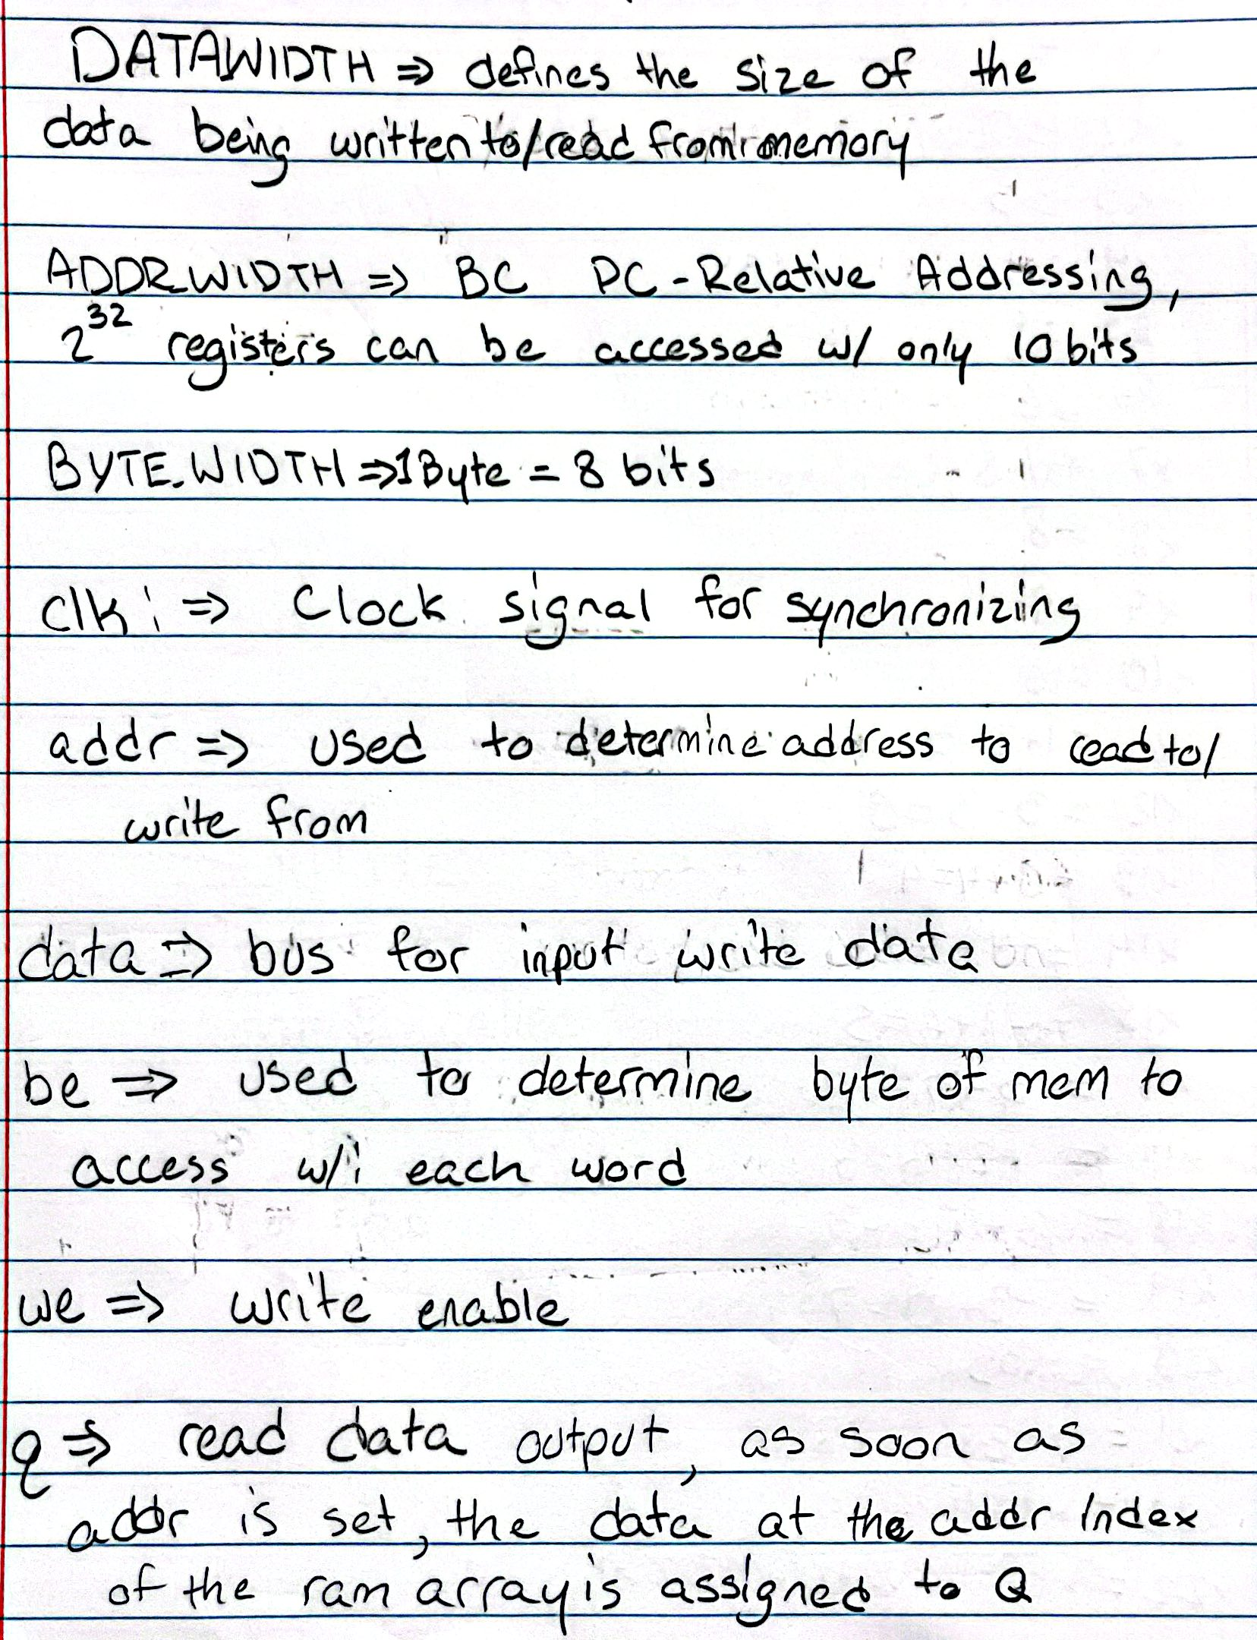

[Part 5 (c)] Waveforms and hex file.

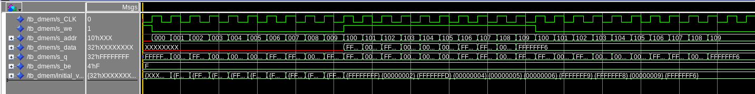

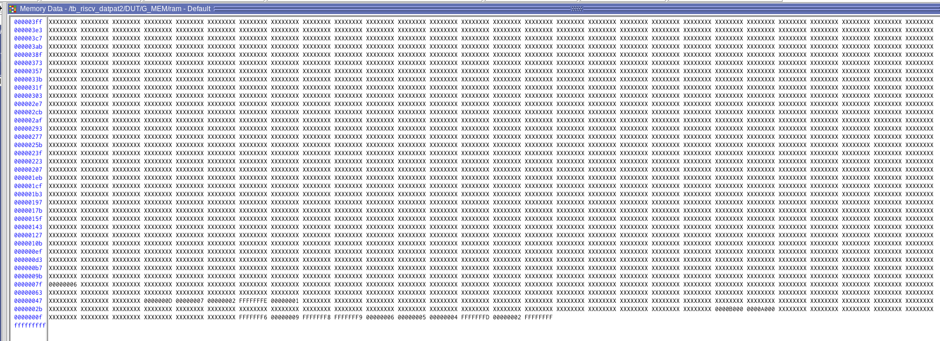
The testbench correctly loaded the first ten location values into the next ten starting at 0x100
[Part 6 (a)] What are the RISC-V instructions that require some value to be sign extended? What are the RISC-V instructions that require some value to be zero extended? What are the RISC-V instructions that require some value to be appended with zero?
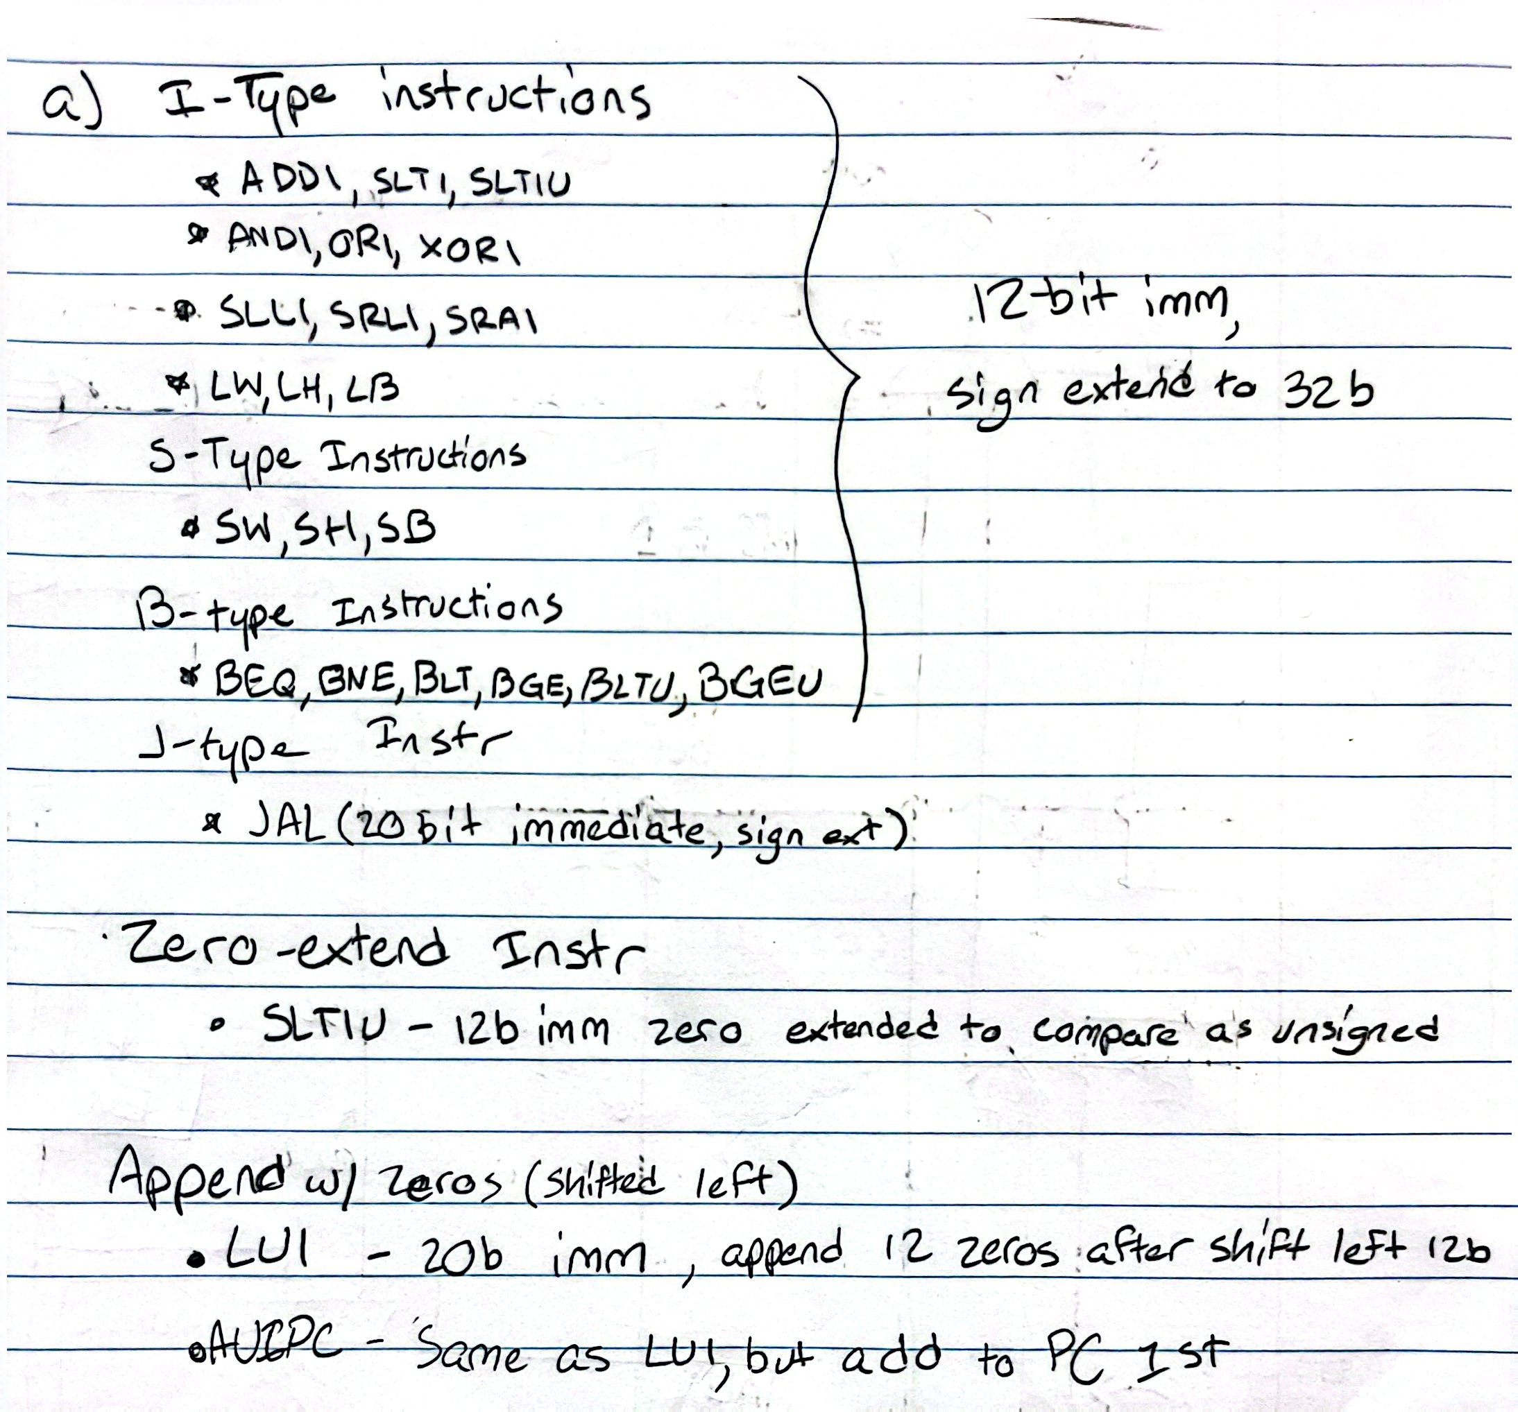

[Part 6 (b)] what are the different “extender” components that would be required by a RISC-V processor implementation (i.e., number of bits of input and sign vs zero extension vs zero appending)?
12-bit sign-extend immediate → 12 bit input, sign extension of 20 bits to 32 bit integer
20-bit sign-extend immediate → 20 bit input, sign extension of 12 bits to 32 bit integer
12-bit zero extend immediate → 12-bit input, zero-extension of 20 bits to 32 bit integer
20-bit zero append immediate → 20-bit input, zero append of 12 bits to 32 bit integer

[Part 6 (d)] Waveform.
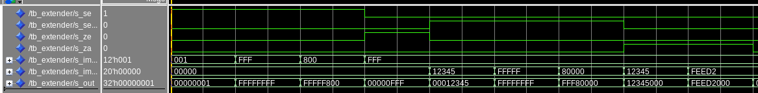
The extender has 6 inputs, four select bits for 12-bit sign/zero extension, zero append, or 20-bit sign extend, and two bus inputs for 12-bit or 20-bit immediates.

As see in the output variable, the input is extended correctly according to the corresponding input. Additionally, a hierarchy is followed as i_se12 → i_se20 → i_ze → i_za

[Part 7 (a)] what control signals will need to be added to the simple processor from part 2? How do these control signals correspond to the ports on the mem.vhd component analyzed in part 3?
a store word signal was added, along with load word and all the extension signals. The store word signal is the only one that directly interacts with the memory block as the we input to allow data from the read out 2 to be stored into memory at the location specified by rs1+imm

[Part 7 (b)] Draw a schematic of a simplified RISC-V processor consisting only of the base components used in part 2, the extender component described in part 4, and the data memory from part 3.
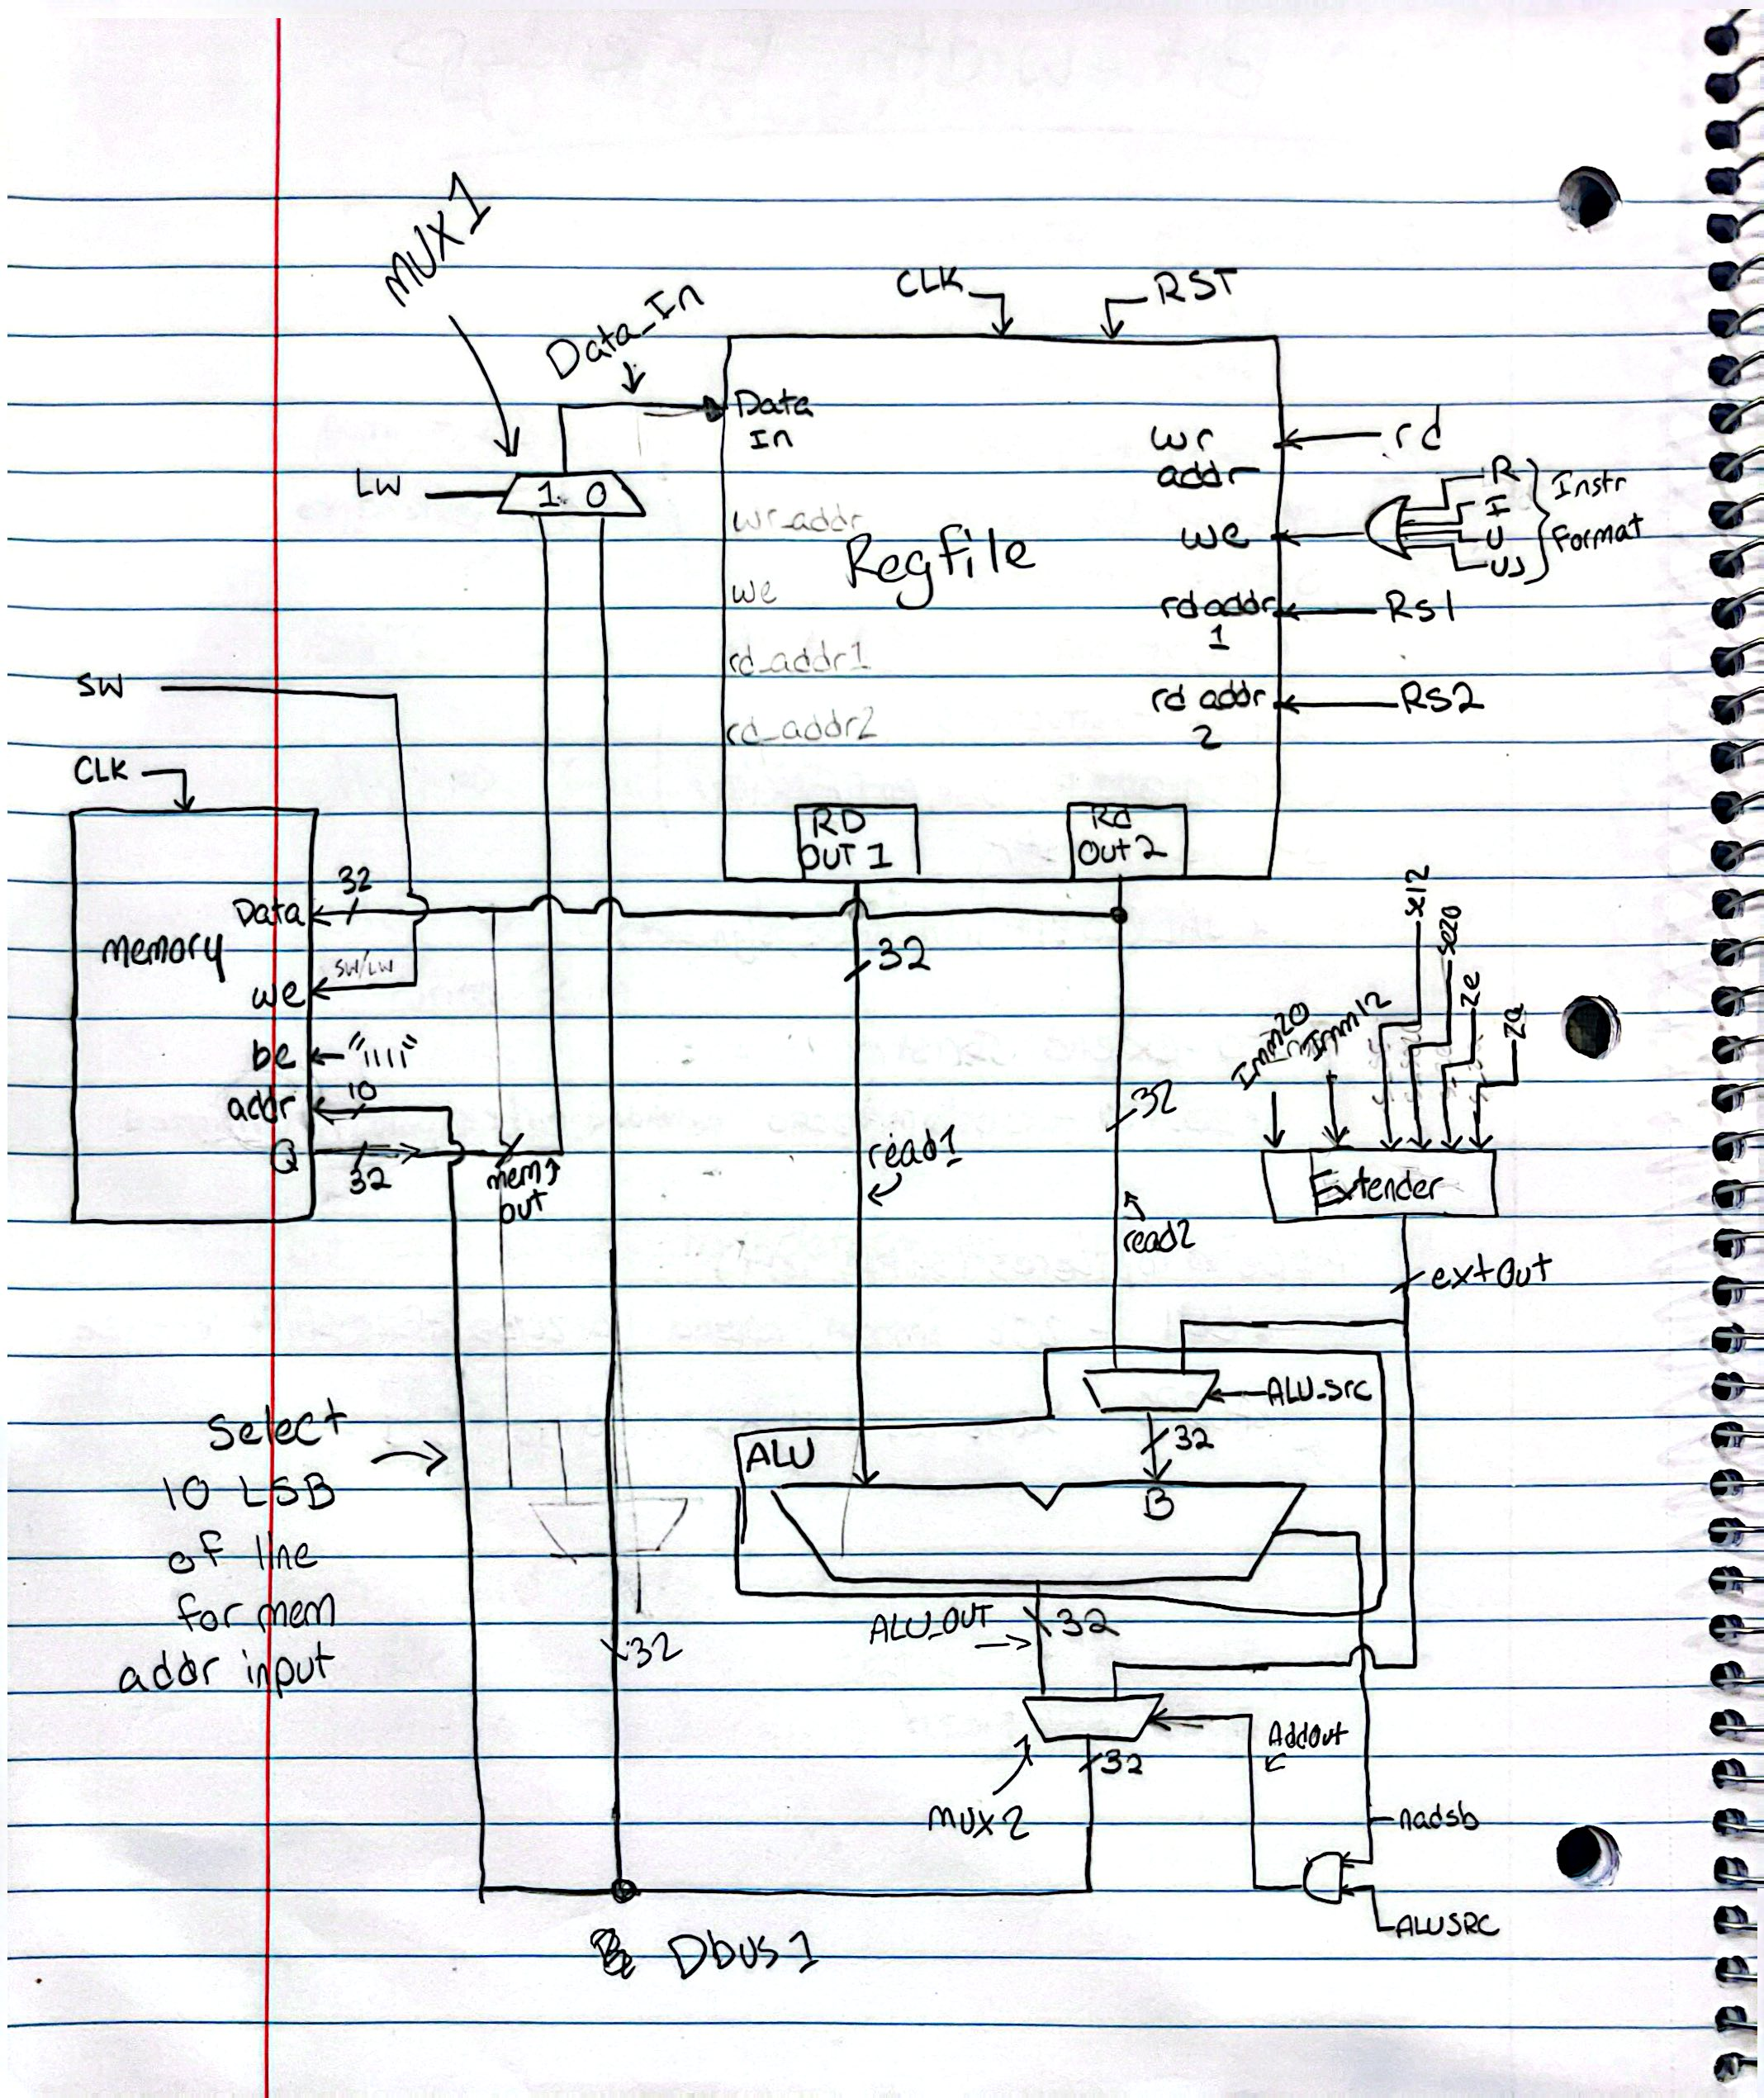

[Part 7 (c)] Waveform.
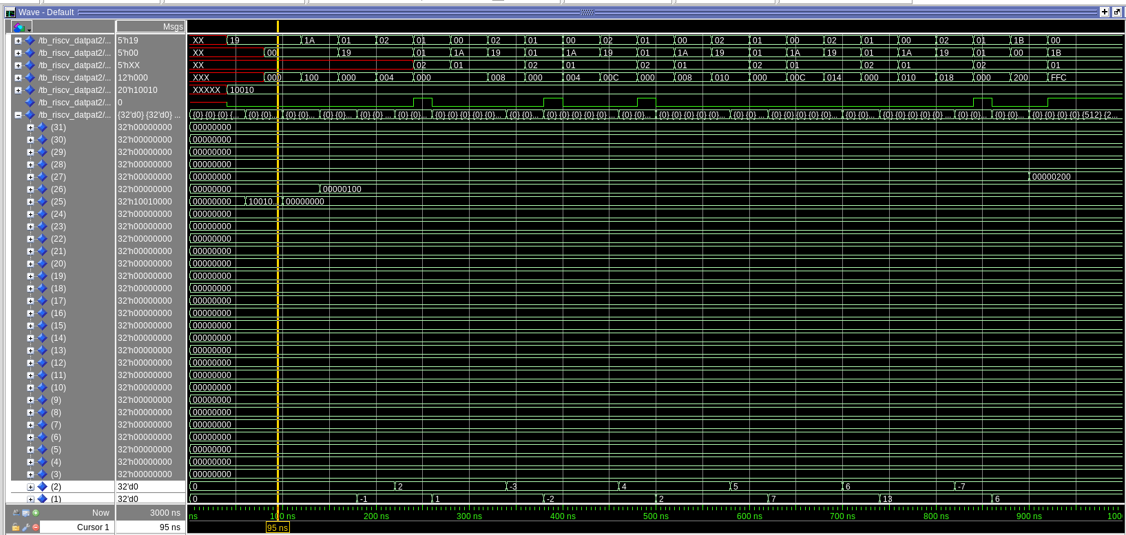
[Part 7 (d)] Compare the Questasim waveform/memory list against the RARs output/memory list.
