**1.) Transposition Cipher**

#include<stdio.h>

void main()

{

int Strlen,Keylen,cols,rows,i,j,key[10],temp,k;

char s[50][50],c;

printf("Enter length of string: ");

scanf("%d",&Strlen);

printf("Enter length of key: ");

scanf("%d",&Keylen);

cols=Keylen;

printf("Enter key: ");

for(k=0;k<Keylen;k++)

{

scanf("%1d", &key[k]);

}

if(Strlen%Keylen==0)

rows=Strlen/Keylen;

else rows=(Strlen/Keylen)+1;

printf("Enter a string to be encrypted: ");

c=getchar();

for(i=0;i<rows;i++)

{

for(j=0;j<cols;j++)

{

if((c=getchar())!='\n')

{

//if(c!=' ')

s[i][j]=c;

//else continue;

}

else

{

s[i][j]='\0';

}

}

}

for(k=0;k<Keylen;k++)

{

temp=--key[k];

for(i=0;i<rows;i++)

{

printf("%c",s[i][temp]);

}

}

}

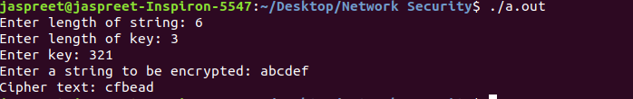

**2. Ceaser Cipher**

#Python3

p=input("Enter plain text:")

#print (p)

key=3 #fixed in ceaser cipher

c=''

temp=''

for i in range(len(p)):

temp=(ord(p[i])+97+key)%(97+26)

if(temp>97):

c=c+chr(temp)

else:

c=c=c+chr(temp+26)

print(c)

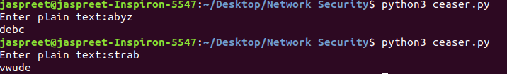

**3. Shift Cipher**

#Python3

p=input("Enter plain text: ")

key=int(input("Enter key: "))#for taking integer input

c=''

for i in range(len(p)):

temp=(ord(p[i])+97+key)%(97+26)

if(temp>97):

c=c+chr(temp)

else:

c=c=c+chr(temp+26)

print(c)

