**ExpenseTracker**

**User Manual**

**Table of Contents:**

Contents

Introduction: 3

Login & Sign up: 3

Dashboard: 5

Receipt Scanner: 8

Prediction By Category: 12

Receipt Gallery: 12

Logout: 13

## Introduction:

Welcome to ExpenseTracker! This document will serve as a guide to navigate through our web application and describe how each component works.

## Login & Sign up:

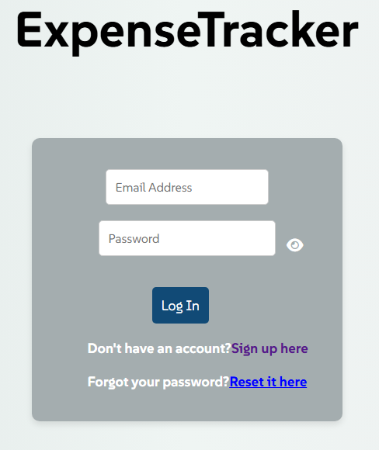

This is the ExpenseTracker login page, to start with a new account, click ‘Sign up here’ to create a brand-new account. If you forgot your password, you can reset it by clicking the ‘Reset it here’ hyperlink.

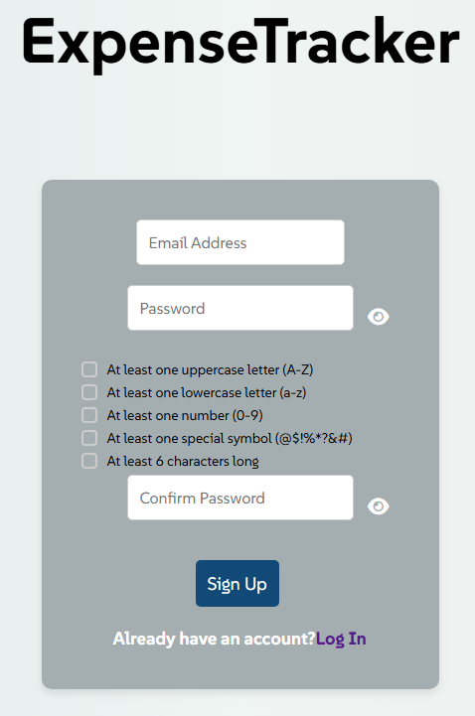

After clicking on ‘Sign up here', you will be guided to the sign up page where you may enter a valid email address and a password that fulfills all the requirements. Click the ‘Sign Up’ button at the bottom of the form and you will be asked to verify your email and be welcomed to the main dashboard.

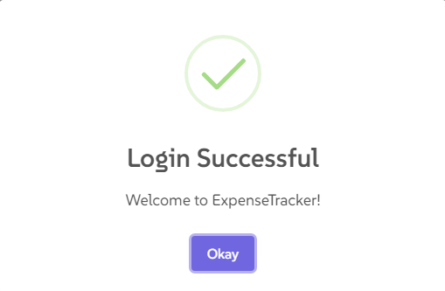

After a successful login, you will be faced with a popup which will confirm that you are logged in and ready to use the application, click the ‘Okay’ button to continue to the Dashboard.

## Dashboard:

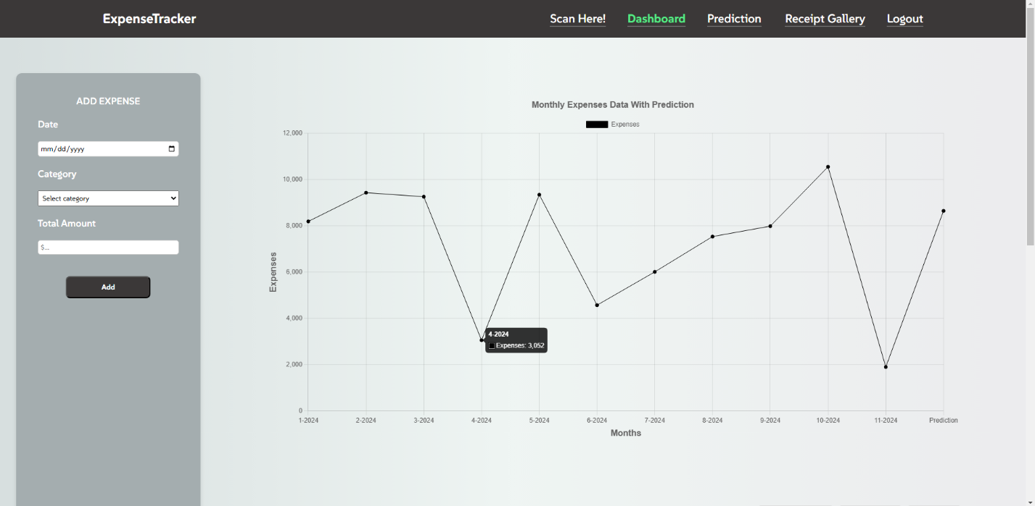

This is the first screen you will see when logged in, which is the Dashboard. Here you will be able to manually add, edit, and delete expenses. Along with adding expenses, you will be able to view your monthly spending and your prediction for next month’s spending.

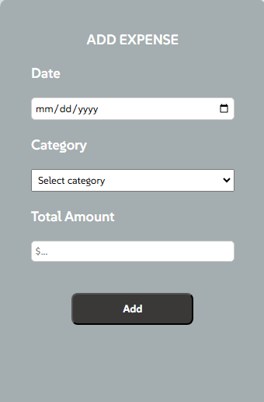

As mentioned above, this is the form to manually add expenses. You must choose a date, category, and the total amount of the item to add the expense.

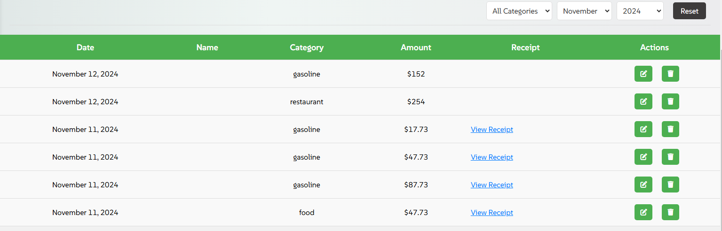

When an expense is added you will be able to see it on the expense table. As you can see, each expense is ordered from the most recent purchase. You may also filter your expenses by category, date, and year. The ‘View Receipt’ hyperlink will allow you to view receipt images on the expense table.

## Receipt Scanner:

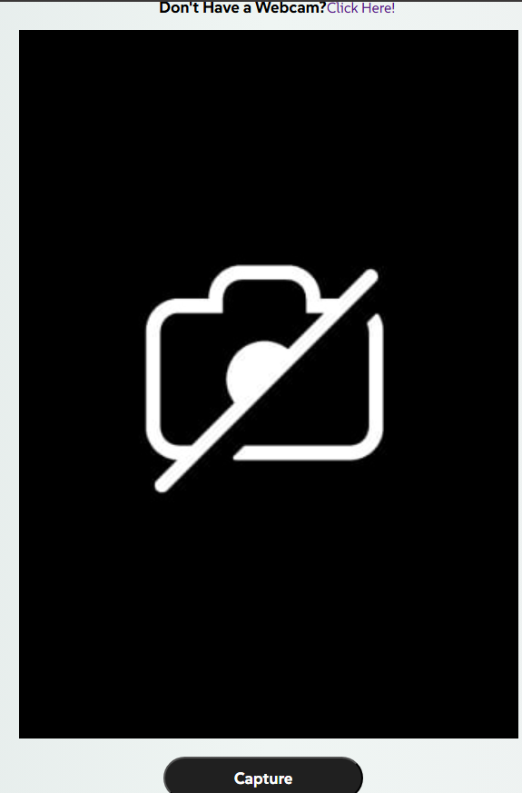

Now, if you navigate to the ‘Scan Here!’ tab from the navigation bar, you will be directed to the receipt scanner page. Here you can scan receipts using your system’s webcam or upload a file if your device does not have a webcam. By clicking on the ‘Don’t Have a Webcam? Click Here!’ hyperlink, you will be automatically scrolled down to the file upload section. To scan a receipt, hold a receipt up to the webcam and click ‘Capture’. After clicking ‘Capture’, a popup that says ‘Processing’ will appear and another popup will appear after showing that the scan was a success along with the information from the receipt.

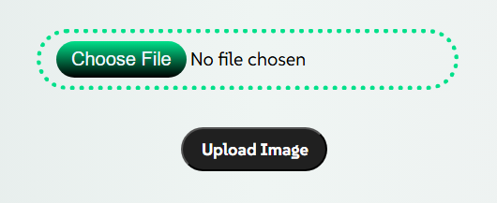

This is the file upload section where you will be able to choose a file from your devices file browser and click on ‘Upload Image’ to scan the receipt. The same procedure as the webcam scanner will occur with the file uploader.

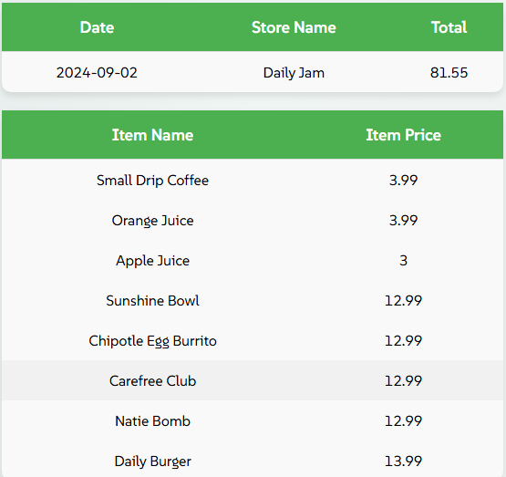

When a receipt is scanned and processed, you will be able to view the itemized results which will include every item on the receipt, the store name, date purchased, and total amount of the receipt.

## Prediction By Category:

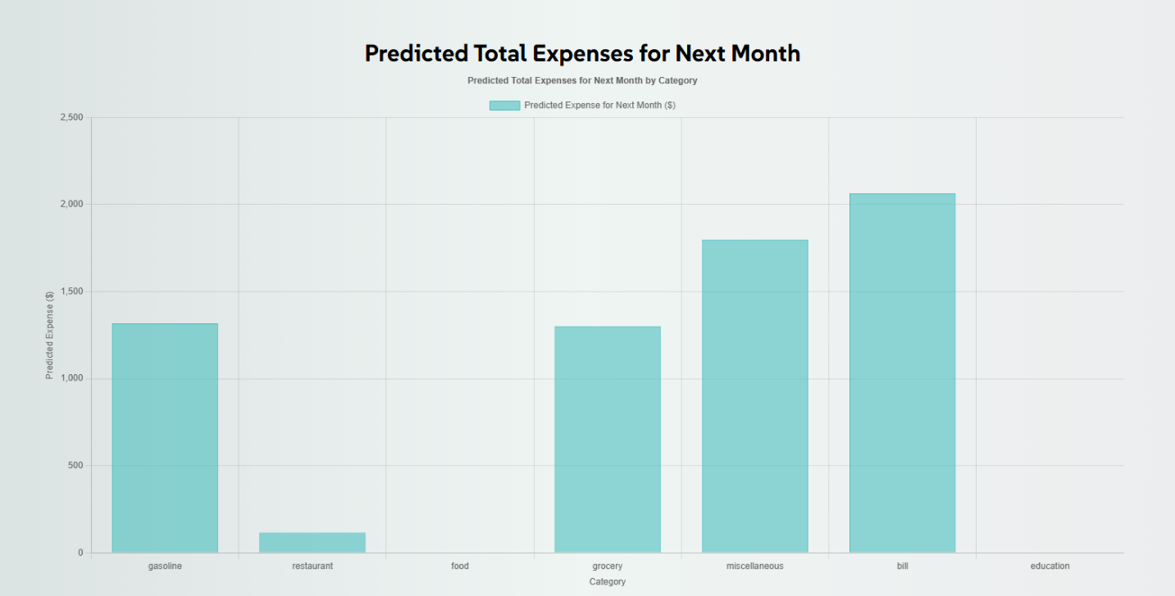

Next up is the prediction by category page which can be accessed by clicking on the ‘Prediction’ tab on the navigation bar. This page is very simple, it shows a prediction of the next month based on each category. For example, the ‘gasoline’ category will show a prediction for how much you will spend on gas next month.

## Receipt Gallery:

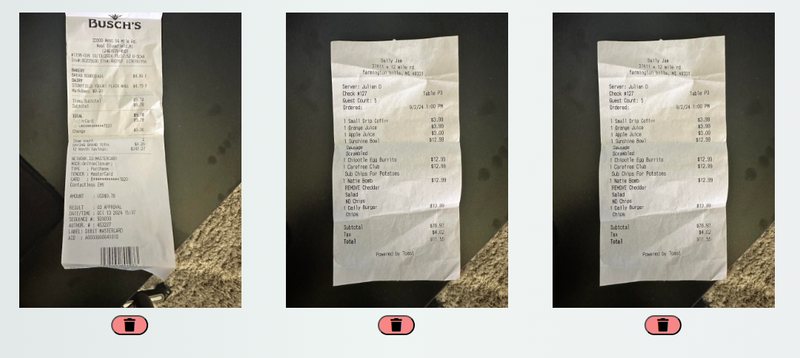

The receipt gallery can be accessed by clicking the ‘Receipt Gallery’ tab on the navigation bar. This page will hold every receipt that you scan or upload, and you will have the option to delete the ones you do not want to keep by clocking the trash icon button.

## Logout:



On the navigation bar is a ‘Logout’ button, which will sign you out of your account and send you back to the login page.