James Brown III / Assignment 8.2

Start

Import JSON File

No more students?

Load through student information

Extract information: Name, ID, Email

Process or Display Information

End

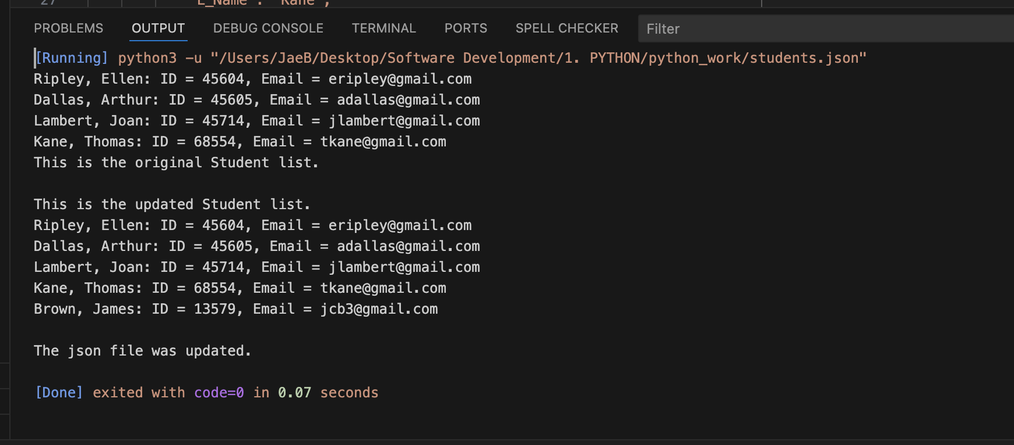

# This code reads student data from a JSON string, prints the original list,

# adds a new student to the list, and writes the updated list back to a JSON file.

import json

# JSON data representing students

student_data = '''

{

"student": [

{

"F_Name": "Ellen",

"L_Name": "Ripley",

"Student_ID": 45604,

"Email": "eripley@gmail.com"

},

{

"F_Name": "Arthur",

"L_Name": "Dallas",

"Student_ID": 45605,

"Email": "adallas@gmail.com"

},

{

"F_Name": "Joan",

"L_Name": "Lambert",

"Student_ID": 45714,

"Email": "jlambert@gmail.com"

},

{

"F_Name": "Thomas",

"L_Name": "Kane",

"Student_ID": 68554,

"Email": "tkane@gmail.com"

}

]

}

'''

data = json.loads(student_data)

# Print the original student list

for student in data['student']:

print(f"{student['L_Name']}, {student['F_Name']}: "

f"ID = {student['Student_ID']}, Email = {student['Email']}")

print("This is the original Student list.")

print()

# Add a new student to the list

new_student = {

"F_Name": "James",

"L_Name": "Brown",

"Student_ID": 13579,

"Email": "jcb3@gmail.com"

}

# Append the new student to the existing list

data['student'].append(new_student)

with open('student.json', 'w') as file:

json.dump(data, file, indent=4)

print("This is the updated Student list.")

# Print the updated student list

for student in data['student']:

print(f"{student['L_Name']}, {student['F_Name']}: "

f"ID = {student['Student_ID']}, Email = {student['Email']}")

print()

print("The json file was updated.")